BMIS 2010 Thematic Analyses Series

Health

24/7/2012
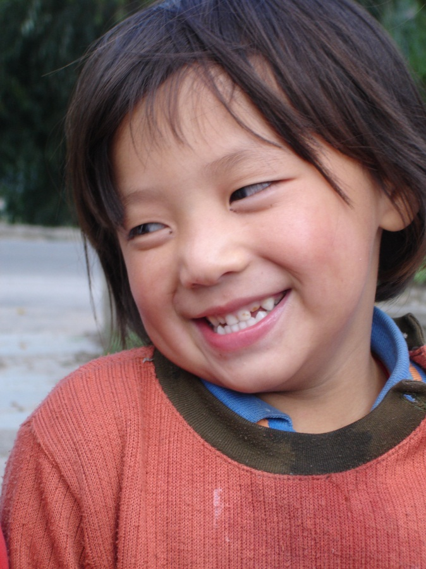
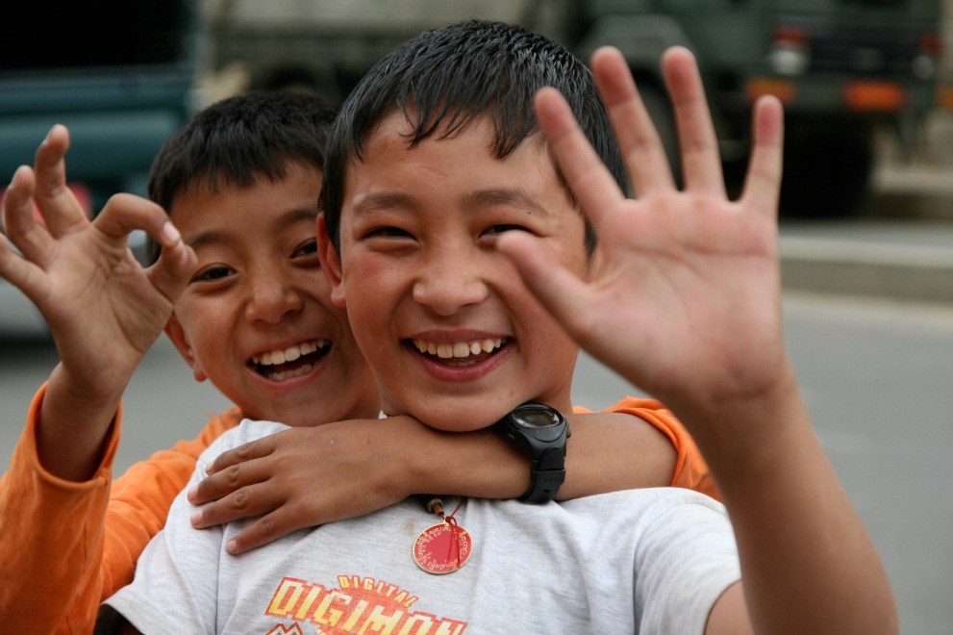
UNFPA, UNICEF, RGOB

Table of contents
Acknowledgements 10
Foreword 11
What this report covers 13
List of abbreviations 15
Executive summary 18
The demographic profile 19
Nutrition 19
Child health 20
Child mortality 20
Reproductive health 21
Maternal mortality 22
HIV/AIDS 22
Water and Sanitation 23
1. Introduction 24
2. Methodology 27
2.1 Working group 27
2.2 Statistical analysis 27
2.3 Data limitations 27
2.4 Technical notes 28
3. The demographic profile 29
3.1 General demography 29
Figure 1: Population pyramids for 2005, 2010 and 2030 (projection based on PHCB 2005) 29
Table 1: Distribution of children under the age of 18 years, Bhutan, 2010 30
Table 2: Sex ratio among children under the age of 5, Bhutan, 2010 31
Table 3: Percent distribution of population by wealth quintiles, Bhutan, 2010 31
Figure 2: Percentage of the population in the poorest wealth quintile by dzongkhag, Bhutan, 2010 33
3.2 Section summary 33
4. Nutrition 34
4.1 Introduction 34
4.2 Nutritional status of children under the age of 5 35
Table 4: Percentage of children under 5 who are moderately or severely stunted, distributed by underweight status, Bhutan, 2010 35
Figure 3: Percentage of children under 5 who are moderately or severely stunted, distributed by underweight status, Bhutan, 2010 36
4.3 Low birth weight and nutritional status of children under the age of 2 36
Table 5: Percentage of children under the age of 2 who were weighed at birth by whether they were delivered in an institution, Bhutan, 2010 37
Table 6: Percentage of children under the age of 2 who are born with low birthweight by mother’s antenatal care, Bhutan, 2010 39
Table 7: Nutritional status of children under the age of 2 by whether they were born underweight, Bhutan, 2010 39
Figure 4: Nutritional status of children under the age of 2 by whether they were born underweight, Bhutan, 2010 40
Figure 5: Percentage of underweight children under the age of 2 by low birthweight status and age, Bhutan, 2010 41
Figure 6: Percentage of stunted children under the age of 2 by low birthweight status and age, Bhutan, 2010 42
Figure 7: Percentage of wasted children under the age of 2 by low birthweight status and age, Bhutan, 2010 43
4.4 Infant and young child feeding 43
Figure 8: Percentage of children aged 0-5 months exclusively breastfed by age, Bhutan, 2010 44
4.4.1 Exclusive breastfeeding and mother’s antenatal care 44
Table 8: Percentage of children aged 0-5 months exclusively breastfed by their mother’s antenatal care and by whether they were delivered in an institution, Bhutan, 2010 44
Figure 9: Percentage of children aged 0-5 months exclusively breastfed by their mother’s antenatal care and by whether they were delivered in a health facility, Bhutan, 2010 45
4.4.2 Feeding practices for children under the age of 2 45
Table 9: Percentage of mothers who gave their newborn something to drink other than breast milk in the first three days after birth, and the type of drink given, among women mothers who gave birth in the last 2 years preceding the survey, Bhutan, 2010 46
Table 10: Percentage of children aged 6-23 months who received solid, semi-solid or soft foods during the previous day by age group and number of times, Bhutan, 2010 47
Figure 10: Distribution of children aged 6-23 months who received solid, semi-solid or soft foods during the previous day by age group and number of times, Bhutan, 2010 47
4.5 Underweight prevalence and mother’s antenatal care 48
Table 11: Percentage of children under 2 years of age who are moderately or severely underweight, by antenatal care received by the mother, Bhutan, 2010 48
4.6 Wasting prevalence and sanitation facilities 48
Table 12: Percentage of moderately or severely wasted children under the age of five by the quality of their household sanitation facilities, Bhutan, 2010 49
4.7 Nutritional statuses and mother’s literacy 49
Table 13: Nutrition indicators of children under 5 of mothers aged 15-49 by the literacy of the mother, Bhutan, 2010 49
4.8 Food security 50
Table 14: Percentage of households with food insecurity by month, Bhutan, 2010 51
Figure 11: Percentage of children under the age of 5 who faced food insecurity by year 52
Figure 12: Mean number of months that households face food insecurity by household size, 2010 52
Figure 13: Percentage of households that faced food insecurity by months of the year, Bhutan, 2010 53
4.7.1 Food security and nutritional status of children under the age of 5 53
Table 15: Nutritional status of children under the age of 5 by food security status of their household, Bhutan, 2010 54
Figure 14: Nutritional status of children under the age of 5 by food security status of their household, Bhutan, 2010 55
4.9 Section summary 55
5. Child health 57
5.1 Introduction 57
5.2 Acute respiratory infections 57
5.2.1 Pneumonia incidence 58
Table 16 and Figure 15: Under-five pneumonia incidence per 10,000 population (MoH), Bhutan, 2010 58
Table 17: Percentage of children under the age of 5 with suspected pneumonia, percentage taken to an appropriate provider, and percentage who received antibiotics, Bhutan, 2010 59
Figure 16: Percentage of children under the age of 5 with suspected pneumonia by mother’s education and wealth quintile, Bhutan, 2010 60
5.2.2 Pneumonia and care-seeking behaviour 60
Table 18: Early Childhood Development Index by care-seeking behavior for suspected pneumonia and care-seeking behavior by inadequate care status and age of mother, Bhutan, 2010 61
5.2.3 Solid fuel use 61
Table 19: Percentage of household members living in households using solid fuels for cooking, Bhutan, 2010 61
Map 2: Percentage of household members living in households using solid fuels for cooking, Bhutan, 2010 62
5.2.4 Pneumonia incidence and solid fuel use 63
Table 20: Percentage of children under the age of 5 with suspected pneumonia by use of solid fuel for cooking in the home, Bhutan, 2010 63
5.3 Diarrhoea 63
Figure 17: Under 5 diarrhoea incidence per 10,000 population 64
5.3.1 Diarrhoea incidence 64
Table 21: Diarrhoea incidence of children under the age of 5 (MoH data), Bhutan, 2010 64
Table 22: Diarrhoea incidence of children under the age of 5, Bhutan, 2010 65
Figure 18: Incidence of diarrhoea among children under the age of 5 by mother’s education and wealth quintile, Bhutan, 2010 66
5.3.2 Treatment of diarrhoea 66
Table 23: Treatment of diarrhoea for children under the age of 5, Bhutan, 2010 67
Figure 19: Percentage of children under the age of 5 who did not receive any treatment or drug for diarrhoea, Bhutan, 2010 68
5.4 Section summary 68
6. Child mortality 70
6.1 Introduction 70
Box 2: Definitions of child mortality 70
6.2 Child mortality estimates 70
Figure 20 : MDG 4: Infant mortality rate and Under-Five Mortality Rate 71
Table 24: Infant and Under-Five Mortality Rates, Bhutan, 2010 (for the year 2006) 72
Figure 21: Under-Five Mortality Rates by individual demographic groups, Bhutan, 2010 (for the year 2006) 73
6.3 Child mortality estimation methodologies 73
6.3.1 Indirect child mortality estimation methodology 74
Table 25 : Indirect estimates of Infant and Under-Five Mortality Rates, Bhutan, 1991-2006 75
Figure 22: Indirect estimates of Infant and Under-Five Mortality Rates, Bhutan, 1991-2006 75
6.3.2 Direct child mortality estimation methodology 75
Table 26 and Figure 23: Direct estimates of Infant and Under-Five Mortality Rates, Bhutan, 1984-2005 76
Box 3: The UN Inter-agency Group on Child Mortality Estimation (UN IGME) 76
The UN Inter-agency Group on Child Mortality Estimation (UNIGME) 76
6.3.3 Regional comparison of child mortality estimates 77
Figure 24: Infant Mortality Rates for selected Asian countries, UN IGME, 2010 77
Figure 25: Under-Five Mortality Rates for selected Asian countries, UN IGME, 2010 78
6.4 Section summary 78
7. Reproductive Health 80
7.1 Introduction 80
7.2 Fertility and fertility preferences 81
7.2.1 Fertility rates 81
Table 27: Age-specific fertility rates among women aged 15-49, Bhutan, 2010 82
Table 28: Distribution of number of children ever born to married women aged 15-49, Bhutan, 2010 83
Figure 26: Distribution of number of children ever born to married women aged 15-49, Bhutan, 2010 83
Figure 27: Mean number of children ever born and mean number of living 84
children among married women aged 15--49, Bhutan, 2010 84
7.2.2 Desire for last birth 84
Table 29: Planning status of births in the two years preceding the survey (including pregnancies), Bhutan, 2010 85
Table 30: Planning status of births in the two years preceding the survey (including pregnancies) by number of living children, Bhutan, 2010 85
Figure 28: Percentage of women aged 15-49 who were pregnant or gave birth in two years preceding the survey not wanting any more children when they got pregnant by their number of living children, Bhutan, 2010 86
7.3 Family planning 86
7.3.1 Contraception 87
Figure 29: Contraceptive Prevalence Rate (CPR) for all women aged 15-49 and for married women aged 15-49, Bhutan, 2003-2010 88
Table 31: Percentage of women aged 15-49 years currently married or in union who are using (or whose partner is using) a contraceptive method, by women's attitude towards domestic violence, Bhutan, 2010 88
7.3.1.1 Contraceptive prevalence and early marriage 89
Table 32: Percentage of women aged 20-49 currently married or in union who were who are using (or whose partner is using) a contraceptive method by their early marriage status, Bhutan, 2010 89
Figure 30: Percentage of women aged 20-49 currently married or in union who are using (or whose partner is using) any contraceptive method by their early marriage status, Bhutan, 2010 90
Figure 31: Percentage of women aged 20-49 currently married or in union who are using (or whose partner is using) any contraceptive method by their number of living children, Bhutan, 2010 91
7.3.2 Contraceptive prevalence and literacy 91
Table 33: Percentage of women currently married or in union age 15-49 who are using a contraceptive method by their literacy status, Bhutan, 2010 92
7.3.3 Unmet need 92
Table 34: Prevalence of unmet need for contraception among women aged 20-49, as a function of their early marriage, Bhutan, 2010 93
Table 35: Unmet need for contraception among married women aged 15-49 by literacy status, Bhutan, 2010 93
7.4 Safe motherhood 94
7.4.1 Antenatal care 94
Table 36: Distribution of the number of antenatal care visits received by women who gave birth during the two years preceding the survey, Bhutan, 2010 95
Figure 32: Percentage of women who received antenatal care at least once, at least four times, and at least eight times, among women aged 15-49 who gave birth in the two years preceding the survey, Bhutan, 2010 96
Figure 33: Distribution of number of antenatal care visits among women who gave birth in the two years preceding the survey, Bhutan, 2010 97
7.4.1.1 Antenatal care and skilled birth assistance 97
Table 37: Percentage of women who received skilled birth attendance by the number of antenatal care visits received, among women aged 15-49 who gave birth in the two years preceding the survey, Bhutan, 2010 98
7.4.1.2 Antenatal care and institutional delivery 98
Table 38: Percentage of women who delivered in a health facility by the number of antenatal care visits received, among women aged 15-49 who gave birth in the two years preceding the survey, Bhutan, 2010 99
Figure 34: Percentage of women who received skilled birth assistance and who delivered in a health facility by the number of antenatal care visits received, among women aged 15-49 who gave birth in the two years preceding the survey, Bhutan, 2010 100
Map 3: Percentage of women who gave birth in the two years preceding the survey who delivered the child at their or another’s home by dzongkhag, Bhutan, 2010 101
Table 39: Percentage of antenatal care visits among women aged 15-49 who gave birth during the two years preceding the survey by place of delivery, Bhutan, 2010 101
Figure 35: Number of antenatal care visits among women aged 15-49 who gave birth in the two years preceding the survey by place of delivery, Bhutan, 2010 102
7.4.1.3 Antenatal care and comprehensive knowledge of HIV/AIDS 102
Table 40: Knowledge of Prevention of Mother-to-Child Transmission of HIV and comprehensive knowledge of HIV transmission by level of antenatal care received, among women aged 15-49 who gave birth in the two years preceding the survey, Bhutan, 2010 103
7.4.1.4 Antenatal care and literacy 104
Table 41: Antenatal care by literacy status, among women aged 15-49 who gave birth in the two years preceding the survey, Bhutan, 2010 104
7.4.2 Postnatal cre 105
7.4.2.1 Postnatal care for mothers 105
Table 42: Postnatal care by a skilled provider: whether and when it was given, among women aged 15-49 who gave birth in the two years preceding the survey, Bhutan, 2010 106
Figure 36: Postnatal care by a skilled provider: when it was given, among women aged 15-49 who gave birth in the two years preceding the survey, Bhutan, 2010 107
7.4.2.2 Postnatal care for newborns 107
Table 43: Postnatal care for newborns by skilled provider: when and whether it was given, among women aged 15-49 who gave birth in the two years preceding the survey, Bhutan, 2010 107
Figure 37: Postnatal care for newborns by a skilled provider: when it was given, among women who gave birth in the two years preceding the surveyBhutan, 2010 109
7.4.3 Postnatal Care, antenatal care, and institutional delivery 109
Table 44: Percentage of women aged 15-49 who received skilled postnatal care within two days of delivery by level of antenatal care received and place of delivery, among women who gave birth in the two years preceding the surveyBhutan, 2010 109
7.4.4 Early childbearing 110
7.4.4.1 Early childbearing among women aged 15-24 110
Table 45: Adolescent birth rate and total fertility rate, Bhutan, 2010 110
Figure 38: Adolescent birth rate, Bhutan, 2010 111
Table 46: Early childbearing among young women aged 15-24, Bhutan, 2010 111
7.4.3.2 Early childbearing, education, and literacy 112
Tables 47 and 48: Secondary level school attendance by early childbearing status among young women aged 15-18, Bhutan, 2010 112
Table 49: Educational attainment by early childbearing status among young women aged 15-19, Bhutan, 2010 113
Table 50: Literacy rates by early childbearing status among mothers aged 20-24, Bhutan, 2010 113
7.4.4 Young motherhood 113
7.4.4.1 Young motherhood and reproductive and newborn health 114
Table 51: Percentage of young women aged 15-49 who received antenatal care and neonatal tetanus protection, by age of mother at birth of child, Bhutan, 2010 115
Table 52: Percentage of women age 15-49 receiving skilled birth assistance, institutional delivery, postnatal care, and child’s weight by age of mother at birth of child, Bhutan, 2010 116
Figure 39: Reproductive and newborn health care among young women aged 15-49 by age of mother at birth of child, Bhutan, 2010 117
7.4.4.2 Young motherhood and child outcomes 117
Table 53: Child health and education outcomes by mother’s age among women aged 15-49, Bhutan, 2010 117
7.5 Section Summary 118
8. Maternal mortality 120
8.1 Introduction 120
8.2 Measuring maternal mortality 120
8.3 Data quality 121
8.4 Adult mortality 121
Table 54: Adult Mortality: Direct estimates of female and male mortality by age during the four years prior to the survey, Bhutan 2010 121
8.5 Maternal mortality 122
Table 55: Direct estimates of maternal mortality for the period 0-4 years prior to the survey, Bhutan 2010 123
Figure 40: Maternal mortality direct method estimates 1996-2010, Bhutan, 2010 123
8.6 Section summary 124
9. HIV/AIDS 125
9.1 Introduction 125
9.2 Comprehensive knowledge of HIV transmission, literacy and education 126
Table 56: Percentage of women aged 15-49 who know three ways HIV can be transmitted from mother to child and percentage of women aged 15-49 with comprehensive knowledge of HIV transmission by their literacy status, Bhutan, 2010 126
Table 57: Comprehensive knowledge of HIV/AIDS transmission among women aged 15-18 by school participation status, Bhutan, 2010 128
Table 58: Comprehensive knowledge of HIV/AIDS among women aged 15-49 by household wealth quintile, Bhutan, 2010 129
9.3 Comprehensive knowledge of HIV transmission and condom use 129
Table 59: Percentage of married women aged 15-49 years who are using a contraceptive method as a function of their HIV knowledge, Bhutan, 2010 130
Table 60: Contraceptive use among currently unmarried sexually active women as a function of their HIV knowledge, Bhutan, 2010 130
9.4 Knowledge of HIV eransmission and early marriage 130
Table 61: Percentage of ever married women aged 15-49 who know three ways HIV can be transmitted from mother to child and percentage of these women with comprehensive knowledge of HIV transmission by their age at first marriage, Bhutan, 2010 131
9.5 Knowledge of HIV transmission and acceptance of PLHIV 132
Table 62: Accepting attitudes towards people living with HIV/AIDS among women aged 15-49 by whether they have comprehensive knowledge of HIV/AIDS transmission, Bhutan, 2010 132
Table 63: Accepting attitudes towards people living with HIV/AIDS among women aged 15-18 against their attendance in secondary school, Bhutan, 2010 133
Table 64: Accepting attitudes towards people living with HIV/AIDS among women aged 15-49 against their HIV testing take-up, Bhutan, 2010 134
9.6 Section Summary 134
10. Water and Sanitation 136
10.1 Introduction 136
10.2 Drinking Water Facilities 136
Figure 41: Proportion of population using an improved drinking water source, Bhutan, 2010 137
10.2.1 Drinking Water Facilities and Diarrhoea Incidence 138
Table 65: Percentage of children who had diarrhoea in the two weeks preceding the survey, according to availability of improved drinking water in the household, Bhutan, 2010 138
Table 66: Percentage of children under 5 who had diarrhoea in the two weeks preceding the survey type of treatment used for drinking water in households without improved drinking water sources, Bhutan, 2010 139
10.2.2 Time to Collect Water and Diarrhoea Incidence 140
Table 67: Percentage of children under 5 who had diarrhoea in the two weeks preceding the survey by whether household has water on the premises, Bhutan, 2010 140
Table 68: Percentage of children under 5 who had diarrhoea in the two weeks precediing the survey, by the time needed to collect water, Bhutan, 2010 141
Table 69: Distribution of type of drinking water facilities for households that do not have water on the premises and for which the time to collect water is less than 30 minutes, Bhutan, 2010 142
Figure 42: Distribution of type of drinking water facilities for those households that do not have water on the premises and the time to collect water is less than 30 minutes, Bhutan, 2010 142
Table 70: Distribution of type of drinking water facilities for those households that do not have water on the premises and the time to collect water is 30 minutes or more, Bhutan, 2010 143
Figure 43: Distribution of type of drinking water facilities for those households that do not have water on the premises and for which the time to collect water is 30 minutes or more, Bhutan, 2010 144
10.3 Sanitation and hygiene 144
10.3.1 Sanitation and diarrhoeal incidence 145
Table 71: Percentage of children under 3 who had diarrhoea in the two weeks preceding the survey, by whether their stool was disposed of safely, Bhutan, 2010 145
Figure 44: Percentage of children under 3 who had diarrhoea in the last two weeks, by whether their stool was disposed of safely, Bhutan, 2010 146
Table 72: Percentage of children under 3 who had diarrhoea in the two weeks preceding the survey, by the method by which their stool was disposed, Bhutan, 2010 146
Figure 45: Percentage of children under 3 who had diarrhoea in the last two weeks, by whether their stool was disposed of safely, Bhutan, 2010 147
Figure 46: Percentage of children under 5 who had diarrhoea in the last two weeks, against the type of toilet facility used in the household 148
10.3.2 Hand washing facilities and diarrhoeal incidence 148
Table 73: Percentage of children under 5 who had diarrhoea in the two weeks preceding the survey, by availability of handwashing facilities at household, Bhutan, 2010 149
Table 74: Percentage of households with hand-washing facilities by quality of drinking water and sanitation facilities, Bhutan, 2010 149
Figure 47: Percentage of households with hand-washing facilities by quality of drinking water and sanitation facilities, Bhutan, 2010 150
10.4 Section summary 150
11. Annexes 152
11.1 Distribution of child population by wealth quintiles, Bhutan, 2010 152
11.2: Percentage of households members that use improved quality of drinking water, sanitation facilities, have electricity, faced food insecurity in the past 12 months, and number of persons per sleeping room for households with and without at least one individual under the age of 18, Bhutan, 2010 152
11.3: The different sources for the underlying data in the UN-IGME estimates and their limitations 153
11.3 Data on Siblings 154
11.4 Data on Sibship size 154

Acknowledgements
UNICEF and MoH Bhutan would like to thank the following people for their industrious contributions in structuring and their resourcefulness in providing technical advisory role in writing the BMIS Health Thematic Report:

- Thomas Patrick Chupein, Consultant
- Kinley Penjor, Unicef
- Dr. Lungten Zangmo Dorji, CPO, MoH
- Dr. Shukhrat Rakhimdjanov, UNICEF
- Vathinee Jitjaturunt, UNICEF
- Dechen Zangmo, UNICEF
- Mongal Singh Gurung, Research Unit, MoH

UNICEF and MoH would like to thank the following individuals who comprise the core working group, without whose contributions and support this report would not have been possible:
- Dr. Chandra Lal Mongar, UNICEF
- Dr. Philip Erbele, JDWNRH, MoH
- Sonam Gyaltshen, PHED, MoH
- Sonam Wangdi, RH, MoH
- Leki Khandu, RH, MoH
- Namgay Tshering, HIV, MoH
- Pemba Yangchen, Nutrition Program, MoH

We hereby acknowledge the following people and organizations for their contributions to this report:
- Sonam Zangpo, MOH
- Kencho Namgyal, UNICEF
- Pem Zam, RH, MoH

Foreword

What this report covers
The BMIS 2010 Health Thematic Analysis (HTA) is the outcome of a partnership between the Royal Government of Bhutan (RGoB), UNICEF Bhutan, and the National Statistical Bureau (NSB). More specifically, it is the output of a working group led by the Ministry of Health, with support from the UNICEF Bhutan Health Section and an international consultant.
This report is an analysis of data collected in the Bhutan Multiple Indicator Survey (BMIS). BMIS was carried out by the National Statistical Bureau (NSB) between March and August 2010. The survey’s main objective was to provide up-to-date information on the situation of children and women in Bhutan. BMIS sampled 15,400 households throughout the country. It was carried out with the technical support of the UNICEF Multiple Indicator Cluster Survey programme (MICS).
The BMIS 2010 Health Thematic Analysis (HTA) takes stock of the nation’s overall health status by universal health indicators such as nutrition, child health, child mortality, reproductive health, maternal mortality, HIV/AIDS, and water and sanitation. Based on this reality check of critical health parameters, the report provides a bulwark of strong policy recommendations that would not only strengthen the ground health status of Bhutan but would also help keep Bhutan on track with realising the MDGs by 2015.
While the report traces the considerable progress that has been made, policy interventions outlined include health measures aimed at improving the nutritional status of children, reduce under-five morbidity and mortality, improve maternal health and reduce maternal mortality, reduce transmission of HIV, and improve drinking water supply and sanitation facilities.

List of abbreviations
AHB Annual Health Bulletin
AIDS Acquired Immune Deficiency Syndrome
ANC Ante-natal Care
APSSC Asia - Pacific Shared Services Centre, a division of UNICEF
ARI Acute Respiratory Infection
BHU Basic Health Unit
BLSS Bhutan Living Standard Survey
BMIS Bhutan Multiple Indicator Survey
CDD Control of Diarrhoeal Diseases
CPR Contraceptive Prevalence Rate
DD Diarrhoeal Diseases
DHS Demographic and Health Survey
ECD Early Childhood Development
ECDI Early Childhood Development Index
EPI Expanded Programme on Immunization
FBH Full Birth History
FYP Five Year Plan
GDP Gross Domestic Product
GNH Gross National Happiness
HCT HIV counseling and testing
HIV Human Immunodeficiency Virus
HTA Health Thematic Analysis
ICD-10 International Statistical Classification of Diseases and Related Health Problems, Tenth Revision, 1992
IMNCI Integrated Management of Neonatal and Childhood Illnesses
IMR Infant Mortality Rate
IUD Intra-Uterine Device
IYCF Infant and Young Child Feeding
JMP Joint Monitoring Programme
LAM Lactational Amenorrhea Method
LTR Lifetime Risk of Maternal Death
MCH Maternal and Child Health
MDG Millennium Development Goal
MICS Multiple Indicator Cluster Survey
MIS Management Information System
MMR Maternal Mortality Ratio
MoH Ministry of Health
MSM Men who have sex with men
MSTF Multi-Sectoral Task Force
MTCT Mother to Child Transmission
NACP National HIV/AIDS & Sexually Transmitted Infections Control Programme
NFE Non-formal Education
NHS National Health Surveys
NMR Neonatal Mortality Rate
ORT Oral Rehydration Therapy
ORS Oral Rehydration Salts
PHCB Population and Housing Census of Bhutan
PHED Public Health Engineering Division
PLHIV People Living with HIV
PMTCT Prevention of Mother to Child Transmission
PNC Post-natal Care
RGoB Royal Government of Bhutan
RH Reproductive Health
RTI Reproductive Tract Infections
RWSS Rural Water Supply and Sanitation
SBA Skilled Birth Attendance
SBH Summary Birth History
SEDI Socio-Economic and Demographic Indicators
SNV Netherlands Development Organization
STI Sexually Transmitted Infections
TAG Technical Advisory Group
TFR Total Fertility Rate
U5MR Under-five Mortality Rate
UNFPA United Nations Population Fund
UNICEF United Nations Children’s Fund
UNIGME United Nations Inter-agency Group for Child Mortality Estimation
VHW Village Health Worker
WHO World Health Organization

Executive summary
This report is the result of an analysis of data collected in the Bhutan Multiple Indicator Survey (BMIS) of 2010, carried out by the National Statistical Bureau (NSB). In order to provide estimates at the national and the dzongkhag level, data from 15,400 households were sampled in both urban and rural areas. Data were collected on universal health indicators such as nutrition, child health, child mortality, reproductive health, maternal mortality, HIV/AIDS, and water and sanitation.
In recent decades, Bhutan has made considerable progress regarding population-level health indicators. Below are some examples where Bhutan has realised good achievements:
- Maternal mortality has declined by 79 percent between 1990 and the period 2006-2010 from an estimated 900 per 100,000 women to 146 per 100,000 women, an achievement that makes Bhutan a world leader in reducing MMR and early achievement of Millennium Development Goal 5.
- Infant mortality rate and under-five mortality rate have both been reduced by 50 percent between 1990 and 2010. Millennium Development Goal 4 calls for a reduction by two-thirds by 2015. Trend-analysis indicates that Bhutan will manage to reach this target.
- Bhutan has made tremendous progress in supplying safer drinking water to its population. The proportion of the Bhutanese without access to safe drinking water declined from 55 percent in 1990 to only 4 percent in 2010.
- Improved water and sanitation facilities, infant and young child feeding practices, and hygienic practices have brought about a significant decrease of 39 percent in the incidence of diarrhoea among children under the age of five between 2005 and 2010.
However, public health challenges remain. Some of the more urgent issues affecting Bhutan are noted below:
- Malnutrition occurs in a considerable proportion of the Bhutanese children. Especially the high prevalence of stunting (low height for age) is a reason for concern. Its prevalence increases from the time of birth to the age of two years, when it reaches 36 percent. Stunting is associated with poverty, inadequate knowledge on maternal health and nutrition, food insecurity, and insufficient antenatal care.
- Diarrhoea and acute respiratory Infections (ARI) continue to affect many children in Bhutan. Diarrhoea occurs in 25 percent, and ARI in at least 7 percent. Both causes are also responsible for a considerable portion of the under-five mortality. Although, ARI is caused by virus and bacteria, it is aggravated by air pollution due to indoor use of solid fuel. 56 percent of the rural population lives in households that use solid fuel for cooking.
- The percentage of women giving birth in an institution, receiving skilled birth assistance and postnatal care is above 60%, but differs strongly among demographic groups. These health services are essential for successful delivery, reducing infant mortality, and assuring a normal physical development of the baby. Therefore, it is imperative to increase this percentage, as well as to improve the quality of antenatal and postnatal care. Antenatal care appears to be a key factor for pregnant women to avail of the other health services mentioned.
- The use of contraceptives in Bhutan is low, particularly among young, unmarried women. This is a serious reason for concern as it impedes efforts to combat the spread of HIV/AIDS and to reduce the number of adolescent pregnancies.

In addition, as healthcare progresses in Bhutan, the data indicate large and growing inequities in healthcare outcomes across different demographic groups. Substantial disparities exist between the urban and the rural populations, the wealthy and the poor, and those with secondary level education and those who have no formal education. Women from rural areas, from the poorest wealth quintile of households, and those with no formal education invariably fare considerably worse than their urban, wealthy and well-educated counterparts. For example, rural children are twice as likely to die before age five as urban children. A child born in the poorest quintile of households is nearly three times as likely to die by the age of five as a child from the wealthiest two quintiles of households. A child whose mother has no education is two and a half times as likely to die before age five as a child whose mother has secondary level education.
Poverty alleviation and education clearly emerge as the two key mechanisms through which Bhutan can improve health outcomes and mitigate healthcare inequities. An individual’s health involves issues that encompass every Ministry of Health section and programme. A concerted effort is required to allocate resources and design programmes that recognize this inter-relationship. An 11th FYP that integrates a synergistic approach to healthcare with special focus on reaching the most marginalised and vulnerable segments of society will facilitate the most rapid and equitable improvements in healthcare for the Bhutanese people.

The demographic profile
In 2005 the total population of Bhutan was 634,982 people and the median age of the Bhutanese population was 22 years, which increased to 24 years in 2010 (BMIS 2010). The population growth rate decreased from 3.1 percent per annum in the 1990s to 1.8 percent in 2005-2010. The Total Fertility Rate (TFR) decreased from over 6 children per woman during the 1980s to 2.6 in 2010. The TFR in Bhutan is nearing the replacement level, but the population is expected to keep increasing for a few decades because of population growth momentum.

Nutrition
Poor nutrition can have serious consequences for the development of a child, such as stunted mental and physical growth, low academic performance, and high morbidity and mortality rates. Malnutrition is monitored by three indicators: the percentage of children who are underweight (low weight for age), stunted (low height for age), and wasted (low weight for height). Of Bhutanese children under the age of five, 13 percent are underweight, 34 percent are stunted, and 6 percent are wasted. Alarmingly, nutritional statuses decline for children after birth till the age of two. Between two and five years of age there is no improvement. This calls for extra attention for these age groups.
Poverty, illiteracy, inadequate knowledge on maternal health and nutrition, food insecurity, and insufficient antenatal care are all associated with poor nutritional status of children under the age of five. Food insecurity affects one in ten Bhutanese households for almost 25 percent of the year. This figure should raise concern, especially as it is related to higher incidence of malnutrition among children. Better education for women, in particular health-related, should be a priority for health policy-makers, as well as improving antenatal care for the most affected groups. This should include stressing the need for exclusive breastfeeding under the age of six months, proper complementary feeding after six months, as well as proper sanitation and hygiene. Addressing these areas at a policymaking level will require collaboration amongst concerned sectors, including agriculture, economics, public health, education, media, and medical services.

Child health
Diarrhoea and Acute Respiratory Infections (ARI) cause nearly half of all under-five deaths, and considerable morbidity. Reducing the prevalence of diarrhoea and ARI is essential if Bhutan is to achieve Millennium Development Goal (MDG) 4, which calls for a reduction by two thirds of the under-five mortality rate by 2015, as compared with the 1990 baseline. Acute Respiratory Infection is aggravated by air pollution caused by high use of solid fuels for heating and cooking in Bhutanese homes. This predominantly affects children from rural areas, the poorest quintile of households, and those whose parents or caretakers are not literate. This can only be addressed by improving the quality of rural households’ energy sources or introducing improved systems for smoke-free combustion. Regarding treatment of ARI in children, more attention is required for older children (48-59 months) who suffer higher rates of pneumonia than younger children.
Diarrhoea affects 25 percent of children under five years of age, with the highest incidence among the youngest children. More than one out of three children younger than 6 months of age with diarrhoea do not receive proper treatment. Improving community level health education for the poorest women and those who are not literate needs to be an immediate focus.

Child mortality
Child mortality is a key indicator of the overall social and economic development status of a country. Bhutan is committed to reaching MDG 4, which calls for reducing the under-five mortality rate (U5MR) by two thirds between 1990 and 2015. However, it is not easy to obtain reliable data on child mortality or its trend. According to BMIS 2010, Bhutan’s U5MR in 2006 stands at 69 deaths per 1,000 live births.
The UN Inter-agency Group on Child Mortality (UN IGME) combines surveys, censuses, and other data sources to produce cross-country comparable estimates. According to the UN-IGME, Bhutan has reduced its U5MR by nearly 60 percent from 139 to 56 between 1990 and 2010. This is the positive effect of Bhutan’s achievements over the past two decades, which include an improvement in household incomes and living conditions, better child and maternal nutrition, and greater access to healthcare and education. Extrapolation of this trend indicates that Bhutan will manage to reach the target of MDG4 for 2015.
However, in comparison with to selected neighbouring countries, Bhutan does not perform well, as higher under-five mortality rates are only found in India and Myanmar. Furthermore, strong disparities between demographic groups remain. Also, there are signs that these disparities are increasing. Apart from diarrhoea and ARI, lack of natal care is the main cause of under-five mortality, which can be addressed by programmes that strengthen antenatal and postnatal healthcare.

Reproductive health
With respect to reproductive health, Bhutan has made notable progress. With regard to family planning, it appears that most Bhutanese women do not want large families. Though 84 percent of the women who gave birth in the two years preceding the survey stated that the pregnancy was wanted, most married women (74 percent) want to limit childbearing after having a second child. This indicates that sustainable population growth is supported by most women’s stated preferences. Contraceptives are mainly used as a means for family planning, evidenced by the fact that the contraceptive use increases dramatically after women have had one or two children.
In 2010, 97 percent of pregnant women received at least one antenatal care visit compared with 51 percent in 2000. The percentage of women receiving the recommended four or more visits was 77 percent. However, this figure varies considerably among demographic groups.
Giving birth in a health institution, receiving skilled birth assistance and receiving postnatal care are considered critical for a successful delivery, reducing both maternal and newborn mortality. There is a high correlation between the utilization of each of these reproductive healthcare services. While the Royal Government of Bhutan strives for 100 percent institutional delivery, the actual figure is only 63 percent. The percentage of women who obtain skilled birth assistance and postnatal care is similar (65 percent and 61 percent, respectively). Giving birth in a health facility is no guarantee for skilled postnatal care, however. Among institutional deliveries, skilled postnatal care was given too late (after two days) in 44 percent of the cases, and not at all in 7 percent of the cases. This situation to requires further attention from the Ministry of Health.
The main finding here is that there are significant differences between demographic groups. Rural women, those from the poorest households, and the non-literate are much less likely to receive antenatal and postnatal services than urban women, those from wealthier households, and those with secondary level education. Among women who do not obtain any antenatal care, the difference in the percentage of women undergoing institutional delivery, having skilled birth assistance and postnatal care between these demographic groups is at least 40 percentage points for each of these services.
The single most efficient measure that can be taken, in this respect, would be to improve access to (coverage) as well as quality of antenatal care for rural, poor, and non-literate women. Antenatal care is a critical entry point for women, as it ensures a better healthcare utilization during and after childbirth. The data show that when these groups receive four or more antenatal visits, the disparities in the uptake of institutional delivery, skilled birth assistance, and postnatal care are mitigated. Policy-makers should make further efforts to ensure that rural, poor, and non-literate women receive the recommended number of quality antenatal care visits.

Maternal mortality
BMIS 2010 estimates suggests that maternal mortality rate (MMR) in Bhutan was 146 deaths per 100,000 women for the period 2006-2010, which is close to the MDG 5 target of 140 for 2015. Assuming a continuous rate of logarithmic decline, the analysis forecasts a decrease in MMR to 105 deaths per 100,000 live births for the period 2011-2015. Furthermore, a recent report by WHO, UNICEF, UNFPA, and the World Bank notes that Bhutan, having reduced its MMR by an estimated rate of 8.6 percent per year between 1990 and 2008, has the fourth most rapid decline in maternal mortality out of a sample of 172 countries.
Maternal mortality is likely to be highest among women with inadequate reproductive healthcare. These are generally women from the poorest households, rural areas, and without formal education. Further reductions in maternal mortality will be most effectively realized by improving reproductive health for these groups, in particular by guaranteeing the recommended level of antenatal care, institutional delivery, skilled birth assistance, skilled postnatal care, access to improved water and sanitation facilities, and proper nutrition for the mother and child.

HIV/AIDS
There are 270 reported cases of HIV/AIDS in Bhutan, including 22 children. However, UNAIDS estimates the total number to be much larger, at 1000 infected individuals. Since 1982, the Royal Government of Bhutan has given high priority to combating the spread of HIV.
This analysis explores the relationship between knowledge required to prevent transmission of HIV and other demographic characteristics. The data reveal that more than four out of five women aged 15-49 have heard of HIV. However, only 51 percent know the two main ways to prevent HIV transmission while 18 percent have comprehensive knowledge of HIV transmission. A large majority of women (80 percent) is aware of the possibility of mother-to-child transmission. The knowledge of how to prevent this varies with age, with women between age 25 and 29 having the best understanding of mother-to-child transmission (60 percent). Slightly more than half of the women (55 percent) know where to get tested for HIV and 26 percent have been tested.
Education and wealth affect knowledge of HIV transmission. Comprehensive knowledge of HIV is three times greater among literate women than among non-literate women, and five times greater among women from the richest households than among women from the poorest households. Still, no single group has more than 35 percent comprehensive knowledge. Among female youth between 15 and 18 years of age HIV knowledge is positively correlated with school participation. Education, knowledge of HIV transmission, school attendance and having been tested for HIV all positively influence the acceptance of people living with HIV.
In general, knowledge of HIV transmission among Bhutanese women doesn’t seem to affect the use of contraceptives, though it does cause a shift towards the use of condoms in a small portion of women. A serious concern for policy-makers should be the fact that only 26 percent of sexually active, unmarried women use contraceptives, and only one out of six in this group use condoms. School girls and boys can be targeted through comprehensive school health programmes and young uneducated woman can be targeted through NFE programmes in collaboration with Ministry of Education.

Water and Sanitation
Access to safe drinking water is a key factor in healthcare, especially in relation to the incidence of diarrhoea among children. The proportion of the population with access to safe drinking water has increased between 1990 and 2010 from 45 percent to 96 percent. The data clearly show that children living in homes with an improved water source are about 30 percent less likely to have diarrhoea than children living in households with unimproved water sources. Appropriate treatment of water from unimproved sources has a similarly positive effect.
However, access to a safe water source doesn’t guarantee safe water consumption, as water is often contaminated during transportation and storage. Households with an on-premises water source show a lower incidence of diarrhoea than those of households with off-premises sources. This indicates that continued efforts to provide a piped water supply to households will contribute to a reduction in the incidence of diarrhoeal and other water-related illnesses. Further, the data suggest that off-premises water sources closer to home (within 30 minutes walking time) are more susceptible to contamination from human sources than sources further from home, as they are associated with a higher incidence of diarrhoea among children.
Unsafe disposal of child faeces increases the risk of diarrhoeal disease for children under three by 30 percent. Regarding access to improved sanitation facilities, Bhutan’s progress is considered insufficient by JMP standards, which excludes pit latrines without slabs and shared toilets. However, the data show no significant difference in incidence of diarrhoea among children under the age of five between improved sanitation facilities, unimproved sanitation facilities and open defecation, indicating that improved sanitation facilities alone cannot reduce diarrhoeal incidence.
Though the use of soap is considered critical for the prevention of diarrhoea, it’s presence in the household has no measurable effect in itself. The data only show a reduction in the incidence of diarrhoea when both water and soap are available in the house. This again underlines the importance of providing piped water to households.

1. Introduction
Bhutan has a relatively young population with a median age of 24 years (BMIS 2010). This indicates that half of the population was age 24 or younger in 2010. Because such a large proportion of the population has yet to enter prime childbearing years, these data imply that the population of Bhutan will experience a natural increase for decades to come. This increase will occur despite a decrease in the population growth rate from 3.1 percent per annum in the 1990s to 1.8 percent in 2005, and a decrease in the total fertility rate (TFR) from over 6 children per woman in the 1980s to 2.6 in 2010. Due to improved healthcare services, not only has Bhutan’s life expectancy increased from 47.5 years in 1984 to 66.3 years in 2005 but the Infant Mortality Rate (IMR) also shows a significant decrease from 102 deaths per 1000 live-births in 1984 to 47 per 1000 live-births in 2010.
The main objective of the Ministry of Health in the 10th Five Year Plan (FYP) is to achieve the Millennium Development Goals (MDGs). A critical factor for measuring progress is the collection of reliable data for important indicators such as maternal mortality, infant mortality, and contraceptive prevalence. However, even when data exist, there remains an insufficient level of analysis required to link and coordinate various programmes to work together towards common goals. Poverty coupled with polluted and unhygienic living conditions, lack of safe drinking water and sanitation, improper nutrition, lack of essential health services, and an alarming lack of awareness about the availability of simple, safe and relatively inexpensive interventions are a few of the key challenges that people face. For this reason, interventions require programmes to work more in tandem to address people’s multiple health vulnerabilities.
Reducing Hunger by half between 1990 and 2015 is the United Nations Millennium Development Goal (MDG) 1. The Nutrition Programme focuses on particularly vulnerable populations; under-five children and pregnant and lactating women. For infants under the age of 6 months, exclusive breastfeeding provides proper nutrition. After the age of six months, appropriate, hygienic complementary food needs to be introduced in adequate amounts. The issues of obesity and chronic diseases that result from excessive or improper eating will have a larger role in future as the country becomes wealthier. Currently, however, malnutrition from inadequate intake of food continues to be predominantly significant. According to BMIS-2010, 13 percent of children under the age of five are underweight, 34 percent are stunted, and 5.9 percent are wasted. Nutrition support initiatives that aim to reach these children should receive more attention.
MDG 4 calls for a reduction by two thirds of the under-five mortality rate by 2015, compared with the 1990 baseline. Diarrhoea and Acute Respiratory Infections (ARI) are the two leading causes of mortality in children worldwide. Since 2009, the Integrated Management of Neonatal and Childhood Illnesses (IMNCI) strategic approach has been implemented in a coordinated and planned manner to address main childhood illnesses. While Bhutan is currently on-track to achieve MDG 4, vigilance is still required, particularly with regard to neonatal mortality (NMR), defined as death in the first 28 days of life, which constitutes the major proportion of infant mortality.

Bhutan is committed to achieve MDG 5, which aims for three-fourths reduction in maternal mortality by the year 2015 from the 1990 baseline. Despite remarkable progress, maternal mortality still remains high in Bhutan. The National Reproductive Health Strategy, which will be implemented from 2012 to 2017, focuses on maternal and newborn care, family planning, prevention of unsafe abortion, prevention of reproductive tract infections (RTI) and sexually transmitted infections (STI) including HIV, cervical cancer and gynaecological issues, adolescent sexual reproductive health, and sexual and reproductive needs of men.

MDG 6 aims to have halted and begun to reverse the spread of HIV/AIDS by 2015. The Ministry of Health established the National HIV/AIDS & Sexually Transmitted Infections Control Programme (NACP) in 1984 to prevent and control the spread of HIV/AIDS and STIs in Bhutan. Since then, the NACP has accorded highest priority to combating this epidemic. 90 percent of HIV cases are believed to occur through heterosexual sex. Hence, significant reduction in HIV will occur only if unprotected sex among this population is prevented. UNAIDS estimated that Bhutan will have at least 1000 cases of HIV by the end of 2010. However, as of 2012, only 270 cases have been reported, yielding a prevalence rate of 0.03 percent. The finding from the HIV/AIDS General Population Survey conducted by MoH, Bhutan, in 2006, indicates that 19.2 percent of both males and females, engaged in extramarital sex in the year preceding the survey. The Behaviour Surveillance Survey (BSS-2008) reports that 83.8 percent of individuals used condoms in the preceding year, during the last sexual experience. However, in contrast to the high rate of condom use reported during the last sexual enounter, consistent condom use was found to be much lower. Condom use with one’s spouse or regular sex partner(s) was only 22.0 percent. Knowledge of PMTCT is not universal among the at-risk groups (draying girls and women, and sex workers).
MDG 7 aims to halve the proportion of people without sustainable access to safe drinking water and basic sanitation by 2015. The long-term objective of the Rural Water and Sanitation Supply (RWSS) programme is to improve the health of the rural population by reducing the incidence of water borne and related diseases. This can be done effectively through ensuring the provision of safe drinking water and promoting improved sanitation facilities and practices. Specifically, the programme aims to provide access to safe drinking water to the whole population, to promote improved sanitary latrines and ensure their proper use, and finally, to ensure that more than 90 percent of the rural water schemes are functioning with regular water quality monitoring systems.
According to the 2011 Annual Health Bulletin (AHB), the most common diseases among the total population include pneumonia, the common cold, skin infections, and diarrhoea. The AHB cites diarrhoea incidence for children under the age of five as 24 percent for the year 2010. The BMIS estimates diarrhoea incidence to be 25 percent for the same year. BMIS 2010 data assesses the extent to which various populations have access to improved drinking water sources, improved sanitation facilities, and the means with which to practice proper hygiene. This report then correlates these data with those related to diarrhoea incidence. These findings enable the RWSS programme staff and the Royal Government planners to design the right set of interventions that are directed towards communities most in need, in order to meet programme objectives and improve the health and well-being of all people in Bhutan.
The BMIS Health Thematic Analysis (HTA) is expected to provide reliable data on important indicators required for programmes to conduct trend analyses and set realistic targets for the future. It is also expected to address programmatic data gaps and interventions that should scale up to achieve international performance indicators such as the MDGs. Accomplishing this task will take a concerted effort involving several ministries. The rewards of success are multiple and far-reaching, including improvements in the nutritional status of children, a reduction in under-five morbidity and mortality, improvements in maternal health and a reduction in maternal mortality, reduction in mother-to-child transmission of HIV, and improved drinking water supply and sanitation facilities.
Box 1: Background of the BMIS 2010
The Bhutan Multiple Indicator Survey (BMIS) was conducted by the National Statistical Bureau (NSB) between March and August 2010. The survey’s main objective was to provide up-to-date information on the situation of children and women in Bhutan. The sample for the BMIS was designed to provide estimates at the national level, urban and rural areas, and the dzongkhag level. The sample design followed a two-stage cluster approach with a total sample size of 15,400 households.
The BMIS was conducted with the technical support of the UNICEF Multiple Indicator Cluster Survey programme (MICS). To download the full BMIS report including datasets and to find out more about the survey methodology please visit:
http://www.childinfo.org/mics4_surveys.html

2. Methodology
This report is the product of a partnership between the Royal Government of Bhutan, UNICEF Bhutan, and the National Statistical Bureau. More specifically, it is the output of the Ministry of Health with support from the UNICEF Bhutan Health Section and an international consultant.

2.1 Working group
This report is the output of a working group, convened and led by the Ministry of Health. The working group met regularly between September 2011 and February 2012 to determine the scope of analysis, interpret data, and write the report.

2.2 Statistical analysis
Consultations between working group members and the international consultant determined the scope of this report, which set a parameter to limit analysis to BMIS 2010 data. Principal activities included:
Identification of health-related issues and policies;
- Selection of key indicators for quantitative analysis relevant to public health, covering areas such as nutrition, child and maternal health, reproductive health, HIV, and water and sanitation;
- Exploration of quantitative relationships between indicators and across sectors; and
- Design and writing of the report based on findings.

Statistical analysis was primarily undertaken by two international consultants with the support of the Bhutan National Statistics Bureau. Statistical analysis was largely restricted to background variable disaggregation and indicator cross-tabulations.

2.3 Data limitations
This report is based on the BMIS 2010, which is a household survey that focuses primarily on women and children, and indicators related to their well-being. Therefore, the survey does not necessarily collect data on all issues relevant to the health status of people in Bhutan. Also, the analysis is limited to the content for which the data were collected. For example, the BMIS does not contain an immunisation module. An additional constraint is that BMIS data for indicators were only collected for specific age groups. For example, nutritional data exists only for children under the age of 5, which doesn’t allow for analysis of women’s nutritional status based on the level of antenatal care received.

2.4 Technical notes
The following apply to the entire data analysis in this report:
Data in brackets indicate that the percentage is based on only 25-49 unweighted cases in the sample. An asterisk indicates that the percentage is calculated on fewer than 25 unweighted cases;
Statistical significance refers to the 95 percent significance level unless otherwise stated. Statistical significance means that, on average, the true means of the two groups being compared will be different in 95 percent of the samples. It refers to whether the critical value of the t-test of independent samples is greater than 1.96 and the p-value is less than 0.05. The p-value represents the probability of observing a difference equal to or greater than the observed difference given that the null hypothesis that the difference is zero is true. 90 percent and 99 percent statistical significance are observed when the critical values of the t-test are greater than 1.645 and 2.576, respectively.
In statistics, practical significance can be tested by evaluating the effect-size of an observed difference. In this report, practical significance refers only to a qualitative assessment of whether the observed difference has a meaningful policy or programming impact.

3. The demographic profile

3.1 General demography
In 2005, Bhutan conducted its first ever Population and Housing Census of Bhutan (PHCB 2005) and in 2010, the Bhutan Multiple Indicators Survey (BMIS 2010) was conducted. According to PHCB 2005, the total population of Bhutan was 634,982 people in 2005, and the median age of the Bhutanese population was 22 years. According to BMIS 2010, the median age of the Bhutanese population was 24 years in 2010. Because such a large proportion of the population has yet to enter prime childbearing years, the population of Bhutan will experience a natural increase for decades to come. This increase is predicted despite a decrease in the population growth rate from 3.1 percent per annum in the 1990s to 1.8 percent in 2005 and a decrease in the total fertility rate (TFR) from over 6 children per woman during 1980s to 2.6 in 2010. Both PHCB 2005 and BMIS 2010 estimate an average household size of 4.6 in Bhutan. While life expectancy in Bhutan has increased from 47.5 years in 1984 to 66.3 years in 2005, the Infant Mortality Rate (IMR) has decreased from 102 deaths per 1000 live-births in 1984 to 40.1 per 1000 live-births in 2005. As Bhutan continues to move through this phase of demographic transition in which life expectancy increases alongside rapid decreases in child and adult mortality, the country’s natural population growth will continue.

Figure 1: Population pyramids for 2005, 2010 and 2030 (projection based on PHCB 2005)
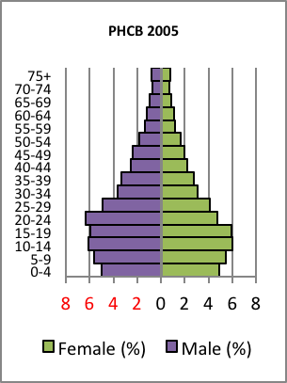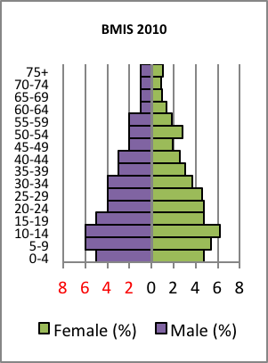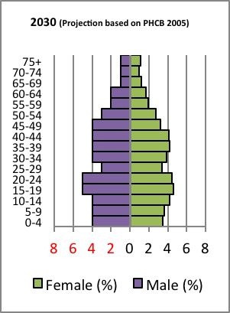

The figures above illustrate the population structure of Bhutan over time. These figures are referred to as population pyramids and use data from PHCB 2005 and BMIS 2010. However, for 2030 the population pyramid uses projections developed by the NSB. The 2005 and 2010 pyramids look similar except that in BMIS 2010, a disproportionally large number of women were reported to be aged 50, and a disproportionally large number of girls were reported to be 14. This unexpected age pattern for these two groups is likely to be caused by age heaping, some survey enumerators who may have tried to avoid conducting interviews with all women by recording the age of a woman outside of the eligible age range of 15-49 years.
Otherwise, both the 2005 and 2010 pyramids depict a wide base, indicating that a significant proportion of the population comprises children and youth. It also implies that in the coming years, when a large proportion of population will be of working age (15-64), Bhutan will reap the benefits of the demographic dividend. While this period has tremendous potential for economic and social progress, it also presents a great risk.
However, according to NSB projections, by 2030, the base of the pyramid will become narrower while the upper end will widen. This shift indicates that the proportion of young people will decrease but that of the aging population will increase. In 2005, about 56 percent of the population was 24 years or younger and only 4.7 percent was aged 65 or older. By 2030, the population aged 65 and older is expected to reach 6.6 percent. The implication of this shift in the age pyramid for public health is that there will be greater need to invest in geriatric healthcare services.
According to BMIS 2010, 68 percent of female respondents aged 15-49 years lived in rural areas and 32 percent in urban areas. The largest segment of individual women respondents (19 percent) were in the age group of 25-29 years and the smallest segment of individual women respondents were found in the 40-44 age groups (11 percent) and the 45-49 year-olds (8 percent). A large portion of the women respondents aged 15-49 were married (71 percent), while 7 percent were formerly married and 22 percent were never married. Slightly more than 70 percent of women aged 15-49 had given birth at least once in their lifetime. In the case of education, 61 percent of women aged 15-49 had never been to school, while 12 percent had primary schooling. Remaining 27 percent had completed their secondary and higher education. In terms of wealth index, it was found that 17 percent belonged to the poorest, while 24 percent to the richest quintile.
Table 1 below shows that children under the age of 18 constitute a very significant 38 percent of Bhutan’s population. In other words, approximately 2 of every 5 people living in Bhutan is a child, which makes this analysis of their health and well-being exceptionally salient for the overall well-being of the Bhutanese society, now and in the future.

Table 1: Distribution of children under the age of 18 years, Bhutan, 2010
Age group | Males |  | Females |  | Total
Age group | % | No. | % | No. | % | No.
0-17 | 38.5 | 12,847 | 38.1 | 12,923 | 38.3 | 25,770
18+ | 61.5 | 20,528 | 61.9 | 21,022 | 61.7 | 41,550
Total | 100 | 33,375 | 100 | 33,945 | 100 | 67,320

Among children under the age of five, 71 percent lived in rural areas while 29 percent resided in urban areas, which mirrors the general urban-rural population distribution. In terms of the wealth index status of the household, children under the age of five are spread quite evenly across all quintiles with 20.6 living in the poorest quintile, indicating that children under the age of five are no more likely to live in poverty than the general population.
Further, the survey reveals that about 79 percent of children aged 0-17 years in Bhutan live with their parents, while 11 percent live with their mother only, and 2 percent live with their father only. Almost one in thirteen children (7 percent) lives with neither parent and 5 percent of the children have at least one parent who has died. The proportion of children not living with a biological parent is higher among girls (9 percent) compared with boys (6 percent), and increases significantly with the age of the child and with household wealth. It is also significantly higher in urban areas (10 percent) as compared to rural areas (6 percent). In contrast, the rate of children having one or both parent(s) dead is higher in rural areas and decreases with household wealth.
Also, the BMIS 2010 interviewed a total of 14,018 women between age 15-49 years on their fertility, fertility preferences, desire for the last birth, contraception, unmet needs, antenatal care, assistance at delivery, their knowledge of HIV AIDS, and on maternal mortality to assess their situation, and to monitor MDG progress on the reproductive health of women in Bhutan. Due to an insufficient sample size, the sex ratio at birth cannot be determined. However, Table 2 shows that the sex ratio for children under the age of five is 1.04.

Table 2: Sex ratio among children under the age of 5, Bhutan, 2010
Total | No. of boys | No. of girls | Sex ratio
Total | 3,216 | 3,081 | 1.04

A critical issue facing policymakers in Bhutan is the substantial disparity between demographic groups across many outcome indicators. In many cases, inequality in health and education outcomes are very high. As stated earlier, inequality poses a serious threat to Bhutan’s aspirations as articulated by the tenets of Gross National Happiness.
The level of inequality for health indicators reflects the overall, increasing level of material inequality in Bhutan. Table 3 below shows that the distribution of income varies widely between dzongkhags, and between urban and rural areas. There is a tremendous chasm in poverty rates between urban and rural areas in Bhutan. Whereas 28 percent of the rural population live in the poorest quintile, this is true for less than one percent of urban residents.

Table 3: Percent distribution of population by wealth quintiles, Bhutan, 2010
 |  | Wealth index quintiles |  |  |  |  | Total | Number of individuals
 |  | Poorest | Second | Middle | Fourth | Richest | Total | Number of individuals
Sex | Male | 20.2 | 20.1 | 20.1 | 20.1 | 19.5 | 100 | 33,375
Sex | Female | 19.8 | 19.9 | 19.9 | 19.9 | 20.5 | 100 | 33,944
Dzongkhag | Bumthang | 8.6 | 25.6 | 30.6 | 18.1 | 17.1 | 100 | 1,605
Dzongkhag | Chukha | 13.8 | 16.1 | 15.6 | 23.9 | 30.6 | 100 | 6,863
Dzongkhag | Dagana | 45.3 | 25.3 | 14.0 | 9.9 | 5.5 | 100 | 2,541
Dzongkhag | Gasa | 24.8 | 36.1 | 28.1 | 7.8 | 3.2 | 100 | 484
Dzongkhag | Haa | 7.8 | 10.1 | 25.9 | 39.1 | 17.2 | 100 | 1,312
Dzongkhag | Lhuntse | 33.4 | 28.0 | 25.3 | 9.5 | 3.7 | 100 | 1,564
Dzongkhag | Mongar | 36.1 | 28.5 | 14.7 | 8.0 | 12.7 | 100 | 4,741
Dzongkhag | Paro | .37 | 6.7 | 29.4 | 37.7 | 25.9 | 100 | 3,776
Dzongkhag | Pemagatshel | 25.6 | 36.8 | 20.2 | 9.8 | 7.6 | 100 | 2,627
Dzongkhag | Punakha | 3.3 | 15.2 | 35.0 | 31.1 | 15.3 | 100 | 2,549
Dzongkhag | S/jongkhar | 33.5 | 18.9 | 16.7 | 20.8 | 10.0 | 100 | 3,892
Dzongkhag | Samtse | 28.7 | 19.0 | 17.6 | 20.6 | 14.2 | 100 | 7,530
Dzongkhag | Sarpang | 13.0 | 14.8 | 20.8 | 26.9 | 24.6 | 100 | 4,127
Dzongkhag | Thimphu | .16 | 1.1 | 11.1 | 29.3 | 58.4 | 100 | 8,372
Dzongkhag | Trashigang | 20.8 | 35.7 | 31.3 | 7.9 | 4.3 | 100 | 5,266
Dzongkhag | Trashiyangtse | 18.8 | 40.6 | 22.1 | 9.5 | 9.0 | 100 | 1,711
Dzongkhag | Trongsa | 24.5 | 29.2 | 21.8 | 16.0 | 8.5 | 100 | 1,510
Dzongkhag | Tsirang | 46.3 | 28.6 | 9.4 | 7.9 | 7.9 | 100 | 2,208
Dzongkhag | Wangdi | 12.1 | 23.7 | 31.5 | 21.8 | 10.9 | 100 | 2,841
Dzongkhag | Zhemgang | 46.3 | 23.2 | 12.8 | 10.5 | 7.3 | 100 | 1,800
Age group | 15-24 years | 18.5 | 19.0 | 19.8 | 20.5 | 22.1 | 100 | 12,502
Age group | 25-49 years | 17.5 | 17.7 | 19.0 | 21.8 | 23.9 | 100 | 21,313
Age group | 50-64 years | 24.3 | 26.7 | 22.8 | 13.4 | 12.8 | 100 | 7,753
Age group | 65+ years | 27.7 | 28.1 | 22.3 | 11.8 | 10.1 | 100 | 3,965
Area | Urban | .3 | 1.0 | 10.1 | 33.4 | 55.2 | 100 | 18,500
Area | Rural | 27.5 | 27.2 | 23.8 | 14.9 | 6.6 | 100 | 48,820
Total |  | 20.0 | 20.0 | 20.0 | 20.0 | 20.0 | 100 | 67,320

Map 1 shows dzongkhag-level data presented in Table 3 above. It shows the percentage of the population living in the poorest wealth quintile, illustrating where material poverty as measured by the wealth index is most concentrated. The poorest quintile of dzongkhags is located in the south and east and the richest dzongkhags are primarily in the west.

Map 1: Share of population in poorest wealth quintile, Bhutan, 2010 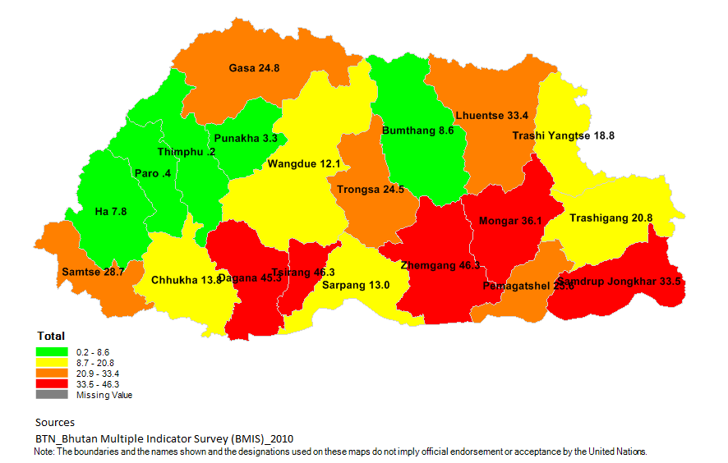

Figure 2: Percentage of the population in the poorest wealth quintile by dzongkhag, Bhutan, 2010
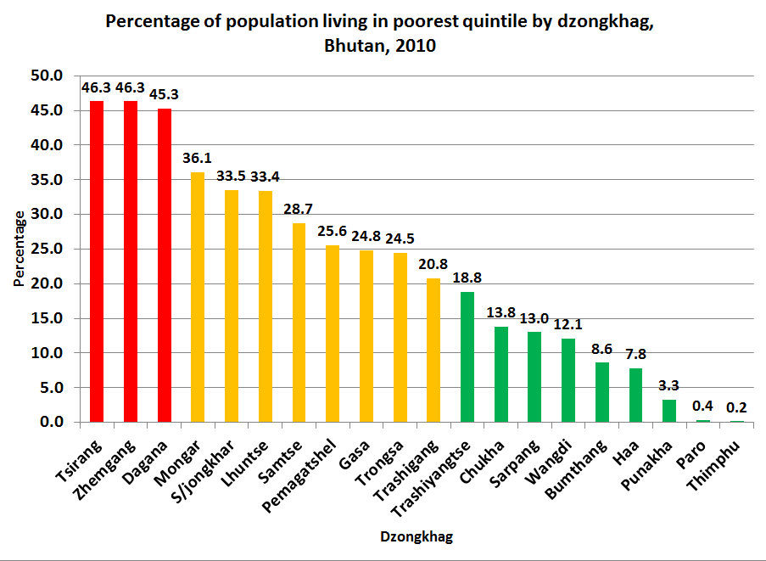

The stark level of material inequality across dzongkhags can also be seen in Figure 8. If all were equal, 20 percent of the population in each dzongkhag would live in the poorest wealth quintile. This graph shows that while less than one percent of people in Paro and Thimphu live in the poorest wealth quintile, more than 40 percent of people in Tsirang, Dagana, and Zhemgang live in the greatest level of poverty. The issue of poverty is very important in the HTA because those from the poorest households and from the rural areas, and those with no formal education usually have the worst outcomes.

3.2 Section summary
In 2005, the total population of Bhutan was 634,982 people and the median age of the Bhutanese population was 22 years. It increased to 24 years in 2010 (BMIS 2010). The population growth rate decreased from 3.1 percent per annum in the 1990s to 1.8 percent in 2005 and total fertility rate (TFR) decreased from over 6 children per woman during 1980s to 3.6 children per woman in 2005 and 2.6 in 2010. However, the population will keep increasing in the next few decades because of population momentum. As Bhutan moves toward replacement level (2.1), health planners will need to monitor the TFR as a decrease below replacement level fertility could make the population structure unstable.

4. Nutrition

4.1 Introduction
Proper nutrition for a population is essential for a healthy, productive, and vibrant society. It is especially important for infants and children as they experience rapid mental and physical development during their early years of life. Improper nutrition during the first five years of life can lead to long-term consequences including lower academic achievements, increased risk of illness, and increased morbidity and mortality. It is estimated that up to half of all deaths in children in developing countries is associated with poor nutrition.
The BMIS 2010 collected nutrition-related data with a strong focus on particularly vulnerable populations: under-five children and pregnant and lactating women. For infants under the age of 6 months, exclusive breastfeeding provides proper nutrition. After the age of six months, appropriate, hygienic, complementary food needs to be introduced in adequate amounts. While issues of obesity and chronic diseases that result from excessive or improper eating are not urgent causes for concern now, they will play a larger role in the future as the population becomes wealthier and older. However, malnutrition from inadequate amounts of food remains a primary public health issue.
The nutritional status of children is monitored by the following three key indicators: the percentage of children who are underweight (low weight for age), stunted (low height for age), and wasted (low weight for height). According to BMIS 2010, 13 percent of children under five are underweight, 34 percent are stunted, and 5.9 percent are wasted.
Babies who begin life with low birthweights are vulnerable to malnutrition, so the survey takes a close look at them. Bhutan should be proud that 86 percent of them achieve normal growth parameters by age two. While the continuation of initiatives that support low-birthweight babies is important, it is critical not to forget the much higher numbers of healthy weight newborns who become malnourished in their first two years.
Because access to food and use of available food is a prerequisite to good nutrition, the survey also analysed food security of households and infant and young child feeding (IYCF) practices. The promotion of exclusive breastfeeding and appropriate complementary feeds needs particular attention.
Improving these nutritional indicators requires time and a comprehensive, multi-disciplinary approach. Beyond ensuring that nutritious food is available, education on proper feeding practices, sanitation issues, and adequate healthcare services are all essential components of a plan to improve nutrition.
MDG 1 strives to reduce hunger by half by 2015. Accomplishing this task will take significant concerted efforts from several ministries. However, the rewards of success are multiple and far-reaching. These include the reduction of under-five morbidity and mortality, and facilitation of children’s growth to reach their full mental and physical potential.

4.2 Nutritional status of children under the age of 5
Nutritional health is critical during infancy and early childhood. This is the time when significant neurological and physical development takes place. Underweight, stunting, and wasting in children are the key nutritional indicators used to monitor children’s growth, development, and overall health. Underweight prevalence (low weight for age), is a composite measure of both acute and chronic malnutrition. The BMIS 2010 reported that 13 percent of children under the age of 5 were moderately or severely underweight at the time of the survey. Stunting (low height for age) reflects a chronic failure to receive adequate nutrition, and is a recurrent or chronic illness. The BMIS 2010 reported that 34 percent of children under 5 were moderately or severely stunted at the time of survey.
Wasting (low weight for height) is an indicator of acute malnutrition. This is caused from acute food shortage or from an illness during which an infant or child fails to gain weight over the short term, or loses weight. The BMIS 2010 reported that approximately 6 percent of children under 5 were moderately or severely wasted at the time of survey.
Table 4 below shows the correlation between underweight and stunting among children under the age of 5. The data show that 28 percent of children under 5 years who are not underweight are stunted compared with a 77 percent stunting rate for children who are moderately or severely underweight, indicating a very strong positive correlation between underweight and stunting. Indeed, children under the age of 5 who are underweight have a stunting rate more than twice the national average.
This analysis finds that the stunting prevalence of children who are underweight increases substantially with the age of the child and at a much higher rate than children who are not underweight. Among children who are not underweight, the stunting prevalence of 16 percent for children aged 0-11 months increases to 28 percent for children aged 48-59 months (an increase of 12 percentage points). For children who are underweight, the much higher stunting rate of 46 percent for children aged 0-11 months increases much more rapidly to a remarkable 83 percent for children aged 48-59 months (an increase of 37 percentage points).
Mother’s education level and household wealth further affect the nutritional status of children. 81 percent of the children whose mothers do not have any education and 85 percent of the children from the poorest households who are moderately or severely underweight are stunted compared with 68 percent for underweight children whose mothers have secondary level education and 67 percent of children from the richest quintile.

Table 4: Percentage of children under 5 who are moderately or severely stunted, distributed by underweight status, Bhutan, 2010
 |  | Percentage of children who are stunted, who are
 |  | not underweight |  | moderately to severely underweight |  | Total
 |  | Percentage stunted | Total number | Percentage stunted | Total number | Percentage stunted | Total number
Area | Urban | 23.5 | 1,539 | 70.6 | 164 | 28.0 | 1,702
Area | Rural | 29.4 | 3,558 | 79.2 | 525 | 35.8 | 4,083
Age | 0-11 months | 16.1 | 1,005 | 45.5 | 101 | 18.8 | 1,106
Age | 12-23 months | 30.4 | 1,014 | 79.4 | 118 | 35.5 | 1,133
Age | 24-35 months | 30.6 | 1,068 | 84.1 | 157 | 37.4 | 1,225
Age | 36-47 months | 33.1 | 1,016 | 82.9 | 177 | 40.5 | 1,193
Age | 48-59 months | 27.6 | 993 | 83.4 | 136 | 34.3 | 1,129
Mother's education | None | 30.6 | 3,346 | 80.7 | 528 | 37.4 | 3,874
Mother's education | Primary | 26.2 | 642 | 63.4 | 78 | 30.3 | 720
Mother's education | Secondary | 19.4 | 1,108 | 67.6 | 83 | 22.7 | 1,190
Wealth index quintiles | Poorest | 33.4 | 1,007 | 84.6 | 184 | 41.3 | 1,191
Wealth index quintiles | Second | 33.2 | 884 | 78.4 | 153 | 39.9 | 1,037
Wealth index quintiles | Middle | 32.4 | 954 | 76.7 | 151 | 38.5 | 1,105
Wealth index quintiles | Fourth | 22.8 | 1,220 | 71.5 | 129 | 27.5 | 1,349
Wealth index quintiles | Richest | 18.4 | 1,032 | 66.8 | 71 | 21.5 | 1,104
Total |  | 27.6 | 5,096 | 77.2 | 689 | 33.5 | 5,785

Figure 3 illustrates the main finding from Table 4 above, and shows the very strong correlation between being moderately or severely underweight and stunting prevalence. It shows that children who are underweight are nearly three times as likely to be stunted as their non-underweight counterparts, magnifying their vulnerability to the long-term effects of under-nutrition.

Figure 3: Percentage of children under 5 who are moderately or severely stunted, distributed by underweight status, Bhutan, 2010
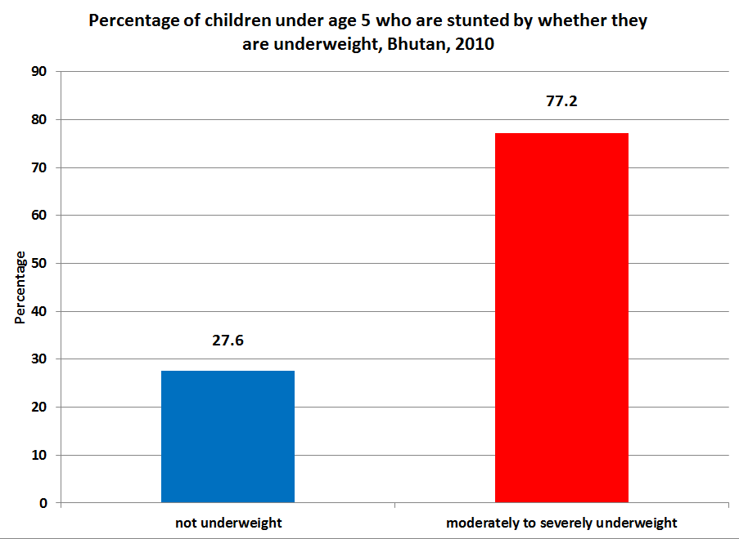

4.3 Low birth weight and nutritional status of children under the age of 2
According to the National Standard of Midwifery Practice for Safe Motherhood (2009), all babies born in health facilities need to be weighed at birth. Weight at birth is a good indicator not only of mother’s health and nutritional status but also the newborn’s chances for survival, growth, and long term health and psychosocial development.
This analysis first looks at the percentage of newborns weighed at birth. Table 5 below shows that 73 percent of all children under the age of 2 born in Bhutan are weighed at birth. There are noteworthy disparities between demographic groups. For example, 94 percent of children born in urban areas are weighed at birth compared with 64 percent of rural children. 96 percent of children whose mothers have secondary level education are weighed at birth compared with 63 percent of children whose mothers have no education. In other words, urban children and those whose mothers are highly educated are approximately 50 percent more likely to be weighed at birth than children from rural areas and whose mothers have no education. However, the most significant disparity is by household wealth, in which children from the richest households are more than twice as likely to be weighed at birth than children from the poorest households (97 percent and 44 percent, respectively).
These findings can largely be explained by whether a child is born in a health facility or at home. 98 percent of children who were delivered in a health facility were weighed at birth, which is very close to the stated goal of 100 percent. This compares with only 28 percent of the children who were not delivered in a health facility. Map 3 on page 62 shows where the highest percentage of home deliveries takes place. These areas are the rural areas, and the poorer dzongkhags in the southern and eastern parts of the country.
The estimate that 28 percent of new-borns delivered outside a health facility are weighed is likely an overestimate as it is unlikely that they were weighed immediately at birth. For children born in a health facility, the percentage weighed at birth never falls below 94 percent irrespective of demographic background. However, children from rural areas, the poorest households, and those whose mothers have no education are statistically less likely to be weighed at birth than children from urban areas, the richest households, and whose mothers have secondary level education. This is so because the poorest women are nearly ten times as likely to deliver in a BHU, which may not always have weighing equipment, as larger hospitals do.

Table 5: Percentage of children under the age of 2 who were weighed at birth by whether they were delivered in an institution, Bhutan, 2010
 |  | Not delivered in health facility |  | Delivered in health facility |  | Total number of children
 |  | Percentage of children weighed at birth | Total number of children | Percentage of children weighed at birth | Total number of children | Percentage of children weighed at birth | Total number of children
Area | Urban | 40.6 | 71 | 100.0 | 620 | 93.9 | 690
Area | Rural | 27.3 | 803 | 97.1 | 875 | 63.7 | 1,678
Education | None | 26.2 | 719 | 97.3 | 764 | 62.9 | 1,484
Education | Primary | 33.7 | 114 | 98.7 | 188 | 74.1 | 302
Education | Secondary + | 52.2 | 40 | 99.5 | 542 | 96.3 | 582
Wealth index quintiles | Poorest | 19.5 | 315 | 94.2 | 156 | 44.3 | 471
Wealth index quintiles | Second | 30.2 | 265 | 95.7 | 183 | 56.9 | 448
Wealth index quintiles | Middle | 31.0 | 169 | 97.6 | 306 | 73.9 | 475
Wealth index quintiles | Fourth | 44.3 | 104 | 99.9 | 414 | 88.7 | 518
Wealth index quintiles | Richest | [39.7] | 19 | 99.8 | 436 | 97.3 | 455
Total |  | 28.4 | 873 | 98.3 | 1,495 | 72.5 | 2,368

The analysis now turns to the issue of low birthweight children. Poor maternal health and nutrition and prematurity are two issues contributing to low birthweight. Newborns with low birthweight require considerable attention and care. They have higher rates of mortality, impaired immune function, diabetes and high blood pressure later in life. Understandably, they also have higher rates of underweight, stunting, and wasting compared with their counterparts born with a healthy weight. However, with proper interventions, most children who are born with low birthweight achieve normal growth parameters within the first two years of life.
It is essential to prevent or at least reduce the numbers of low birthweight babies. This analysis tested the prevalence of low birthweight by whether the mother of the child received the recommended number of antenatal care visits. Table 6 below shows that mothers who received four or more antenatal care visits were less likely to give birth to low birthweight babies than mothers who received less than four antenatal care visits (8 percent and 13 percent, respectively). This difference of 70 percent is statistically as well as practically significant. The positive relationship between a higher number of antenatal care visits and reduced likelihood of low birthweight is particularly strong for women in urban areas, with secondary-level education, and from the wealthier households. This finding suggests that these more privileged demographic groups may have additional resources with which to increase the likelihood of their child being born with a healthy weight.
Among women who do receive four or more antenatal care visits, disparities among demographic groups in the percentage of children born with low birthweight remain. Women from the two poorest wealth quintiles do not show a benefit from a higher number of ANC visits. Those of the poorest quintile who received 4 or more antenatal care visits are still more than twice as likely to bear children with low birthweight than their counterparts from the richest quintile. Likewise, women with no education who receive antenatal care 4 or more times are twice as likely to have children with low birthweight as women with secondary level education. In both cases, the disparities are statistically significant. This suggests that these groups lack the resources to improve their level of nutrition. It may also be attributed to a lower level antenatal care and/or a lower up-take of antenatal care by these groups, as well as less access to health-related information in general.
Even though urban women benefit much more from an increased number of ANC visits, urban women who receive less than four antenatal care visits, are also twice as likely to have low birthweight children than rural women (20 percent and 10 percent, respectively), a difference which is statistically significant. This may be because urban women have less access to the resources required to enhance their nutritional status than rural women who can cultivate food for their own consumption, particularly if they are poor.

Table 6: Percentage of children under the age of 2 who are born with low birthweight by mother’s antenatal care, Bhutan, 2010
 |  | Antenatal care |  |  |  | Total number of women
 |  | Mothers did not receive antenatal care 4+ times |  | Mothers received antenatal care 4+ times |  | Total number of women
 |  | % of children born underweight | Total number of women | % of children born underweight | Total number of women | Total number of women
Area | Urban | 19.6 | 85 | 6.9 | 608 | 698
Area | Rural | 10.1 | 192 | 8.1 | 834 | 1,039
Mother's education | None | 13.8 | 173 | 9.8 | 747 | 930
Mother's education | Primary | 9.6 | 46 | 6.0 | 176 | 222
Mother's education | Secondary | 13.3 | 58 | 5.0 | 519 | 585
Wealth index quintiles | Poorest | 11.3 | 45 | 12.9 | 155 | 204
Wealth index quintiles | Second | 9.5 | 57 | 9.6 | 187 | 250
Wealth index quintiles | Middle | 11.3 | 69 | 9.7 | 272 | 344
Wealth index quintiles | Fourth | 16.4 | 72 | 6.1 | 389 | 465
Wealth index quintiles | Richest | [17.6] | 33 | 4.9 | 438 | 475
Total |  | 13.0 | 276 | 7.6 | 1,442 | 1,737
The cases of 731 women are missing because their child was not weighed at birth or the woman did not know whether the child was weighed at birth of if the child was weighted, his or her weight was unknown.

The analysis now considers the nutritional status of children under the age of 2 by whether or not they were born with low birthweight. Table 7 below shows that the underweight, stunting, and wasting prevalence are worse for children born with low birthweight than their peers who were not born with low birthweight. In all cases, the differences are statistically significant. Table 7 shows that 18 percent of children under the age of two who were born with low birthweight remained underweight at the time of the survey. This estimate of underweight prevalence is twice the level of children who were not born underweight (9 percent). The table also shows that children born underweight at birth have a higher rate of stunting during the first two years of life than children not born underweight (31 percent and 26 percent, respectively). Likewise, children born with low birthweight have a higher prevalence of wasting than children not born with low birthweight (14 and 9 percent, respectively).

Table 7: Nutritional status of children under the age of 2 by whether they were born underweight, Bhutan, 2010
 |  | % of children under 2 years who are underweight, stunted, or exhibit wasting, among all children who were weighed at birth and who were:
 |  | Not underweight at birth (weighing >= 2500 grams) |  |  |  |  |  | Underweight at birth (weighing < 2500 grams)
 |  | % under  weight | Total | % stunted | Total | % wasted | Total | % under weight | Total | % stunted | Total | % wasted | Total
Sex | Male | 9.9 | 793 | 28.0 | 733 | 10.5 | 723 | 22.9 | 66 | 41.8 | 56 | 11.7 | 49
Sex | Female | 7.8 | 766 | 24.5 | 726 | 8.0 | 709 | 14.5 | 78 | 21.9 | 73 | 15.7 | 72
Area | Urban | 9.1 | 626 | 28.3 | 570 | 9.1 | 564 | [26.7] | 61 | [35.7] | 52 | [22.0] | 47
Area | Rural | 8.7 | 933 | 25.0 | 889 | 9.3 | 869 | 12.2 | 83 | 27.0 | 77 | 9.0 | 74
Age in months | 0-11 | 7.5 | 818 | 18.7 | 756 | 11.8 | 714 | 22.5 | 74 | 26.7 | 65 | 16.0 | 59
Age in months | 12-23 | 10.4 | 741 | 34.4 | 703 | 6.7 | 718 | 14.1 | 70 | 34.4 | 64 | 12.2 | 62
Total |  | 8.9 | 1,559 | 26.3 | 1,459 | 9.2 | 1,432 | 18.4 | 144 | 30.5 | 129 | 14.1 | 121

Figure 4 below illustrates the main findings from Table 7 above, showing that children who are born underweight are more likely to have poorer nutritional statuses during their first two years of life than children who are not born underweight.

Figure 4: Nutritional status of children under the age of 2 by whether they were born underweight, Bhutan, 2010
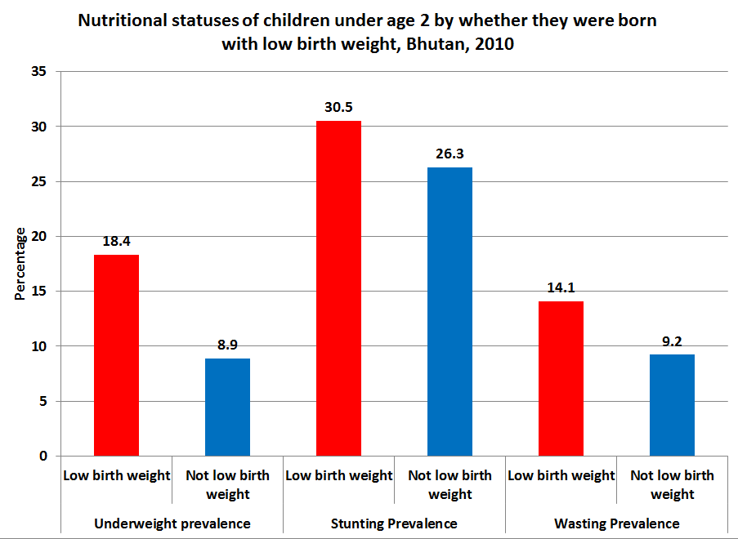

However, one must consider that the degree of prematurity and severity of the low birthweight will affect how quickly the child’s growth will catch up to others. Figure 5 below shows that infants born with low birthweight improve rapidly over their first two years of life in terms of their underweight status. When one considers that 100 percent of those born with low birthweight were initially underweight, it is an achievement that by 0-11 months and 12-23 months the percent of these children remaining underweight decreased to 22.5 and 14.1 percent, respectively. This can likely be attributed to premature and low weight infants receiving more attention by mothers, care givers, and healthcare healthcare providers. On the contrary, it is cause for concern that of the large numbers of children born with a normal weight of 2500 grams or more, 7.5 percent are underweight by 0-11 months and 10.4 percent are underweight by 12-23 months.

Figure 5: Percentage of underweight children under the age of 2 by low birthweight status and age, Bhutan, 2010
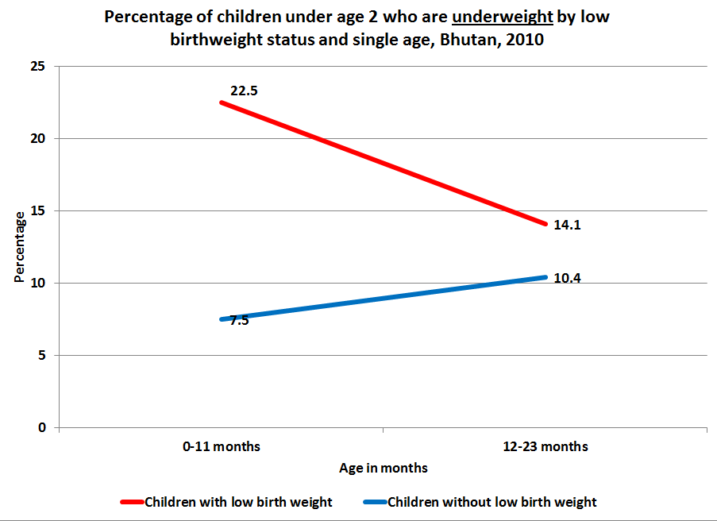

With regard to stunting, although the difference is not statistically significant, low birthweight children have a higher point estimate of stunting during the first year of life (27 percent and 19 percent, respectively). This difference can be accounted for by the fact that infants born with low birthweight due to prematurity or other medical reasons will likely have a shorter length at birth. The gap between the two groups evaporates entirely as both converge to a stunting rate of 34 percent. Of primary concern for policymakers is that the stunting prevalence for all children increases from the time of birth to age two. Equally important, stunting increases more rapidly for children who are not born underweight, and is likely a function of this group’s corresponding increase in underweight prevalence (see Figure 6 below).

Figure 6: Percentage of stunted children under the age of 2 by low birthweight status and age, Bhutan, 2010
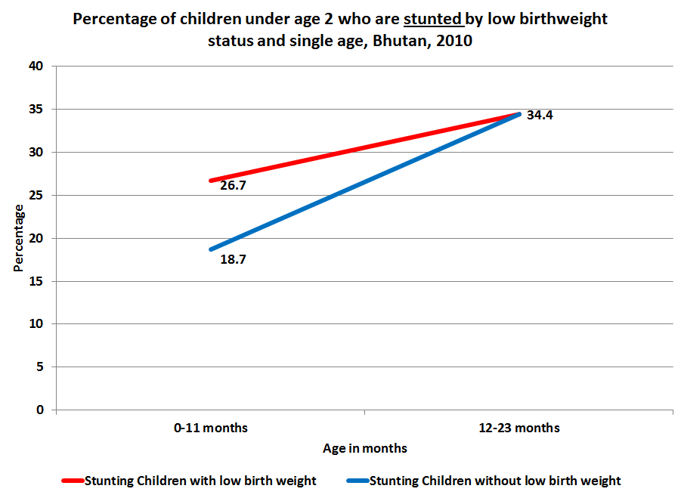

In terms of wasting, Figure 7 below shows that children born with low birthweight have a higher point estimate of wasting during both the first and second year of life than children not born underweight. However, the differences in these estimates are not statistically significant. While the wasting prevalence for both groups decreases as the child grows older for both groups, it declines more rapidly for children who are not born underweight. The higher prevalence of wasting in children born with a low birthweight can likely be explained by the fact that these children have less physiologic reserve, and when they suffer from an acute illness, they will most likely not recover as quickly as their counterparts who were not born underweight.

Figure 7: Percentage of wasted children under the age of 2 by low birthweight status and age, Bhutan, 2010
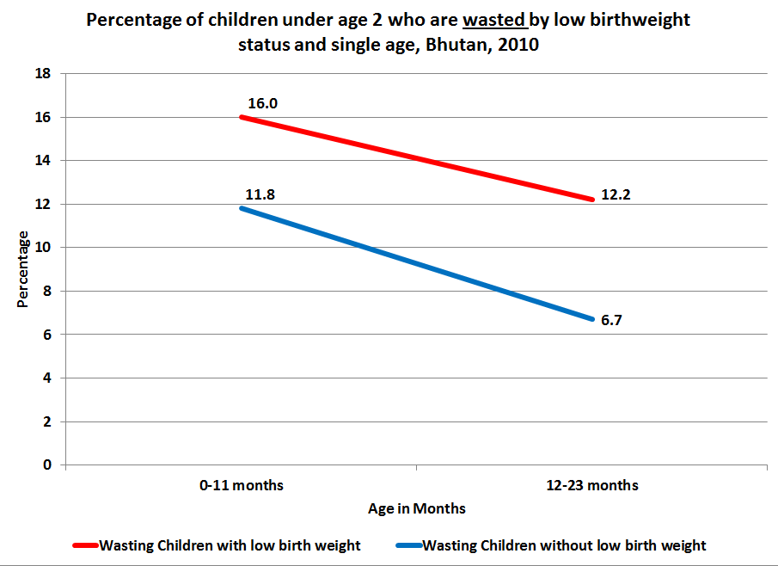

In summary, Table 7 and the related figures above suggest that the underweight status of low birthweight children can be corrected with appropriate and timely interventions. More alarming is the large percentage of children who were not born underweight who become underweight in the first two years of life. More significant investment in reducing the underweight prevalence of all children in this age group will help to ameliorate the sharp rise in the stunting prevalence of all children, which should be of urgent concern for policymakers. Correcting low birthweight children’s higher rate of wasting is a more difficult challenge that will require strong interventions during the first two years of children’s lives.

4.4 Infant and young child feeding
Breast milk is undeniably the best food to meet the nutritional needs of infants. It provides maternal antibodies to protect the baby against infections, particularly diarrheal illnesses. It is safe, clean, economical, and promotes maternal-baby bonding as well. Multiple other benefits have been studied, including benefits to maternal health. On the contrary, infant formula, while nutritionally adequate, lacks protective antibodies, and can pose a threat if made with unsafe water. UNICEF and the World Health Organization recommend initiation of breastfeeding within the first hour of life, exclusive breastfeeding for the first six months, and continued breastfeeding for two or more years. Complementary foods in the right amounts need to be added at six months of age to meet the increased metabolic needs of the growing child. Unfortunately, many women fail to breastfeed, do not feed as long as recommended, or fail to provide adequate complementary foods.
BMIS 2010 data indicate that 59 percent of children under the age of two are breastfed within the first hour of birth and 93 percent of children under the age of two within one day of birth.
Figure 8 below shows that while 74 percent of children receive exclusive breastfeeding during the first month of life, this figure drops rapidly in the third month and thereafter. Overall, only 14 percent of infants are exclusively breastfed throughout the first six months of life, as recommended.

Figure 8: Percentage of children aged 0-5 months exclusively breastfed by age, Bhutan, 2010
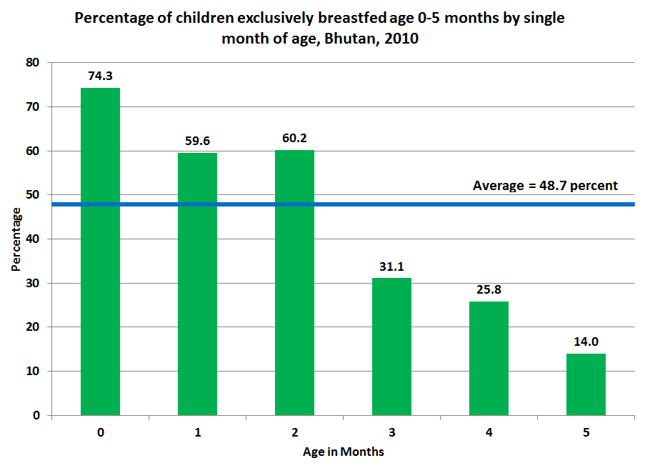

4.4.1 Exclusive breastfeeding and mother’s antenatal care
Table 8 below shows the percentage of children aged 0-5 months who are exclusively breastfed by whether their mother received the recommended level of antenatal care (4 or more visits), and by whether their children were delivered in a health facility. As anticipated, women who obtain more antenatal care exhibit a higher rate of exclusive breastfeeding than women who receive less antenatal care (55 percent versus 32 percent, respectively). These differences are statistically significant.
Similarly, 55 percent of mothers of children 0-5 months who delivered in a health facility exclusively breastfed, compared with 35 percent of mothers who did not deliver in a health facility. These differences are also statistically significant.

Table 8: Percentage of children aged 0-5 months exclusively breastfed by their mother’s antenatal care and by whether they were delivered in an institution, Bhutan, 2010
 |  | Antenatal care |  |  |  | Institutional delivery |  |  |  | Total number of children
 |  | Did not receive antenatal care 4+ times |  | Received antenatal care 4+ times |  | Did not deliver in health facility |  | Delivered in health facility |  | Total number of children
 |  | % exclusively breastfed | No. of children | % exclusively breastfed | No. of children | % exclusively breastfed | No. of children | % exclusively breastfed | Number of children | Total number of children
Sex | Male | 33.0 | 51 | 53.5 | 224 | 31.1 | 99 | 55.4 | 198 | 297
Sex | Female | 31.5 | 61 | 56.5 | 228 | 39.3 | 94 | 54.8 | 212 | 306
Area | Urban | * | 18 | 63.6 | 167 | * | 18 | 59.3 | 177 | 195
Area | Rural | 32.2 | 93 | 50.1 | 285 | 34.7 | 175 | 51.9 | 233 | 408
Total |  | 32.2 | 111 | 55.1 | 452 | 35.1 | 193 | 55.1 | 410 | 603

Figure 9 below illustrates the data presented in Table 8 above, showing higher rates of exclusive breastfeeding among women who receive the appropriate level of antenatal care and among women who delivered their child in a health facility.

Figure 9: Percentage of children aged 0-5 months exclusively breastfed by their mother’s antenatal care and by whether they were delivered in a health facility, Bhutan, 2010
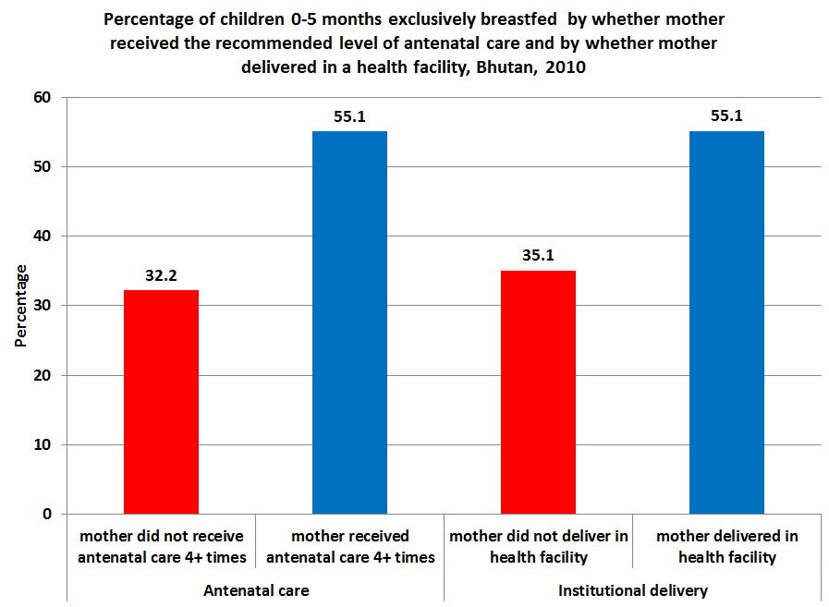

4.4.2 Feeding practices for children under the age of 2
Government policy regarding infant and young child feeding (IYCF) clearly states that infants should be exclusively breastfed for 6 months. In addition, women are advised during antenatal care not to give their newborns anything other than breast milk during the first three days after birth. Nevertheless, Table 9 below shows that 8 percent of mothers of children under the age of two gave their child something to drink or eat other than breast milk during the first three days of life.
Of children who received something other than breast milk during the first three days, the most common items offered in order of prevalence are infant formula (29 percent), plain water (23 percent), butter (19 percent), and milk (15 percent). While sample sizes are relatively small, the data suggest that women in the richest households choose to offer infant formula at a much higher rate than women in the poorest households (60 percent versus 14 percent, respectively). Conversely, the poorest women choose butter at a much higher rate than the richest women (34 percent versus 2 percent, respectively).

Table 9: Percentage of mothers who gave their newborn something to drink other than breast milk in the first three days after birth, and the type of drink given, among women mothers who gave birth in the last 2 years preceding the survey, Bhutan, 2010
 |  | % of children who received something to drink other than breast milk in first three days | No. of mothers | Type of drink given to those children who received something other than breast milk in first three days |  |  |  |  |  |  |  |  |  | Number of mothers
 |  |  | No. of mothers | Milk (other than breast milk) | Plain water | Sugar or glucose water | Sugar-salt-water solution | Fruit juice | Infant formula | Tea / Infusion | Honey | Butter | Other | Number of mothers
Area | Urban | 8.3 | 690 | 7.7 | 26.1 | 7.1 | 0.0 | 0.0 | 50 | 3.1 | 0 | 5.9 | 0 | 57
Area | Rural | 8.2 | 1,678 | 18.0 | 22.3 | 7.6 | 0.0 | 0.3 | 20.4 | 2.8 | 0 | 24.5 | 4.1 | 137
Education | None | 7.7 | 1,484 | 16.9 | 27.7 | 4.4 | 0.0 | 0.3 | 19.3 | 4.6 | 0 | 24 | 3.0 | 114
Education | Primary | 7.5 | 302 | * | *] | * | * | * | * | * | * | * | * | 23
Education | Secondary + | 9.8 | 582 | 3.9 | 16.7 | 13 | 0.0 | 0.0 | 57.6 | 0 | 0 | 8.8 | 0.0 | 57
Wealth index quintiles | Poorest | 8.2 | 471 | [14.9] | [18.2] | [6.2] | [0.0] | [0.0] | [13.7] | [4.4] | [0.0] | [33.8] | [8.8] | 39
Wealth index quintiles | Second | 8.8 | 448 | [17.4] | [11.8] | [5.2] | [0.0] | [.01] | [18.3] | [4.6] | [0.0] | [36] | [5.7] | 40
Wealth index quintiles | Middle | 7.3 | 475 | [25.2] | [16.5] | [11.5] | [0.0] | [0.0] | [21.7] | [2.4] | [0.0] | [22.8] | [0.0] | 35
Wealth index quintiles | Fourth | 7 | 518 | [11.3] | [57.4] | [2.6] | [0.0] | [0.0] | [26.8] | [[0.0] | [0.0] | [1.9] | [0.0] | 36
Wealth index quintiles | Richest | 9.8 | 455 | [8.0] | [15.9] | [11.3] | [0.0] | [0.0] | [59.7] | [2.8] | [0.0] | [2.2] | [0.0] | 45
Total |  | 8.2 | 2,368 | 15.0 | 23.4 | 7.4 | 0.0 | 0.2 | 29.1 | 2.9 | 0.0 | 19.0 | 2.9 | 194

As a child grows, so do their nutritional requirements. In order to ensure proper growth and development and to prevent malnutrition, complementary foods need to be added to a child’s diet at the appropriate time. Complementary foods are nutrient-rich, safe, and appropriate foods that need to be introduced when breast milk alone is no longer sufficient to meet the increasing caloric and nutrient requirements of the growing child. These foods initially are soft and cooked foods that can be easily made into a thick, soft consistency.
In specific terms, this requires children aged 6-8 months, who are currently breastfed to be fed two or three meals of complementary food per day. Breastfed children aged 9-23 months require 3 or four complementary meals per day. BMIS 2010 data used this standard to estimate the number of children under the age of two who receive appropriate feeding. Table 11 below shows that 93 percent of children aged 6-8 months and 74 percent age 9-23 months receive the appropriate number of feeds in addition to breastfeeding. Unfortunately, one limitation of the BMIS data is that it is not possible to determine the exact quantity or quality of the food given. The 2009 National Nutrition Infant and Young Child Feeding survey, however, provides details of the types of foods children are given to eat. Carbohydrate-rich foods made up a majority of a child’s intake, whereas protein-rich foods that are needed for growth were very limited in the diets. One positive finding is that there are no significant disparities by demographic background in the percentage of children who are appropriately fed.

Table 10: Percentage of children aged 6-23 months who received solid, semi-solid or soft foods during the previous day by age group and number of times, Bhutan, 2010
 |  | Children age 6-8 months |  |  | Children age 9-23 months
 |  | 1 time | 2 or more times | Number of children age 6-8 months | 1 time | 2 times | 3 or more times | Number of children age 9-23 months
Sex | Male | 7.7 | 92.3 | 126 | 7.6 | 19.9 | 72.5 | 558
Sex | Female | 6.5 | 93.5 | 103 | 5.5 | 18.6 | 75.9 | 544
Area | Urban | [1.7] | [98.3] | 67 | 6.8 | 18.9 | 74.2 | 304
Area | Rural | 9.5 | 90.5 | 162 | 6.5 | 19.4 | 74.1 | 798
Mother's education | None | 8 | 92 | 140 | 7.7 | 20 | 72.2 | 730
Mother's education | Primary | [9.1] | [90.9] | 22 | 5.3 | 18.4 | 76.3 | 157
Mother's education | Secondary+ | 4.8 | 95.2 | 67 | 3.7 | 17.4 | 78.9 | 225
Wealth index quintiles | Poorest | 8 | 92 | 45 | 10.3 | 19.6 | 70 | 229
Wealth index quintiles | Second | [18.7] | [81.3] | 41 | 4.8 | 19.6 | 75.6 | 228
Wealth index quintiles | Middle | 0.4 | 99.6 | 44 | 4.4 | 17.9 | 77.7 | 204
Wealth index quintiles | Fourth | 8.4 | 91.6 | 49 | 6.9 | 19.2 | 73.9 | 248
Wealth index quintiles | Richest | [1.8] | [98.2] | 50 | 6 | 20.1 | 73.9 | 193
Total |  | 7.2 | 92.8 | 229 | 6.6 | 19.3 | 74.1 | 1,103

Figure 10 below depicts the percentage of children aged 6-23 months who are fed the appropriate number of complementary foods per day, in addition to breastfeeding. While it shows that 93 percent of children aged 6-8 months old are fed the appropriate number of times, only 74 percent of children 9-23 receive the appropriate number of complementary food each day. One noteworthy observation is that nearly 7 percent of children aged 9-23 months receive only one meal per day alongside breast milk. As mentioned previously, information on the quantity and quality of these food servings was not collected in the survey.

Figure 10: Distribution of children aged 6-23 months who received solid, semi-solid or soft foods during the previous day by age group and number of times, Bhutan, 2010
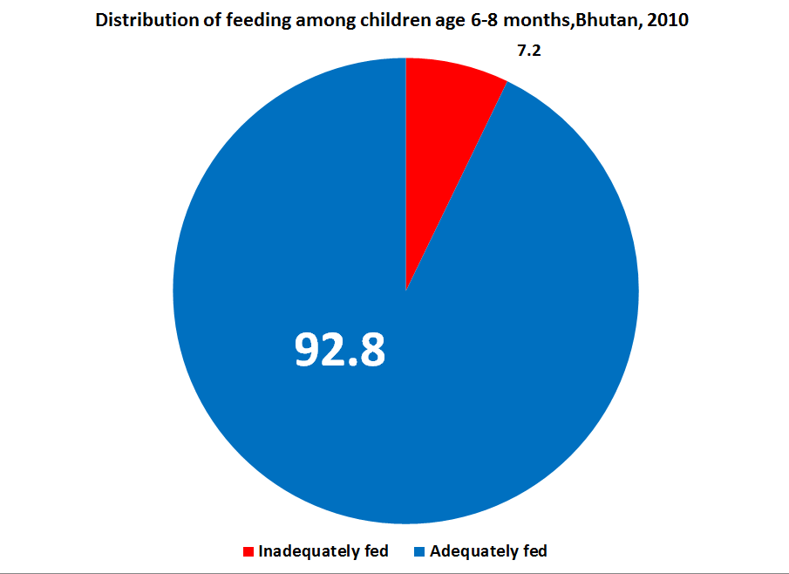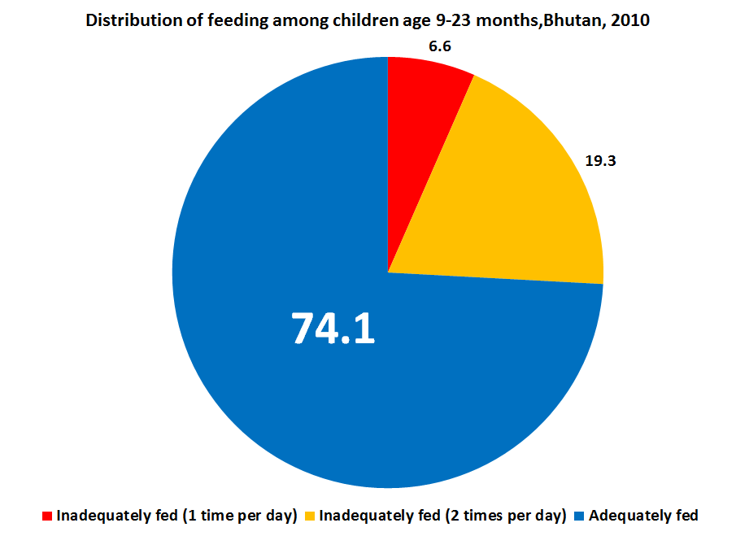

The importance of exclusive breastfeeding for six months needs to be consistently emphasized during women’s antenatal care visits. Health workers also need to constantly reinforce the intake of appropriate nutritious complementary food on every antenatal visit.

4.5 Underweight prevalence and mother’s antenatal care
The World Health Organization (WHO) recommends at least four antenatal care visits for pregnant women. Table 11 below presents data on the underweight prevalence of children under the age of two by the level of antenatal care received by their mother. It shows that 21 percent of children under two years of age whose mothers received no antenatal care are moderately or severely underweight, which is twice the level of children whose mothers obtained at least one antenatal care visit. These mothers receiving no antenatal care are more likely to live in rural areas, to come from the poorest two quintiles, to have no formal education, and/or to be aged 35-49.

Table 11: Percentage of children under 2 years of age who are moderately or severely underweight, by antenatal care received by the mother, Bhutan, 2010
Percent of women who had
 | No Antenatal visits |  | 1-3 visits |  | 4 or more visits |  | Total
 | % of underweight children | No. of children | % of underweight children | No. of children | % of underweight children | No. of children | % of underweight children | No. of children
Total | 21.3 | 137 | 11.5 | 443 | 9.5 | 1,808 | 10.6 | 2,389

4.6 Wasting prevalence and sanitation facilities
Wasting is an acute form of malnutrition (“low weight for height”) and can be caused in part by repeated cases of diarrhoea, which in turn are more likely to occur in households without improved sanitation facilities. According to BMIS 2010 data, rural households are far more likely to use unimproved sanitation facilities than urban households (45 percent versus 6 percent, respectively). This may lead to the hypothesis that rural children are more likely to be wasted than urban children. However, the data show no statistically significant difference between the occurrence of wasting between urban and rural children under the age of five (7 percent and 6 percent, respectively).
Given that the national statistics show no difference in wasting prevalence among children under five by the quality of their household sanitation facilities, a striking finding is the significantly higher level of wasting among urban children from households with unimproved sanitation facilities (13 percent), compared with those from urban households with improved sanitation facilities (6 percent), a difference that is statistically highly significant (see Table 12). These children who are wasted and do not have improved sanitation facilities in the urban areas are likely to be the urban poor who live in slums and temporary shelters. The outlier status of the wasting estimate for the urban poor indicates that these children likely face an array of other household and environmental conditions that are detrimental to their overall health. There is no difference in the percentage of the children who are moderately or severely wasted in the rural areas when assessed for the type of sanitation facilities.

Table 12: Percentage of moderately or severely wasted children under the age of five by the quality of their household sanitation facilities, Bhutan, 2010
 |  | Use of Unimproved Sanitation Facilities |  | Use of Improved Sanitation Facilities |  | Total
 |  | % with wasting | Total | % with wasting | Total | % with wasting | Total
Area | Urban | 13.1 | 103 | 6.1 | 1610 | 6.5 | 1713
Area | Rural | 5.3 | 1867 | 5.8 | 2283 | 5.6 | 4150
Total |  | 5.7 | 1969 | 5.9 | 3893 | 5.9 | 5863

4.7 Nutritional statuses and mother’s literacy
The education level of the mother has a strong positive effect on the overall health of a child. Table 13 below considers the nutritional status of children under the age of five by the literacy status of their mother. It shows that the underweight prevalence of children whose mothers are not literate is 74 percent higher than the estimate for children whose mothers are literate (14 percent versus 8 percent, respectively). This gap holds even when controlling singly for sex, area of residence (urban/rural), mother’s educational attainment, and household wealth. The disparity in underweight prevalence by mother’s literacy status is most pronounced among children who are rural, whose mothers have no education, and who come from the poorest quintile, indicating the larger benefit of literacy for women and children in these demographic groups.
Likewise with stunting, children whose mothers are not literate are 52 percent more likely to be stunted than children whose mothers are literate (36 percent versus 24 percent, respectively). As with the underweight estimates, this difference is statistically highly significant. The data show no difference in the estimate for wasting prevalence by mother’s education.

Table 13: Nutrition indicators of children under 5 of mothers aged 15-49 by the literacy of the mother, Bhutan, 2010
 |  | Percentage of underweight children |  |  |  | Percentage of stunted children |  |  |  | Percentage of children with wasting
 |  | Mother is illiterate |  | Mother is literate |  | Mother is illiterate |  | Mother is literate |  | Mother is illiterate |  | Mother is literate
 |  | % | No. | % | No. | % | No. | % | No. | % | No. | % | No.
Sex | Male | 15.0 | 2,270 | 8.7 | 815 | 37.0 | 2,169 | 23.4 | 759 | 6.1 | 2,200 | 6.7 | 754
Sex | Female | 13.5 | 2,212 | 7.7 | 774 | 36.5 | 2,135 | 25.1 | 743 | 5.6 | 2,172 | 5.0 | 737
Area | Urban | 11.8 | 954 | 8.9 | 846 | 33.2 | 924 | 21.9 | 789 | 6.5 | 922 | 6.4 | 791
Area | Rural | 14.9 | 3,528 | 7.3 | 743 | 37.7 | 3,380 | 26.7 | 713 | 5.7 | 3,450 | 5.2 | 700
Mother's education | None | 14.3 | 3,750 | 5.2 | 108 | 37.6 | 3,606 | 31.3 | 106 | 6.0 | 3,639 | 8.5 | 106
Mother's education | Primary | 11.7 | 485 | 9.7 | 247 | 29.6 | 468 | 31.5 | 240 | 5.2 | 472 | 4.0 | 236
Mother's education | Secondary | * | * | 8.2 | 1,235 | * | * | 22.0 | 1,156 |  |  | 6.0 | 1,148
Wealth index quintiles | Poorest | 16.7 | 1,170 | 5.3 | 63 | 41.3 | 1,135 | 42.5 | 62 | 4.9 | 1,158 | 7.3 | 59
Wealth index quintiles | Second | 16.9 | 1,009 | 8.4 | 97 | 41.5 | 944 | 24.6 | 95 | 6.8 | 969 | 4.6 | 96
Wealth index quintiles | Middle | 14.6 | 926 | 11.9 | 224 | 38.3 | 892 | 39.0 | 215 | 6.2 | 903 | 7.3 | 218
Wealth index quintiles | Fourth | 10.8 | 1,046 | 8.8 | 366 | 29.9 | 1,010 | 20.6 | 344 | 6.0 | 1,010 | 4.9 | 340
Wealth index quintiles | Richest | 7.7 | 331 | 7.1 | 840 | 24.1 | 324 | 20.3 | 787 | 4.8 | 332 | 5.9 | 778
Total |  | 14.3 | 4,482 | 8.2 | 1,589 | 36.8 | 4,304 | 24.2 | 1,502 | 5.8 | 4,372 | 5.9 | 1,490

4.8 Food security
Food security in Bhutan is an important, cross-cutting issue that involves areas of agriculture, forestry, livestock breeding, trade and commerce, and transportation to name a few. The issue affects both the urban and rural populations across the country and requires collaborative effort in the short- and long-term at the national, dzongkhag, and local levels of the government, as well as from the private sector, communities, and households across the country.
A comprehensive approach to achieving sustainable food security in Bhutan should address household food availability, access, and utilization. Food availability refers to the level of food supplies, production, and market supplies stemming from domestic production, food stocks, and food imports. Access to food is the ability to acquire food, both physically and financially. Utilization refers to an individual's nutritional consumption, infant and child feeding practices, and the ability to productively use their caloric intake.
The BMIS 2010 defines food insecurity as “a situation in which there was not enough food to feed all members of the household” during the twelve months preceding the survey. Table 14 below indicates that 11 percent of households faced food insecurity in the year prior to the survey. Among food insecure households, the average number of months for which households reported a food shortage was 2.7 months of the year. In other words, approximately one in ten households in Bhutan has insufficient food to feed the family for close to 25 percent of the year. The achievement of food security needs to be a top priority for the 11th Five Year Plan. Quite obviously, these households are overwhelmingly poor and located in rural areas, particularly in the poorer dzongkhags such as Lhuentse and Samtse. For example, a household in Samtse is 15 times as likely to face food insecurity as one in Thimphu dzongkhag. Larger households are also more likely to face food insecurity than smaller households. A household of seven or more is twice as likely to experience a food shortage as compared to a household of one individual (16 percent versus 7 percent, respectively).
Figure 11 below shows the percentage of children under the age of 5 that have faced food insecurity during the year prior to the survey. The data show that children in households that are rural, poor, or have a mother without any education face a dramatically greater risk of food insecurity. Children living in a rural area are 8 times more likely to face food insecurity than children from urban areas. If a child lives in a household from the poorest wealth quintile, they have a 1 in 3 chance of facing food insecurity during the year.

Table 14: Percentage of households with food insecurity by month, Bhutan, 2010
 |  | Percentage of households that have faced food insecurity in past 12 months | Mean number of months with inadequate food among food insecure households | Among food insecure households, percentage of households with food insecurity in the month of: |  |  |  |  |  |  |  |  |  |  |  | Number of households
 |  |  |  | January | February | March | April | May | June | July | August | September | October | Novermber | December | Number of households
Dzongkhag | Bumthang | 8.2 | 2.3 | 15.6 | 35.8 | 38.7 | 50.6 | 22.4 | 17.9 | 11.4 | 7.3 | 2.7 | 12.6 | 5.7 | 5.4 | 26
Dzongkhag | Chukha | 15.8 | 2.3 | 6.4 | 13.1 | 23.5 | 28.6 | 30.1 | 42.9 | 32.1 | 22.1 | 13.4 | 4.6 | 5.4 | 4.8 | 233
Dzongkhag | Dagana | 2.5 | * | * | * | * | * | * | * | * | * | * | * | * | * | 14
Dzongkhag | Gasa | 8.5 | * | * | * | * | * | * | * | * | * | * | * | * | * | 9
Dzongkhag | Haa | 5.9 | [2.2] | [8.7] | [27.5] | [30.3] | [32.5] | [72.9] | [38.1] | [4.16] | [0.0] | [0.0] | [0.0] | [0.0] | [4.4] | 17
Dzongkhag | Lhuntse | 16.7 | 3.1 | 8.7 | 14.5 | 23.0 | 27.5 | 34.8 | 53.0 | 54.6 | 41.7 | 19.2 | 12.5 | 8.0 | 8.7 | 61
Dzongkhag | Mongar | 6.1 | [2.7] | [14.1] | [22.1] | [17.6] | [19.9] | [34.7] | [56.2] | [42.3] | [15.1] | [5.4] | [11.9] | [11.7] | [23.2] | 59
Dzongkhag | Paro | 8.3 | 2.1 | 16.3 | 20.0 | 27.1 | 52.8 | 37.8 | 16.0 | 1.9 | 12.5 | 5.8 | 3.7 | 4.4 | 11.2 | 66
Dzongkhag | Pemagatshel | 9.4 | 2.1 | 1.8 | 7.7 | 22.8 | 29.8 | 42.6 | 47.8 | 30.0 | 8.7 | 4.4 | 2.1 | 2.6 | 6.0 | 53
Dzongkhag | Punakha | 7.9 | 2.2 | 3.0 | 4.7 | 6.4 | 15.2 | 29.7 | 38.8 | 55.2 | 37.5 | 12.0 | 3.6 | 6.4 | 5.5 | 41
Dzongkhag | S/ jongkhar | 16.0 | 2.6 | 1.6 | 1.6 | 18.7 | 39.5 | 52.6 | 49.7 | 39.7 | 23.4 | 13.7 | 10.0 | 5.0 | 3.7 | 132
Dzongkhag | Samtse | 27.8 | 3.0 | 2.7 | 8.0 | 21.9 | 42.6 | 54.9 | 62.4 | 54.0 | 27.7 | 14.1 | 5.5 | 2.5 | 2.6 | 456
Dzongkhag | Sarpang | 2.5 | [2.2] | [0.0] | [14.7] | [20.5] | [33.3] | [57.4] | [54.9] | [41.3] | [1.6] | [0.0] | [0.0] | [0.0] | [0.0] | 23
Dzongkhag | Thimphu | 1.9 | * | * | * | * | * | * | * | * | * | * | * | * | * | 36
Dzongkhag | Trashigang | 9.7 | 2.4 | 8.0 | 8.7 | 7.3 | 13.3 | 39.0 | 54.6 | 56.4 | 29.6 | 10.9 | 3.9 | 4.4 | 6.9 | 121
Dzongkhag | Trashiyangtse | 12.4 | 3.0 | 4.1 | 3.4 | 2.5 | 15.0 | 39.3 | 86.6 | 77.0 | 42.8 | 16.8 | 3.9 | 3.5 | 2.6 | 55
Dzongkhag | Trongsa | 6.2 | 3.8 | 28.6 | 44.1 | 62.2 | 53.8 | 41.5 | 40.3 | 28.5 | 17.1 | 15.4 | 14.8 | 13.7 | 21.6 | 20
Dzongkhag | Tsirang | 11.2 | 4.3 | 18.4 | 26.6 | 39.9 | 53.3 | 59.0 | 69.7 | 60.9 | 37.5 | 21.8 | 14.8 | 11.0 | 14.0 | 53
Dzongkhag | Wangdi | 16.5 | 2.5 | 5.5 | 7.7 | 15.7 | 18.4 | 24.8 | 47.7 | 50.2 | 35.7 | 17.1 | 9.7 | 10.1 | 11.1 | 103
Dzongkhag | Zhemgang | 1.9 | * | * | * | * | * | * | * | * | * | * | * | * | * | 7
Area | Urban | 2.3 | 2.6 | 16.4 | 32.9 | 29.7 | 29.7 | 28.5 | 24.9 | 25.1 | 17.4 | 14.4 | 6.8 | 17.3 | 15.0 | 100
Area | Rural | 14.3 | 2.7 | 6.0 | 10.8 | 20.5 | 33.7 | 44.0 | 53.9 | 46.0 | 26.3 | 12.8 | 6.8 | 4.8 | 6.1 | 1,484
Education of household head | None | 14.7 | 2.8 | 7.4 | 12.2 | 21.5 | 34.4 | 45.5 | 52.0 | 43.5 | 25.7 | 13.2 | 7.0 | 5.5 | 7.1 | 1,363
Education of household head | Primary | 8.9 | 2.4 | 1.8 | 12.4 | 18.2 | 24.9 | 26.9 | 52.9 | 55.2 | 27.0 | 10.9 | 5.9 | 5.2 | 3.0 | 191
Education of household head | Secondary + | 0.9 | * | * | * | * | * | * | * | * | * | * | * | * | * | 29
Number of household members | 1 | 7.3 | 3.4 | 19.1 | 25.9 | 36.5 | 37.5 | 38.8 | 50.1 | 46.2 | 36.0 | 13.6 | 14.1 | 10.1 | 12.8 | 65
Number of household members | 2 | 9.9 | 3.2 | 11.8 | 19.6 | 30.9 | 34.9 | 42.7 | 56.5 | 44.8 | 24.5 | 19.4 | 9.7 | 9.1 | 11.7 | 157
Number of household members | 3 | 9.1 | 2.6 | 4.8 | 9.8 | 21.4 | 42.4 | 47.4 | 47.5 | 41.8 | 19.2 | 11.0 | 7.4 | 3.5 | 8.1 | 191
Number of household members | 4 | 9.2 | 2.6 | 5.7 | 10.1 | 19.5 | 26.1 | 38.6 | 54.7 | 43.9 | 29.8 | 11.5 | 5.5 | 4.9 | 6.7 | 272
Number of household members | 5 | 10.5 | 2.6 | 5.7 | 12.7 | 14.9 | 30.4 | 43.4 | 51.0 | 47.2 | 27.6 | 13.8 | 4.6 | 4.7 | 3.8 | 291
Number of household members | 6 | 11.4 | 2.6 | 5.1 | 10.3 | 20.4 | 33.1 | 41.7 | 50.5 | 42.4 | 24.4 | 14.4 | 8.4 | 5.7 | 6.3 | 228
Number of household members | 7 | 15.3 | 2.6 | 4.8 | 8.2 | 19.4 | 36.4 | 49.4 | 52.9 | 41.1 | 21.7 | 11.7 | 6.3 | 6.1 | 6.5 | 173
Number of household members | 8+ | 16.5 | 2.7 | 6.4 | 11.9 | 21.7 | 34.8 | 42.2 | 52.6 | 49.7 | 26.3 | 9.8 | 4.9 | 4.8 | 4.1 | 206
Wealth index quintiles | Poorest | 26.8 | 2.9 | 6.1 | 11.8 | 25.2 | 41.8 | 53.4 | 59.3 | 45.3 | 22.8 | 11.2 | 6.6 | 4.7 | 6.6 | 741
Wealth index quintiles | Second | 17.0 | 2.6 | 5.5 | 9.0 | 14.3 | 22.7 | 35.3 | 53.0 | 50.2 | 30.8 | 15.5 | 7.9 | 6.0 | 6.5 | 483
Wealth index quintiles | Middle | 9.0 | 2.4 | 9.2 | 17.2 | 21.4 | 27.8 | 29.7 | 38.9 | 39.7 | 26.7 | 13.4 | 6.5 | 4.9 | 7.1 | 269
Wealth index quintiles | Fourth | 2.7 | 2.3 | 10.1 | 15.1 | 23.5 | 41.1 | 43.0 | 29.5 | 25.3 | 18.8 | 10.7 | 2.6 | 10.8 | 4.6 | 83
Wealth index quintiles | Richest | 0.2 | * | * | * | * | * | * | * | * | * | * | * | * | * | 7
Total |  | 10.8 | 2.7 | 6.6 | 12.2 | 21.1 | 33.4 | 43.0 | 52.1 | 44.7 | 25.7 | 12.9 | 6.8 | 5.6 | 6.7 | 1,584

Figure 11: Percentage of children under the age of 5 who faced food insecurity by year
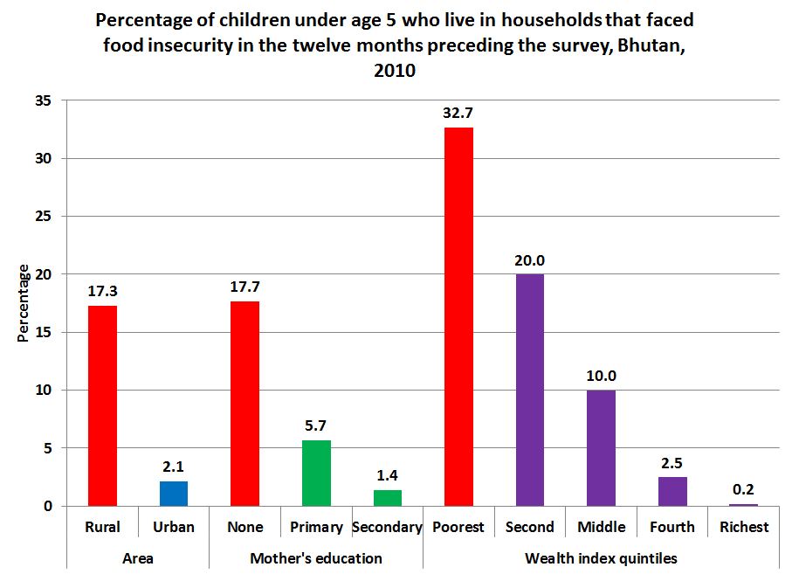

There is a strong association between the size of a household and food insecurity; larger households are more likely to face food insecurity. However, of the households that face food insecurity, those with only one or two members also experience food insecurity, on average, for 3.2 months of the year compared with those households with 3 or more members who face food insecurity, on average, for a period of 2.6 months (see Figure 12 below). This difference is statistically significant. It is also practically significant in that it indicates that the smallest households with food insecurity, which often comprise vulnerable elderly persons, experience additional weeks each year without enough food compared with larger households. The data do not show any significant difference between urban and rural households in the average number of months households experience food insecurity.

Figure 12: Mean number of months that households face food insecurity by household size, 2010
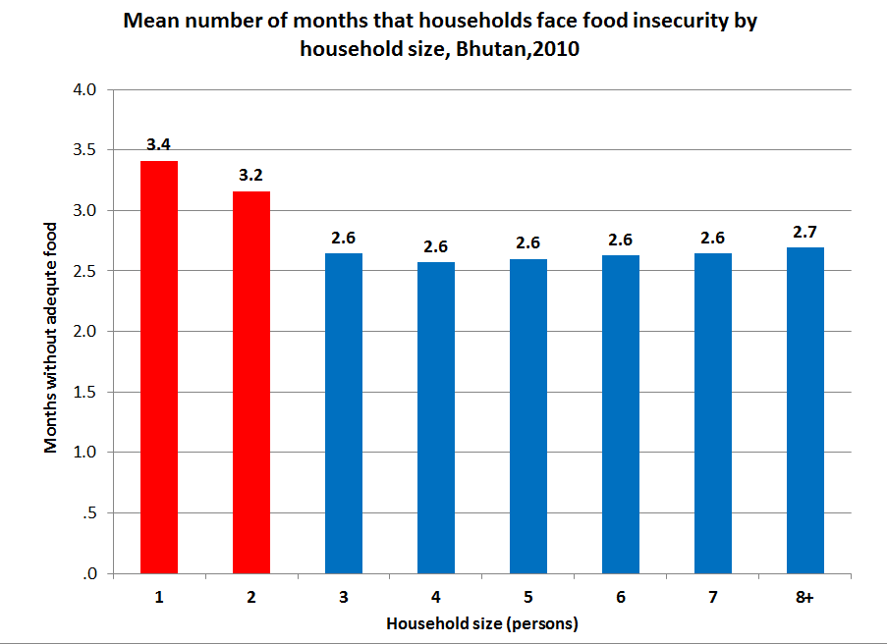

Figure 13 below illustrates these data, showing how food insecurity begins to increase in February, reaching its peak in June when more than half of all food insecure households (52 percent) do not have enough food to feed the family, and then decreasing from July onwards when farmers begin to harvest crops. These data will help planners in designing programmes that address food security and hunger during the most critical time of the year, which is from April to July.

Figure 13: Percentage of households that faced food insecurity by months of the year, Bhutan, 2010
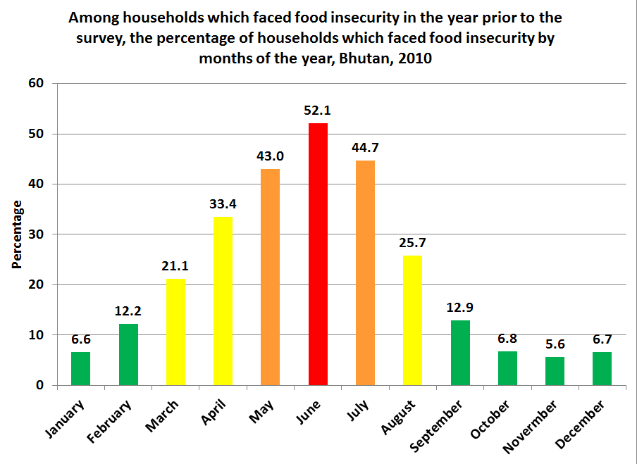

4.7.1 Food security and nutritional status of children under the age of 5
The analysis now turns to the critical relationship between food security and nutrition. Table 15 below shows the nutritional status of children under the age of five by whether their household faced food insecurity during the twelve months preceding the survey. The data show a clear positive correlation between food security and a better nutritional status of children. Of children who live in food secure homes, 12 percent are underweight as compared with 18 percent of children in food insecure homes, a difference that is statistically significant. These data indicate that children who face food insecurity at any point in the year are 50 percent more likely to be underweight than their counterparts who do not face food insecurity. The difference in underweight prevalence between children in food secure and food insecure homes is also statistically significant for individual demographic groups including males, females, rural children, and those whose mothers have no formal education.
Similarly, 33 percent of children in food secure homes are stunted, an estimate in line with the national average, compared with 39 percent of children in food insecure homes. This difference is also statistically and practically significant as children in food insecure homes are nearly 20 percent more likely to be stunted. With regard to wasting, the data do not show a statistically significant difference by whether children’s households faced food insecurity.

Table 15: Nutritional status of children under the age of 5 by food security status of their household, Bhutan, 2010
 |  | Experienced food shortage during past 12 months |  | Did not experience food shortage in past 12 months |  | Experienced food shortage during past 12 months |  | Did not experience food shortage in past 12 months |  | Experienced food shortage during past 12 months |  | Did not experience food shortage in past 12 months
 |  | Percentage of underweight children | Number of children | Percentage of underweight children | Number of children | Percentage of stunted children | Number of children | Percentage of stunted children | Number of children | Percentage of wasting children | Number of children | Percentage of wasting children | Number of children
Sex | Male | 20.1 | 369 | 12.4 | 2,716 | 40.6 | 350 | 32.5 | 2,578 | 7.1 | 358 | 6.1 | 2,596
Sex | Female | 15.7 | 407 | 11.4 | 2,580 | 36.8 | 390 | 33.1 | 2,488 | 6.3 | 399 | 5.3 | 2,510
Area | Urban | [16.1] | 38 | 10.3 | 1,762 | [41.2] | 33 | 27.8 | 1,680 | [3.5] | 37 | 6.5 | 1,676
Area | Rural | 17.9 | 738 | 12.7 | 3,534 | 38.5 | 707 | 35.2 | 3,386 | 6.8 | 721 | 5.3 | 3,429
Mother's education | None | 17.8 | 715 | 13.6 | 3,329 | 38.6 | 687 | 37.1 | 3,199 | 7.0 | 699 | 5.9 | 3,237
Mother's education | Primary | [10.5] | 43 | 11.3 | 707 | [36.0] | 41 | 30.1 | 686 | [2.7] | 42 | 4.7 | 688
Mother's education | Secondary | * | 18 | 7.7 | 1,259 | * | 13 | 22.4 | 1,180 | * | 16 | 5.9 | 1,179
Wealth index quintiles | Poorest | 15.4 | 402 | 16.5 | 830 | 38.9 | 391 | 42.6 | 805 | 5.0 | 395 | 5.1 | 822
Wealth index quintiles | Second | 24.7 | 221 | 14.0 | 885 | 42.6 | 203 | 39.3 | 836 | 8.8 | 212 | 6.1 | 854
Wealth index quintiles | Middle | 17.4 | 115 | 13.7 | 1,036 | 38.4 | 110 | 38.4 | 997 | 9.1 | 115 | 6.1 | 1,006
Wealth index quintiles | Fourth | [4.5] | 35 | 10.4 | 1,376 | [15.0] | 34 | 27.9 | 1,320 | [4.7] | 34 | 5.7 | 1,316
Wealth index quintiles | Richest | * | 2 | 7.3 | 1,169 | * | 2 | 21.5 | 1,108 | * | 2 | 5.6 | 1,107
Total |  | 17.8 | 776 | 11.9 | 5,296 | 38.6 | 740 | 32.8 | 5,065 | 6.7 | 758 | 5.7 | 5,105

Figure 14 below illustrates data from Table 15 above, showing how children in food insecure homes are more likely to have poorer nutritional status than their food secure counterparts.

Figure 14: Nutritional status of children under the age of 5 by food security status of their household, Bhutan, 2010
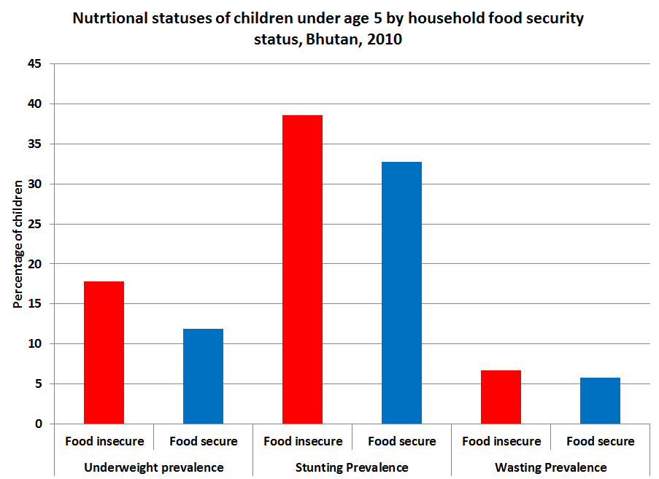

4.9 Section summary
Nutrition is a critical component of the health and well-being of Bhutan. The human and financial resources invested in the improvement of nutrition for the country, especially infants and children, will provide benefits for decades to come. By promoting better nutrition primarily in the young, a healthier and more productive society will develop. Simultaneously, the negative consequences of poor nutrition among the most vulnerable will be reduced. These include poor mental and physical growth, low academic performance, poor health, and high mortality rates.
Malnutrition is monitored by three indicators: the percentage of children who are underweight (low weight for age), stunted (low height for age), and wasted (low weight for height). Of the Bhutanese children under the age of five, 13 percent are underweight, 34 percent are stunted, and 6 percent are wasted. A major concern for policymakers should be that the stunting prevalence for all children increases from the time of birth to a staggering 36 percent at the age of two. Between the age of two and five, stunting prevalence initially increases, then drops to 34 percent at the age of five.
The data show that the way mothers feed their children is far from ideal. Almost 70 percent of the Bhutanese women with young children do not continue exclusive breastfeeding after two months, while 6 months of exclusive breastfeeding is required.
The most relevant issues related to child malnutrition are mother’s antenatal care, mother’s education level, household food insecurity, and household wealth. Addressing these areas at a policymaking level will require initiatives in agriculture, economics, public health, education, media, and medical services.
Antenatal visits are consistently associated with good nutritional outcomes. Newborns of mothers with adequate antenatal care are less at risk of being born with low birthweight and are more likely to have better nutritional status during the first two years of life. Ensuring that every pregnant woman in Bhutan receives at least four antenatal care visits is an important policy goal (the new policy of eight visits is obviously even better). Supporting programmes that expand on the comprehensive healthcare services for mothers, infants, and children is important. One could be the development of antenatal, postnatal, and newborn healthcare services that, beyond providing medical care, focus more on providing comprehensive health education. Areas of expanded education would include exclusive breast feeding during the first 6 months, proper complementary feeding practices during the following years, and other public health issues like sanitation and hygiene that affect nutrition. Every visit should include a minimum of 5 minutes of directed patient education.
Households with food insecurity have higher percentages of children with malnutrition. Food insecurity shows a clear connection to poverty, is more frequent in larger households, and strongly predominant in rural areas and in poorer dzongkhags. It will require a concerted effort to make food available and accessible to the households that regularly face food shortage. Additionally, education on appropriate food utilization is necessary to help households optimize their nutrition.
Mother’s education level and literacy exhibit a strongly positive correlation with nutritional outcomes among young children. Therefore, encouraging young women to complete their secondary education needs to be a country-wide priority.
Another area policy makers must address is the inequality seen in nutrition, antenatal, postnatal, and newborn care in rural areas and amongst the poorest and least educated sections of society. Further evaluation of the reasons why mothers are not receiving adequate antenatal care or not having an institutional delivery is critical, in order to formulate a plan to address these issues. Possibly, services need to be provided in more locations to make it easier for mothers and children to seek care. Maybe it is necessary to take services directly to the mother’s/infant’s home.
Further education of healthcare workers at all levels needs to continually be stressed by policy makers. One of the most sustainable and economical ways of promoting better nutrition and overall health is the continual advancement and training of healthcare providers. Health assistants, general nurse midwives, and others need continual refreshment and advancement of their skills in nutrition, antenatal, postnatal, and new-born care.
Bhutan has advanced considerably in its health and nutritional outcomes over the past decades. Continual emphasis and improvement on nutrition to promote a healthier future is essential to sustain this progress.

5. Child health

5.1 Introduction
Millennium Development Goal 4 (MDG4) calls for a reduction by two thirds of the Under-five Mortality Rate (U5MR) by 2015, compared with the 1990 baseline. In 1990, U5MR was 139 deaths per 1,000 live births. The global distribution of the primary causes of all under-five deaths shows that pneumonia kills more children than any other illness – accounting for 19 per cent of all under-five deaths. This figure, however, does not include deaths due to pneumonia during the first four weeks of life, the neonatal period. It has been estimated that 26 per cent of neonatal deaths, or 10 per cent of all under-five deaths, are caused by severe infections during the neonatal period. And a significant proportion of these infections are caused by pneumonia/sepsis. In the South East Asia region, acute diarrhoea and pneumonia, both communicable problems, still account for 17 percent and 19 percent, respectively, of all under-five deaths. In Bhutan, diarrhoea and pneumonia cause 40 percent of U5MR. Addressing acute diarrhoea and respiratory infections is critical to achieving MDG 4.
ARI (Acute Respiratory Infection) and diarrhoea have been on the list of Bhutan’s top ten childhood diseases for many decades and still top the child morbidity chart. In order to address child health in Bhutan, the ARI/CDD (Acute Respiratory Tract Infection and Control of Diarrheal Disease Programme) was established in 1982. Since then, there has been a reduction in diarrhoeal diseases and an improvement in diarrhoeal case management at the community level.
However, there seems to be no change in the incidence of ARI over the years. In the ninth plan, ECD (Early Childhood Development) was incorporated as an integrated approach to dealing with child health in Bhutan. In 2009, the Integrated Management of Neonatal and Childhood Illnesses programme (IMNCI) was introduced. It has implemented a strategic approach to address main childhood illnesses in a coordinated and planned manner. The IMNCI programme addresses common childhood diseases among children under five years of age, including counselling mothers and caregivers about home care. Interventions under IMNCI have reached the most vulnerable population on the periphery of the health system.

5.2 Acute respiratory infections
ARIs, classified as upper or lower respiratory tract infections, are the primary cause of morbidity among children under five across the world. In Bhutan, ARIs constitute the most common illnesses among children under the age of five, and are the primary cause of their mortality. Except for neonates, children in this age group average three to six episodes of ARIs annually regardless of their socio-economic status or where they live in Bhutan. This section presents data on the use of solid fuels in the home, which contributes to air pollution and exacerbates ARIs that afflict children in Bhutan.

5.2.1 Pneumonia incidence
Because pneumonia kills more children than any other illness, any effort to improve overall child survival must make the reduction of pneumonia a priority. Prevention efforts include many well-known child survival interventions, such as expanding vaccine coverage, promoting adequate nutrition, and reducing indoor air pollution. But once a child develops pneumonia, a caregiver must recognize the symptoms and seek appropriate care immediately. Since a large proportion of severe pneumonia cases in children of the developing world are caused by bacterial pathogens, prompt treatment with a full course of effective antibiotics is a key to reducing pneumonia deaths. This approach is proven, affordable, and relatively straightforward to implement.
A healthy child has many natural defences that protect its lungs from the invading pathogens that cause pneumonia. However, children and infants with compromised immune systems have weakened defences. Undernourished children, particularly those not exclusively breastfed or with inadequate zinc intake, are at a higher risk of developing pneumonia. Similarly, children and infants suffering from other illnesses, such as AIDS or measles, are more likely to develop pneumonia. Environmental factors, such as living in crowded homes and exposure to parental smoking or indoor air pollution, may also play a role in increasing children’s susceptibility to pneumonia and its severe consequences.
Data from the Ministry of Health record a small decrease in the incidence of pneumonia among children under the age of five during the period 2005 to 2010. Table 16 and Figure 15 below show 1,135 recorded cases of pneumonia per 10,000 under-five children population in 2010, compared with 1,298 cases per 10,000 population in 2005, a decline of 13 percent. This decline may be attributed in part to the successful reduction of indoor pollution in rural areas by bringing the use of solid fuel down from 77 percent in 2005 to 56 percent in 2010. Reduction of ARI morbidities may possibly be due to increased general public awareness through non-formal education, Village Health Workers, and local and religious leaders.

Table 16 and Figure 15: Under-five pneumonia incidence per 10,000 population (MoH), Bhutan, 2010

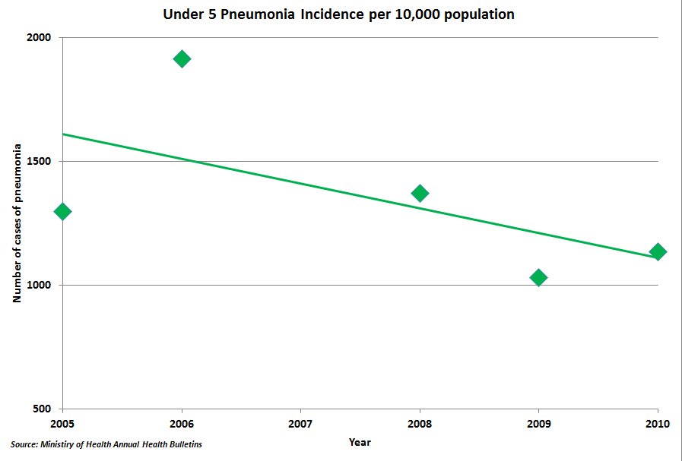
Year | Under 5 Pneumonia Incidence per 10,000 population
2005 | 1,298
2006 | 1,915
2007 | na
2008 | 1,372
2009 | 1,031
2010 | 1,135
Source: Ministry of Health

The Ministry of Health 2010 data above indicate a pneumonia incidence rate of 11 percent compared with the BMIS 2010 estimate of 7 percent shown in Table 18 below. The difference in estimates may be due to a difference in the data collection period. The Ministry of Health data represent recorded cases for the entire calendar year. The BMIS data reflect questions asked to ascertain suspected pneumonia during the two weeks preceding the survey, which occurred during one season (March-July). Table 17 below shows that children in the poorest households, in rural areas, and whose mothers have no education are more likely to have suspected pneumonia than their more privileged counterparts. Pneumonia incidence is higher among males and among older children aged 48-59 months than among the youngest children aged 0-11 months. All these differences in pneumonia incidence are statistically significant.
Of the children in the survey with suspected pneumonia, approximately three-quarters were taken to an appropriate provider. Unlike the incidence of pneumonia, there are no great disparities in care-seeking for children across different groups. Care-seeking for sick children does not fall below 60 percent for any individual demographic group. Table 18 below also shows the percentage of children under the age of five with suspected pneumonia who received antibiotics.
Nearly half of all of the children received antibiotics (49 percent). Treatment with antibiotics was found to increase with wealth and mother’s education. Although it appears as though antibiotic treatment is higher for males and among children in urban areas, these differences are not statistically significant. Antibiotic treatment was lowest for older children aged 48-59 months (35 percent), children from the poorest households (41 percent), and for those whose mothers have no formal education (42 percent).

Table 17: Percentage of children under the age of 5 with suspected pneumonia, percentage taken to an appropriate provider, and percentage who received antibiotics, Bhutan, 2010
 |  | Had suspected pneumonia in the last two weeks | Percentage of children taken to a appropriate provider | Percentage of children with suspected pneumonia who received antibiotics in the last two weeks | Number of children under the age of 5 with suspected pneumonia
Sex | Male | 7.9 | 76.1 | 49.8 | 253
 | Female | 5.9 | 71.5 | 47.3 | 182
Area | Urban | 4.4 | 74.1 | 58.4 | 81
 | rural | 7.9 | 74.2 | 46.5 | 354
Age | 0-11 | 5.3 | 72.2 | 50.3 | 65
 | 12_23 | 6.5 | 76.6 | 61.6 | 80
 | 24-35 | 7.0 | 71.9 | 44.7 | 93
 | 36-47 | 7.8 | 80.3 | 54.5 | 100
 | 48-59 | 7.9 | 69.3 | 35 | 97
Mother's education | None | 7.7 | 75 | 41.9 | 323
 | Primary | 7.7 | 61.1 | 69.6 | 60
 | Secondary | 4 | 84.3 | 66.9 | 52
Wealth index quintiles | Poorest | 10.1 | 63.6 | 40.6 | 131
 | Second | 7.7 | 80.6 | 46.8 | 89
 | Middle | 6 | 77.6 | 61.5 | 72
 | Fourth | 6.9 | 76.5 | 44.6 | 99
 | Richest | [3.6] | [81.8] | [65.6] | 44
 |  | 6.9 | 74.2 | 48.7 | 435
* Appropriate providers include hospital, BHU, satellite clinic. VHW, outreach clinic, and private physicians

Figure 16 below illustrates data on suspected pneumonia from Table 17 above. It shows that children from the richest quintile of households and those whose mothers have secondary level education are statistically less likely to report pneumonia symptoms (3 and 4 percent, respectively) than children from poorer households and/or whose mothers have less than secondary level education (10 and 8 percent, respectively).

Figure 16: Percentage of children under the age of 5 with suspected pneumonia by mother’s education and wealth quintile, Bhutan, 2010
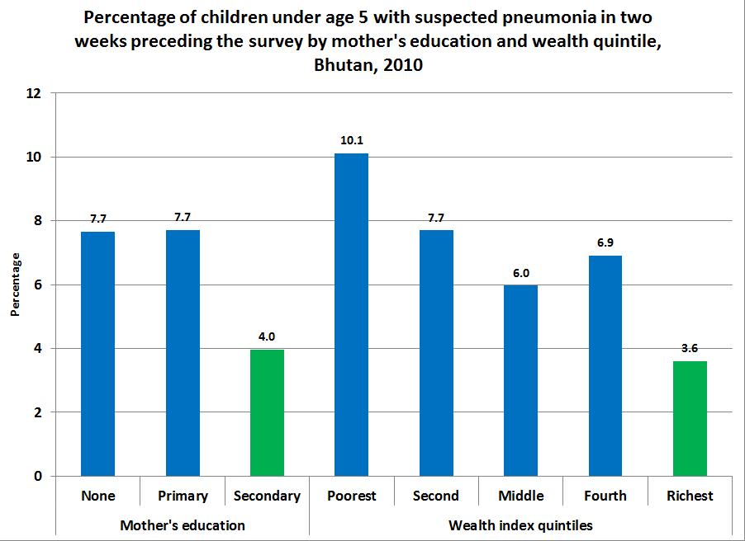

5.2.2 Pneumonia and care-seeking behaviour
The results of a global epidemiological analysis of the incidence and distribution of pneumonia, which also assesses current levels of treatment and prevention, are sobering. This analysis considers the relationship between care-seeking behaviour by parents of children with suspected pneumonia and the child’s overall development. While not shown here, this report tested children’s Early Childhood Development Index (ECDI) by whether their parents sought care for their suspected pneumonia. The test found no statistically significant difference in the ECDI scores of children aged 36-59 months by whether they were taken to an appropriate healthcare provider or not.
This analysis also considered whether children with suspected pneumonia and who have been left with inadequate care in the week preceding the survey were less likely to be taken to an appropriate healthcare provider. The data show no significant disparity in care-seeking behaviour of parents by whether the child has been left with inadequate care. Similarly, the report finds no difference in care-seeking behaviour by the age of the child’s mother.

Table 18: Early Childhood Development Index by care-seeking behavior for suspected pneumonia and care-seeking behavior by inadequate care status and age of mother, Bhutan, 2010
Summary Table for Pneumonia and Care-Seeking
 | Children who received care from appropriate provider | Number of children aged 36-59 months | Children who not receive care from appropriate provider | Number of children aged 36-59 months
ECDI | 77.3 | 128 | 64.4 | 45
 | Children left with inadequate care | Number of children under the age of 5 | Children who were not left with inadequate care | Number of children under the age of 5
Percentage of children taken to appropriate provider | 79.4 | 83 | 72.4 | 352
 | Children whose mother is age 15-24 | Number of children under the age of 5 | Children whose mother is age 25-49 | Number of children under the age of 5
Percentage of children taken to appropriate provider | 77.9 | 117 | 71.1 | 291

5.2.3 Solid fuel use
Indoor air pollution caused by the use of solid fuels in the home is considered one of the primary catalysts for ARIs. Table 19 below shows that nearly 40 percent of the population live in homes that use solid fuels for cooking, wood being by far, the most common material. The disparity in use of solid fuels by household wealth could not be any higher. 100 percent of the poorest households in Bhutan use solid fuels in the home as compared to 0 percent of the richest households. Staggering disparities exist across other dimensions of demography as well. 56 percent of the rural population uses solid fuels compared with only 2 percent of urban households. Similarly, 51 percent of households, in which the household head has no education, use solid fuels compared with 4 percent of households whose heads have secondary level education. The consequence is that the poorest children, those in rural areas, and those who live in households, in which the adults have no education, are far more likely to be exposed to air pollution that aggravates respiratory problems.

Table 19: Percentage of household members living in households using solid fuels for cooking, Bhutan, 2010
 |  | Solid fuels*for cooking | No. of household members
Dzongkhag | Bumthang | 45.2 | 1,605
Dzongkhag | Chukha | 38.7 | 6,863
Dzongkhag | Dagana | 78.7 | 2,541
Dzongkhag | Gasa | 57.1 | 484
Dzongkhag | Haa | 15.3 | 1,312
Dzongkhag | Lhuntse | 46.9 | 1,564
Dzongkhag | Mongar | 56.8 | 4,741
Dzongkhag | Paro | 5.5 | 3,776
Dzongkhag | Pemagatshel | 65.5 | 2,627
Dzongkhag | Punakha | 12.4 | 2,549
Dzongkhag | Samdrup jongkhar | 52.9 | 3,892
Dzongkhag | Samtse | 61.3 | 7,530
Dzongkhag | Sarpang | 34.0 | 4,127
Dzongkhag | Thimphu | .6 | 8,372
Dzongkhag | Trashigang | 31.9 | 5,266
Dzongkhag | Trashiyangtse | 39.5 | 1,711
Dzongkhag | Trongsa | 54.5 | 1,510
Dzongkhag | Tsirang | 78.3 | 2,208
Dzongkhag | Wangdi | 31.2 | 2,841
Dzongkhag | Zhemgang | 63.7 | 1,800
Area | Urban | 2.2 | 18,500
Area | Rural | 56.0 | 48,820
Education of household head | None | 50.9 | 44,415
Education of household head | Primary | 34.3 | 10,129
Education of household head | Secondary + | 3.8 | 12,763
Wealth index quintiles | Poorest | 99.9 | 13,461
Wealth index quintiles | Second | 70.0 | 13,468
Wealth index quintiles | Middle | 22.8 | 13,466
Wealth index quintiles | Fourth | 4.4 | 13,462
Wealth index quintiles | Richest | .3 | 13,462
Total |  | 39.5 | 67,319
*Solid fuels include coal, wood, straw, and grass: data for 13 cases in which education of the household head is not known are not shown
Map 2 below illustrates data from Table 19 above on the household use of solid fuels. It shows that the highest rates of solid fuel use in Bhutan are found in the poorest dzongkhags in the south and east, particularly in Tsirang and Dagana. In fact, the ten poorest dzongkhags are also the ten dzongkhags with the highest rates of solid fuel use. The lowest rates of solid fuel use are in a contiguous region from Thimphu and Paro.

Map 2: Percentage of household members living in households using solid fuels for cooking, Bhutan, 2010
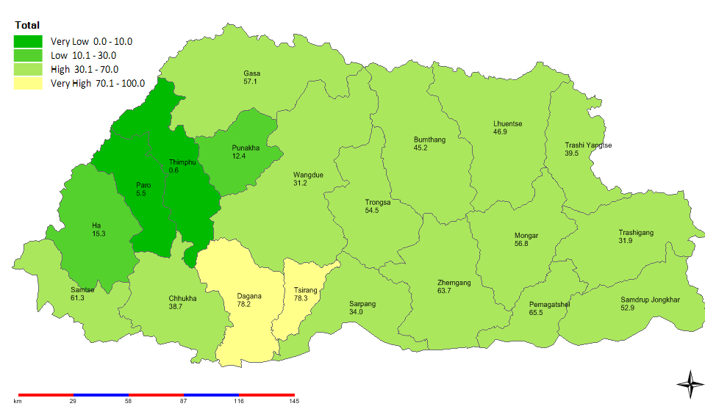

5.2.4 Pneumonia incidence and solid fuel use
Solid fuel use is strongly associated with respiratory infections. For this reason, this analysis tested whether children under the age of five who live in homes that use solid fuels for cooking exhibit a higher rate of pneumonia symptoms. Table 20 below shows that 8.5 percent of children in homes with solid fuel use were suspected to have pneumonia compared with 5.9 percent of their counterparts in homes without solid fuel use, a difference that is statistically significant. As stated above, solid fuel use is highest in the poorest households, in rural areas, the poorest dzongkhags, and in households in which the head has no formal education. These data suggest that children from these demographic groups are more likely to contract pneumonia-like symptoms – an observation borne out in the data presented in Table 19 above.

Table 20: Percentage of children under the age of 5 with suspected pneumonia by use of solid fuel for cooking in the home, Bhutan, 2010
 |  | Not using solid fuels |  | Using solid fuels |  | Total number of children under the age of 5
 |  | Percentage who had suspected pneumonia in the last two weeks | Number of children under the age of 5 | Percentage who had suspected pneumonia in the last two weeks | Number of children under the age of 5 | Total number of children under the age of 5
Area | Urban | 4.4 | 1,810 | [4.0] | 30 | 1,841
Area | Rural | 7.2 | 2,051 | 8.5 | 2,405 | 4,456
Education of household head | None | 7.7 | 1,799 | 8.7 | 2,048 | 3,847
Education of household head | Primary | 5.6 | 687 | 6.8 | 338 | 1,024
Education of household head | Secondary + | 3.7 | 1,374 | 11.1 | 50 | 1,423
Wealth index quintiles | Poorest | * | 1 | 10.1 | 1,293 | 1,294
Wealth index quintiles | Second | 8.6 | 340 | 7.3 | 819 | 1,159
Wealth index quintiles | Middle | 6.0 | 929 | 5.8 | 268 | 1,197
Wealth index quintiles | Fourth | 7.2 | 1,386 | .0 | 52 | 1,438
Wealth index quintiles | Richest | 3.6 | 1,205 | * | 3 | 1,208
Total |  | 5.9 | 3,861 | 8.5 | 2,436 | 6,297
Data for 2 cases in which the education of the household head is not known are not shown

5.3 Diarrhoea
Diarrhoea is defined as having loose or watery stools at least three times per day, or more frequently than normal for an individual. Most episodes of childhood diarrhoea are mild. However, acute cases can lead to significant fluid loss and dehydration, which may result in severe negative effects to a child’s health, and sometimes even death. Frequent episodes of diarrhoea over a long duration can lead to under-nutrition and increased risk of infections due to decreased immunity. In addition, children who are frequently ill or weak due to diarrhoea may be less likely to attend school, which can have an adverse effect on their educational outcomes. In Bhutan, diarrhoea among children under-five continues to be a major concern as it ranks second, only after ARI.

Figure 17: Under 5 diarrhoea incidence per 10,000 population
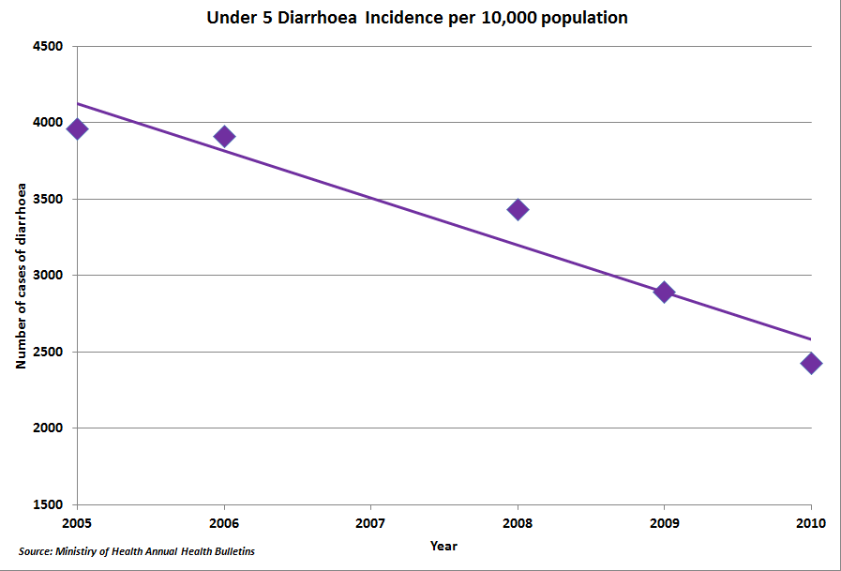

5.3.1 Diarrhoea incidence
Data from the Ministry of Health record a very significant decrease in the incidence of diarrhoea among children under the age of five during the period 2005 to 2010. Table 21 and Figure 17 show 2,428 recorded cases of diarrhoea per 10,000 population in 2010 compared with 3,960 cases per 10,000 population in 2005, a decline of 39 percent in just five years. Several factors are likely to contribute to this significant reduction in the incidence of diarrhoea, including expanded access and use of improved water and sanitation facilities, and improvements in infant and young child feeding practices. Improved hygienic practices such as hand washing as well as public health awareness campaigns carried out by the non-formal education programme along with knowledge dissemination of hygiene conveyed by village health workers (VHWs), the media, and religious leaders have played a significant role.

Table 21: Diarrhoea incidence of children under the age of 5 (MoH data), Bhutan, 2010
 | Under 5 Diarrhea Incidence per 10,000 populations
2005 | 3,960
2006 | 3,911
2007 | na
2008 | 3,432
2009 | 2,829
2010 | 2,428
Source: Ministry of Health

Table 22 below shows that 25 percent of children under the age of five had diarrhoea in the two weeks preceding the BMIS 2010 survey. Although the data collection and time period differ, the BMIS estimate is remarkably similar to the Ministry of Health estimate of 24 percent (see Table 21 above). The incidence of diarrhoea decreases with wealth status and with mother’s educational level. The data do not show significant disparities by sex, area of location (urban/rural) or dzongkhag.

Table 22: Diarrhoea incidence of children under the age of 5, Bhutan, 2010
 |  | Had diarrhoea in last two weeks | Number of children aged 0-59 months
Sex | Male | 26.4 | 3,216
Sex | Female | 23.8 | 3,081
Dzongkhag | Bumthang | 17.2 | 171
Dzongkhag | Chukha | 30.0 | 648
Dzongkhag | Dagana | 24.5 | 237
Dzongkhag | Gasa | [21.4] | 43
Dzongkhag | Haa | 23.0 | 121
Dzongkhag | Lhuntse | 30.4 | 124
Dzongkhag | Mongar | 25.2 | 466
Dzongkhag | Paro | 25.7 | 337
Dzongkhag | Pemagatshel | 15.7 | 214
Dzongkhag | Punakha | 27.6 | 218
Dzongkhag | Samdrup jonkhar | 20.2 | 410
Dzongkhag | Samtse | 24.7 | 755
Dzongkhag | Sarpang | 20.5 | 350
Dzongkhag | Thimphu | 25.2 | 801
Dzongkhag | Trashigang | 26.5 | 479
Dzongkhag | Trashiyangtse | 25.6 | 169
Dzongkhag | Trongsa | 23.4 | 133
Dzongkhag | Tsirang | 21.2 | 186
Dzongkhag | Wangdi | 36.3 | 261
Dzongkhag | Zhemgang | 28.7 | 175
Area | Urban | 25.3 | 1,841
Area | Rural | 25.0 | 4,456
Age | 0-11 | 29.8 | 1,229
Age | 12_23 | 36.2 | 1,234
Age | 24-35 | 24.3 | 1,337
Age | 36-47 | 20.2 | 1,275
Age | 48-59 | 15.2 | 1,222
Mother's education | None | 26.5 | 4,207
Mother's education | Primary | 26.9 | 781
Mother's education | Secondary | 19.7 | 1,309
Wealth index quintiles | Poorest | 26.3 | 1,294
Wealth index quintiles | Secondary | 25.0 | 1,159
Wealth index quintiles | Middle | 28.0 | 1,197
Wealth index quintiles | Fourth | 27.0 | 1,438
Wealth index quintiles | Richest | 18.8 | 1,208
Total |  | 25.1 | 6,297

It is well known that mother’s education level has a contributing effect on the health of the child. Figure 18 below illustrates the data shown in Table 22 above and shows that 27 percent of children whose mothers have no education had diarrhoea, compared with 20 percent of children whose mothers have secondary level education, a difference which is statistically significant. Children under the age of five from the richest households had a diarrhoea rate of 19 percent, which is considerably (and statistically) lower than children from the other four wealth quintiles.

Figure 18: Incidence of diarrhoea among children under the age of 5 by mother’s education and wealth quintile, Bhutan, 2010
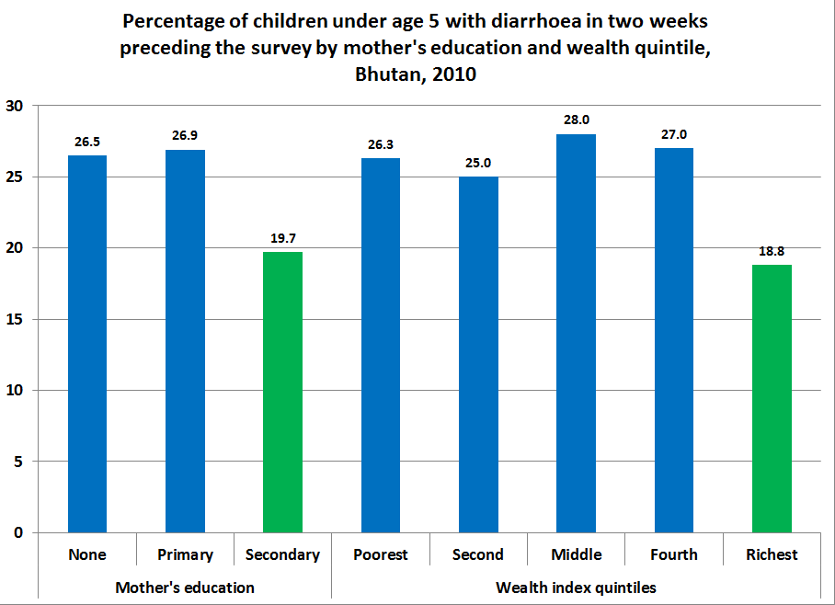

Research has shown that children with poor nutritional status as well as those exposed to poor environmental conditions are more susceptible to severe diarrhoea and dehydration than healthy children. Notwithstanding this evidence, this analysis tested whether the diarrhoeal incidence among children under the age of five differed by nutritional status. While not shown here, the data show no significant difference in diarrhoea incidence by nutritional status except in the case in which children who are moderately or severely stunted have a slightly higher (but significant) incidence of diarrhoea than children who are not stunted.

5.3.2 Treatment of diarrhoea
BMIS data show that the large majority of children under the age of five who experience diarrhoea receive some level of treatment. Table 23 below shows that 74 percent of children who had diarrhoea in the two weeks preceding the survey received oral rehydration salts (ORS) or increased fluids. There is little variation by demographic characteristics with the notable exception of the youngest children aged 0-5 months, of which only 48 percent received this treatment.
The most appropriate treatment of diarrhoea is oral rehydration therapy (ORT) with continued feeding. 62 percent of children under five received this more substantial treatment for their diarrhoea. Again, the data reveal little variation among demographic groups with the exception of 0-5 month old children, of whom only one-third (33 percent) receive ORT with continued feeding. This result is likely a function of the fact that nearly half (49 percent) of the children in Bhutan in this age group are exclusively breastfed and are therefore not given any treatment or drugs. Instead, mothers are advised to breastfeed immediately after the child has diarrhoea. In this respect, these data do not indicate a negative outcome.

Table 23: Treatment of diarrhoea for children under the age of 5, Bhutan, 2010
 |  | ORS or increased fluids | ORT (ORS or recommended homemade fluids or increased fluids) | ORT with continued feeding | Not given any treatment or drug | Number of children aged 0-59 months with diarrhea
Sex | Male | 73.3 | 86.7 | 63.0 | 9.6 | 850
Sex | Female | 74.0 | 83.9 | 60.0 | 12.0 | 732
Area | Urban | 78.8 | 86.6 | 60.0 | 10.7 | 467
Area | Rural | 71.4 | 84.9 | 62.3 | 10.7 | 1,115
Age | 0-5 | 47.7 | 54.5 | 32.5 | 37 | 141
Age | 06_11 | 68.9 | 82.4 | 59.1 | 14.4 | 225
Age | 12_23 | 76.4 | 88.5 | 63.1 | 8.2 | 447
Age | 24-35 | 81.5 | 93.8 | 70.9 | 5.4 | 325
Age | 36-47 | 80.2 | 90.5 | 61.6 | 3.4 | 258
Mother's education | 48-59 | 69.0 | 83.5 | 66.8 | 11.7 | 186
Mother's education | None | 72.3 | 85.3 | 59.3 | 10.6 | 1,114
Mother's education | Primary | 77.3 | 87.6 | 71.2 | 7.6 | 210
Mother's education | Secondary | 76.1 | 84.1 | 63.7 | 13.7 | 257
Wealth index quintiles | Poorest | 69.1 | 83.5 | 60.9 | 12.3 | 341
Wealth index quintiles | Second | 72.0 | 86.1 | 64.6 | 10.7 | 290
Wealth index quintiles | Middle | 70.5 | 85.6 | 61.5 | 11.0 | 336
Wealth index quintiles | Fourth | 78.9 | 88.2 | 60.8 | 7.5 | 389
Wealth index quintiles | Richest | 78.0 | 82.6 | 60.4 | 13.2 | 227
Total |  | 73.6 | 85.4 | 61.6 | 10.7 | 1,582

Although the majority of children with diarrhoea receive treatment, approximately 11 percent are left to overcome diarrhoea with no intervention. Figure 19 below presents data from Table 23 above. It shows that the youngest children ages 0-5 months are far more likely than older children to receive no treatment for diarrhoea. 37 percent of children in this age group receive no treatment, which is likely a function of exclusive breastfeeding during this age. However, 14 percent of children aged 6-11 months, for whom treatment is advised, receive no treatment. This finding is of concern as the diarrhoeal incidence rate for children in this age group is very high at 36 percent. As a result, they are at a much greater risk of suffering from the repercussions of diarrhoea than the older children.

Figure 19: Percentage of children under the age of 5 who did not receive any treatment or drug for diarrhoea, Bhutan, 2010
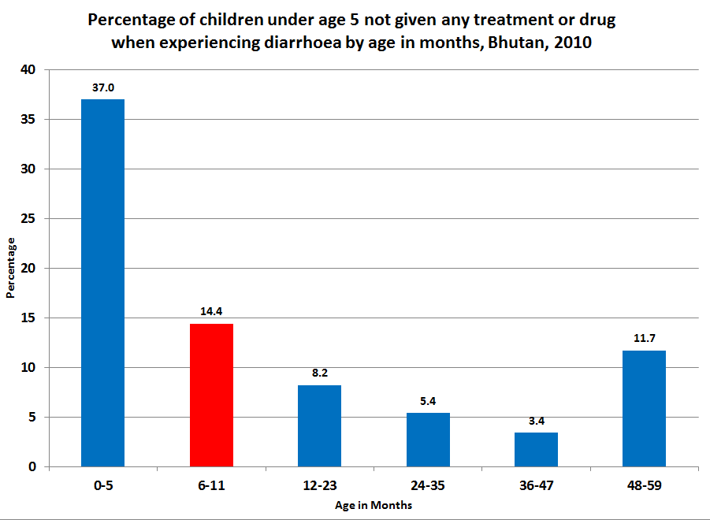

This analysis also tested differences in nutritional status by whether children with diarrhoea received ORT. While not shown here, the data show that children who did not receive ORT are no more likely to be underweight or stunted than children who did receive ORT. However, children who did not receive ORT have a higher prevalence of wasting than children who did receive ORT. The data also show that the likelihood of children receiving ORT does not differ by the age of their mother.

5.4 Section summary
Acute Respiratory Infections (ARI) and diarrhoeal diseases are responsible for 40 percent of the under-five mortality rate in Bhutan. Apart from this, non-lethal occurrence of ARI and diarrhoeal diseases is one of the most important child healthcare issues in Bhutan. It affects the well-being and physical and mental development of children, for instance, through lower school attendance. Serious improvements have been made in reducing diarrhoeal diseases, with a decrease of 40 percent in the number of cases among children under the age of five since 2005. However, Bhutan’s 25 percent diarrhoeal incidence rate is still high. With respect to ARI, there has been less improvement, with only a 15 percent reduction of pneumonia incidence since 2005. In order to meet MDG 4, which calls for a reduction by two thirds of the under-five mortality rate by 2015 as compared to the 1990 baseline, increased efforts to reduce diarrhoeal diseases and ARI are needed.
Indoor air pollution, caused by the use of solid fuels, is considered to be a major contributing factor to ARI. It is, or should be, a major public healthcare concern in Bhutan as 40 percent of the population uses solid fuels for cooking. Solid fuel use is almost completely confined to the rural areas, being highest in the poorest districts in the south and east. Children from the poorest households and those whose parents have no formal education are far more likely to be exposed to solid fuel use in the home that aggravates respiratory infections.
The strong connection between solid fuel use, poverty, and lack of education on the one hand and the incidence of Bhutan’s number two cause of child mortality on the other gives policy-makers a number of handles on the issue of respiratory infections. The foremost policy goal would be to ensure that rural households get access to clean energy sources. In the short-run, improved systems for smoke-free combustion of firewood can be introduced.
Though care-seeking for children does not present a major problem for any demographic group, proper treatment is probably often lacking. Although figures for Bhutan are absent, globally only one out of five care givers recognise the danger signs of pneumonia. As delayed proper care presents a key risk factor for fatal pneumonia, this can be addressed through additional training of health workers.
The data show differences in the treatment of children with pneumonia symptoms taken to health facilities. Older children (48-59 months), children from the poorest households, and those whose mothers have no formal education are less likely to receive antibiotics. Therefore, more attention should be given to ensuring that equitable healthcare services are provided to all people in Bhutan, irrespective of demographic group or type of health facility accessed.
The occurrence of diarrhoea is a country-wide phenomenon which does not differ much between dzongkhags or between urban and rural areas. Access to and treatment by health facilities does not seem to be a key factor. Occurrence of diarrhoeal diseases is clearly related, however, to poverty and lack of education. A mother’s education level has a direct effect on child health, through better understanding of the need of hygiene and the transmittance of infections.
Mothers’ education is positively correlated with lower morbidity and increased treatment for illnesses. Improving community-level health education of the poorest households and parents with no education would be a positive intervention to reduce illnesses among these groups.

6. Child mortality

6.1 Introduction
Child mortality rates are the key indicators of the population’s health and wellbeing, and crucial determinants of priorities in public health and social spending. These measures show whether a country has sufficient and equitable distribution of basic goods and services, and whether a country’s institutions, policies and programmes are effective to mitigate poverty. MDG 4 calls for a reduction of child mortality by two-thirds by 2015, compared with the 1990 baseline.

Box 2: Definitions of child mortality
Definitions of child mortality
The Infant Mortality Rate is the probability (expressed as a rate per 1,000 live births) of a child, born in a specified year, dying before reaching the age of one if subject to current age-specific mortality rates.
The Under-Five Mortality Rate (U5MR) is the probability (expressed as a rate per 1,000 live births) of a child, born in a specified year, dying before reaching the age of five if subject to current age-specific mortality rates.
A live birth is the complete expulsion or extraction from its mother of a product of conception, irrespective of the duration of the pregnancy, which, after such separation, breathes or shows any other evidence of life—such as beating of the heart, pulsation of the umbilical cord, or definite movement of voluntary muscles—whether or not the umbilical cord has been cut or the placenta is attached. Each product of such a birth is considered a live birth.
Source: XXXXXXXX

6.2 Child mortality estimates
Child mortality estimates for Bhutan differ by source. The BMIS 2010 data show that Bhutan is well on-track to achieve the MDG 4 targets of 32 deaths per 1,000 live births for IMR and 46 deaths per 1,000 live births for U5MR by 2015.
Figure 20 below illustrates Bhutan’s highly positive trend in its progress towards achievement of the MDG 4. Since 1990, Bhutan has successfully reduced the country’s U5MR, bringing it down from 139 deaths per 1,000 live births in 1990 to 69 deaths per 1,000 live births in 2006. These estimates indicate that Bhutan has had a remarkable achievement by cutting its U5MR in half in only 16 years.

Figure 20 : MDG 4: Infant mortality rate and Under-Five Mortality Rate
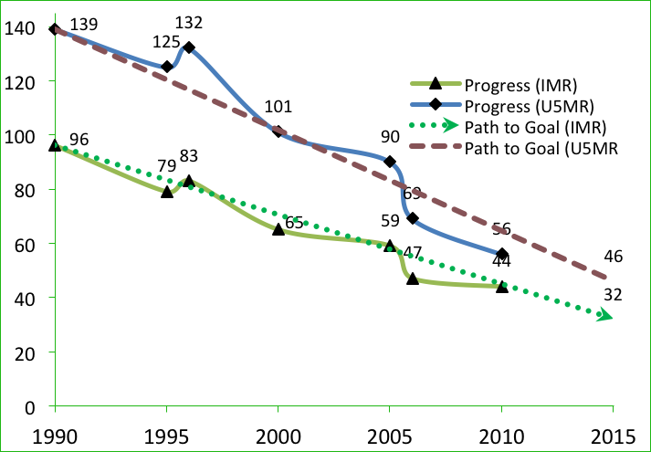

This positive trend also applies to a corresponding reduction in the IMR from 96 deaths per 1,000 live births in the baseline year of 1990 to 47 deaths in 2006. As with the U5MR, Bhutan has cut its IMR in half in this short span of time.
Figure 20 also shows the United Nations estimate for Bhutan’s U5MR and IMR for 2010 (56 and 44, respectively), indicating continued and rapid progress towards the achievement of MDG 4.
The leading primary causes of U5MR in Bhutan in 2006 included neo-natal causes (39 percent), diarrhoea (21 percent), and pneumonia (19 percent). Among the neo-natal causes, infections (36 percent), asphyxia (24 percent) and pre-maturity (24 percent) comprise the most common causes of death.
Neonatal mortality (NMR), which covers deaths in the first 28 days after birth, is of particular interest as the health interventions needed to address the major causes of neonatal deaths generally differ from those needed to address other under-five deaths. NMR is increasingly important because the proportion of under-five deaths that occur globally during the neonatal period is increasing as overall under-five mortality is decreasing.
Globally, decreases in child mortality are highly correlated with increases in income at the country level as measured by the Gross Domestic Product (GDP). Mortality rates are positively influenced by the advantages of higher incomes, including improved living conditions, better child and maternal nutrition, and greater access to basic services such as healthcare and education. Bhutan has successfully converted its significant gains in national income into expansion in access to and improvements in the quality of healthcare for the population. Improvements in child health and decreases in child mortality, can be, to a large extent, attributed to Bhutan’s successful implementation of Expanded Programme on Immunization (EPI) with its high coverage, improvement of access and services for children with major childhood illnesses, and the national referral system.
However, in spite of the overall positive trend, the health sector reform process in Bhutan faces serious challenges, which makes it difficult to ensure sustainable quality health service delivery to the population, especially to the most vulnerable groups, such as poor households, the rural population, and children and women. Bhutan’s challenging geography and scattered population, the associated high operational costs, and resource scarcity represent constraints towards full realization of the MDGs. Table 24 below presents data on the IMR and U5MR for children from various demographic backgrounds. The IMR and U5MR for males is approximately 35 percent higher than for females, which indicates that there is no female infanticide which is normally prevalent in many developing countries. The data show very significant disparities in child mortality across groups. For example, a child born in the poorest quintile of households is nearly three times as likely to die by the age of five as a child from the wealthiest two quintiles of households. A child whose mother has no education is two and a half times as likely to die before age five as a child whose mother has secondary level education. The urban-rural gap in U5MR is also quite significant; rural children are twice as likely to die before age five than urban children. These disparities in U5MR are equally significant for IMR as well. Data from the PHCB 2005 and BMIS 2010 suggest that despite decreases in the IMR and U5MR, disparities in mortality rates by wealth, mother’s education, and by area of location are increasing. Unless progressive policy measures undertake the effective reform of the health sector, and are designed to support children most vulnerable to mortality, Bhutan may achieve its MDG targets but not with the equity aspired to by GNH.

Table 24: Infant and Under-Five Mortality Rates, Bhutan, 2010 (for the year 2006)
Infant and under-five morality rates, North Model, |Bhutan,2010
 |  | Infant Mortality Rate | Under-five Morality
 |  | (IMR) | Rate (U5MR)
Sex | Male | 54 | 79
 | Female | 40 | 58
Area | Urban | 31 | 41
 | Rural | 54 | 81
Mother's | None | 51 | 77
Education | Primary | 42 | 61
 | Secondary + | 24 | 31
Wealth index | Poorest | 68 | 106
quintiles | Second | 58 | 88
 | Middle | 50 | 74
 | Fourth/Richest | 28 | 39
Total |  | 47 | 99
Reference period for these data is 2006, North Model was assumed to approximate the age pattern of morality in Bhutan

Figure 21 below illustrates U5MR data for each demographic group presented in Table 24 above. It can be clearly seen that children from the poorest quintile of households, in rural areas, and whose mothers have no formal education have a greater likelihood of dying before age five than children from wealthier households, urban areas, and whose mothers have formal education.

Figure 21: Under-Five Mortality Rates by individual demographic groups, Bhutan, 2010 (for the year 2006)
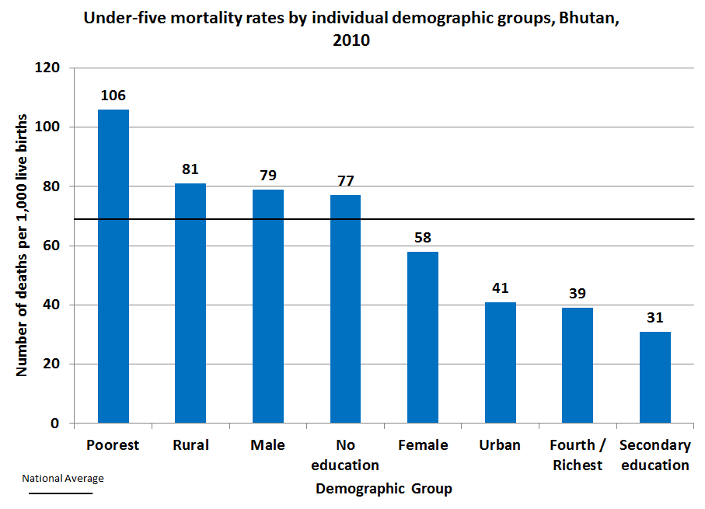

6.3 Child mortality estimation methodologies
Nationally representative estimates of child mortality can be derived from a number of different sources, including civil registration and sample surveys, but excluding demographic surveillance sites and hospital data, which are rarely representative. Globally, the preferred source of data is a civil registration system that records births and deaths on a continuous basis; if registration is complete and the system functions efficiently, the resulting estimates will be accurate and timely. However, Bhutan’s vital registration system has incomplete coverage. Therefore, household surveys such as the BMIS 2010 and National Health Surveys (NHS) as well as population censuses have become the primary source of data for infant and under-five mortality.
The majority of survey data comes in one of two forms: the full birth history (FBH), whereby women are asked for the date of birth of each of their children, whether the child is still alive, and if not the age at death; and the summary birth history (SBH), whereby women are asked only about the number of their children ever born and the number that have died (or equivalently, the number still alive). FBH data, collected by all Demographic and Health (DHS) surveys, allow the calculation of child mortality indicators for specific time periods in the past. These calculations produce estimates for five 5-year periods before the survey, most commonly the previous 0-4 year period. SBH data, collected by censuses and many Multiple Indicator Cluster Survey (MICS) surveys such as the BMIS 2010, use the age of the woman as an indicator of exposure time and exposure time period of the children, and use models to estimate mortality indicators for periods in the past for women aged 25 to 29 through 45 to 49.
The child mortality data from BMIS 2010 presented above in Table 24 have been calculated by averaging mortality estimates obtained from women aged 25-29 and 30-34. Prior to the BMIS, the Ministry of Health primarily relied on child mortality estimates from the PHCB 2005 as presented in the Socio-Economic and Demographic Indicators (SEDI) report of the same year. The BMIS 2010 uses an indirect method to produce an estimated IMR of 47 and a U5MR of 69 per 1,000 live births. The PHCB 2005 report uses the simple direct method, which yields an estimated IMR of 40 and a U5MR of 62 per 1,000 live births.

6.3.1 Indirect child mortality estimation methodology
Indirect estimates: The indirect method utilizes data commonly collected in censuses and many general surveys: the number of children ever born to women and the number of living children each woman has had along with their ages. Unlike the direct method, the indirect method is dependent upon several assumptions that may or may not hold true: little or no change in fertility levels and age patterns over time, no change or a linear decline in mortality, and a pattern of mortality by age that conforms to known “families,” basically derived from the European experience. Overall, the indirect estimation methodology is considered superior as the responses are perceived to be more accurate than those obtained through the direct methodology. One reason is that the questions asked in the indirect method help to mitigate distortions that arise from the sensitivity of the subject matter.
Indirect methods used for estimation of IMR and U5MR in Bhutan are the UN_IGME 2010 data, BMIS 2010, and the SEDI 2005. According to UN_IGME 2010, Bhutan’s IMR declined from 89 in 1991 to 68 in 2000. The BMIS provides a new IMR estimate of 47 for the year 2006. In terms of U5MR, the UN IGME 2010 reports a decline from 143 in 1991 to 106 in 2000. BMIS 2010 shows a further decline in U5MR to 69 in 2006.
The SEDI 2005 report used the indirect method to estimate Bhutan’s IMR to be 97 in 1991, falling to 50 by 2005. With regard to U5MR, the SEDI 2005 estimated U5MR to be 157 in 1991, falling precipitously to 75 by the year 2005. In addition, SEDI also estimated the annual reduction of these mortality rates at 5 percent, which is used for calculating these rates for years that have no rates. The projected annual rate of reduction corresponds to the estimated figures, except in 1996 with SEDI, for which the estimated figures for U5MR and IMR are 127 and 80 per 1,000 live births.
For the years 1991 and 2000, for which there exist multiple estimates, this analysis averages the estimates with equal weight to arrive at a single estimate, which is then input into the trend analysis presented in Table 25 and Figure 22 below. According to Table 25, which presents estimates of child mortality for Bhutan from 1991 to 2006, the country’s IMR has fallen by 49 percent in this 15 year period, which translates to a 3.3 percent average annual decline. Similarly, the U5MR has fallen by 54 percent during the same period that shows an average annual rate of 3.6 percent decline.

Table 25 : Indirect estimates of Infant and Under-Five Mortality Rates, Bhutan, 1991-2006
Indirect Estimates of Infant and Under-Five Morality Rates, Bhutan
Year | IMR | U5MR | Source(s)
1991 | 93 | 150 | SEDI 2005/IGME2010
1996 | 80 | 127 | SEDI 2005
2000 | 67 | 104 | IGME 2010
2005 | 50 | 75 | SEDI 2005
2006 | 47 | 69 | BMIS2010

Figure 22: Indirect estimates of Infant and Under-Five Mortality Rates, Bhutan, 1991-2006
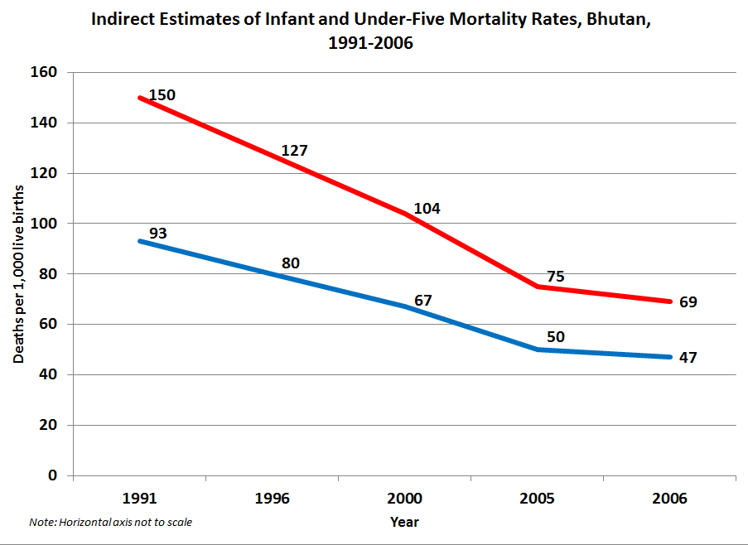

6.3.2 Direct child mortality estimation methodology
Direct estimates: Direct methods of child mortality calculation use data on the date of birth of children, their survival status, and the dates of death or ages at death of deceased children. The direct method requires data that are usually obtained only in specifically designed surveys with birth histories or from vital statistics systems, which generally have incomplete coverage in developing countries.
Direct methods used for estimation of Bhutan’s IMR and U5MR include the Population and Housing Census of Bhutan (PHCB) 2005 and National Health Surveys (NHS). According to the PHCB 2005, the IMR and U5MR were estimated to be 40 and 62 per 1,000 live births, respectively, in that year, which are lower than the indirect method estimates of 50 and 75 by the SEDI report, published in the same year. NHS estimated the IMR and U5MR to be 102 and 162 per 1,000 live births, respectively, in 1984. The 2000 NHS reports a significant decrease, with IMR and U5MR estimates of 60 and 84, respectively.
Table 26 and Figure 23 below report the trend in direct method child mortality estimates from 1984 to 2005. These estimates indicate a 2.9 percent average annual rate of decline for both IMR and U5MR.

Table 26 and Figure 23: Direct estimates of Infant and Under-Five Mortality Rates, Bhutan, 1984-2005
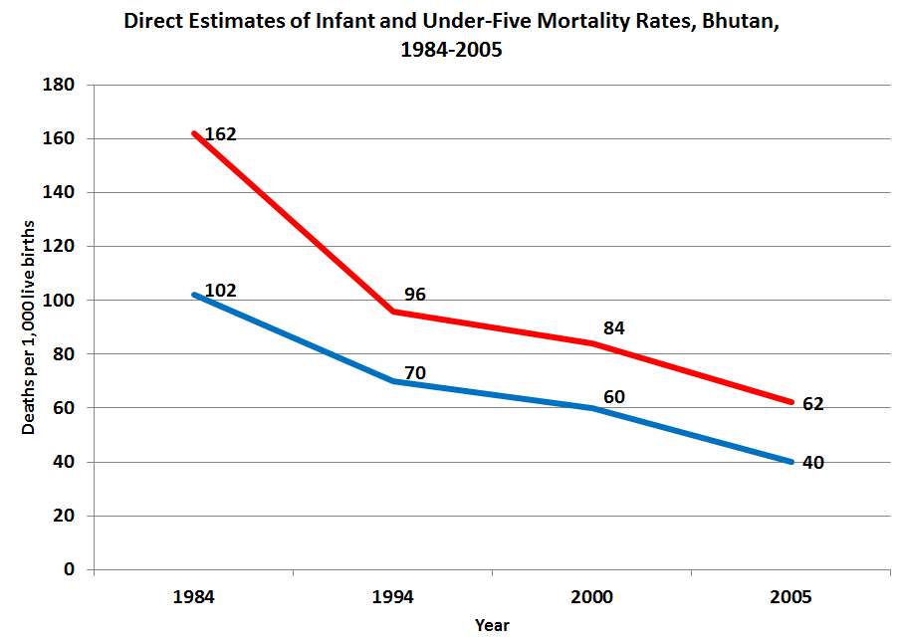
Direct Estimates of Infant and Under-five moraility Rates, 1984-2005
Year | IMR | U5MR | |Source(s)
1984 | 102 | 162 | NHS 1984
1994 | 70 | 96 | NHS 1994
2000 | 60 | 84 | NHS 2000
2005 | 40 | 62 | PHCB 2005

In summary, both direct and indirect methods of child mortality estimation show a strongly positive trend in the reduction of IMR and U5MR in Bhutan between 1984 and 2006. In order to establish a reliable child mortality trend, comparability with other surveys conducted in different years and with other countries, the UN Inter-agency Group on Child Mortality (UN IGME) estimates has been used. Figure 23 above uses IGME estimates to construct trend lines for IMR and U5MR. The sources used to calculate UN IGME estimates of child mortality, along with their respective limitations, are detailed in Annex 1: Table 11.2 of this report.

Box 3: The UN Inter-agency Group on Child Mortality Estimation (UN IGME)

The UN Inter-agency Group on Child Mortality Estimation (UNIGME)
The UN Inter-agency Group on Child Mortality Estimation was established in 2004 to share data on child mortality, harmonize estimates within the UN system, improve methods for child mortality estimation, report on progress towards the Millennium Development Goals and enhance country capacity to produce timely and properly assessed estimates of child mortality. The UN Inter-agency Group for Child Mortality Estimation (IGME) is committed to producing the best estimates possible by using advanced statistical methods and working jointly with countries in order to use the most reliable available data. The child mortality estimates are based on the work of IGME, which includes UNICEF, WHO, UNFPA and the World Bank. This group updates the estimates annually based on a detailed review of all newly available data points and assessing data quality. At times, this review will result in adjustments to previously reported estimates. The UN IGME estimates for child mortality may differ from national estimates or other reported estimates from academic institutions, due to different methods applied. It is important to point out that in the absence of error-free data there will always be substantial uncertainty around data or estimates.
Technical Advisory Group (TAG): The UN-IGME is advised by an independent Technical Advisory Group (TAG) which is chaired by Professor Kenneth Hill from Harvard University and includes other leading scholars from various universities and institutes, as well as independent experts in the field of demography. The role of the TAG is to advise the UN-IGME on methodological issues related to the estimation of child mortality and evaluating data quality.

6.3.3 Regional comparison of child mortality estimates
This section positions Bhutan’s child mortality estimates within the context of selected countries in South and Southeast Asia. According to UN IGME data for the year 2010, Bhutan’s infant mortality rate is estimated to be 44. This estimate is slightly lower than the BMIS estimate for 2006 and reflects on-track progress towards achievement of MDG 4 to reduce the IMR to 32 by 2015. Figure 24 below shows that this estimate is also very close to those for neighbouring countries, including Bangladesh, India, and Nepal.

Figure 24: Infant Mortality Rates for selected Asian countries, UN IGME, 2010
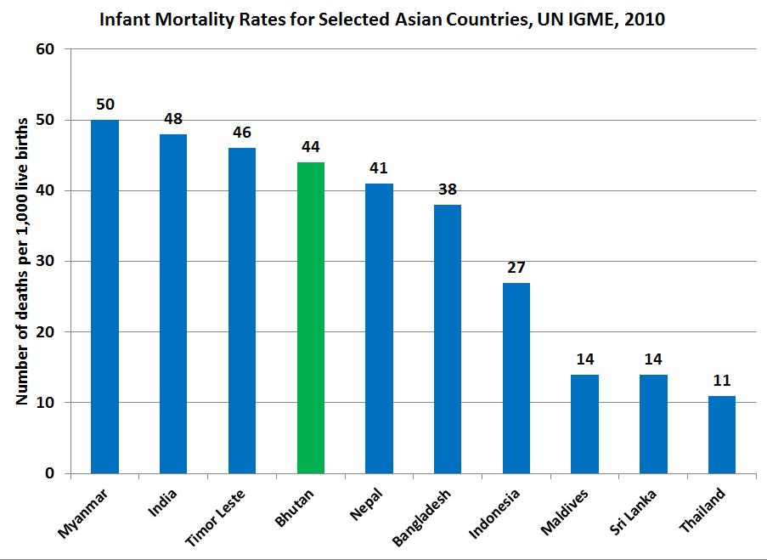

With regard to under-five mortality, the UN IGME estimates Bhutan’s U5MR to be 56 in the year 2010. This represents a considerable decline from the BMIS estimate of 69 for 2006 and reflects on-track progress towards achievement of the MDG 4 goal to reduce the U5MR in Bhutan to 46 by 2015. However, Figure 25 below shows that within the context of selected countries in South Asia, Bhutan’s U5MR estimate is only surpassed by India.

Figure 25: Under-Five Mortality Rates for selected Asian countries, UN IGME, 2010
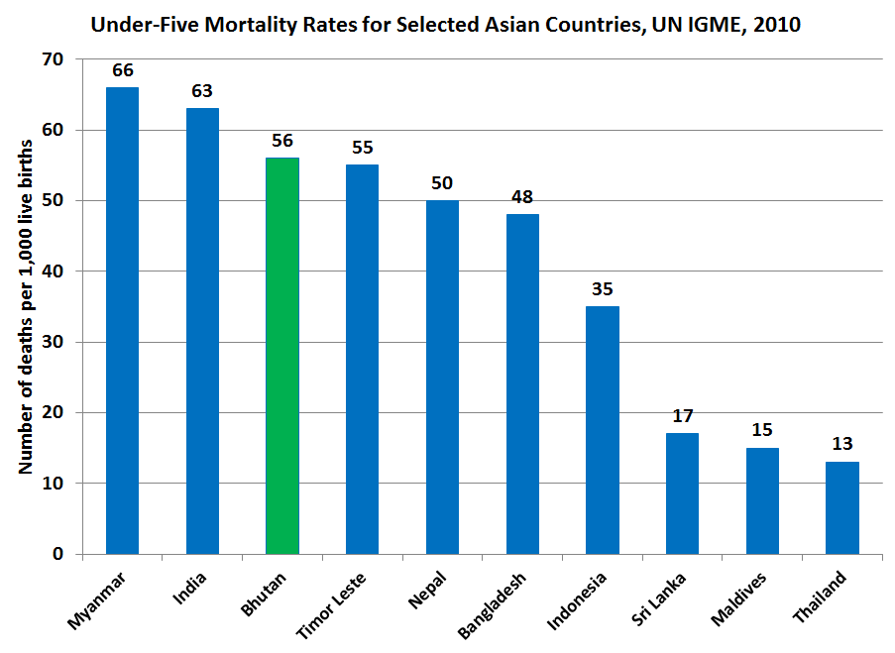

6.4 Section summary
Child mortality rate is a key indicator not only of child health and nutrition, but also of the implementation of child survival interventions and, more broadly, of social and economic development. MDG 4 calls for a reduction of child mortality by two-thirds by 2015 compared with the 1990 baseline. For Bhutan, this means reducing the U5MR from 56 (2010 estimate) to 44 per 1,000 live births, and the IMR from 44 (2010 estimate) to 32. Achieving the reduction of the U5MR by 21 percent and the IMR by 27 percent by 2015 remains a challenge.
Generating accurate estimates of child mortality is not easy because of the limited availability of high-quality data for Bhutan. The country still has to improve its vital registration systems in order to accurately record all births and deaths. Different surveys, such as census data with direct estimates (obtained from interviews) and BMIS data with indirect estimates, are currently used as the primary sources of data on child mortality. To establish a reliable child mortality trend, as well as comparability with surveys conducted in different years and in other countries, estimates by the UN Inter-agency Group on Child Mortality (UN IGME) have been used. The IGME uses all available national level data on child mortality, including data from vital registration systems, population censuses and household surveys. To estimate the under-five mortality trend series, a statistical model was fitted to data points that meet the quality standards of IGME, and then used to predict a trend line that was extrapolated to a common reference year, set at 2010.
Nevertheless, all approaches show a marked decline of approximately 50 percent in the U5MR and the IMR between 1990 and 2010. According to UN IGME estimates, under-five mortality rate has dropped from 139 per 1,000 live births in 1990 to 56 deaths per 1,000 live births in 2010. Extrapolating the trend, UN IGME estimates, as well as the other approaches, indicate that Bhutan will manage to reach the target of MDG 4 by 2015.
Globally, under-five mortality rates are positively influenced by the advantages of higher incomes, including improved living conditions, better child and maternal nutrition as well as greater access to basic services, such as healthcare and education. It is likely that the same factors apply in Bhutan. The marked reduction of child mortality thus far is an indication that the government has successfully invested in healthcare and education to improve outcomes.
Despite the clear negative trend, strong disparities between demographic groups and between rural and urban areas remain. Under-five mortality is twice as high among rural children and those whose parents have no formal education than among urban children and those whose parents have secondary-level education. Furthermore, alongside neighbouring countries, Bhutan’s absolute mortality levels do not compare well. According to the UN IGME estimates, only India and Myanmar exhibit a higher U5MR (among selected countries for which there are data).
The leading primary causes of U5MR in Bhutan in 2006 included neo-natal causes, diarrhoea and pneumonia. Among the neo-natal causes, infections, asphyxia (lack of oxygen) and pre-maturity comprise the most common causes of death. All of these illnesses can, to a large extent, be addressed by programmes on education and antenatal and postnatal healthcare. Diarrhoea and pneumonia have been discussed in detail in chapter 5. Given the large number of deaths caused by infections at birth, there is need for improvement of both the quality of healthcare as well as health-related education. Additionally, it is advised to look into the causes of asphyxia and pre-maturity, in order to develop specific interventions.
More broadly, a more equity-focused approach to healthcare by policymakers is needed. Policymakers should design interventions that empower women, remove financial and social barriers to accessing critical healthcare services, develop innovations that facilitate the supply of these services to the poor and rural, and increase accountability of local health systems.

7. Reproductive Health

7.1 Introduction
Reproductive health spans a multitude of issues relating to population growth and control, fertility, family planning, antenatal and postnatal care, and the health of mothers and children. It also bears strongly on the position and rights of women, both as mothers and wives or partners.
The Reproductive Health Programme of the Ministry of Health began as the Maternal and Child Health (MCH) programme in the 1970s. The primary concerns at that time were to reduce high maternal mortality and infant mortality, and to address the high population growth rate in Bhutan. However, with the need to address the broader aspects of reproductive health and as per recommendations of the International Conference on Population and Development in 1994, Bhutan adopted a broader concept of reproductive health in 1997.
The National Reproductive Health Strategy, which will be implemented from 2012 to 2017, focuses on maternal and newborn care, family planning, prevention of unsafe abortion, prevention of reproductive tract infections (RTI) and sexually transmitted infections (STI) including HIV, cervical cancer and gynaecological issues, adolescent sexual reproductive health and sexual and reproductive needs of men. Over the decades, Bhutan has experienced substantial progress in the key indicators of population and reproductive health. The population growth rate declined from 3.1 percent in 1994 to 1.8 in 2005. Similarly, the Total Fertility Rate TFR decreased from 5.6 in 1994 to 2.6 in 2010 (BMIS). This is still above the replacement level (2.1),which the RGoB had hoped to reach by 2012. However, further decrease in the TFR is expected.
Family planning, apart from being a means to control population, is a very important instrument in a society where women have the right to determine the number of children they will have. Apart from this, the use of condoms is critical in preventing the spread of STIs, including HIV and AIDS. The overall contraceptive prevalence rate (CPR), among all women, aged 15 and 49 years in Bhutan is approximately 48 percent. Limited availability and insufficient knowledge of contraceptives can limit their use, as well as social factors such as opposition to its use, or health concerns. In Bhutan, women with children appear to see contraceptives primarily as a means to regulate or spread child birth period.
Antenatal care and postnatal care are considered essential services by any society in order to safeguard and improve the health of women and their newborns. ANC, in particular, is a critical intervention as it acts as a key gateway towards institutional delivery, skilled birth assistance, and postnatal care. The World Health Organization (WHO) recommends at least four ANC visits, which 77 percent of Bhutanese women obtain. However, the RGoB has recently increased its recommendation to eight visits. ANC is also seen as a key intervention in which to transmit knowledge of HIV to pregnant women, in particular, mother-to-child transmission.
Skilled Birth Assistance (SBA) and the option to deliver in a health institution are two other critical reproductive health services. Proper hygienic conditions during delivery and skilled medical assistance can greatly reduce the risks of infections and other complications. In this respect, it should be mentioned that the foremost cause of under-five mortality in Bhutan is complications at birth (see Chapter 6, Section Summary). Though the majority of pregnant Bhutanese women make use of the mentioned facilities, there remains a significant disparity in access between different demographic groups.
Post Natal Care (PNC) is equally important as antenatal care. It not only provides an opportunity to treat complications arising from the delivery, it also offers new mothers critical information on how to care for herself and her infant. Although 71 percent of newborns in Bhutan receive some form of PNC, concerns remain regarding its quality and timeliness.
Early childbearing is often associated with early marriages. In Bhutan, childbearing among femal youth aged 15-18 is 59 births per 1000 female youth. While this is Bhutan’s lowest recorded level of childbearing, the number of female youth concerned is still considerable. Because early childbearing poses significant risks for both mother and child, the issue remains an important public health concern.

7.2 Fertility and fertility preferences
In BMIS 2010, adolescent birth rates and total fertility rates are calculated by using information on the date of last birth of each woman, and the one-year period (1-12 months) preceding the survey. Rates are underestimated by a very small margin due to the absence of information on multiple births (twins, triplets, etc.) and on women having multiple deliveries during the one year period preceding the survey. The adolescent birth rate (age-specific fertility rate for women aged 15-19) is defined as the number of births to female youth aged 15-19 years during the one year period preceding the survey, divided by the average number of female youth aged 15- 19 (number of women-years lived between ages 15 through 19, inclusive) during the same period, expressed per 1,000 female youth. The total fertility rate (TFR) is calculated by summing the age-specific fertility rates calculated for each of the five-year age groups of women, from age 15 through to age 49. The TFR is expressed as the average number of births per woman. It denotes the average number of children to which a woman will have given birth by the end of her reproductive years if current fertility rates prevailed.

It is imperative to have insight into the fertility preferences of individuals, which are considered to have an important bearing on fertility outcomes and contraceptive use behaviour. Changes in the environment of the individual, including social, economic, and demographic conditions can make the individual reformulate his or her fertility preferences.

This analysis assesses the fertility preferences of women aged 15-49 years including their desire for their last birth and unmet need for contraception, and how these preferences vary with demographic backgrounds.

7.2.1 Fertility rates
The key measure of population growth is the total fertility rate (TFR) of women in their reproductive years. Table 27 below shows Bhutan’s TFR to be 2.6, indicating that women have, on average, 2.6 children in their lifetime. This figure has held steady since the 2005 census estimate and remains well above the RGoB goal of reaching the population replacement rate of 2.1. The TFR is highest in Gasa, Pemagatshel, and Zhemgang (4.0, 4.0, and 4.1, respectively) and lowest in Tsirang, Samdrup Jongkhar, and Chukha (2.1, 2.0, and 1.9, respectively) where it is at or below replacement rate. Rural women give birth to more children, on average, than urban women and women from the poorest quintile have, on average, one more child in their lifetime than women from the richest quintile (3.1 vs. 2.0, respectively).
Table 27 also shows the age-specific fertility rate for women aged 15-49 by five-year age groups. It shows that fertility is highest among women aged 20-29. The data also indicate that women with no formal education and women from the poorest wealth quintile give birth earlier in life than women with secondary level or above education, and/or women from the wealthiest households. In all age groups except the one of 45-49 years, women in rural areas have higher fertility rates than women in urban areas.

Table 27: Age-specific fertility rates among women aged 15-49, Bhutan, 2010
 |  | Age group |  |  |  |  |  |  | Total Fertility Rate
 |  | 15-19 | 20-24 | 25-29 | 30-34 | 35-39 | 40-44 | 45-49 | Total Fertility Rate
Dzongkhag | Bumthang | 41 | 177 | 206 | 97 | 45 | 31 | * | 3.0
Dzongkhag | Chukha | 29 | 120 | 101 | 77 | 36 | 12 | * | 1.9
Dzongkhag | Dagana | 124 | 189 | 112 | 81 | 71 | 20 | * | 3.0
Dzongkhag | Gasa | 332 | 272 | 187 | * | * | * | * | 4.0
Dzongkhag | Haa | 53 | 120 | 150 | 71 | 24 | 13 | 5 | 2.2
Dzongkhag | Lhuntse | 67 | 133 | 153 | 34 | 29 | 36 | * | 2.3
Dzongkhag | Monggar | 138 | 155 | 147 | 103 | 81 | 13 | 26 | 3.3
Dzongkhag | Paro | 42 | 192 | 154 | 117 | 30 | 10 | 26 | 2.9
Dzongkhag | P/gatshel | 163 | 206 | 203 | 148 | 16 | 57 | * | 4.0
Dzongkhag | Punakha | 35 | 177 | 201 | 62 | 67 | 12 | * | 2.8
Dzongkhag | S/jongkhar | 20 | 145 | 98 | 55 | 55 | 34 | * | 2.0
Dzongkhag | Samtse | 63 | 190 | 122 | 96 | 48 | * | * | 2.6
Dzongkhag | Sarpang | 37 | 176 | 163 | 95 | 28 | * | 5 | 2.5
Dzongkhag | Thimphu | 34 | 124 | 139 | 50 | 35 | 20 | 38 | 2.2
Dzongkhag | T/gang | 86 | 127 | 145 | 95 | 77 | 41 | * | 2.9
Dzongkhag | T/yangtse | 54 | 179 | 164 | 145 | 113 | 13 | * | 3.3
Dzongkhag | Trongsa | 95 | 163 | 119 | 110 | 40 | 20 | * | 2.7
Dzongkhag | Tsirang | 60 | 102 | 118 | 93 | 33 | 9 | * | 2.1
Dzongkhag | Wangdue | 51 | 181 | 119 | 59 | 69 | * | * | 2.4
Dzongkhag | Zhemgang | 150 | 248 | 173 | 71 | 124 | 58 | * | 4.1
Area | Urban | 30 | 145 | 132 | 73 | 49 | 7 | 21 | 2.3
Area | Rural | 77 | 164 | 144 | 89 | 51 | 22 | 5 | 2.8
Education | None | 113 | 182 | 127 | 90 | 48 | 17 | 4 | 2.9
Education | Primary | 70 | 149 | 112 | 45 | 84 | 32 | * | 2.5
Education | Secondary+ | 29 | 128 | 177 | 89 | 20 | 34 | 116 | 3.0
Wealth Quintile | Poorest | 112 | 179 | 135 | 107 | 62 | 20 | 10 | 3.1
Wealth Quintile | Second | 95 | 138 | 129 | 97 | 61 | 37 | 1 | 2.8
Wealth Quintile | Middle | 97 | 190 | 153 | 80 | 53 | 20 | * | 3.0
Wealth Quintile | Fourth | 36 | 182 | 127 | 69 | 46 | 7 | 10 | 2.4
Wealth Quintile | Richest | 10 | 101 | 151 | 75 | 33 | 7 | 26 | 2.0
Total |  | 59 | * | * | * | * | * | * | 2.6

Another measure of fertility is the number of children ever born to women. Table 28 below shows that the mean number of children ever born to all women is 2.2 and is 2.8 among currently married women. The number of children ever born increases steadily with age. Among women at or near the end of their reproductive age (45-49) the mean number of children ever born is 4.5 for all women and 4.8 for currently married women. Table 28 also shows the number of living children. This figure correlates closely with the number of children ever born among younger women. However, the gap increases with age until the discrepancy between the number of children ever born and the number who are living for all women aged 45-49 is greater than one (4.5 vs. 3.2, respectively), meaning that women in this age group have lost, on average, 1.3 children during their lifetime.
92 percent of women aged 15-19 have never given birth to a child, a number that gets cut in half to 46 percent for women aged 20-24. However, among married women only 50 percent of 15-19 year olds have never given birth, indicating that childbearing follows shortly after marriage, even among female youth in this age group. For married women aged 45-49, just over half (51 percent) have given birth to five or more children and only 1.4 percent have never given birth, suggesting a very low primary infertility rate in Bhutan.

Table 28: Distribution of number of children ever born to married women aged 15-49, Bhutan, 2010
 |  | Number of children ever born to all women aged 15-49 (percentage of women) |  |  |  |  |  |  |  |  |  |  | Total number of women aged 15-49 | Children ever born | No. of living children
 |  | 0 | 1 | 2 | 3 | 4 | 5 | 6 | 7 | 8 | 9 | 10+ | Total number of women aged 15-49 | Children ever born | No. of living children
Age | 15-19 | 91.5 | 7.4 | 1.1 | .1 | 0.0 | 0.0 | 0.0 | 0.0 | 0.0 | 0.0 | 0.0 | 2,052 | .1 | .1
Age | 20-24 | 46.3 | 31.5 | 18.0 | 3.7 | .5 | .0 | .0 | 0.0 | 0.0 | 0.0 | 0.0 | 2,502 | .8 | .8
Age | 25-29 | 19.7 | 24.0 | 32.5 | 16.5 | 5.3 | 1.6 | .2 | .0 | 0.0 | 0.0 | 0.0 | 2,721 | 1.7 | 1.6
Age | 30-34 | 6.3 | 9.9 | 29.8 | 27.8 | 16.7 | 6.7 | 2.2 | .4 | .1 | .1 | 0.0 | 2,219 | 2.7 | 2.4
Age | 35-39 | 3.6 | 5.8 | 17.9 | 26.8 | 22.5 | 14.0 | 5.2 | 3.1 | .8 | .2 | .2 | 1,856 | 3.4 | 2.9
Age | 40-44 | 4.4 | 3.9 | 11.7 | 20.1 | 23.1 | 16.8 | 9.3 | 4.7 | 3.1 | 1.7 | 1.1 | 1,561 | 4.0 | 3.1
Age | 45-49 | 3.5 | 3.5 | 9.9 | 19.6 | 15.9 | 15.6 | 12.9 | 7.6 | 6.6 | 2.1 | 2.8 | 1,106 | 4.5 | 3.2
Total |  | 27.7 | 14.4 | 18.9 | 15.6 | 10.6 | 6.4 | 3.1 | 1.6 | 1.0 | .4 | .4 | 14,018 | 2.2 | 1.8
 |  | Children ever born to married women aged 15-49 (percentage of women) |  |  |  |  |  |  |  |  |  |  | Total number of women aged 15-49 | Children ever born | Number of living children
 |  | 0 | 1 | 2 | 3 | 4 | 5 | 6 | 7 | 8 | 9 | 10+ | Total number of women aged 15-49 | Children ever born | Number of living children
Age | 15-19 | 50.0 | 43.2 | 6.3 | .5 | 0.0 | 0.0 | 0.0 | 0.0 | 0.0 | 0.0 | 0.0 | 312 | .6 | .5
Age | 20-24 | 19.6 | 46.1 | 27.8 | 5.7 | .7 | .1 | .1 | 0.0 | 0.0 | 0.0 | 0.0 | 1,568 | 1.2 | 1.2
Age | 25-29 | 10.1 | 25.5 | 37.1 | 18.8 | 6.3 | 1.9 | .3 | .0 | 0.0 | 0.0 | 0.0 | 2,257 | 1.9 | 1.8
Age | 30-34 | 1.6 | 8.6 | 30.7 | 30.2 | 18.6 | 7.5 | 2.2 | .4 | .1 | .1 | 0.0 | 1,923 | 2.9 | 2.6
Age | 35-39 | 1.5 | 4.2 | 17.9 | 27.3 | 24.0 | 15.1 | 5.5 | 3.3 | .8 | .2 | .2 | 1,650 | 3.6 | 3.0
Age | 40-44 | 2.3 | 2.8 | 10.8 | 21.0 | 23.9 | 17.7 | 9.8 | 5.1 | 3.5 | 1.9 | 1.2 | 1,363 | 4.2 | 3.2
Age | 45-49 | 1.4 | 2.6 | 8.7 | 19.3 | 16.9 | 16.7 | 13.5 | 7.9 | 7.4 | 2.4 | 3.1 | 957 | 4.8 | 3.3
Total |  | 7.9 | 17.3 | 24.0 | 20.1 | 13.9 | 8.4 | 4.0 | 2.1 | 1.3 | .5 | .5 | 10,029 | 2.8 | 2.4

Figure 26 below illustrates data presented in Table 28 above showing that more than 90 percent of married women aged 15-49 have given birth to at least one child and approximately one in six women has given birth to five or more children.

Figure 26: Distribution of number of children ever born to married women aged 15-49, Bhutan, 2010
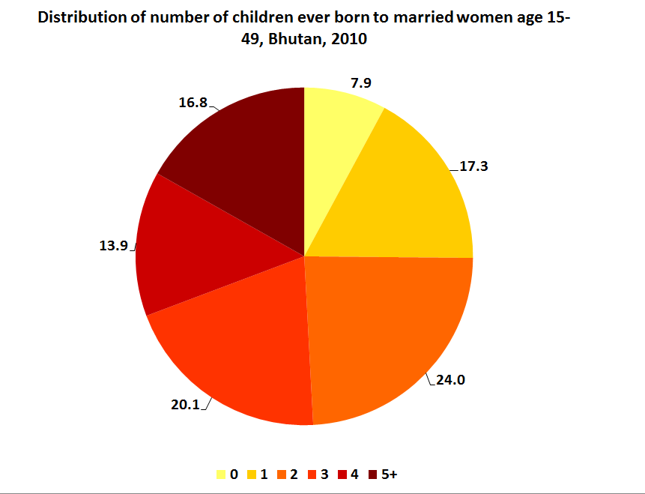
Figure 27 below compares the mean number of children ever born to married women aged 15-49 to the mean number of their children who are still living. It shows that among younger women, there is little difference between the two, indicating a low prevalence of deaths. Among older women aged 45-49, the gap between the average number of children ever born and the average number of living children is 1.5 children. This means that approximately 30 percent of the children ever born to women in this age group have died. There are two main reasons why the gap increases with women’s age. First, the likelihood that a woman’s child will die increases with the age of the woman and her child. Second, Bhutan’s child mortality rates have decreased dramatically over the past three decades.

Figure 27: Mean number of children ever born and mean number of living

children among married women aged 15--49, Bhutan, 2010
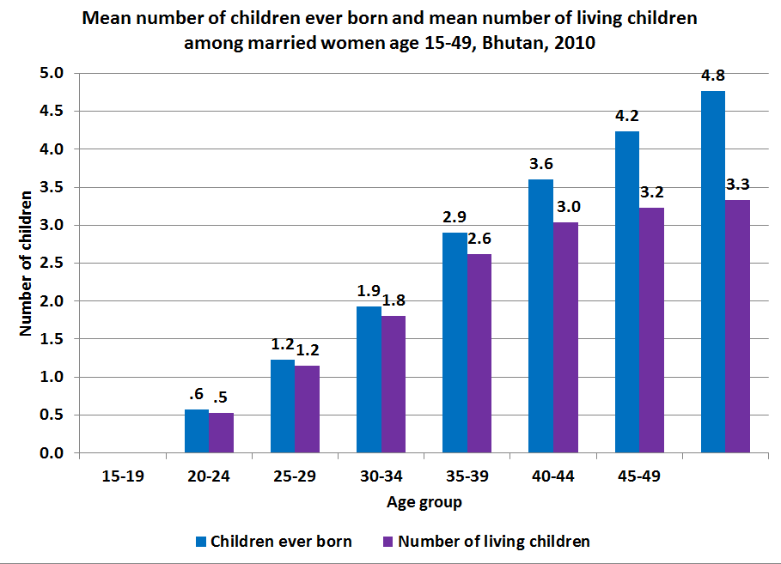

7.2.2 Desire for last birth
The BMIS questionnaire asked women who gave birth in the two years preceding the survey and who were pregnant at the time of the survey whether they wanted their child at the time. If women said “No”, they were asked if they would have wanted the child at a later date or not at all. Table 29 shows that the overwhelming majority of women who were pregnant or gave birth in the two years preceding the survey wanted to get pregnant at the time (82 percent). This figure holds rather steady across all demographic groups except among women aged 35-49 and women who have four or more children, only 66 percent and 64 percent of whom wanted the pregnancy at that time. This decrease and similarity between the two groups should be expected as older women and those who have the most children are often the same women. Nevertheless, nearly one out of five births and pregnancies was unwanted at the time (18 percent).
Table 29 also shows that the percentage of women who state that they want no more children increases rapidly with the number of living children from only 1 percent among women with no living children at the time to 33 percent among women with four or more children. The percentage of women aged 15-49 who want no more children is also higher among those with no formal education or who are from the poorest quintile of households. This outcome is probably related to the greater number of children these women have and at an earlier time in their lives than their counterparts who have secondary education or are from wealthy households.

Table 29: Planning status of births in the two years preceding the survey (including pregnancies) of all women, Bhutan, 2010
 |  | Planning Status |  |  |  | Total | Total number of births and pregnancies
 |  | Wanted then  (percentage) | Wanted later  (percentage) | Did not want any more children (percentage) | Missing / Don't know  (percentage) | Total | Total number of births and pregnancies
Age | 15-24 | 87 | 9.4 | 3.6 | 0.0 | 100 | 1,100
Age | 25-34 | 82.7 | 4.9 | 12.4 | 0.0 | 100 | 1,505
Age | 35-49 | 66 | 3 | 31 | 0.0 | 100 | 336
Area | Urban | 83.5 | 6.4 | 10.1 | 0.0 | 100 | 890
Area | Rural | 81.9 | 6.3 | 11.7 | 0.0 | 100 | 2,050
Education | None | 82.2 | 4.7 | 13.1 | 0.0 | 100 | 1,808
Education | Primary | 80.7 | 7.4 | 11.9 | 0.0 | 100 | 371
Education | Secondary + | 83.6 | 9.9 | 6.5 | 0.0 | 100 | 761
Wealth index quintiles | Poorest | 81.2 | 6.2 | 12.6 | 0.0 | 100 | 566
Wealth index quintiles | Second | 80.5 | 6.1 | 13.4 | 0.1 | 100 | 545
Wealth index quintiles | Middle | 79.4 | 7.9 | 12.7 | 0.0 | 100 | 582
Wealth index quintiles | Fourth | 85.3 | 5.9 | 8.8 | 0.0 | 100 | 660
Wealth index quintiles | Richest | 85.1 | 5.8 | 9.1 | 0.0 | 100 | 587
Number of living children | 0 | 90.2 | 8.4 | 1.3 | 0.2 | 100 | 242
Number of living children | 1 | 89 | 8.8 | 2.2 | 0.0 | 100 | 1,015
Number of living children | 2 | 85.9 | 5.2 | 8.9 | 0.0 | 100 | 802
Number of living children | 3 | 75.5 | 4.7 | 19.8 | 0.0 | 100 | 435
Number of living children | 4+ | 63.6 | 3.4 | 33.0 | 0.0 | 100 | 447
Total |  | 82.4 | 6.4 | 11.2 | 0.0 | 100 | 2,940

Table 30 looks a little more closely at the desire to limit childbearing by presenting data on the percentage of women who give birth or were pregnant in the two years preceding the survey who indicated that they did not want any more children at the time when they got pregnant. It shows that this figure climbs steadily with the number of living children that women have. Among women with no living children who got pregnant or had a child, only 16 percent indicated that they did not want to have any children. This figure climbs to 74 percent among women with two living children and to 90 percent for women with four or more children. These data indicate that the overwhelming majority of women, on average, prefer smaller families (i.e. 2 or fewer children).
The data also show that women in the rural areas who have 0-2 living children are more likely to want another child than their counterparts in urban areas. However, these differences dissipate among women with 3 children or more in which more than 80 percent of women from nearly every demographic group indicate that they do not want any more children.

Table 30: Planning status of births in the two years preceding the survey (including pregnancies) by number of living children, Bhutan, 2010
 |  | Number of living children |  |  |  |  |  |  |  |  |  | Total number of births and pregnancies
 |  | 0 |  | 1 |  | 2 |  | 3 |  | 4+ |  | Total number of births and pregnancies
 |  | Wanted no more children (percentage) | Total number of married women aged 15-49 | Wanted no more children | Total number of married women aged 15-49 | Wanted no more children (percentage) | Total number of married women aged 15-49 | Wanted no more children (percentage) | Total number of married women aged 15-49 | Wanted no more children (percentage) | Total number of married women aged 15-49 | Total number of births and pregnancies
Age | 15-24 | 18.0 | 170 | 33 | 610 | 73.7 | 273 | [75.8] | 43 | * | 4 | 1,100
Age | 25-34 | 9.7 | 72 | 35.3 | 391 | 74.3 | 490 | 86.3 | 329 | 91.0 | 224 | 1,505
Age | 35-49 | * | . | * | 14 | [80.0] | 39 | 88.7 | 63 | 88.5 | 219 | 336
Area | Urban | 11.4 | 97 | 28.3 | 326 | 75.7 | 268 | 81.1 | 114 | 89.6 | 85 | 890
Area | Rural | 18.4 | 145 | 37.4 | 689 | 73.7 | 534 | 87.2 | 321 | 90.0 | 362 | 2,050
Education | None | 17.1 | 108 | 36.8 | 496 | 71.8 | 489 | 85.6 | 334 | 89.3 | 380 | 1,808
Education | Primary | [22.3] | 24 | 42.8 | 120 | 77.5 | 126 | 92.4 | 53 | 90.4 | 47 | 371
Education | Secondary + | 12.7 | 109 | 29.1 | 398 | 79.0 | 186 | 78.0 | 48 | * | 19 | 761
Wealth index quintiles | Poorest | [6.4] | 30 | 43.6 | 174 | 68.3 | 132 | 87.5 | 101 | 88.6 | 129 | 566
Wealth index quintiles | Second | [19.7] | 33 | 36.1 | 167 | 74.2 | 147 | 89.9 | 87 | 90.5 | 110 | 545
Wealth index quintiles | Middle | 31.8 | 46 | 31.3 | 210 | 73.9 | 150 | 90.5 | 83 | 89.6 | 94 | 582
Wealth index quintiles | Fourth | 7.7 | 63 | 34.7 | 228 | 75.1 | 194 | 75.5 | 106 | 93.1 | 68 | 660
Wealth index quintiles | Richest | [14.1] | 69 | 29.3 | 235 | 78.5 | 179 | 87.2 | 58 | [88.2] | 45 | 587
Total |  | 15.6 | 242 | 34.5 | 1,015 | 74.4 | 802 | 85.6 | 435 | 89.9 | 447 | 2,940

Figure 28 below illustrates the dramatic increase in the percentage of women who state that they did not want any more children at the time of their last pregnancy. It shows that while only 16 percent of women with no living children did not want to have any children, 90 percent of women with four or more children did not want another child.

Figure 28: Percentage of women aged 15-49 who were pregnant or gave birth in two years preceding the survey not wanting any more children when they got pregnant by their number of living children, Bhutan, 2010
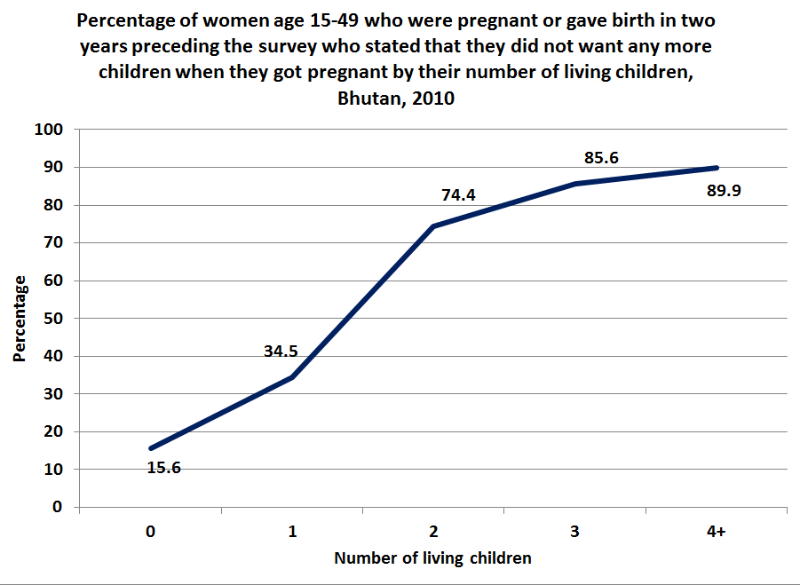

7.3 Family planning
Family planning services, antenatal care, postnatal care, immunization of children, and pregnant women are important components of the reproductive health service, which is an integral part of the primary healthcare system. The RGoB is committed to providing comprehensive quality maternal and child healthcare services, which is not limited to just family planning and promotion of institutional delivery.

BMIS 2010 data indicate that 66 percent of all married or in union women use some form of contraception. The most popular method is injectables, which are used by 29 percent of married women and women in union in Bhutan. Adolescents are far less likely to use contraception than older women. Only about 30 percent of married young women and those in union aged 15-19 currently use a method of contraception compared with 57 percent of 20-24 year olds and 71 percent of 40-44 year olds. As expected, married women with children are more likely to use contraception then women who have not had children.

7.3.1 Contraception
The use of contraception in Bhutan has been increasing over the past decade. Traditionally, Bhutan has calculated the Contraceptive Prevalence Rate (CPR) as the percentage of all women aged 15-49 who use some method of contraception, regardless of their marital status or whether they are sexually active. As Figure 29 below indicates, the CPR, under this definition, has climbed from 28 percent in 2003, as estimated by the Bhutan Living Standard Survey (BLSS), to approximately 48 percent in 2010, as estimated by the BMIS 2010.
The global definition, however, calculates the CPR for married or in union women only. This helps to partially eliminate women who have no need for contraception because they are not sexually active. Under this definition, contraception use has been increasing as well, albeit at a slower rate. The BMIS estimates a CPR for married women of 66 percent, which is an increase over the BLSS CPR estimate of 59 percent for married women in 2003. In a separate calculation not shown here, the CPR for unmarried, sexually active women in Bhutan is only 26 percent. This estimate is very low and should raise concern for policymakers who are interested in safeguarding women’s reproductive and sexual health. Along with unmarried women who are not sexually active, this figure contributes to the lower CPR for all women as shown in Figure 29.

Figure 29: Contraceptive Prevalence Rate (CPR) for all women aged 15-49 and for married women aged 15-49, Bhutan, 2003-2010
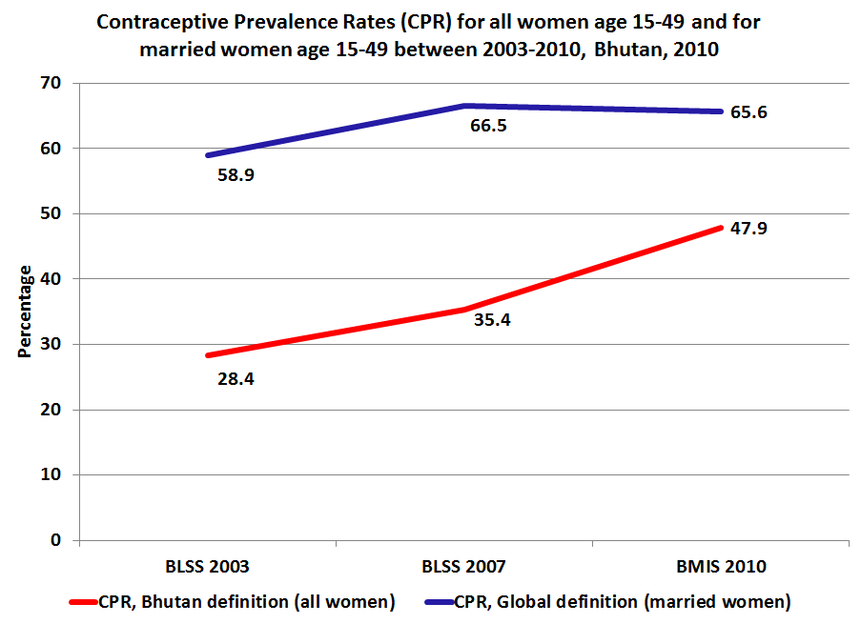

This analysis also assessed the percentage of married women aged 15-49 who use the male condom by their attitude toward domestic violence (as a potential proxy for intra-household bargaining power). As shown in Table 31 below, women who believe domestic violence is justified report a statistically lower use of the male condom than women who do not believe domestic violence is justified (7 percent versus 5 percent, respectively). This difference is most prominent among women with education and those from the richest households. Women in these groups report higher use of the male condom than women with no education and from poorer households regardless of whether they accept domestic violence.

Table 31: Percentage of women aged 15-49 years currently married or in union who are using (or whose partner is using) a contraceptive method, by women's attitude towards domestic violence, Bhutan, 2010
 |  | Does not accept domestic violence for the five specified reasons |  | Accepts domestic violence for any of five specified reasons
 |  | Uses male  condom  (percentage) | No. of women currently married or in union | Uses male  condom  (percentage) | No. of women currently married or in union
Area | Urban | 12.9 | 1,153 | 10 | 1,833
Area | Rural | 3.9 | 2,004 | 2.8 | 5,039
Age | 15-19 | 4.4 | 75 | 2.1 | 236
Age | 20-24 | 4.7 | 446 | 6.5 | 1,122
Age | 25-29 | 11.5 | 786 | 7 | 1,472
Age | 30-34 | 6.4 | 601 | 5.1 | 1,322
Age | 35-39 | 10.5 | 527 | 3.5 | 1,122
Age | 40-44 | 2.6 | 424 | 3.2 | 939
Age | 45-49 | 2 | 299 | 1.3 | 658
Education | None | 3.5 | 2,082 | 2.6 | 5,004
Education | Primary | 8.2 | 341 | 4.7 | 823
Education | Secondary + | 17.2 | 734 | 15 | 1,044
Wealth index quintiles | Poorest | 0.9 | 561 | 1.4 | 1,294
Wealth index quintiles | Second | 1.2 | 509 | 1.7 | 1,380
Wealth index quintiles | Middle | 4.3 | 535 | 3.3 | 1,402
Wealth index quintiles | Fourth | 8 | 642 | 5.2 | 1,547
Wealth index quintiles | Richest | 15.5 | 912 | 12.8 | 1,248
Number of living children | 0 | 5.1 | 270 | 7.1 | 566
Number of living children | 1 | 11.9 | 575 | 6.7 | 1,293
Number of living children | 2 | 8.4 | 880 | 5.9 | 1,760
Number of living children | 3 | 5.3 | 679 | 3.7 | 1,521
Number of living children | 4+ | 4.4 | 754 | 2.3 | 1,731
Total |  | 7.2 | 3,158 | 4.8 | 6,871

While not shown here, a separate analysis shows that 11 percent of married women, who have comprehensive knowledge of HIV transmission, report on using the male condom as a preferred choice of contraception, compared with only 5 percent of women who do not have comprehensive knowledge of HIV.

7.3.1.1 Contraceptive prevalence and early marriage

Table 32 below shows that 72 percent of currently married (or in union) women aged 20-49 who married before age 18 use any method of contraception compared with 64 percent of women who married at or after age 18, a difference which is statistically significant. This disparity in use of contraception by age of marriage is most significant among women from urban areas, with secondary level education, and in the age group 20-29.
Irrespective of age at first marriage, women who have no living children exhibit the lowest contraceptive prevalence rate. 8 percent of women married before age 18 and 14 percent of women married at or after age 18 use contraception. The use of contraception more than quadruples for women who have one living child (51 percent and 57 percent, respectively). The highest rates of contraceptive use are reported by women in their thirties and those who have at least two living children.

Table 32: Percentage of women aged 20-49 currently married or in union who were who are using (or whose partner is using) a contraceptive method by their early marriage status, Bhutan, 2010
 |  | Contraception prevalence rate among married women aged 20-49 who were:
 |  | Married before age 18 |  |  |  |  | Married at or after age 18
 |  | No method  (percentage) | Any modern method  (percentage) | Any method  (percentage) | Number of married women 20-49 | No method  (percentage) |  | Any modern method  (percentage) | Any method  (percentage) | Number of married women 20-49
Area | Urban | 28.5 | 71.3 | 71.5 | 895 | 38.9 |  | 60.6 | 61.1 | 2,050
Area | Rural | 28.3 | 71.7 | 71.7 | 2,491 | 34.5 |  | 65.3 | 65.5 | 4,282
 | 20-24 | 32.8 | 67 | 67.2 | 608 | 50.2 |  | 49.7 | 49.8 | 959
 | 25-29 | 26.3 | 73.6 | 73.7 | 719 | 42.3 |  | 57.3 | 57.7 | 1,538
 | 30-34 | 23.6 | 76.4 | 76.4 | 663 | 28 |  | 71.7 | 72 | 1,260
 | 35-39 | 26.3 | 73.7 | 73.7 | 626 | 24.3 |  | 75.4 | 75.7 | 1,024
 | 40-44 | 27.2 | 72.8 | 72.8 | 489 | 30.1 |  | 69.4 | 69.9 | 874
 | 45-49 | 41.3 | 58.7 | 58.7 | 281 | 40.7 |  | 58.7 | 59.3 | 676
Education | None | 28 | 71.9 | 72 | 2,740 | 33.6 |  | 66.1 | 66.4 | 4,153
Education | Primary | 31.5 | 68.4 | 68.5 | 466 | 32.6 |  | 66.9 | 67.4 | 643
Education | Secondary | 24.2 | 75.8 | 75.8 | 180 | 43.4 |  | 56.1 | 56.6 | 1,536
Wealth index quintiles | Poorest | 24.8 | 75.2 | 75.2 | 742 | 33.4 |  | 66.3 | 66.6 | 1,033
Wealth index quintiles | Second | 28.2 | 71.8 | 71.8 | 700 | 34.4 |  | 65.5 | 65.6 | 1,093
Wealth index quintiles | Middle | 26.5 | 73.5 | 73.5 | 669 | 36.6 |  | 62.8 | 63.4 | 1,184
Wealth index quintiles | Fourth | 32 | 67.9 | 68 | 744 | 33.9 |  | 65.8 | 66.1 | 1,410
Number of living children | 0 | 91.4 | 8.6 | 8.6 | 67 | 85.9 |  | 13.9 | 14.1 | 608
Number of living children | 1 | 49 | 51 | 51 | 361 | 42.9 |  | 56.8 | 57.1 | 1,371
Number of living children | 2 | 24.5 | 75.3 | 75.5 | 931 | 28.7 |  | 71 | 71.3 | 1,696
Number of living children | 3 | 22.4 | 77.5 | 77.6 | 890 | 24.4 |  | 75.2 | 75.6 | 1,309
Number of living children | 4+ | 25.8 | 74.2 | 74.2 | 1,137 | 26.4 |  | 73.1 | 73.6 | 1,349
 | Richest | 30.6 | 69 | 69.4 | 531 | 39.7 |  | 59.9 | 60.3 | 1,611
Total |  | 28.3 | 71.6 | 71.7 | 3,386 | 35.9 |  | 63.8 | 64.1 | 6,332

Figure 30 below illustrates the significant gap in contraceptive use among younger women by their age of marriage. The graph shows a significant 17 percentage point gap in the use of contraception among 20-24 year-old women by whether they were married before or after age 18. This gap dissipates to a statistically insignificant difference by age 35.

Figure 30: Percentage of women aged 20-49 currently married or in union who are using (or whose partner is using) any contraceptive method by their early marriage status, Bhutan, 2010
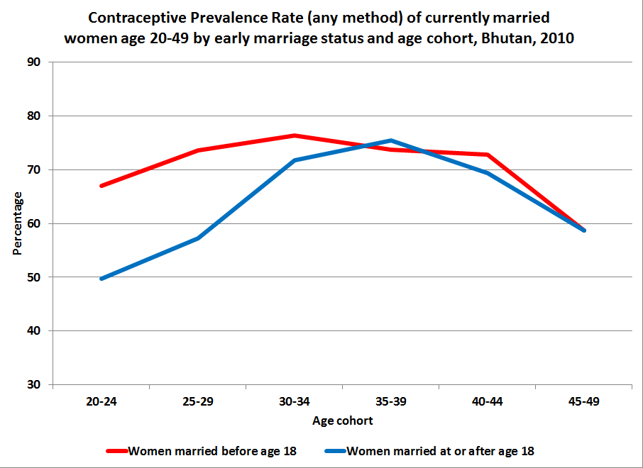

The key explanation behind these data can be seen in Figure 31 below, which shows the contraceptive prevalence rate of currently married women by age of marriage, controlling for the number of living children they have. As can be seen clearly, given the equivalent number of living children, married women use contraception at the same rate regardless of their age at first marriage.
The reason younger women who married at or after age 18 use contraception at a lower rate than their peers who married early is because they have less children on average. Women aged 20-49 married before age 18 have had, on average, 3.4 children ever born compared with women married at or after age 18 who have had, on average, 2.6 children ever born. Overall, 65 percent of women in the sample married at or after age 18. However, 90 percent of women aged 20-49 with no living children, and 79 percent of women with one living child first married at or after age 18. These data show that contraceptive prevalence among women aged 20-49 is primarily a function of the number of living children a woman has, rather than a function of their age at first marriage. These data do not provide support for the hypothesis that those women who marry early have a lower rate of contraceptive use due to lack of information, access, or intra-household bargaining power.

Figure 31: Percentage of women aged 20-49 currently married or in union who are using (or whose partner is using) any contraceptive method by their number of living children, Bhutan, 2010
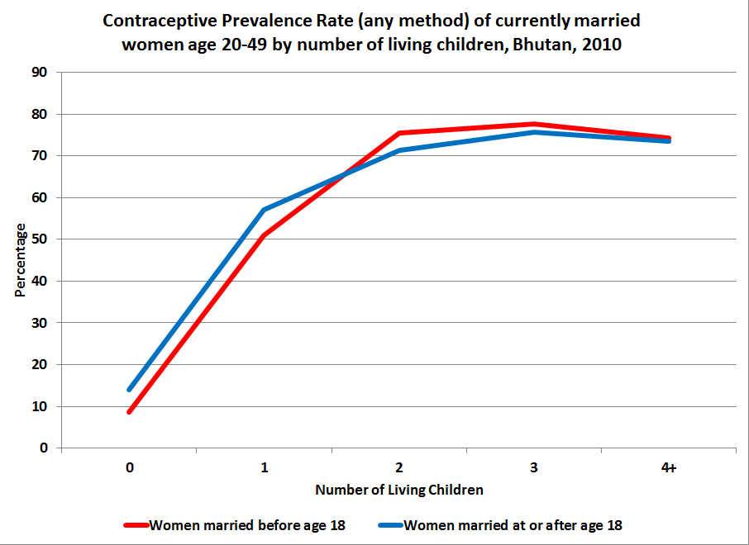

7.3.2 Contraceptive prevalence and literacy
Women with a higher level of education consistently exhibit better reproductive health outcomes than women with little to no formal education. In addition to acquiring data on women’s educational attainment, the BMIS 2010 assessed the literacy of women on their achievement of secondary level education and for women with no or only primary level education, on their ability to read a simple sentence.
This analysis assesses the percentage of currently married (or in union) women aged 15-49 who use any method of contraception, and more specifically a male condom, by their literacy status. As with Table 32 above, Table 33 below shows that both literate and non-literate women report the same level of overall contraceptive use after controlling for the number of living children. However, the choice of contraceptive method differs by women’s literacy status.
Literate women are nearly five times as likely to use a male condom than women who are not literate (14 percent versus 3 percent). Literate women are considerably more likely to be younger, urban, and from the wealthier quintiles of households. These are the same groups of women who have a higher level of comprehensive knowledge of HIV. It may be that literate women are choosing male condoms as their preferred choice of contraception, in part, because of their higher rate of knowledge about the transmission modes of HIV.
Table 32 also suggests that the disparity in preference for male condoms by women’s literacy status is highest among women from urban areas and those from wealthier households. This may suggest that some women who live in rural or remote areas or who are from poorer households, who would otherwise chose a male condom as the preferred choice for contraception, may not, because of lack of access. The data in Table 33 also show a disproportionately high disparity in use of a male condom by women’s literacy status among those who have one or two living children. This could be because literate women with this family size are more likely to use a male condom as a limiting or spacing method in family planning than non-literate women who have, on average, larger families.

Table 33: Percentage of women currently married or in union age 15-49 who are using a contraceptive method by their literacy status, Bhutan, 2010
 |  | Not Literate |  |  | Literate |  |  | Total number of women aged 15-49
 |  | male condom  (percentage) | any method  (percentage) | Total number of women aged 15-49 | male condom  (percentage) | any method  (percentage) | Total number of women aged 15-49 | Total number of women aged 15-49
Area | Urban | 6.4 | 67.9 | 1,663 | 17.1 | 59 | 1,324 | 2,986
Area | Rural | 2 | 67.9 | 5,985 | 9.9 | 57 | 1,058 | 7,043
Age | 15-19 | 2.3 | 29.8 | 215 | 3.6 | 31 | 97 | 312
Age | 20-24 | 2.5 | 59 | 980 | 11.9 | 52.4 | 588 | 1,568
Age | 25-29 | 3.4 | 66.2 | 1,463 | 18.2 | 56.5 | 795 | 2,257
Age | 30-34 | 3.2 | 75.1 | 1,462 | 12.9 | 68.6 | 461 | 1,923
Age | 35-39 | 3.7 | 75.9 | 1,409 | 18 | 68.8 | 241 | 1,650
Age | 40-44 | 2.7 | 72.4 | 1,215 | 5.3 | 59.2 | 148 | 1,363
Age | 45-49 | 1.4 | 59.5 | 904 | [3.3] | [52.6] | 53 | 957
Education | None | 2.8 | 67.8 | 6,870 | 6.3 | 56.1 | 216 | 7,087
Education | Primary | 4.2 | 68.7 | 777 | 8.7 | 61.2 | 387 | 1,165
Education | Secondary + | . | . | . | 15.9 | 57.7 | 1,778 | 1,778
Wealth index quintiles | Poorest | 1.1 | 69.5 | 1,773 | 4.5 | 59.4 | 82 | 1,855
Wealth index quintiles | Second | 1.4 | 67.3 | 1,744 | 3.6 | 44.9 | 144 | 1,888
Wealth index quintiles | Middle | 2.7 | 66.9 | 1,653 | 8.8 | 54.5 | 285 | 1,937
Wealth index quintiles | Fourth | 4.2 | 68.7 | 1,637 | 11.3 | 59.7 | 551 | 2,189
Wealth index quintiles | Richest | 7.9 | 66.4 | 840 | 17.7 | 59.6 | 1,320 | 2,160
Total |  | 2.9 | 67.9 | 7,648 | 13.9 | 58.1 | 2,382 | 10,029

7.3.3 Unmet need
Unmet need refers to women and couples who do not want another birth within the next two years, or ever, but are not using a method of contraception. Studies showed that unmet need results from growing demand, service delivery constraints, lack of support from communities and spouses, misinformation, financial costs, and transportation restrictions.
The BMIS 2010 indicates that 12 percent of women in Bhutan report an unmet need for contraception. Total unmet need for contraception is simply the sum of unmet need for spacing and unmet need for limiting. Spacing is creating an interval of desired length between consecutive births, limiting is the preventing of any further pregnancies. Unmet need is higher for younger age 15-19 (27 percent) than for women aged 45-49 (7 percent). Unmet need is slightly higher for limiting (7 percent) than for spacing (5 percent).
However, further analysis was done to assess the unmet need for contraception among married women aged 15-49 years against their knowledge of mother-to-child transmission of HIV and their attitudes towards domestic violence. No significant difference was found. Very little difference exists in the prevalence of unmet need for contraception among women aged 20-49 years between those who married before and after 18 years of age (see Table 34 below). No significant differences were found either between women who received post-natal care and those that received no care.

Table 34: Prevalence of unmet need for contraception among women aged 20-49, as a function of their early marriage, Bhutan, 2010
 |  | Percentage of currently married women aged 20-49 having an unmet need for contraception, who: |  |  |  | Total number of women aged 20-49
 |  | married after age 18 |  | married before age 18 |  | Total number of women aged 20-49
 |  | percentage | Total number of women aged 20-49 | percentage | Total number of women aged 20-49 | Total number of women aged 20-49
Area | Urban | 11.0 | 2,050 | 8.3 | 895 | 2,945
Area | Rural | 12.4 | 4,282 | 10.2 | 2,491 | 6,773
Age group | 20-24 | 19.9 | 959 | 11.5 | 608 | 1,568
Age group | 25-29 | 15.9 | 1,538 | 10.6 | 719 | 2,257
Age group | 30-39 | 9.7 | 2,284 | 9.7 | 1,288 | 3,573
Age group | 40-49 | 6.6 | 1,550 | 7.4 | 770 | 2,320
Education | None | 10.6 | 4,153 | 9.3 | 2,740 | 6,893
Education | Primary | 11.9 | 643 | 13.1 | 466 | 1,109
Education | Secondary + | 15.8 | 1,536 | 6.7 | 180 | 1,715
Wealth index quintiles | Poorest | 11.8 | 1,033 | 9.2 | 741 | 1,774
Wealth index quintiles | Second | 13.2 | 1,093 | 8.9 | 700 | 1,792
Wealth index quintiles | Middle | 12.9 | 1,184 | 10.4 | 669 | 1,854
Wealth index quintiles | Fourth | 10.4 | 1,410 | 10.0 | 744 | 2,155
Wealth index quintiles | Richest | 11.9 | 1,611 | 10.3 | 531 | 2,143
Total |  | 12.0 | 6,332 | 9.7 | 3,386 | 9,718

This analysis considers unmet need for contraception among married women aged 15-49 by literacy status to examine the relationship between literacy and the decision of women to use contraception.
Unmet need for contraception among married women aged 15-49 is higher among literate women (15 percent) than among the illiterate women (11 percent). Among rural women unmet need is higher than among urban women. The difference in unmet need between rural and urban women is more pronounced among literate women (18 percent versus 13 percent, respectively) than among non-literate women (11 percent versus 8 percent, respectively). This could be attributed to factors like opposition to contraception use, lack of knowledge of either method or its source, method related reasons, side effects, health concerns, difficulty in obtaining contraceptives, etc.
Girls and young women aged 15-19 years have a higher unmet need (27 percent for illiterate and 20 percent for literate women) than women aged 45-49 years (around 7 percent for both literate and illiterate women). Furthermore, though not shown here, the data indicate that 31 percent of married female youth aged 15-18 years have an unmet need for contraception, which can result in early child bearing, with consequent risks for the health of both mother and child.

Table 35: Unmet need for contraception among married women aged 15-49 by literacy status, Bhutan, 2010

 |  | Not Literate |  | Literate |  | Total number of women aged 15-49
 |  | Percentage with unmet need | Total number of women aged 15-49 | Percentage with unmet need | Total number of women aged 15-49 | Total number of women aged 15-49
Area | Urban | 8.3 | 1,663 | 12.9 | 1,324 | 2,986
Area | Rural | 11.2 | 5,985 | 18.4 | 1,058 | 7,043
Age | 15-19 | 26.8 | 215 | 28.9 | 97 | 312
Age | 20-24 | 14.9 | 980 | 19.4 | 588 | 1,568
Age | 25-29 | 12.9 | 1,463 | 16.5 | 795 | 2,257
Age | 30-34 | 9.7 | 1,462 | 12.1 | 461 | 1,923
Age | 35-39 | 8.9 | 1,409 | 9.6 | 241 | 1,650
Age | 40-44 | 7.2 | 1,215 | 6.4 | 148 | 1,363
Age | 45-49 | 6.4 | 904 | 7.3 | 53 | 957
Education | None | 10.4 | 6,870 | 16.6 | 216 | 7,087
Education | Primary | 12.0 | 777 | 15.1 | 387 | 1,165
Education | Secondary + | . | - | 15.2 | 1,778 | 1,778
Wealth index quintiles | Poorest | 10.9 | 1,773 | 14.6 | 82 | 1,855
Wealth index quintiles | Second | 11.1 | 1,744 | 28.8 | 144 | 1,888
Wealth index quintiles | Middle | 12.1 | 1,653 | 19.2 | 285 | 1,937
Wealth index quintiles | Fourth | 9.7 | 1,637 | 12.2 | 551 | 2,189
Wealth index quintiles | Richest | 7.1 | 840 | 14.4 | 1,320 | 2,160
Total |  | 10.5 | 7,648 | 15.3 | 2,382 | 10,029

7.4 Safe motherhood
Every pregnancy faces risk and it is important that pregnant women understand all the risks associated with their pregnancy and childbirth. Appropriate care during pregnancy begins with comprehensive antenatal care. The World Health Organization and UNICEF recommend a minimum of at least four visits during the course of a woman’s pregnancy. The number of antenatal care visits and the quality of services a pregnant woman avails will be indicative of whether she will seek skilled birth assistance, deliver safely in a hospital or clinic, or whether she is likely to seek postnatal care for herself and her child. The number of ANC visits also impacts the nutritional status of their newborns. This analysis will show that the likelihood of a newborn having low birth weight decreases with an increase in the number of ANC visits.
The Ministry of Health has responded to this global body of evidence by initiating a policy to increase the number of recommended level of antenatal care to eight or more visits. The data presented in this section provide further evidence that comprehensive antenatal care as measured by the number of visits contributes powerfully to reduced risks during pregnancy and to the health of both mother and child.

7.4.1 Antenatal care
Comprehensive Antenatal Care (ANC) represents a critical intervention that aims to protect and promote the health of women and their newborns. Table 36 below shows the distribution of the number of ANC visits received by women who gave birth in the two years preceding the survey. It shows that Bhutan has achieved near universal coverage (98 percent) of at least one visit to a skilled ANC provider.
However, only 77 percent of women receive the four or more ANC visits recommended by the WHO. Women from rural areas, the poorest households, and those with no formal education receive a statistically significant lower number of antenatal care visits than their counterparts from the richest households, urban areas, or with secondary level education. The disparities in the level of antenatal care are practically significant as well as evidenced by the 28 percentage point gap in four or more ANC visits between the richest women (92 percent) and the poorest women (64 percent). Substantial geographical disparities are evident as well, with 95 percent of women from Sarpang reporting four or more ANC visits compared to 58 percent of women from Zhemgang. The data also show that women under the age of 20 and age 35-49 are also statistically less likely to receive four or more ANC visits than women of prime childbearing age.
Recently, the Ministry of Health revised upward its recommended number of ANC visits from four or more to eight or more. For this reason, Table 35 shows the percentage of women who received at least eight antenatal care visits by any provider. The table shows that 13 percent of women have received at least eight ANC visits. Women from the richest households, urban areas, or with secondary level education are most likely to reach this new threshold. Indeed, women from the richest households are nearly four times as likely to have eight or more ANC visits than women from the poorest households.
Finally, it should be noted that 2.5 percent of women aged 15-49 years who had a live birth during the two years preceding the survey did not receive any antenatal care at all. These women come from overwhelmingly poor households, the poorest dzongkhags, and rural areas. They have no formal education and/or are older mothers of the age 35-49 years. Together, these data indicate that the Ministry of Health must urgently prioritize the needs of women from marginalized groups to increase the quantity and quality of antenatal care for all women in Bhutan.

Table 36: Distribution of the number of antenatal care visits received by women who gave birth during the two years preceding the survey, Bhutan, 2010
 |  | Percentage of women who had: |  |  |  |  |  |  |  |  | At least once | At least 4 times | At least 8 times | No. of women
 |  | No ANC visits | 1 visit | 2 visits | 3 visits | 4 visits | 5 visits | 6 visits | 7 visits | 8 or more visits
Dzongkhag | Bumthang | 2.5 | 3.2 | 4.9 | 16.9 | 18.7 | 21.0 | 12.6 | 9.9 | 10.2 | 97.5 | 72.4 | 10.2 | 69
Dzongkhag | Chukha | 2.0 | 2.4 | 3.3 | 8.1 | 11.7 | 13.5 | 19.0 | 15.1 | 25.0 | 98.0 | 84.2 | 25.0 | 223
Dzongkhag | Dagana | 2.3 | 4.0 | 5.3 | 16.9 | 23.3 | 24.3 | 12.3 | 6.6 | 4.3 | 97.7 | 70.7 | 4.3 | 100
Dzongkhag | Gasa | [10.8] | [7.0] | [7.7] | [8.3] | [14.2] | [7.3] | [8.6] | [3.3] | [22.2] | [89.2] | [55.6] | [22.2] | 28
Dzongkhag | Haa | 2.4 | 2.4 | 2.1 | 7.3 | 16.2 | 8.9 | 10.5 | 7.7 | 42.5 | 97.6 | 85.8 | 42.5 | 43
Dzongkhag | Lhuntse | 4.3 | 4.4 | 17.8 | 13.7 | 27.2 | 19.9 | 3.2 | 1.9 | 7.7 | 95.7 | 59.8 | 7.7 | 47
Dzongkhag | Mongar | 0.7 | 3.0 | 8.4 | 9.1 | 18.3 | 20.7 | 21.7 | 7.1 | 10.2 | 99.3 | 78.1 | 10.2 | 186
Dzongkhag | Paro | 1.1 | 3.4 | 6.2 | 11.9 | 22.9 | 21.9 | 12.9 | 4.4 | 13.8 | 98.9 | 75.9 | 13.8 | 146
Dzongkhag | P/gatshel | 13.0 | 2.0 | 4.0 | 9.3 | 26.7 | 13.5 | 20.8 | 3.7 | 5.7 | 87.0 | 70.4 | 5.7 | 94
Dzongkhag | Punakha | 1.6 | 2.2 | 6.2 | 12.9 | 26.4 | 17.1 | 20.7 | 7.4 | 5.4 | 98.4 | 77.1 | 5.4 | 100
Dzongkhag | S/jongkhar | 1.6 | 3.3 | 6.9 | 17.3 | 23.8 | 19.0 | 16.4 | 3.2 | 7.7 | 98.4 | 70.1 | 7.7 | 163
Dzongkhag | Samtse | 0.8 | 1.5 | 3.7 | 7.2 | 31.3 | 29.0 | 12.8 | 7.4 | 6.2 | 99.2 | 86.8 | 6.2 | 221
Dzongkhag | Sarpang | 0.0 | 0.3 | 0.0 | 4.9 | 18.1 | 25.6 | 18.7 | 6.7 | 25.8 | 100.0 | 94.9 | 25.8 | 132
Dzongkhag | Thimphu | 1.6 | 2.3 | 3.7 | 8.2 | 14.4 | 20.6 | 19.5 | 16.4 | 12.8 | 98.4 | 83.6 | 12.8 | 298
Dzongkhag | T/gang | 4.1 | 5.2 | 3.5 | 16.9 | 34.4 | 13.8 | 10.2 | 0.8 | 10.1 | 95.9 | 69.3 | 10.1 | 161
Dzongkhag | T/yangtse | 5.2 | 0.0 | 8.6 | 14.7 | 25.2 | 14.0 | 15.0 | 5.4 | 11.0 | 94.8 | 70.5 | 11.0 | 60
Dzongkhag | Trongsa | 1.4 | 3.6 | 4.0 | 17.8 | 23.0 | 15.5 | 20.6 | 5.6 | 8.4 | 98.6 | 73.2 | 8.4 | 50
Dzongkhag | Tsirang | 0.7 | 2.0 | 3.3 | 12.5 | 52.0 | 18.6 | 3.8 | 0.0 | 5.5 | 99.3 | 79.8 | 5.5 | 62
Dzongkhag | Wangdi | 0.7 | 2.5 | 8.9 | 14.2 | 21.0 | 21.5 | 16.1 | 1.5 | 12.6 | 99.3 | 72.6 | 12.6 | 103
Dzongkhag | Zhemgang | 7.6 | 4.5 | 9.4 | 20.4 | 12.2 | 13.7 | 12.4 | 6.5 | 13.4 | 92.4 | 58.2 | 13.4 | 82
Area | Urban | 0.7 | 2.2 | 2.6 | 6.7 | 16.5 | 20.1 | 19.3 | 12.6 | 18.6 | 99.3 | 87.1 | 18.6 | 690
Area | Rural | 3.2 | 3.0 | 6.3 | 13.5 | 24.6 | 19.0 | 14.3 | 5.3 | 10.1 | 96.8 | 73.3 | 10.1 | 1,678
Mother's age at birth | Less than 20 | 3.3 | 3.3 | 7.1 | 11.1 | 23.6 | 17.3 | 15.1 | 7.9 | 9.9 | 96.7 | 73.8 | 9.9 | 269
Mother's age at birth | 20-34 | 2.0 | 2.5 | 4.6 | 11.2 | 22.0 | 19.9 | 16.2 | 7.4 | 13.5 | 98.0 | 79.1 | 13.5 | 1,852
Mother's age at birth | 35-49 | 5.2 | 3.9 | 8.2 | 14.6 | 21.9 | 17.1 | 13.1 | 7.1 | 8.5 | 94.8 | 67.5 | 8.5 | 247
Education | None | 3.2 | 3.4 | 5.9 | 12.8 | 23.8 | 20.3 | 14.0 | 5.7 | 10.0 | 96.8 | 73.8 | 10.0 | 1,484
Education | Primary | 0.9 | 2.4 | 5.2 | 16.2 | 24.7 | 14.5 | 15.1 | 8.7 | 11.9 | 99.1 | 74.9 | 11.9 | 302
Education | Secondary + | 1.4 | 1.3 | 3.6 | 5.9 | 16.7 | 19.4 | 20.7 | 11.3 | 19.6 | 98.6 | 87.7 | 19.6 | 582
Wealth index quintiles | Poorest | 4.3 | 4.2 | 9.8 | 17.2 | 25.0 | 21.2 | 8.6 | 3.4 | 5.8 | 95.7 | 64.0 | 5.8 | 471
Wealth index quintiles | Second | 4.7 | 3.5 | 7.2 | 14.7 | 25.3 | 17.1 | 14.3 | 5.5 | 6.6 | 95.3 | 68.8 | 6.6 | 448
Wealth index quintiles | Middle | 2.0 | 2.1 | 3.8 | 13.5 | 21.9 | 21.6 | 16.4 | 5.2 | 12.7 | 98.0 | 77.8 | 12.7 | 475
Wealth index quintiles | Fourth | 0.8 | 2.4 | 4.1 | 8.3 | 22.0 | 19.8 | 19.1 | 7.4 | 15.4 | 99.2 | 83.7 | 15.4 | 518
Wealth index quintiles | Richest | 0.8 | 1.5 | 1.4 | 4.2 | 16.6 | 16.8 | 20.4 | 15.9 | 22.1 | 99.2 | 91.8 | 22.1 | 455
Total |  | 2.5 | 2.7 | 5.3 | 11.5 | 22.2 | 19.3 | 15.8 | 7.4 | 12.6 | 97.5 | 77.3 | 12.6 | 2,368

Figure 32 below presents data on the number of antenatal care visits received by women aged 15-49 by various benchmarks. It shows that while Bhutan has made tremendous strides in the level of ANC received, much work remains, to achieve the objective of having women obtain eight or more antenatal care visits. According to BMIS data, only one in eight women receives this recommended level of antenatal care.

Figure 32: Percentage of women who received antenatal care at least once, at least four times, and at least eight times, among women aged 15-49 who gave birth in the two years preceding the survey, Bhutan, 2010
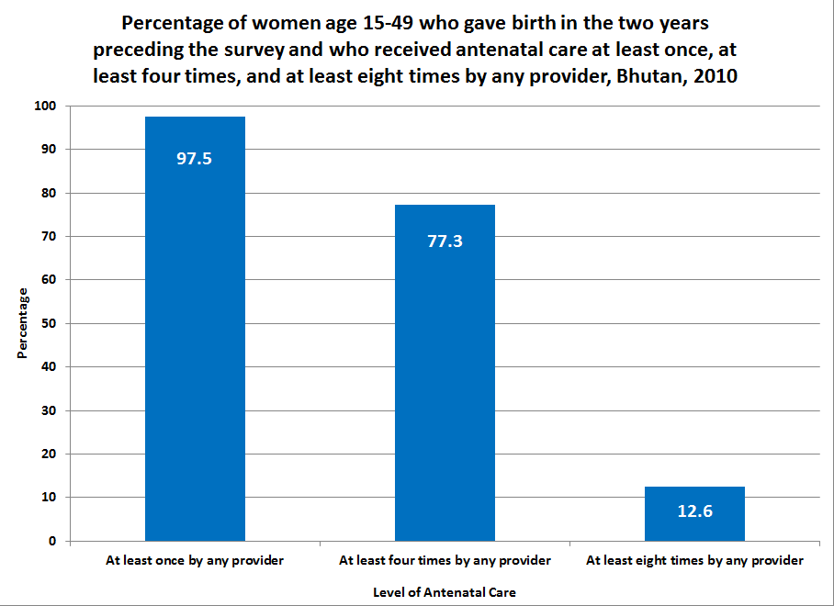

Figure 33 below provides a more disaggregated illustration of the data presented in Table 36 and Figure 32 above, showing the distribution of the number of ANC visits received by women aged 15-49 who gave birth in the two years preceding the survey. In addition to the 13 percent of women who receive eight or more antenatal care visits, another 23 percent receive 6-7 ANC visits and are on the cusp of reaching the new benchmark. These women are more likely to be from urban areas, have secondary level education, and hail from middle to upper segments of the wealth distribution. However, policymakers should not lose sight of the urgent need to reach those women who receive little to no antenatal care, the majority of whom come from the most deprived demographic groups.

Figure 33: Distribution of number of antenatal care visits among women who gave birth in the two years preceding the survey, Bhutan, 2010
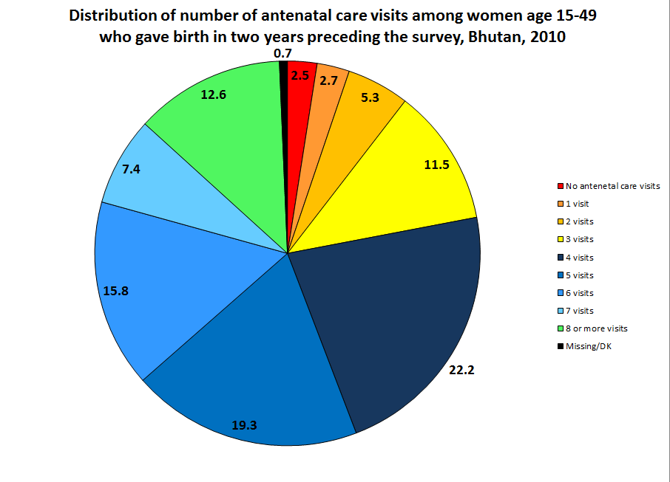

7.4.1.1 Antenatal care and skilled birth assistance
As stated above, antenatal care represents a crucial gateway to other reproductive health services. Skilled birth attendants (i.e. doctor, nurse/midwife, health assistant, and assistant clinical officer) have a higher level of training and expertise to help manage and refer pregnancy complications more effectively than non-skilled birth attendants. Ensuring skilled birth assistance is widely seen as the single most critical intervention for reducing both maternal and newborn mortality.
BMIS data indicate that 65 percent of women who gave birth in the two years preceding the survey received skilled birth assistance. Table 36 below analyses the data further to test the percentage of women who receive skilled birth assistance by the level of antenatal care received. Indeed, the data show a statistically significant and strong positive correlation between the level of antenatal care received and the percentage of women who receive skilled birth assistance. 47 percent of women who receive less than the recommended four antenatal care visits receive SBA compared to 63 percent of women who receive 4-5 ANC visits. This figure climbs steadily to 80 percent for women with eight or more visits, making women with the highest level of antenatal care twice as likely to receive SBA than women with the least amount of antenatal care.
Irrespective of how much antenatal care a woman receives, there are tremendous disparities in the level of skilled birth assistance by area of residence, level of education, and household wealth. However, antenatal care appears to help mitigate these disparities, as the marginal effect of antenatal care on the likelihood of receiving SBA is much higher for women from these deprived demographic groups. For example, the 41 percentage point urban-rural gap in skilled birth assistance for women who receive less than four ANC visits falls to 18 points for women with eight or more ANC visits. A similar closing of the inequity also occurs by education level and household wealth.
Given this strong evidence of the positive effect of antenatal care on skilled birth assistance alongside the fact that women from the poorest households, rural areas, and with no education exhibit the lowest uptake of antenatal care, policymakers should strongly focus on reaching these populations with safe motherhood programmes designed to improve the well-being of women and children in Bhutan, and to achieve MDG goals.

Table 37: Percentage of women who received skilled birth attendance by the number of antenatal care visits received, among women aged 15-49 who gave birth in the two years preceding the survey, Bhutan, 2010
 |  | Percentage receiving skilled birth assistance among mothers who received antenatal care: |  |  |  |  |  |  |  | Total number of women who gave birth in the past 2 years
 |  | 0-3 times |  | 4-5 times |  | 6-7 times |  | 8+ times |  | Total number of women who gave birth in the past 2 years
 |  | % of births with skilled birth assistance | No. of women who gave birth in the past 2 years | % of births with skilled birth assistance | No. of women who gave birth in the past 2 years | % of births with skilled birth assistance | No. of women who gave birth in the past 2 years | % of births with skilled birth assistance | No. of women who gave birth in the past 2 years | Total number of women who gave birth in the past 2 years
Area | Urban | 81.3 | 82 | 88.3 | 253 | 93.6 | 221 | 90.6 | 128 | 690
Area | Rural | 40.2 | 394 | 53.7 | 728 | 69.4 | 329 | 72.9 | 170 | 1,678
Education | None | 41.1 | 340 | 52.1 | 652 | 68.8 | 292 | 72.5 | 148 | 1,484
Education | Primary | 45.2 | 73 | 63.6 | 117 | 82.9 | 72 | [58.4] | 36 | 302
Education | Secondary | 83.6 | 63 | 94.7 | 210 | 93.7 | 186 | 97.9 | 114 | 582
Wealth index quintiles | Poorest | 25.6 | 149 | 38.6 | 218 | 49.5 | 57 | [36.2] | 27 | 471
Wealth index quintiles | Second | 33.2 | 118 | 45.1 | 189 | 52.6 | 89 | [68.3] | 30 | 448
Wealth index quintiles | Middle | 62.3 | 96 | 62.3 | 204 | 83.6 | 103 | 71.1 | 61 | 475
Wealth index quintiles | Fourth | 71.2 | 80 | 80.7 | 217 | 84.4 | 137 | 86.6 | 80 | 518
Wealth index quintiles | Richest | [95.5] | 32 | 93.5 | 152 | 96.2 | 165 | 97.1 | 101 | 455
Total |  | 47.3 | 476 | 62.6 | 980 | 79.1 | 550 | 80.5 | 298 | 2,368

7.4.1.2 Antenatal care and institutional delivery
Increasing the number of women to deliver in an institution ensures proper medical attention and hygienic conditions during delivery. This helps reduce the risks of complications and infections that can cause morbidity and mortality to either the mother or the baby. BMIS data indicate that 63 percent of women who gave birth in the two years preceding the survey delivered their child in a health facility against the Ministry of Health goal of 100 percent institutional delivery for all women. This means that more than 1 in 3 births in Bhutan still occurs at home, putting the health and lives of women and children at increased risk.
As with skilled birth assistance, this analysis tested the relationship between the level of antenatal care and institutional delivery. Again, the data indicate a strongly positive, statistically significant correlation between antenatal care and delivery in a health facility. For women with less than four ANC visits, 45 percent delivered in an institution as compared with 60 percent institutional delivery for women with 4-5 ANC visits. And as with skilled birth assistance, this figure further increased to 82 percent for women who received eight or more ANC visits.
Naturally, skilled birth assistance and institutional delivery are highly correlated so the parallel relationship between ANC and these two indicators should not come as a surprise. Likewise, it should be expected that, regardless of the amount of antenatal care received, the data show that the poorest women, those in rural areas, and those with no formal education are least likely to deliver in a health facility. For example, women with no education are more than twice as likely to deliver their child at home than women with secondary level education.
Again, the higher rate of institutional delivery associated with the greater number of antenatal care visits is largely driven by these same groups of women. For example, the 43 percentage point gap in institutional delivery by level of education for women with the least amount of antenatal care gets cut by nearly 40 percent to 27 points among women with the highest level of antenatal care. These data provide further evidence that a strong programmatic focus on getting the most deprived women to increase the number of their antenatal care visits yields the highest marginal benefit in subsequent reproductive healthcare uptake. That the poorest women, those in rural and remote areas, and with no education are also least likely to receive the appropriate level of antenatal care only strengthens the argument that policymakers prioritize women from the most deprived backgrounds.

Table 38: Percentage of women who delivered in a health facility by the number of antenatal care visits received, among women aged 15-49 who gave birth in the two years preceding the survey, Bhutan, 2010
 |  | Percentage of women who delivered in a health facility who received antenatal care: |  |  |  |  |  |  |  | Total number of women who gave birth in the past 2 years
 |  | 0-3 times |  | 4-5 times |  | 6-7 times |  | 8+ times |  | Total number of women who gave birth in the past 2 years
 |  | % of births in a health facility | No. of women who gave birth in the past 2 years | % of births in a health facility | No. of women who gave birth in the past 2 years | % of births in a health facility | No. of women who gave birth in the past 2 years | % of births in a health facility | No. of women who gave birth in the past 2 years | Total number of women who gave birth in the past 2 years
Area | Urban | 81.3 | 82 | 88.2 | 253 | 93.6 | 221 | 91.5 | 128 | 690
Area | Rural | 37.3 | 394 | 50.7 | 728 | 68.5 | 329 | 74.1 | 170 | 1,678
Education | None | 38.7 | 340 | 49.2 | 652 | 68.3 | 292 | 71.8 | 148 | 1,484
Education | Primary | 42.1 | 73 | 63.1 | 117 | 82.3 | 72 | [66.9] | 36 | 302
Education | Secondary + | 81.6 | 63 | 93.4 | 210 | 93.3 | 186 | 98.9 | 114 | 582
Wealth index quintiles | Poorest | 22.8 | 149 | 36 | 218 | 53.2 | 57 | [47.3] | 27 | 471
Wealth index quintiles | Second | 31.7 | 118 | 41.4 | 189 | 49.8 | 89 | [68.3] | 30 | 448
Wealth index quintiles | Middle | 57.4 | 96 | 59.6 | 204 | 81.1 | 103 | 70.1 | 61 | 475
Wealth index quintiles | Fourth | 70.2 | 80 | 78.2 | 217 | 84.5 | 137 | 87.6 | 80 | 518
Wealth index quintiles | Richest | [95.5] | 32 | 94.6 | 152 | 96.2 | 165 | 97.1 | 101 | 455
Total |  | 44.9 | 476 | 60.4 | 980 | 78.6 | 550 | 81.6 | 298 | 2,368

Figure 34 below provides a visual summary of the data presented above in Tables 37 and 38, showing the strongly positive relationship between antenatal care, skilled birth assistance, and institutional delivery. An increase from less than four ANC visits to more than eight ANC visits almost doubles the likelihood that a woman will receive skilled birth assistance and/or institutional delivery. The gains appear to level off somewhat after a woman receives at least 6-7 ANC visits.
As noted, skilled birth assistance and institutional delivery are almost perfectly correlated. In terms of process, the likely relationship among these indicators is that antenatal care increases the likelihood of institutional delivery, which in turn increases the likelihood of skilled birth assistance at an almost equal rate. The takeaway point is that antenatal care provides the critical entry point for women to take up other reproductive health services, particularly women from the most marginalised backgrounds.

Figure 34: Percentage of women who received skilled birth assistance and who delivered in a health facility by the number of antenatal care visits received, among women aged 15-49 who gave birth in the two years preceding the survey, Bhutan, 2010
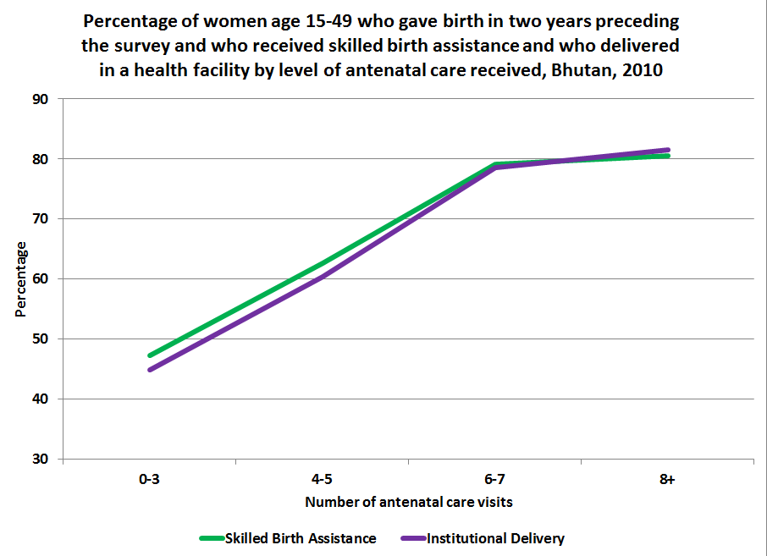

Turning now to women who do not give birth in a health facility, Map 3 below shows the percentage of women who give birth at home by dzongkhag. It shows that the highest rates of home delivery occur primarily in southern and eastern dzongkhags, most notably in Trashigang and Zhemgang where nearly two-thirds of women give birth at home (64 and 63 percent, respectively). These figures are ten times as high as the 6 percent home delivery rate in Thimphu dzongkhag. Given the positive relationship between antenatal care and institutional delivery, ANC outreach should place a special focus on those dzongkhags with the highest rates of home delivery, which also happen to be the dzongkhags with the lowest levels of antenatal care uptake.

Map 3: Percentage of women who gave birth in the two years preceding the survey who delivered the child at their or another’s home by dzongkhag, Bhutan, 2010
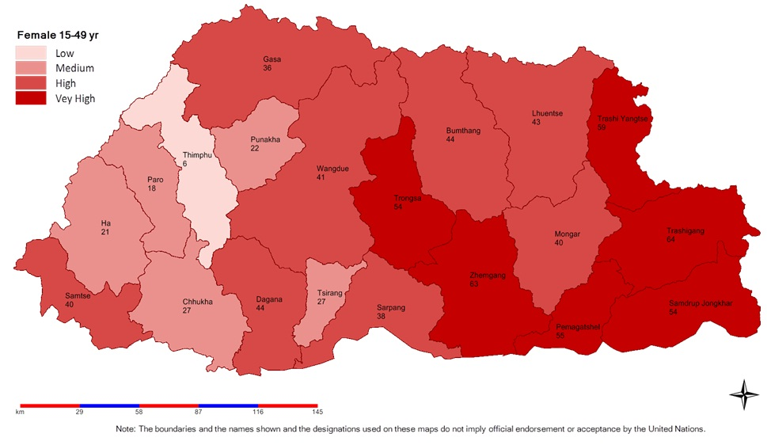

Table 39 below assesses the number of ANC visits received by women by whether they deliver at home or in a health facility. The data show that women who deliver at home are more than twice as likely to receive less than the recommended four ANC visits as women with institutional delivery (31 percent versus 14 percent, respectively). Conversely, women who deliver at home are only 40 percent as likely to receive eight or more ANC visits as women with institutional delivery (7 percent versus 17 percent, respectively). Even among women who deliver at home, there are disparities. Women from the poorest households and in rural areas who deliver at home receive a statistically lower number of ANC visits than women from wealthier households and in urban areas who deliver at home, indicating that increased wealth and access to health facilities can contribute to a somewhat higher level of antenatal care, which may help mitigate some risks associated with home delivery.

Table 39: Percentage of antenatal care visits among women aged 15-49 who gave birth during the two years preceding the survey by place of delivery, Bhutan, 2010
 |  | Women who did not deliver in health facility |  |  |  |  |  | Women who delivered in health facility |  |  |  |  |  | Number of women who gave birth in the last 2 years
 |  | Number of antenatal care visits |  |  |  | Total | Number of women who gave birth in the last 2 years | Number of antenatal care visits |  |  |  | Total | Number of women who gave birth in the last 2 years | Number of women who gave birth in the last 2 years
 |  | 0-3 times | 4-5 times | 6-7 times | 8+ times | Total | Number of women who gave birth in the last 2 years | 0-3 times | 4-5 times | 6-7 times | 8+ times | Total | Number of women who gave birth in the last 2 years | Number of women who gave birth in the last 2 years
Area | Urban | 19.8 | 43.5 | 20.7 | 15.9 | 100 | 71 | 10.6 | 36.4 | 33.8 | 19.2 | 100 | 620 | 690
Area | Rural | 32.4 | 47.9 | 13.8 | 5.9 | 100 | 803 | 16.3 | 42.9 | 26.2 | 14.6 | 100 | 875 | 1,678
Education | None | 30.4 | 49.5 | 13.9 | 6.2 | 100 | 719 | 16.4 | 42.8 | 26.6 | 14.1 | 100 | 764 | 1,484
Education | Primary | 37.6 | 39.8 | 11.7 | 10.9 | 100 | 114 | 16.4 | 39.4 | 31.5 | 12.7 | 100 | 188 | 302
Education | Secondary + | 29.4 | 35.5 | 31.9 | 3.1 | 100 | 40 | 9.6 | 36.8 | 32.5 | 21.2 | 100 | 542 | 582
Wealth index quintiles | Poorest | 38.6 | 47.5 | 9 | 4.9 | 100 | 315 | 21.7 | 50.6 | 19.4 | 8.3 | 100 | 156 | 471
Wealth index quintiles | Second | 32.2 | 45.7 | 18.3 | 3.9 | 100 | 265 | 19.8 | 44 | 24.9 | 11.3 | 100 | 183 | 448
Wealth index quintiles | Middle | 25.4 | 51.2 | 12.1 | 11.3 | 100 | 169 | 17.2 | 40.8 | 27.8 | 14.2 | 100 | 306 | 475
Wealth index quintiles | Fourth | 22 | 47 | 21.1 | 9.9 | 100 | 104 | 13.3 | 41.4 | 28.3 | 17.1 | 100 | 414 | 518
Wealth index quintiles | Richest | 7.7 | 43.3 | 33.2 | 15.7 | 100 | 19 | 7.1 | 33.4 | 36.9 | 22.7 | 100 | 436 | 455
Total |  | 31.3 | 47.5 | 14.4 | 6.7 | 100 | 873 | 13.9 | 40.2 | 29.4 | 16.50 | 100 | 1,495 | 2,368

Figure 35 below illustrates the difference in the level of antenatal care received by women by whether they deliver at home or in an institution, as presented in Table 38 above. The positive relationship between a higher number of ANC visits and institutional delivery can be seen in the imbalance in antenatal care between the two groups.

Figure 35: Number of antenatal care visits among women aged 15-49 who gave birth in the two years preceding the survey by place of delivery, Bhutan, 2010
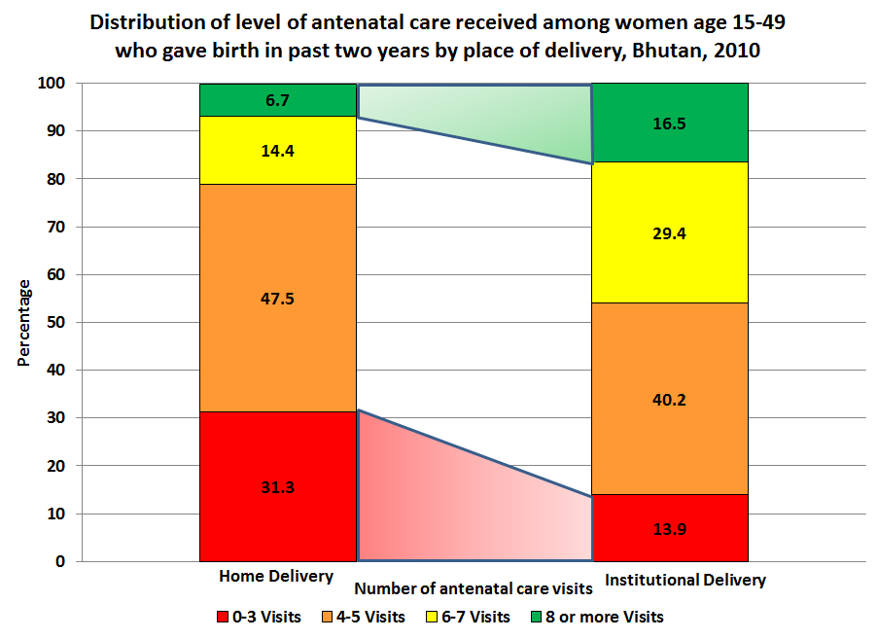

With regard to place of delivery, this report disaggregates institutional delivery to measure the proportion of deliveries that take place in hospitals versus BHUs. Of women who delivered in a health facility, 88 percent delivered in hospitals and 12 percent delivered in a BHU. Women from rural areas are more than three times as likely to deliver in BHUs than urban women (17 percent versus 5 percent, respectively). Women from the poorest households are nearly ten times as likely to deliver in a BHU than women from the richest households (33 percent versus 4 percent, respectively). Women under the age of 20 are nearly twice as likely to deliver in a BHU than women aged 20-34. As women who deliver in BHUs are disproportionately from disadvantaged demographic groups, policymakers should strengthen the quality of reproductive healthcare services provided in BHUs so that disparities in wealth and education are not exacerbated by inequality in care.

7.4.1.3 Antenatal care and comprehensive knowledge of HIV/AIDS
Counseling and the provision of information on the prevention of Sexually Transmitted Infections (STIs), HIV, and prevention of mother-to-child transmission (PMTCT) of HIV is an integral part of antenatal care in Bhutan as reflected in the National Midwifery Standard. To assess the association of antenatal care on the knowledge of HIV, this analysis tested PMTCT knowledge and comprehensive knowledge of HIV transmission by the level of antenatal care visits women received.
As shown in Table 40 below, there is no statistical difference in PMTCT knowledge between women who received four or more antenatal care visits and those who received less than four antenatal care visits (62 percent versus 58 percent, respectively). This may be due, in part, to the fact that only about half (54 percent) of pregnant women received HIV counselling during antenatal care, which is a required component of ANC services.
Table 40 shows a statistically significant, higher level of comprehensive knowledge of HIV among women who attended four or more antenatal care visits (21 percent), as compared to those who received less than four ANC visits (11 percent). However, given the absence of a significantly higher level of PMTCT knowledge among women with a higher level of antenatal care, which would ostensibly be the primary information about HIV communicated during ANC, the higher level of comprehensive knowledge is unlikely a function of increased antenatal care. Rather, women with a greater number of antenatal care visits are more likely to already have a higher level of comprehensive knowledge of HIV. Indeed, women who receive more ANC are considerably more likely to be younger, from urban areas, have secondary level education, and come from the richest quintile of households. These are the same demographic groups that demonstrate a significantly higher level of knowledge about HIV.
The key finding of these data is that increased antenatal care is not associated with a higher level of the HIV knowledge required to prevent mother-to-child transmission of the virus. The key programming implication is that, in addition to expanding uptake of the recommended level of ANC to all women, particularly those from the most deprived groups, the Ministry of Health must redouble its efforts to ensure that comprehensive HIV counselling is part of every woman’s antenatal care and that it focuses strongly on inculcating PMTCT knowledge.
More specifically, there is need for the MoH Reproductive Health Programme to actively collaborate with the National Aids Control Programme (NACP).

Table 40: Knowledge of Prevention of Mother-to-Child Transmission of HIV and comprehensive knowledge of HIV transmission by level of antenatal care received, among women aged 15-49 who gave birth in the two years preceding the survey, Bhutan, 2010
 |  | Women who did not receive antenatal care 4+ times, who: |  |  |  | Women who received antenatal care 4+ times, who: |  |  | Total number of women aged 15-49 who gave birth in past two years
 |  | Know three ways HIV can be transmitted from mother to child (PMTCT)  (percentage) | Have comprehensive knowledge of HIV  (percentage) | Number of women aged 15-49 who gave birth in past two years | Know three ways HIV can be transmitted from mother to child (PMTCT)  (percentage) |  | Have comprehensive knowledge of HIV  (percentage) | Number of women aged 15-49 who gave birth in past two years
Area | Urban | 65.0 | 22.5 | 84 | 65.8 |  | 34.5 | 601 | 690
Area | Rural | 56.9 | 8.6 | 394 | 59.8 |  | 14.0 | 1,230 | 1,678
Age | 15-19 | [70.9] | [7.9] | 30 | 51.5 |  | 14.7 | 106 | 140
Age | 20-24 | 58.2 | 11.8 | 142 | 62.9 |  | 19.7 | 561 | 718
Age | 25-29 | 65.4 | 15.3 | 140 | 63.4 |  | 25.4 | 623 | 781
Age | 30-34 | 50.3 | 7.0 | 91 | 59.5 |  | 20.7 | 329 | 427
Age | 35-39 | 48.2 | 5.8 | 46 | 64.1 |  | 13.9 | 153 | 209
Age | 40-44 | [58.3] | [15.7] | 20 | 53.0 |  | 4.4 | 48 | 72
Age | 45-49 | * | * | 9 | * |  | * | 11 | 21
Education | None | 53.7 | 7.7 | 341 | 57.9 |  | 11.9 | 1,095 | 1,484
Education | Primary | 60.3 | 15.4 | 73 | 61.7 |  | 17.2 | 226 | 302
Education | Secondary + | 80.7 | 23.7 | 64 | 70.0 |  | 41.3 | 511 | 582
Wealth index quintiles | Poorest | 43.5 | 4.5 | 149 | 54.0 |  | 4.3 | 302 | 471
Wealth index quintiles | Second | 62.6 | 12.2 | 119 | 60.4 |  | 8.7 | 309 | 448
Wealth index quintiles | Middle | 71.7 | 7.6 | 96 | 61.8 |  | 13.3 | 370 | 475
Wealth index quintiles | Fourth | 61.3 | 17.7 | 80 | 66.1 |  | 28.0 | 433 | 518
Wealth index quintiles | Richest | [63.9] | [29.3] | 34 | 63.7 |  | 40.5 | 418 | 455
Total |  | 58.3 | 11.0 | 478 | 61.7 |  | 20.7 | 1,831 | 2,368

7.4.1.4 Antenatal care and literacy
Literacy is an important determinant to acquiring the knowledge necessary to practise good behaviour and safeguard one’s health. For this reason, this analysis tests the relationship between literacy and the number of antenatal care visits received by women. Table 41 below shows a slight but statistically significant difference in the percentage of women who received at least one antenatal care visit between those who are literate (99 percent) and those who are not literate (97 percent). The observed gap in antenatal care by literacy status is most pronounced among women from rural areas and from the poorest two wealth quintiles, suggesting a disproportionately positive effect of literacy on antenatal care uptake for women from these demographic backgrounds.
The narrow differences noted above are largely a corollary function of Bhutan’s success in achieving near-universal coverage of at least one ANC visit for pregnant women with no single demographic group falling below 94 percent uptake. With respect to the recommended four or more ANC visits however, significant disparities by literacy status begin to emerge. 86 percent of literate women received four or more ANC visits compared with 74 percent of women who are not literate, a difference, which is highly statistically significant. As with the previous indicator, these observed differences are more pronounced among women from rural areas, from the poorer wealth quintiles and those with no formal education.
Overall, these data suggest that, when controlling for single demographic characteristics, literacy is associated with a higher level of antenatal care uptake, particularly in the case of four or more visits.

Table 41: Antenatal care by literacy status, among women aged 15-49 who gave birth in the two years preceding the survey, Bhutan, 2010
 |  | Not literate |  |  | Literate |  |  | Total
 |  | % of women who have received skilled ANC at least once | % of women who have received skilled ANC at least four times | Number of women aged 15-49 | % of women who have received skilled ANC at least once | % of women who have received skilled ANC at least four times | Number of women aged 15-49 | % of women who have received skilled ANC at least once | % of women who have received skilled ANC at least four times | Number of women aged 15-49
Area | Urban | 99.8 | 83.2 | 310 | 98.4 | 91.3 | 380 | 99.1 | 87.7 | 690
Area | Rural | 95.9 | 71.7 | 1,314 | 98.9 | 81.1 | 364 | 96.6 | 73.8 | 1,678
Education | None | 96.4 | 73.7 | 1,430 | [100.0] | [94.6] | 54 | 96.5 | 74.5 | 1,484
Education | Primary | 98.6 | 75.3 | 194 | 99.2 | 74.5 | 108 | 98.8 | 75 | 302
Education | Secondary + | . | . | - | 98.5 | 87.7 | 582 | 98.5 | 87.7 | 582
Wealth index quintiles | Poorest | 95.6 | 64 | 437 | [97.5] | [71.3] | 35 | 95.7 | 64.5 | 471
Wealth index quintiles | Second | 94.5 | 67.9 | 401 | 99.3 | 85.1 | 47 | 95 | 69.7 | 448
Wealth index quintiles | Middle | 96.9 | 77.7 | 351 | 99.4 | 79.2 | 125 | 97.5 | 78.1 | 475
Wealth index quintiles | Fourth | 99.6 | 84.7 | 339 | 98.3 | 83.7 | 179 | 99.2 | 84.4 | 518
Wealth index quintiles | Richest | 99.5 | 92.3 | 97 | 98.6 | 91.6 | 358 | 98.8 | 91.8 | 455
Total |  | 96.7 | 73.9 | 1,624 | 98.7 | 86.3 | 744 | 97.3 | 77.8 | 2,368

7.4.2 Postnatal care
Postnatal care (PNC) is important for the well-being of the mother and the child. It provides an opportunity to treat complications arising from the delivery, and it provides the mother with important information on how to care for herself and her infant. The postnatal period is defined as the time between delivery of the placenta and 42 days (6 weeks) following delivery. The timing of postnatal care is important because the first two days after delivery are critical; most maternal and neonatal deaths occur during this period. Globally, 50 percent of all maternal deaths occur during the first 24 hours after delivery. To promote PNC and mitigate this risk, it is important that every pregnant woman deliver in a health facility to obtain immediate care for the mother and the newborn.

7.4.2.1 Postnatal care for mothers
The BMIS 2010 asked women who gave birth in the past two years if anyone checked on their health after delivery, how long after delivery did the first check take place, and by whom. Table 42 below shows that 61 percent of women in Bhutan receive postnatal care at any time by a skilled provider. Not surprisingly, this figure differs dramatically by whether a woman gave birth in an institution or not. 80 percent of women who give birth in a hospital or BHU receive postnatal care compared with 29 percent of women who gave birth at home. As institutional delivery is highly correlated with living in an urban area and with increased wealth and education, PNC is much higher among these more privileged groups of women. For example, urban women and those with secondary level education are 55 percent more likely to receive PNC than their counterparts from rural areas and without any formal education. Women from the richest quintile of households are more than twice as likely to receive PNC than women from the poorest quintile (85 percent versus 40 percent). Dzongkhag-level disparities are not smaller. As expected, Thimphu dzongkhag records the highest rate of PNC at 90 percent, which is nearly three times the figure of 34 percent in Zhemgang. All of these differences are highly statistically and practically significant, that require increased policy and programming attention from central and district levels.

Table 42: Postnatal care by a skilled provider: whether and when it was given, among women aged 15-49 who gave birth in the two years preceding the survey, Bhutan, 2010
 |  | Percentage of women who received post-natal care at any time from skilled provider | Number of women who gave birth in past 2 years | Time for first postnatal examination |  |  |  |  |  | Total number of women who received postnatal care
 |  |  | Number of women who gave birth in past 2 years | Less than 4 hours  (percentage) | 4-23 hours  (percentage)  (percentage) | Within 1-2 days  (percentage) | Within 3-41 days  (percentage) | Dont' know’  (percentage) | Total | Total number of women who received postnatal care
Area | Urban | 81.9 | 690 | 61.0 | 3.5 | 10.3 | 24.7 | 0.4 | 100 | 565
Area | Rural | 52.5 | 1,678 | 52.1 | 3.3 | 11.2 | 32.5 | 1.0 | 100 | 880
Education | None | 52.8 | 1,484 | 53.8 | 3.2 | 9.9 | 32.1 | 1.0 | 100 | 783
Education | Primary | 59.3 | 302 | 61.4 | 2.6 | 15.3 | 19.9 | 0.8 | 100 | 179
Education | Secondary + | 83.0 | 582 | 56.4 | 3.9 | 10.7 | 28.8 | 0.3 | 100 | 483
Wealth index quintiles | Poorest | 39.7 | 471 | 44.9 | 1.6 | 10.6 | 41.7 | 1.3 | 100 | 187
Wealth index quintiles | Second | 47.5 | 448 | 52.2 | 2.9 | 8.7 | 34.6 | 1.5 | 100 | 213
Wealth index quintiles | Middle | 62.9 | 475 | 56.3 | 3.2 | 9.1 | 30.4 | 1.1 | 100 | 299
Wealth index quintiles | Fourth | 69.7 | 518 | 55.7 | 4.6 | 13.3 | 26.2 | 0.2 | 100 | 361
Wealth index quintiles | Richest | 84.7 | 455 | 62.1 | 3.4 | 11.3 | 23.0 | 0.2 | 100 | 386
Place of delivery | Non-institutional | 29.1 | 873 | 12.0 | 1.3 | 9.8 | 75.8 | 1.1 | 100 | 254
Place of delivery | Institutional | 79.7 | 1,495 | 64.9 | 3.8 | 11.1 | 19.6 | 0.6 | 100 | 1,192
Total |  | 61.0 | 2,368 | 55.6 | 3.4 | 10.8 | 29.5 | 0.7 | 100 | 1,445

Table 42 also shows the distribution of the time when women received their first postnatal care checks. Of the 61 percent of women who received any postnatal care, 56 percent received their first PNC check within four hours after delivery. The first 24 hour period after birth is especially critical to prevent maternal death and provide timely healthcare intervention. Every mother should receive a PNC check within this period. However, only 59 per cent of women who received any postnatal care received their first check within this time period. The 50 percentage point gap in receiving any PNC between women who give birth in a health facility and women who give birth at home is exaggerated further when considering whether they get their first check within 24 hours. Among women who receive any postnatal care, 69 percent of those who deliver in a health facility receive PNC within 24 hours compared with only 13 percent for those who deliver at home.
Figure 36 below shows the total distribution of time of first postnatal check of women after giving birth.

Figure 36: Postnatal care by a skilled provider: when it was given, among women aged 15-49 who gave birth in the two years preceding the survey, Bhutan, 2010
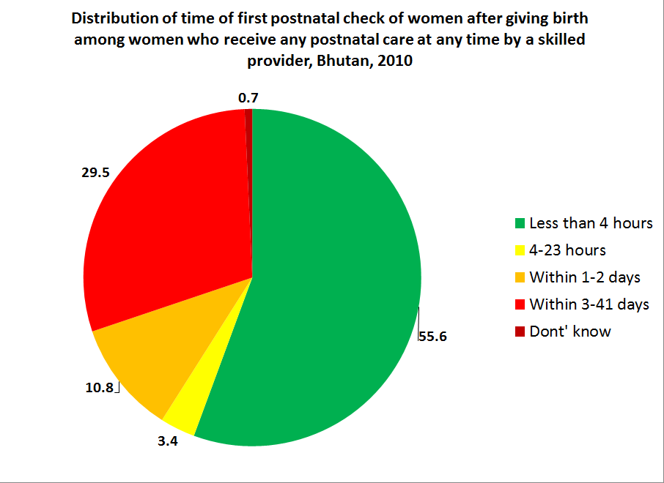

In summary, only 61 percent of women in Bhutan receive any postnatal care after giving birth. Of all women who gave birth regardless of place of delivery, only 36 percent of women received PNC within the critical 24 hours. Even though the vast majority of these women gave birth in an institution, delivering one’s child in a health facility is no guarantee of receiving postnatal care. These findings have significant programme implications to develop strategies to increase the PNC coverage both at the health facilities and at home. The MoH needs to design and implement innovative PNC interventions through involvement of community volunteers.

7.4.2.2 Postnatal care for newborns
The BMIS 2010 survey also measured the extent to which newborns receive postnatal care. Table 43 below shows that 71 percent of children received postnatal care at any time by a skilled provider, a figure slightly higher than postnatal care for women (61 percent). One positive note is that the disparity in postnatal care for children between those born in an institution and those born at home is much smaller than the disparity in postnatal care for women by this distinction. In both places of delivery, the majority of children receive postnatal care at some point. 76 percent of children born in an institution receive PNC compared with 63 percent of children born at home. Children born in urban areas, to mothers with secondary level education, and from the richest households are statistically more likely to receive postnatal care than their counterparts from rural areas, with mothers who have no education, and from the poorest quintile. However, the disparities between demographic groups for postnatal care for children are not as significant as those of postnatal care for women.

Table 43: Postnatal care for newborns by skilled provider: when and whether it was given, among women aged 15-49 who gave birth in the two years preceding the survey, Bhutan, 2010
 |  | % of children who received post-natal care at any time from skilled provider | Number of women who gave birth in past 2 years | Time for first postnatal examination |  |  |  |  |  | Total number of children who received PNC
 |  |  | Number of women who gave birth in past 2 years | Less than four hours  (percentage) | 4-23 hours  (percentage) | Within 1-2 days  (percentage) | Within 3-41 days  (percentage) | Don’t know  (percentage) | Total | Total number of children who received PNC
Area | Urban | 81.1 | 690 | 51.8 | 2.8 | 9.1 | 19.4 | 16.9 | 100 | 560
Area | Rural | 67.3 | 1,678 | 29.9 | 1.9 | 7.0 | 20.2 | 41.1 | 100 | 1,130
Education | None | 68.9 | 1,484 | 31.4 | 2.1 | 6.5 | 19.1 | 40.9 | 100 | 1,023
Education | Primary | 66.7 | 302 | 41.5 | 0.9 | 8.8 | 12.4 | 36.3 | 100 | 201
Education | Secondary + | 79.8 | 582 | 47.9 | 3.1 | 9.7 | 25.0 | 14.2 | 100 | 465
Wealth index quintiles | Poorest | 63.4 | 471 | 21.1 | 1.0 | 4.5 | 21.4 | 52.0 | 100 | 299
Wealth index quintiles | Second | 65.9 | 448 | 25.6 | 1.2 | 3.6 | 20.4 | 49.2 | 100 | 296
Wealth index quintiles | Middle | 68.4 | 475 | 39.6 | 2.2 | 6.8 | 20.5 | 30.9 | 100 | 325
Wealth index quintiles | Fourth | 74.5 | 518 | 39.0 | 3.2 | 11.8 | 18.2 | 27.9 | 100 | 386
Wealth index quintiles | Richest | 84.4 | 455 | 54.6 | 3.1 | 9.9 | 19.6 | 12.8 | 100 | 384
Place of delivery | Non-institutional | 63.4 | 873 | 3.5 | 0.2 | 3.8 | 27.8 | 64.7 | 100 | 554
Place of delivery | Institutional | 76.0 | 1,495 | 53.5 | 3.2 | 9.5 | 16.1 | 17.6 | 100 | 1,135
Total |  | 71.3 | 2,368 | 37.1 | 2.2 | 7.7 | 19.9 | 33.0 | 100 | 1,689

Table 43 also considers the distribution of the time in which the first postnatal care checks took place among children who received any postnatal care. It shows that 37 percent of children, who received any PNC, received the check within four hours of birth. 47 percent of children received their first check within the critical two-day period after birth. Given that only 71 percent of children receive any postnatal care, the percentage of all newborns who receive postnatal care within two days of birth is 34 percent. Again, this figure is much higher for children born in a health facility (56 percent) than for children born at home, only 5 percent of which receive PNC within two days of birth. Of newborns who receive any postnatal care, those born at home are far less likely to receive the first check within two days (8 percent) than those born in a health facility (66 percent). In fact, nearly two-thirds of women who delivered their child at home do not recollect when their newborn’s first check took place.
Figure 37 below shows the total distribution of time of first postnatal check of women after giving birth.

Figure 37: Postnatal care for newborns by a skilled provider: when it was given, among women who gave birth in the two years preceding the survey Bhutan, 2010
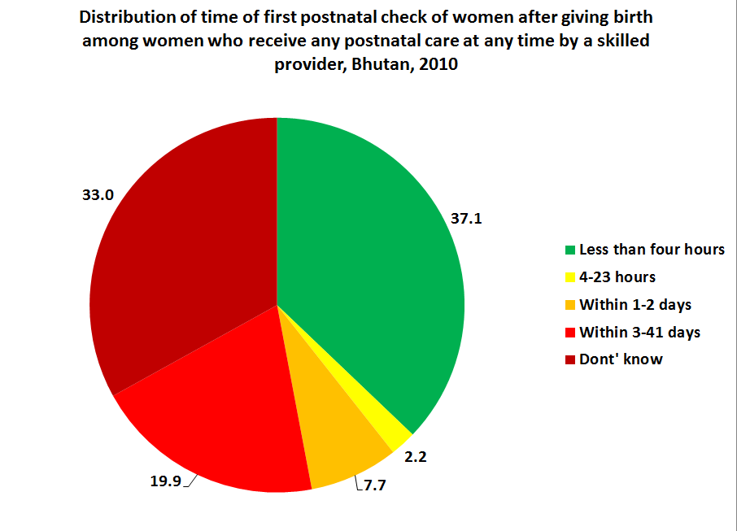

7.4.3 Postnatal Care, antenatal care, and institutional delivery
This analysis has tried to argue the association between antenatal care and institutional delivery, and between institutional delivery and postnatal care. It is evident that antenatal care and institutional delivery have a strongly positive association with postnatal care. While the proportion of women with less than four ANC visits who received PNC is 34 percent, women who received four or more ANC visits have a PNC rate of 46 percent. Although every woman who delivers in a health facility is expected to receive her first PNC visit at the facility, 6.8 percent of women who delivered in a health facility report that they did not receive a postnatal care check.

Table 44: Percentage of women aged 15-49 who received skilled postnatal care within two days of delivery by level of antenatal care received and place of delivery, among women who gave birth in the two years preceding the survey, Bhutan, 2010
 |  | Antenatal care |  |  |  | Institutional delivery |  |  |  | Total number of women aged 15-49
 |  | Post-natal care among women who did not receive antenatal care 4+ times |  | Post-natal care among women who received antenatal care 4+ times |  | Post-natal care among women who did not deliver in health facility |  | Post-natal care among women who delivered in health facility |  | Total number of women aged 15-49
 |  | Percentage of women who received skilled PNC within two days of delivery | Number of women aged 15-49 | Percentage of women who received skilled PNC within two days of delivery | Number of women aged 15-49 | Percentage of women who received skilled PNC within two days of delivery | Number of women aged 15-49 | Percentage of women who received skilled PNC within two days of delivery | Number of women aged 15-49 | Total number of women aged 15-49
Area | Urban | 52.3 | 84 | 62.7 | 601 | 8.0 | 71 | 67.4 | 620 | 690
Area | Rural | 30.1 | 394 | 37.8 | 1,230 | 6.6 | 803 | 60.9 | 875 | 1,678
Education | None | 28.0 | 341 | 39.1 | 1,095 | 5.8 | 719 | 63.1 | 764 | 1,484
Education | Primary | 34.1 | 73 | 51.8 | 226 | 11.0 | 114 | 68.8 | 188 | 302
Education | Secondary + | 66.1 | 64 | 58.3 | 511 | 10.4 | 40 | 62.5 | 542 | 582
Wealth index quintiles | Poorest | 15.8 | 149 | 27.6 | 302 | 3.3 | 315 | 61.7 | 156 | 471
Wealth index quintiles | Second | 29.5 | 119 | 32.4 | 309 | 7.8 | 265 | 63.0 | 183 | 448
Wealth index quintiles | Middle | 40.5 | 96 | 44.6 | 370 | 4.6 | 169 | 64.4 | 306 | 475
Wealth index quintiles | Fourth | 52.2 | 80 | 51.6 | 433 | 14.7 | 104 | 60.5 | 414 | 518
Wealth index quintiles | Richest | 68.6 | 34 | 64.8 | 418 | 23.2 | 19 | 66.9 | 436 | 455
Total |  | 34.0 | 478 | 46.0 | 1,831 | 6.7 | 873 | 63.6 | 1,495 | 2,368

Among women who did not deliver at a health facility, the proportion of women from the poorest wealth quintile who receive postnatal care is 3 percent compared with 23 percent among women from the richest wealth quintile. However, there is no statistical difference in the percentage of who receive postnatal care among women who delivered at a health facility. 62 percent of women from the poorest quintile receive PNC, compared with 67 percent of women from the richest quintile. This elimination in the postnatal care wealth gap is likely a consequence of how once women make it to an institution to give birth, health workers are likely to give them relatively equal service, regardless of their demographic background.

7.4.4 Early childbearing
Early marriage often leads to early childbearing with all its associated risks to the health of young women. According to UNICEF, female youth between the age of 15 and 19 are twice as likely to die during pregnancy or childbirth as women in their twenties. In Bhutan, as with marriage before age 15, the percentage of girls who give birth before age 15 is at its lowest level ever among women aged 15-49 at only 0.5 percent for female youth aged 15-19. However, the percentage of girls and women aged 15-49 who have had a live birth before age 18 has not only remained stable (like early marriage) but has actually increased over time. For this reason, early childbearing and the impact it has on women’s well-being remains an issue worth examining.

7.4.4.1 Early childbearing among women aged 15-24
Table 45 below shows the age-specific fertility rate (ASFR) for female youth aged 15-19, estimated at 59 births per 1,000 in Bhutan. There are tremendous differences in fertility among these young women by demographic background. The adolescent birth rate for rural women is more than twice that of urban women; women with no formal education have a birth rate more than three times that of women with secondary level education; and most strikingly, women from the poorest households have a birth rate 11 times that of women from the richest households.
The total fertility rates (TFRs) shown in Table 45 do not show such a significant disparity, indicating the disproportionate level of early childbearing among the poorest, the rural, and those with no education. However, the TFR for adolescent women remains above the government’s goal of reaching the replacement level TFR of 2.1 by 2012.

Table 45: Adolescent birth rate and total fertility rate, Bhutan, 2010
 |  | Adolescent birth rate (Age-specific fertility rate for women aged 15-19) | Total Fertility Rate
Area | Urban | 30 | 2.3
Area | Rural | 77 | 2.8
Mother's education | None | 113 | 2.9
Mother's education | Primary | 70 | 2.5
Mother's education | Secondary+ | 29 | 3.0
Wealth index quintile | Poorest | 112 | 3.1
Wealth index quintile | Second | 95 | 2.8
Wealth index quintile | Middle | 97 | 3.0
Wealth index quintile | Fourth | 36 | 2.4
Wealth index quintile | Richest | 10 | 2.0
Total |  | 59 | 2.6

Figure 38: Adolescent birth rate, Bhutan, 2010
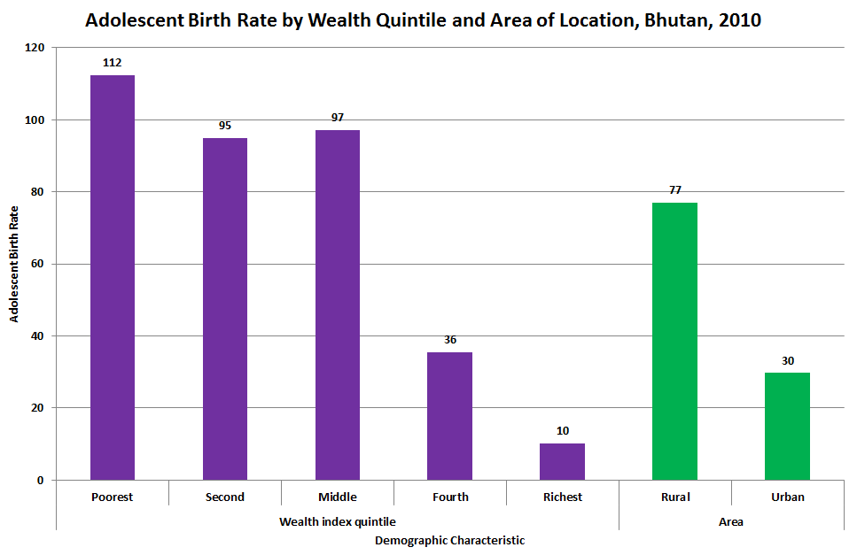

Looking more closely at the data, Table 46 shows that these disparities by area of location, education, and wealth status in early childbearing hold across every indicator. In each of the three early childbearing indicators below, women who live in rural areas, come from the poorest households, or have no education, are anywhere from 2 to 12 times more likely to experience early childbearing vis-à-vis their more privileged counterparts in each demographic domain. The high correlation between these identities means that many of these women inhabit all three of these demographic characteristics – that is, there is a large number of rural women with no education and who come from the poorest households. This combination of multiple vulnerabilities almost certainly increases the likelihood of early childbearing.

Table 46: Early childbearing among young women aged 15-24, Bhutan, 2010
 |  | Percentage of young women that have begun childbearing | Number of women aged 15-19 | Percentage of women young who have had a live birth before age 15 | Number of women aged 15-24 | Percentage of young women who have had a live birth before age 18 | Number of women aged 20-24
Area | Urban | 3.7 | 753 | 0.4 | 1,635 | 10.3 | 882
Area | Rural | 15.3 | 1,299 | 1.1 | 2,920 | 18 | 1,620
Education | None | 25.1 | 548 | 1.7 | 1,706 | 24 | 1,158
Education | Primary | 15.7 | 304 | 0.7 | 643 | 22.7 | 340
Wealth index quintiles | Secondary+ | 3.4 | 1,201 | 0.3 | 2,205 | 2.7 | 1,004
Wealth index quintiles | Poorest | 18.3 | 316 | 1.5 | 718 | 21.1 | 402
Wealth index quintiles | Second | 21.2 | 323 | 1.2 | 737 | 17.7 | 413
Wealth index quintiles | Middle | 18.6 | 339 | 1.6 | 839 | 16.8 | 499
Wealth index quintiles | Fourth | 6 | 441 | 0.3 | 1,055 | 17.1 | 614
Wealth index quintiles | Richest | 1.5 | 633 | 0.3 | 1,207 | 6.3 | 574
Total |  | 11 | 2,052 | 0.9 | 4,555 | 15.3 | 2,502

7.4.3.2 Early childbearing, education, and literacy
As with early marriage, this report examines the relationship between early childbearing and women’s level of school participation, educational attainment, and literacy. Table 47 below shows that among female youth aged 15-18, who have not begun childbearing, the secondary school net attendance ratio is almost 58 percent whereas for those female youth who have begun childbearing, secondary school participation drops to only 1.2 percent. Another way of looking at these data is to divide this group of female youth aged 15-18 into those who attend secondary level school or higher and those who do not. Table 48 reveals that of those who do attend school, 0.2 percent have begun childbearing compared with 17.2 percent of those female youth who do not attend school.

Tables 47: Secondary level school attendance by early childbearing status among young women aged 15-18, Bhutan, 2010
Secondary School attendance among women aged 15-18 by whether they have begun childbearing
 | Have not begun child bearing |  | Have begun child bearing |  | Total
 | Secondary School net attendance ratio | No. of women aged 15-18 | Secondary School net attendance ratio | No. of women aged 15-18 | Secondary School net attendance ratio | No. of women aged 15-18
Total | 57.9 | ,489 | 1.2 | 132 | 53.3 | 1,621

Table 48: Young women aged 15-18 who had early childbearing by secondary school participation, Bhutan, 2010

Percentage of women aged 15-18 who have begun childbearing by secondary school participation status
 | Not in the secondary school |  | Attending secondary school |  | Total
 | % of women who have begun child bearing | No. of women of secondary school age | % of women who have begun child bearing | No. of women of secondary school age | % of women who have begun child bearing | No. of women of secondary school age
Total | 17.2 | 757 | 0.2 | 863 | 8.1 | 1621

As early marriage and early childbearing exhibit a strongly positive correlation, it should not come as a surprise that the data show a significantly detrimental effect of early childbearing on school participation. The evidence shows that women who get married, pregnant, and/or have children have either already dropped out of school, which increases the likelihood of early marriage and childbearing, or if they have remained in school, face significant obstacles in continuing their education.
Table 49 below provides evidence for the hypothesis that women with less education are more likely to begin early childbearing. The data show that early childbearing among female youth aged 15-19 is highly concentrated among those with no formal education. Three out of every five women who begin early childbearing have no education. While not shown in this table, women with no education are 60 percent more likely to begin childbearing than those who have ever attended primary school. In other words, ever attending school is associated with a significant decrease in the likelihood of early childbearing.

Table 49: Educational attainment by early childbearing status among young women aged 15-19, Bhutan, 2010
 | Level of educational attainment |  |  | Total | No. of women aged 15-19
 | None | Primary | Secondary+ | Total | No. of women aged 15-19
Have not begun childbearing | 22.5 | 14.0 | 63.5 | 100 | 1,826
Have begun childbearing | 60.8 | 21.2 | 18.0 | 100 | 226
Total | 26.7 | 14.8 | 58.5 | 100 | 2,052

This negative relationship between early childbearing and educational attainment carries forward to educational outcomes such as literacy, a key indicator for women’s empowerment and improved well-being. Table 50 below shows that the literacy rate of mothers aged 20-24 who gave birth before age 18 is only half that of mothers who have gave birth at or after age 18 (19 percent versus 38 percent, respectively). This difference holds when controlling for each area of location and wealth quintile. The literacy gap between early and non-early mothers increases with wealth quintile.

Table 50: Literacy rates by early childbearing status among mothers aged 20-24, Bhutan, 2010
 |  | Percentage of mothers who: |  |  |  | Number of mothers aged 20-24
 |  | Had first birth after age 18 |  | Had first birth before age 18 |  | Number of mothers aged 20-24
 |  | Literacy | Number of non-early mothers aged 20-24 | Literacy | Number of early mothers aged 20-24 | Number of mothers aged 20-24
Area | Urban | 55.6 | 292 | 31.8 | 91 | 383
Area | Rural | 30.3 | 669 | 15.5 | 292 | 962
Education | None | 4.2 | 532 | 6.6 | 278 | 810
Education | Primary | 38.4 | 141 | 37.3 | 77 | 219
Education | Secondary + | 100 | 288 | 100 | 27 | 315
Wealth index quintiles | Poorest | 12.3 | 189 | 5.7 | 85 | 274
Wealth index quintiles | Second | 21.6 | 169 | 12.6 | 73 | 242
Wealth index quintiles | Middle | 35.4 | 207 | 21.3 | 84 | 291
Wealth index quintiles | Fourth | 45.2 | 242 | 22.6 | 105 | 347
Wealth index quintiles | Richest | 79.5 | 154 | 51.5 | 36 | 191
Total |  | 38 | 961 | 19.4 | 383 | 1,344
Although not shown here, data show that when expanding the population to include all women aged 20-24 irrespective of their motherhood status, the disparity in literacy between women who gave birth before age 18 increases from 19 percentage points to 34 percentage points, indicating the even higher literacy rate of women aged 20-24 who have never given birth.

7.4.4 Young motherhood
As there is concern for the effect of early childbearing on a woman’s education, so is there for the impact it may have on a woman’s health and that of her newborn. This section also considers associations between the age of a woman at the birth of her child and her reproductive health outcomes. It also tests child health and education outcomes against the age of the mother.

7.4.4.1 Young motherhood and reproductive and newborn health
A concern often expressed by many in the health sector is that young pregnant women have a lower uptake of antenatal care than older women. To test this, the analysis considered the percentage of women who received antenatal care at least once by a skilled provider and at least four times by any provider if they had given birth in the past two years by the age of the mother at birth. Table 50 below shows the results. As at least one skilled antenatal care visit is nearly universal in Bhutan, the difference between any two groups never exceeds 5 percentage points and there is no statistically significant difference by age of mother. When considering at least four antenatal care visits, disparities across demographic characteristics, as well as by age of mother, appear to exist. However, only one of the permutations for comparing means shows any statistically significant difference. The report’s conclusion then is that the uptake of antenatal care for young women is statistically equivalent to that of older women in Bhutan.
However, the analysis shows statistically significant differences in neonatal tetanus protection among women by their age at birth. Girls and young women aged 15-19 have a lower level of neonatal tetanus protection than women aged 20-24. However, young women aged 15-19 and 20-24 have a higher level of protection than women aged 25-49.
At the time of birth, there are several indicators of reproductive health. The analysis now considers the proportion of women by age group who have received skilled birth assistance, institutional delivery, post-natal care, and whose newborns are born with low birth weight.

Table 51: Percentage of young women aged 15-49 who received antenatal care and neonatal tetanus protection, by age of mother at birth of child, Bhutan, 2010

 |  | Mother's age at birth
 |  | 15-19 |  |  |  | 20-24 |  |  |  | 25-49
 |  | Received antenatal care at least once by skilled provider  (percentage) | Received antenatal care 4+ times  (percentage) | Protected against tetanus  (percentage) | Total number of women aged 15-49 | Received antenatal care at least once by skilled provider  (percentage) | Received antenatal care 4+ times | % protected against tetanus | Total number of women aged 15-49 | Received antenatal care at least once by skilled provider | Received antenatal care 4+ times | % protected against tetanus | Total number of women aged 15-49
Area | Urban | 100 | 84.0 | [84.3] | 52 | 99.0 | 88.3 | 86.3 | 250 | 98.9 | 86.8 | 65.6 | 388
Area | Rural | 94.9 | 70.9 | 72.7 | 213 | 98.0 | 74.7 | 78.7 | 565 | 96.0 | 72.9 | 68.5 | 896
Education | None | 94.4 | 72.7 | 74.0 | 158 | 97.9 | 76.9 | 78.7 | 472 | 96.2 | 72.1 | 66.7 | 850
Education | Primary | 97.3 | 64.0 | 68.7 | 51 | 99.7 | 72.4 | 76.5 | 120 | 98.5 | 81.3 | 60.3 | 131
Education | Secondary | 98.9 | 84.1 | 83.2 | 56 | 98.4 | 86.6 | 88.4 | 223 | 98.4 | 89.2 | 73.4 | 303
Wealth index quintiles | Poorest | 96.2 | 64.7 | 73.9 | 66 | 97.9 | 68.5 | 76.9 | 155 | 94.1 | 60.5 | 66.8 | 247
Wealth index quintiles | Second | 94.1 | 65.3 | 81.3 | 73 | 98.4 | 70.1 | 81.7 | 132 | 93.5 | 69.2 | 61.9 | 243
Wealth index quintiles | Middle | 95.0 | 79.4 | 64.9 | 69 | 96.7 | 80.5 | 74.6 | 176 | 98.9 | 75.4 | 68.1 | 231
Wealth index quintiles | Fourth | 98.7 | 84.2 | [77.3] | 47 | 98.9 | 84.4 | 83.5 | 214 | 99.5 | 83.0 | 68.9 | 257
Wealth index quintiles | Richest | 100 | 100 | * | 10 | 100 | 88.6 | 89.3 | 139 | 98.2 | 93.0 | 71.3 | 306
Total |  | 95.9 | 73.5 | 74.9 | 265 | 98.3 | 78.9 | 81.0 | 816 | 96.9 | 77.1 | 67.6 | 1,284
4 women who gave birth before age 15 not included.

As Table 52 shows, women aged 15-19 experience a lower level of reproductive healthcare for all three indicators than their counterparts aged 20-24. Similarly, women in this age group are more likely to give birth to newborns with low birth weight, defined as weighing less than 2,500 grams. All of these differences are statistically significant. And, although the youngest cohort of women appear to fare worse than women aged 25-49, none of the observed differences are statistically significant except for postnatal care, which is the only indicator in reproductive health that improves consistently with age. Outcomes for women aged 20-24 are equivalent to those of older women except in the case of institutional delivery in which the younger cohort fares better.

Table 52: Percentage of women age 15-49 receiving skilled birth assistance, institutional delivery, postnatal care, and child’s weight by age of mother at birth of child, Bhutan, 2010

 |  | Mother's age at birth
 |  | 15-19 |  |  |  |  | 20-24 |  |  |  |  | 25-49
 |  | Received skilled birth assistance  (percentage) | Delivered in health facility  (percentage) | Received postnatal care within two days  (percentage) | Birth below 2500 grams | Number of women who gave birth in last two years | Skilled birth assistance  (percentage) | Delivered in health facility  (percentage) | Received postnatal care within two days  (percentage) | Birth below 2500 grams | Number of women who gave birth in last two years | Received skilled birth assistance  (percentage) | Delivered in health facility  (percentage) | Received postnatal care within two days  (percentage) | Birth below 2500 grams | Number of women who gave birth in last two years
Area | Urban | [92.2] | [92.2] | [54.3] | [10.2] | 52 | 93.4 | 92.9 | 60.4 | 7.5 | 250 | 86.6 | 87.4 | 62.9 | 8.1 | 388
Area | Rural | 50.2 | 48.9 | 30.4 | 11.1 | 213 | 56.1 | 55.7 | 34.7 | 9.3 | 565 | 54.1 | 50.8 | 36.3 | 10 | 896
Education | None | 50.5 | 49.6 | 27.7 | 10.9 | 158 | 58.3 | 57.1 | 37 | 9.2 | 472 | 51.5 | 48.8 | 36 | 9.8 | 850
Education | Primary | 51 | 49.1 | 32.5 | 10.3 | 51 | 56.6 | 56.3 | 46.1 | 8.3 | 120 | 72 | 72.8 | 53.5 | 10.6 | 131
Education | Secondary+ | 87.7 | 87 | 58 | 11.8 | 56 | 92.9 | 94.1 | 52.7 | 8.5 | 223 | 95.1 | 93.6 | 63.6 | 8.1 | 303
Wealth index quintles | poorest | 31.6 | 31.3 | 16.9 | 12.1 | 66 | 33.5 | 35.2 | 25.2 | 9.6 | 155 | 35.4 | 32.2 | 22.4 | 12.3 | 247
Wealth index quintles | Second | 39.4 | 38.5 | 25.2 | 11.5 | 73 | 44.8 | 43.6 | 29.2 | 9.7 | 132 | 43.7 | 40 | 32.5 | 9.4 | 243
Wealth index quintles | Middle | 77.4 | 75.6 | 52.1 | 10.2 | 69 | 69.3 | 66.4 | 42.8 | 9.9 | 176 | 62.7 | 59.5 | 40.6 | 9.2 | 231
Wealth index quintles | Fourth | [89] | [87.6] | [41.2] | [10.5] | 47 | 85.9 | 86.1 | 51.2 | 7.4 | 214 | 75.2 | 73.2 | 53.7 | 10 | 257
Wealth index quintles | Richest | * | * | * | * | 10 | 96.6 | 96.6 | 61.3 | 7.4 | 139 | 94.3 | 95.2 | 66.3 | 7 | 306
Total |  | 58.4 | 57.4 | 35.1 | 11 | 265 | 67.5 | 67.5 | 42.6 | 8.9 | 816 | 63.9 | 61.8 | 44.3 | 9.6 | 1284
Data for 4 women who gave birth before age 15 not included

Figure 39 below illustrates the above discussion, showing the somewhat lower level of reproductive and newborn health for the youngest mothers aged 15-19 and the relatively better outcomes for women aged 20-24.

Figure 39: Reproductive and newborn health care among young women aged 15-49 by age of mother at birth of child, Bhutan, 2010
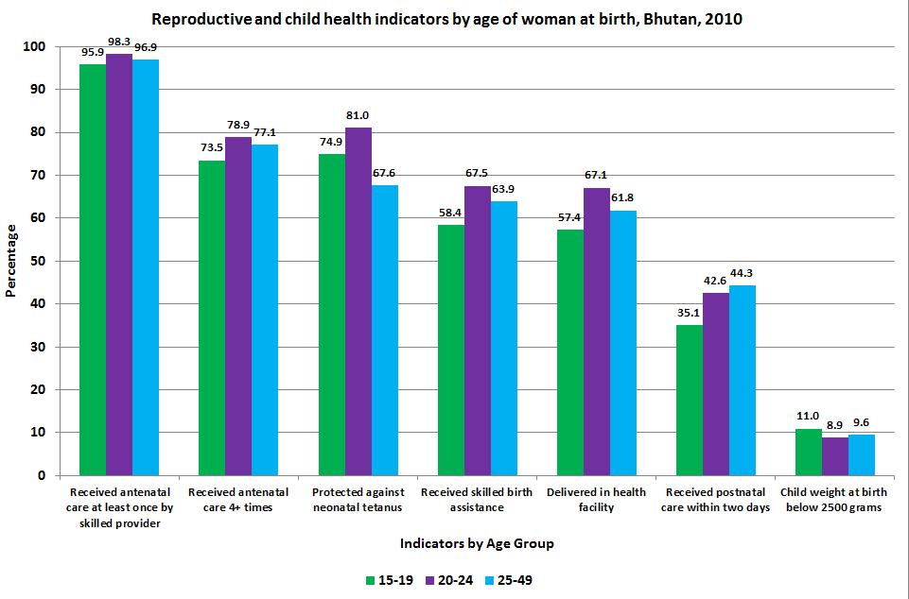

7.4.4.2 Young motherhood and child outcomes
A key concern in public health is whether children of young mothers are more likely to have poorer health and educational outcomes than children of older mothers. For this reason, the analysis looked at a range of child well-being indicators by age of mother and found very little evidence for this hypothesis in Bhutan. Selected indicators cover education such as participation in formal early childhood education, having learning materials in the home, having adequate adult care, the Early Childhood Development Index (ECDI), and primary level school participation. They also include critical health issues such as breastfeeding and nutritional indicators, appropriate treatment for diarrhoea, and care-seeking behaviour during suspected pneumonia.

Table 53 below notes the national-level statistics for these key health and educational outcomes of young children. In most cases, children’s outcomes by age of mother are statistically equivalent. In fact, in three of the four cases in which there is a statistical difference, children of younger mothers have a better outcome than children of older mothers. In only one case – the percentage of children attending early childhood education – is the estimate lower for children of young mothers than for children of older mothers. Given these data, this analysis concludes that there is no evidence that mother’s age bears a significant impact on the health and educational outcomes of young children in Bhutan.

Table 53: Child health and education outcomes by mother’s age among women aged 15-49, Bhutan, 2010
Indicator | Age Group | Mother's age group
Indicator | Age Group | 15-24 |  | 25-49
Indicator | Age Group | % | No. | % | No.
Early Childhood Education | 36-59 months | 6.8 | 478 | 10.3 | 1,866
Learning Materials in the Home | 0-59 months | 50.4 | 1,701 | 52 | 4,306
Inadequate Care | 0-59 months | 12 | 1,701 | 14.8 | 4,306
Early Childhood Development Index Score | 36-59 months | 68.4 | 478 | 72.2 | 1,866
Primary School Attendance** | 6-12 years | 90.4 | 4,474 | 88.9 | 4,310
Breastfeeding within one hour of birth** | 0-2 years | 58.8 | 1081* | 58.9 | 1284*
Exclusive Breastfeeding** | 0-5 months | 46.5 | 173 | 51.2 | 363
Appropriate treatment of diarrhea | 0-59 months | 82.0 | 446 | 79.5 | 1,064
Care-seeking behaviour for suspected pneumonia | 0-59 months | 77.9 | 117 | 71.1 | 291
Underweight Prevalence | 0-59 months | 10.9 | 1,701 | 13.1 | 4,306
Stunting Prevalence | 0-59 months | 32.9 | 1,701 | 33.5 | 4,306
Wasting Prevalence | 0-59 months | 5.8 | 1,701 | 5.9 | 4,306
* Number of mothers who gave birth in past 2 years, 3 women who gave birth before age 15 not shown. |  |  | ** Indicator uses mother's age at birth of child

7.5 Section Summary
Reproductive health is a multi-faceted issue. It is an important component of healthcare, influencing the well-being of women and their children. It also influences demographic developments, and consequently, the socio-economic development of Bhutan. It directly affects the physical well-being of mothers during and after pregnancy and affects the conditions under which the newborn begins his or her life as well as future child development. It encompasses the prevention of sexually transmitted infections, population management, and equitable access to family planning through proper use and availability of contraceptives. As such, reproductive healthcare is a key factor affecting the emancipation of women.
This chapter provides new analysis of BMIS 2010 data in the areas of fertility rates, fertility preferences, birth control, use of and unmet need for contraceptives, antenatal care, skilled birth assistance, institutional delivery, postnatal care, early childbearing and young motherhood. An attempt was made to illuminate differences in health outcomes, as well as disparities in accessibility, availability, and utilization of services across demographic groups.
Population growth in Bhutan is gradually decreasing, from 3.1 percent in 1994 to 1.8 percent in 2005. The key indicator for population growth is the total fertility rate (TFR) of women in their reproductive years. This is the total number of children that women have, on average, during their lifetime. As of 2010, Bhutan’s TFR is 2.6. A stable population is attained when the TFR reaches replacement level, which means that for every man and woman, there are two new individuals born to replace them. Taking into account mortality before reproduction, the population replacement rate is 2.1 in Bhutan.
The overall picture that emerges from the data analysis on reproductive health parameters is clear. Though Bhutan has made considerable progress on many fronts regarding reproductive health, there are still large disparities between demographic groups. For key indicators of reproductive health, women from rural areas, the poorest households, and with little to no formal education invariably fare considerably worse than urban women, those from the wealthiest households, and/or have at secondary level education or above. These findings provide compelling evidence that calls for a public health strategy that focuses on the needs of marginalized and poor women. The strategy should be holistic, encompassing access to quality healthcare services and education.
Long-term, the most effective way to improve women’s reproductive healthcare in Bhutan is by improving the income situation of the rural poor. This calls for a concerted effort from all government departments to direct resources towards and design policies and programmes that focus on the poorest households, remote areas, and those with no education. Improving access to and quality of education is the most powerful and long-lasting way to improve RH outcomes. Moreover, as it influences key elements such as early child bearing, uptake of ANC and PNC, and the probability of institutional delivery, very serious efforts should be made to substantially increase the literacy rate among women.
Apart from this, improving the availability and stimulating the use of contraceptives, especially among unmarried women and young women without children, should be a priority for the Ministry of Health. Present use is very low, which may result in the increase of STD and unwanted early childbearing.
Further, antenatal care emerges as a key factor for the uptake and success of healthcare given at and after birth. The Ministry of Health can ensure significant progress here, in particular among the women in rural areas, the poorest households, and those with no formal education, by addressing the following issues. As ANC coverage remains relatively low among these groups, this should be increased by ensuring that all underprivileged women receive at least four, but preferably eight, ANC visits. HIV-counseling and knowledge transfer on mother-to-child-transmission should be a compulsory component of the visit. At the same time, the quality of care delivered at health institutions, especially at BHUs, should be improved. Access to quality and timely postnatal care requires attention as the data show inadequate levels for both mother and child. The effect of these measures, taken together, can and should lead to a significant reduction in the inequality of reproductive health outcomes between demographic groups, which in turn will contribute to Gross National Happiness.

8. Maternal mortality

8.1 Introduction
Maternal health is an important part of the healthcare system aimed at reducing morbidity and mortality related to pregnancy. The healthcare that a woman receives during pregnancy, at the time of delivery, and soon after delivery is important for the survival and well-being of both the mother and child. As a result, it has been considered as a healthcare priority by the Royal Government of Bhutan since the establishment of the Reproductive Health Programme called the Maternal and Child Health (MCH) in the 1970s. Bhutan is committed to realising MDG 5 by reducing maternal mortality by three-fourths by 2015.
The most commonly used indicator to estimate the prevalence of maternal deaths is the Maternal Mortality Ratio (MMR), which is widely acknowledged to be a general indicator of population health, of the status of women in society, and of the healthcare system functionality.
The measurement of maternal death is complex because of the comparative rarity of the absolute number of maternal deaths in Bhutan, which is less than 20 per year. Other context-specific factors such as a reluctance to report abortion-related deaths, errors due to poor memory recall, or lack of accurate medical reporting also make the measurement of maternal death complex.
Maternal mortality is defined as the death of women while pregnant or within 42 days of termination of pregnancy, irrespective of the duration and site of the pregnancy from any causes related to or aggravated but not from accidental or incidental causes. The causes of deaths can be divided into; a) direct causes that are related to obstetric complications during pregnancy, labour or the post-partum period, and b) indirect causes. There are five direct causes of maternal death: haemorrhage (usually occurring postpartum), sepsis, eclampsia, obstructed labour, and complications from abortion. Indirect obstetric deaths occur from either previously existing conditions or from conditions arising in pregnancy, which are not related to direct obstetric causes but may be aggravated by the physiological effects of pregnancy.

8.2 Measuring maternal mortality
Measuring maternal mortality requires a comprehensive and accurate reporting of maternal deaths. Globally, various sources are used to measure maternal mortality, including civil registration systems, household surveys, sisterhood estimation methods (indirect and direct), reproductive-age mortality studies, verbal autopsies, and censuses.
Of the different approaches described above, the BMIS 2010 uses the Direct Sisterhood Method wherein the data on the age of surviving sisters of survey respondents, the age at death of sisters who have died, and the number of years since the death of sisters were used. During the survey, all women aged 15 through 49 were asked about all the sisters and brothers born to their natural mother in chronological order starting with the oldest. Then they were asked about the survivorship of each of the siblings, the ages of surviving siblings, the years since death of deceased siblings, and the age at death of deceased siblings. For all dead female siblings, the respondents were asked additional questions to determine whether the death was maternity-related; that is, whether the sister was pregnant when she died; if not, whether the sister died during childbirth; and if not, whether the sister died within two months of the end of a pregnancy or childbirth. Listing all siblings in chronological order of their birth is believed to result in better reporting of events than would be the case if only information on sisters were sought. Moreover, the information collected also allows direct estimates of adult male and female mortality.

8.3 Data quality
Before estimating mortality, the data quality must be ensured and one measure of the quality of the data collected is the completeness of information on siblings. Another crude measure of the quality of maternal mortality data is the distribution of respondents’ year of birth in relation to their siblings’. If there is no bias in reporting, the year of birth of respondents overall should be equivalent to the year of birth of siblings.
Table 11.3 in the report annex shows that the median year of birth of respondents (1973) is almost equal to that of their siblings (1972). This indicates respondents’ accurate reporting of siblings. Yet another crude measure of data quality is the mean number of siblings, or the mean sib-ship size (see Table 11.4 in the Annex). The mean sib-ship size should decline over time in line with the decline in fertility rates. That it does not monotonically decline suggests some reporting error, but this should not affect subsequent calculations of mortality rates, which are given only for the four year period preceding the survey.

8.4 Adult mortality
Maternal mortality is a subset of adult mortality. If the overall adult mortality estimates display a stable and expected pattern, the maternal mortality estimates have greater credibility.
The BMIS 2010 collected data for male and female adult mortality through the sibling history module of the women’s questionnaire. Age-specific death rates are computed by dividing the number of deaths in each age group by the total women-years of exposure in that age group during a specified reference period. Table 54 below shows the direct estimates of age-specific mortality rates for females and males. Note that mortality rates presented are age-adjusted.

Table 54: Adult Mortality: Direct estimates of female and male mortality by age during the four years prior to the survey, Bhutan 2010
Adult Mortality: Direct estimates of female and male mortality by age during the four years prior to the survey, Bhutan 2010
Maternal Age | Deaths | Exposure | Age-Adjusted Mortality Rate*
Female
15-19 | 8 | 18872 | 0.1
20-24 | 21 | 22088 | 0.2
25-29 | 30 | 21339 | 0.3
30-34 | 35 | 17483 | 0.3
35-39 | 20 | 13095 | 0.2
40-44 | 14 | 8404 | 0.2
45-49 | 17 | 6375 | 0.2
15-49 | 145 | 107656 | 1.4
Male
15-19 | 14 | 20052 | 0.1
20-24 | 33 | 22926 | 0.3
25-29 | 42 | 22177 | 0.4
30-34 | 33 | 17901 | 0.3
35-39 | 23 | 13827 | 0.2
40-44 | 29 | 9549 | 0.3
45-49 | 23 | 6828 | 0.3
15-49 | 197 | 113259 | 1.8
Total
15-19 | 22 | 38924 | 0.1
20-24 | 53 | 45014 | 0.2
25-29 | 72 | 43516 | 0.3
30-34 | 68 | 35384 | 0.3
35-39 | 44 | 26922 | 0.2
40-44 | 43 | 17953 | 0.3
45-49 | 39 | 13293 | 0.2
15-49 | 342 | 220915 | 1.6
*Expressed per 1,000 population

Further, to minimize the impact of possible heaping of reported years, death direct estimates are presented for the period 0-4 years before the survey rather than 0-5 years. Therefore, these estimates roughly correspond to the period 2006-2010.
Since the number of sibling deaths is very small and sampling variability is large, the data over the age range 15-49 have been aggregated. The overall adult mortality rate is 1.6 deaths per 1,000 population as shown in Table 54 above. There are more male than female deaths in the five years preceding the survey (197 versus 145, respectively). The male mortality rate is 1.8 deaths per 1,000 population and is 29 percent higher than the female mortality rate of 1.4 deaths per 1,000 population.

8.5 Maternal mortality
Government investments in maternal health have contributed to a reduction in Bhutan’s (MMR) from 380 in 1994 to 255 in 2000. This BMIS 2010 is the first time since 2000 that Bhutan has produced a robust estimate of MMR. Table 55 below shows data on maternal mortality for the period 0-4 years before the BMIS 2010. Age-specific maternal mortality rates are calculated by dividing the number of maternal deaths by total women-years of exposure, after which maternal mortality rates are age-adjusted. Because the women’s questionnaire is not administered to women over age 49, maternal mortality rates could suffer from ‘truncation bias’. To remove this statistical bias, the overall MMR for women aged 15-49 is standardized by the age distribution of the survey respondents.
As stated earlier, maternal deaths are defined as any death that occurred during pregnancy, childbirth, or within two months after the birth or termination of a pregnancy. For each age group, maternal deaths are a relatively rare occurrence. Therefore, the age-specific pattern should be interpreted with caution. In the BMIS 2010, the respondents reported 12 maternal deaths in the five years preceding the survey. Maternal deaths accounted for eight percent of all deaths in women aged 15-49; in other words, about one in twelve Bhutanese women who died in the five years preceding the survey died from pregnancy or pregnancy-related causes.
The maternal mortality ratio (MMR) is often considered a more useful measure of maternal mortality because it measures the obstetric risk associated with each live birth. Table 54 below shows that the MMR for Bhutan for the period 2006-2010 is 145.7 deaths per 100,000 live births.

Table 55: Direct estimates of maternal mortality for the period 0-4 years prior to the survey, Bhutan 2010
Direct estimates of maternal mortality for the period 0-4 years prior to the survey, Bhutan 2010
Maternal Age | Deaths | Exposure | Age-Adjusted Mortality Rate* | Proportion of maternal deaths to all female deaths
0-4 YEARS
Maternal Age
15-19 | 1 | 18872 | 0 | 0.12
20-24 | 1 | 22088 | 0 | 0.05
25-29 | 6 | 21339 | 0.1 | 0.20
30-34 | 0 | 17483 | 0 | 0.00
35-39 | 3 | 13095 | 0 | 0.15
40-44 | 1 | 8404 | 0 | 0.08
45-49 | 0 | 6375 | 0 | 0.00
Total | 12 | 107656 | 0.1 | 0.08
General Fertility Rate (GFR) |  |  | 0.0686
Maternal Mortality Ratio (MMR)** |  |  | 145.7
*Expressed per 1,000 women-years of exposure; **Expressed per 100,000 live births; calculated as the maternal mortality rate divided by the general fertility

Figure 40 below presents data from BMIS 2010 on maternal mortality estimates using the direct method. The data provide point estimates for MMR for three five-year periods from 1996-2010. These estimates suggest that MMR has declined in Bhutan from 262 during the period 1996-2000 to 146 during the period 2006-2010. This decline in MMR represents a 116 point (44 percent) decrease in one decade, using a given year for each five-year period. Assuming a continual rate of logarithmic decline, this analysis forecasts a decrease in MMR to 105 deaths per 100,000 live births for the period 2011-2015.

Figure 40: Maternal mortality direct method estimates 1996-2010, Bhutan, 2010

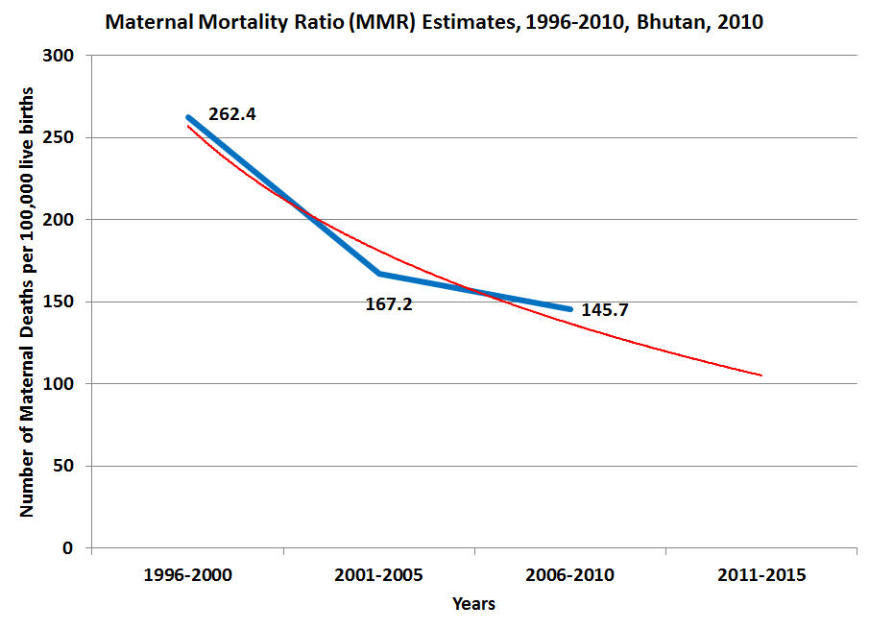

8.6 Section summary
The World Health Organization, UNICEF, UNFPA, and the World Bank recently published a report titled, Trends in Maternal Mortality: 1990 to 2008. This document provides robust estimates of many countries’ maternal mortality ratios over this time period. The report estimates Bhutan’s MMR for 1990 at 940 per 100,000 live births. For 2008, the estimate is 200 with a confidence interval of 110 to 370. The BMIS estimate for the period 2006-2010 is 146, which is squarely within, and at the lower end, of this interval.
The report notes that only fourteen countries in its 172 country sample have reduced their MMR by more than 5.5 percent per year between 1990 and 2008. Bhutan is one of those fourteen countries that has reduced its MMR by an estimated rate of 8.6 percent per year. In doing so, Bhutan has achieved a 79 percent decrease in its MMR and ranks fourth out of 172 countries for the most rapid decline in maternal mortality.
The report states that of the 87 countries that had an MMR greater than 100 in 1990, only ten are on track to achieve MDG 5 of reducing maternal mortality by three-fourths. Bhutan is one of these countries and by these estimates, which report a 79 percent decline by 2008, Bhutan has already achieved MDG 5 several years early. If this report’s forecast for a MMR of 105 for the period 2011-2015 is accurate, Bhutan will have reduced its maternal mortality by 89 percent in just one generation. New Reproductive Health Strategy has been recently developed and it is targeted towards this end along with addressing other reproductive health related issues.

9. HIV/AIDS

9.1 Introduction
The Ministry of Health established the National HIV/AIDS & Sexually Transmitted Infections (STIs) Control Programme (NACP) in 1984 to prevent and control the spread of HIV/AIDS and STIs in Bhutan. Since then, the NACP has accorded high priority to combat the epidemic. The HIV prevalence in the general population in Bhutan is below 0.03 per cent.
[[UNAIDS estimates that about 1,000 people in Bhutan are currently HIV-positive. In December 2011, the RGoB recorded a cumulative total of 270 confirmed HIV infections since the first case was detected in 1993. Out of the 270, 22 are children and 207 individuals are still living. The discrepancy between these two numbers is likely a function of the low number of HIV cases that are detected and reported to the MoH. It is very likely that many HIV-positive individuals in Bhutan do not know that they have the virus. As a consequence, the true number of HIV-positive individuals in Bhutan is probably considerably higher than MoH reported cases and more in line with UNAIDS estimates.]]
More than one in four (30 percent) of reported cases of HIV are housewives, and among young people aged 15- 24 years, 31 percent are women. In total, 43 percent of men and 29 percent of women are more than 24 years of age. Among reported cases, while heterosexual contact is the main route of HIV transmission (90 percent), vertical transmission accounts for another 9 percent. Cases have been confirmed among diverse demographic groups that include female sex workers, farmers, corporate employees, prison inmates, and uniformed service personnel. To date, however, there are no data available on HIV prevalence among most at risk people. Although sex work is illegal in Bhutan, its existence is well known. The drug using population is estimated to be small but findings from a rapid assessment conducted in 2006 among 200 drug users indicate that 19 per cent inject, which increases their risk of contracting HIV. Despite lack of accurate data, the RGoB has called for increased drug use prevention in schools and monastic communities. The third largest number of People Living with HIV (PLHIV) is found among uniformed forces. Little data exist on same sex behaviour but an HIV and AIDS survey conducted in 2006 among 3,200 men and women aged 15-49 residing in urban and rural showed 2 percent of married men report engaging in sex with male partners.

MDG 6 aims to halt and begin to reverse the spread of HIV/AIDS by 2015. In general, it is believed that Bhutanese exhibit relaxed sexual mores relative to this region of Asia. A key finding from the General Population Survey in 2006 indicates that 19 percent of both males and females had extramarital sex in the prior year. Respondents reported an average of two sexual partners in the six months prior to the survey. The 2008 Behaviour Surveillance Survey (BSS) reported that condom use during last sex in the year prior to the survey was 84 percent. However, in contrast to the high rate of condom use reported during last sexual act, consistent use of a condom was much lower. Condom use with a spouse or regular sex partner(s) was only 22 percent.
The National Strategic Plan 2012-2016 has been developed with priority focus on reaching the target population with targeted intervention approach. The strategic information has been strengthened at all levels to facilitate evidence-based decision-making and to achieve result-based outcomes. However, there are certain gaps in addressing the programmatic interventions. Bhutan Multiple Indicator Survey (BMIS) thematic analysis report is expected to fill key data gaps to help guide programme planning in its efforts to achieve its goals and contribute globally to MDG 6.

9.2 Comprehensive knowledge of HIV transmission, literacy and education
Comprehensive knowledge of HIV transmission refers to the ability of individuals to correctly identify the two ways of preventing HIV infection, to know that a healthy looking person can have HIV, and to reject the two most common local misconceptions about HIV transmission. The BMIS 2010 survey assessed the comprehensive knowledge of HIV of all women aged 15-49.
The survey shows that more than four out of five women who were interviewed have heard of HIV (84 percent) but that only half of these women (51 percent) know the two main ways to prevent transmission.
This analysis tested whether knowledge of HIV/AIDS transmission differs by women’s literacy status. Table 56 below shows that 32 percent of women aged 15-49 who are literate have comprehensive knowledge of HIV transmission compared with only 10 percent of women in the same age group who are not literate. This disparity in knowledge by women’s literacy status holds across every demographic group, suggesting an impact of literacy on women’s knowledge of HIV, separate from the impact of one’s area of location, educational attainment, or wealth. It may be that some HIV/AIDS awareness campaign messages in the written are not understood by non-literate women. Part of the difference in comprehensive knowledge of HIV transmission between dzongkhags may be attributed to differences in methodology and the intensity with which HIV awareness campaigns are conducted at the dzongkhag-level, given the decentralised operational structure of the Multi-Sectoral Task Force (MSTF).

Table 56: Percentage of women aged 15-49 who know three ways HIV can be transmitted from mother to child and percentage of women aged 15-49 with comprehensive knowledge of HIV transmission by their literacy status, Bhutan, 2010
 |  | Not literate |  |  | Literate |  |  | Total number of women aged 15-49
 |  | % who know three ways HIV can be transmitted from mother to child | Percentage who have comprehensive knowledge of HIV | Number of women aged 15-49 | % who know three ways HIV can be transmitted from mother to child | Percentage who have comprehensive knowledge of HIV | Number of women aged 15-49 | Total number of women aged 15-49
Dzongkhag | Bumthang | 86.5 | 7.0 | 192 | 87.8 | 11.1 | 146 | 337
Dzongkhag | Chukha | 34.3 | 5.5 | 928 | 54.6 | 29.3 | 622 | 1,550
Dzongkhag | Dagana | 50.0 | 6.8 | 405 | 58.7 | 18.3 | 104 | 509
Dzongkhag | Gasa | 62.3 | 26.1 | 91 | * | * | 16 | 107
Dzongkhag | Haa | 76.8 | 38.7 | 192 | 70.9 | 61.3 | 90 | 282
Dzongkhag | Lhuntse | 43.6 | 17.7 | 241 | 73.2 | 27.2 | 65 | 307
Dzongkhag | Mongar | 59.0 | 1.8 | 700 | 72.2 | 19.1 | 226 | 926
Dzongkhag | Paro | 56.7 | 16.8 | 456 | 51.7 | 36.6 | 343 | 799
Dzongkhag | Pemagatshel | 48.2 | 6.0 | 394 | 56.5 | 15.1 | 95 | 489
Dzongkhag | Punakha | 67.8 | 8.8 | 325 | 66.0 | 23.7 | 181 | 506
Dzongkhag | S/jongkhar | 47.6 | 5.3 | 600 | 74.7 | 28.6 | 175 | 775
Dzongkhag | Samtse | 36.1 | 11.0 | 1,143 | 47.8 | 28.4 | 420 | 1,562
Dzongkhag | Sarpang | 44.1 | 9.8 | 584 | 54.7 | 38.8 | 340 | 924
Dzongkhag | Thimphu | 58 | 26.9 | 864 | 71.2 | 42.8 | 1,190 | 2,054
Dzongkhag | Trashigang | 66.3 | 3.6 | 764 | 81.5 | 14.9 | 176 | 940
Dzongkhag | Trashiyangtse | 55.1 | 9.5 | 253 | 73.2 | 29.3 | 48 | 301
Dzongkhag | Trongsa | 56.7 | 6.0 | 202 | 56.2 | 33.9 | 91 | 294
Dzongkhag | Tsirang | 33.8 | 6.5 | 345 | 70.0 | 39.0 | 118 | 463
Dzongkhag | Wangdi | 62.1 | 3.1 | 456 | 63.0 | 10.7 | 106 | 562
Dzongkhag | Zhemgang | 81.9 | 18.2 | 258 | 81.0 | 39.3 | 73 | 331
Area | Urban | 57.0 | 17.2 | 1,937 | 64.6 | 36.8 | 2,510 | 4,448
Area | Rural | 51.0 | 8.5 | 7,457 | 63.7 | 26.9 | 2,113 | 9,570
Education | None | 51.7 | 9.8 | 8,306 | 67.5 | 20.3 | 280 | 8,585
Education | Primary | 56.3 | 14.0 | 1,089 | 60.9 | 17.9 | 598 | 1,687
Education | Secondary + | . | . | - | 64.4 | 35.4 | 3,746 | 3,746
Wealth index quintiles | Poorest | 43.3 | 5 | 2,216 | 71.1 | 14.8 | 203 | 2,419
Wealth index quintiles | Second | 51.7 | 5.8 | 2,202 | 62.2 | 18.5 | 332 | 2,533
Wealth index quintiles | Middle | 56.3 | 9.2 | 2,069 | 68.4 | 24.3 | 590 | 2,659
Wealth index quintiles | Fourth | 58.3 | 19.6 | 1,860 | 63.7 | 32.6 | 1,181 | 3,040
Wealth index quintiles | Richest | 53.3 | 16.6 | 1,048 | 63 | 37.6 | 2,319 | 3,367
Motherhood status | Never given birth | 44.4 | 9.2 | 1,413 | 63.9 | 30.8 | 2,473 | 3,886
Motherhood status | Has ever given birth | 53.6 | 10.5 | 7,981 | 64.5 | 33.9 | 2,150 | 10,132
Total |  | 52.2 | 10.3 | 9,395 | 64.2 | 32.3 | 4,623 | 14,018

With regard to knowledge of prevention of mother-to-child transmission (PMTCT) of HIV, there is also a statistically significant difference by women’s literacy status. Table 56 above shows that 64 percent of women who are literate exhibit proper PMTCT knowledge compared with 52 percent of women who are not literate. As with comprehensive knowledge of HIV, knowledge of PMTCT among literate women is higher across all demographic groups, suggesting a separate positive effect of literacy on the knowledge of HIV transmission. Interestingly, the strongest gains in PMTCT knowledge by women’s literacy status are among women from rural areas, the poorest wealth quintiles, and with no formal education. This suggests that the marginal benefit of literacy on women’s knowledge of mother-to-child transmission is higher among these more vulnerable demographic groups. Given that these women also exhibit a lower overall level of knowledge of HIV, programming planners should place special emphasis on targeting women who are poor, rural, and/or have little to no formal education.
As with literacy above, comprehensive knowledge differs significantly by whether female youth are attending school. Table 57 below shows that, among female youth aged 15-18, 31 percent who are currently attending school have comprehensive knowledge of HIV transmission compared with only 12 percent of those who are not in school. This is plausible given the formal introduction of HIV awareness into the secondary level education curriculum.This difference is both statistically and practically significant and holds across all demographic groups, suggesting a positive effect of school attendance on knowledge of HIV.
Comprehensive knowledge of HIV transmission is higher in female youth in urban areas than in those from rural areas, regardless of their school attendance status. Of those females who are out of school, knowledge is higher in those in urban areas than in those in rural areas. This may be due to greater accessibility to HIV education in urban areas through various media to which rural females may not have access. However, the 16 percentage point gap in HIV knowledge between urban and rural girls who are out of school diminishes to only 7 percentage points for those who attend school. The same closing of HIV knowledge gap exists by wealth quintile except for those young females from the poorest wealth quintile. These data suggest a positive effect of school attendance on ameliorating the disparity in HIV knowledge among female youth by area of location.

Table 57: Comprehensive knowledge of HIV/AIDS transmission among women aged 15-18 by school participation status, Bhutan, 2010
 |  | Currently out of school |  | Currently in school |  | Number of female youth aged 15-18
 |  | Percentage who have comprehensive knowledge of HIV | Number of female youth aged 15-18 | Percentage who have comprehensive knowledge of HIV | Number of female youth aged 15-18 | Number of female youth aged 15-18
Area | Urban | 23.5 | 161 | 34 | 427 | 588
Area | Rural | 8.2 | 558 | 27.3 | 463 | 1,021
Education | None | 6.4 | 398 | . | 0 | 398
Education | Primary | 9.8 | 160 | 11.6 | 92 | 252
Education | Secondary + | 26.7 | 160 | 32.7 | 798 | 958
Wealth index quintiles | Poorest | 4.5 | 190 | 13.9 | 65 | 256
Wealth index quintiles | Second | 8.6 | 169 | 28.8 | 80 | 249
Wealth index quintiles | Middle | 9.7 | 122 | 26.8 | 133 | 255
Wealth index quintiles | Fourth | 18.5 | 90 | 35.9 | 260 | 350
Wealth index quintiles | Richest | 21.8 | 147 | 31.4 | 352 | 499
Total |  | 11.6 | 719 | 30.5 | 890 | 1,609

Table 58 below presents data on comprehensive knowledge of HIV transmission for several demographic groups of women aged 15-49, controlling by their wealth status. As can be seen, comprehensive knowledge increases considerably with wealth, ranging from 6 percent among women in the poorest quintile of households to 31 percent for women in the richest quintile of households, a statistically significant factor of five. In every wealth quintile, women who have secondary level or above education and/or are literate exhibit the highest rates of knowledge of HIV transmission. Indeed, the steepest increase in knowledge of HIV by wealth occurs among literate women. The data also show that wealth has a dramatic effect on comprehensive knowledge among rural women, helping to completely close the urban-rural gap in HIV knowledge. Women who have no formal education and/or are illiterate have the least amount of gains in comprehensive knowledge of HIV from the poorest to wealthiest wealth quintiles. Knowledge among these women increases from 5 percent in those from the poorest wealth quintile to only 16 percent in the richest quintile. These data suggest that lack of education and illiteracy have a dampening effect on the positive effects of wealth on the knowledge of HIV.

Table 58: Comprehensive knowledge of HIV/AIDS among women aged 15-49 by household wealth quintile, Bhutan, 2010
 |  | Wealth index quintiles |  |  |  |  |  |  |  |  |  | Total number of women 15-49
 |  | Poorest |  | Second |  | Middle |  | Fourth |  | Richest |  | Total number of women 15-49
 |  | Percentage with comprehensive knowledge of HIV | Number of women 15-49 | Percentage with comprehensive knowledge of HIV | Number of women 15-49 | Percentage with comprehensive knowledge of HIV | Number of women 15-49 | Percentage with comprehensive knowledge of HIV | Number of women 15-49 | Percentage with comprehensive knowledge of HIV | Number of women 15-49 | Total number of women 15-49
Area | Urban | * | 9 | [0.0] | 29 | 17.8 | 395 | 26.4 | 1,417 | 31.2 | 2,598 | 4,448
Area | Rural | 5.8 | 2,409 | 7.6 | 2,504 | 11.7 | 2,264 | 23.1 | 1,623 | 30.6 | 769 | 9,570
Education | None | 5.2 | 2,126 | 5.7 | 2,050 | 9.6 | 1,883 | 19.5 | 1,681 | 16.2 | 846 | 8,585
Education | Primary | 5.3 | 208 | 8.3 | 282 | 11.2 | 380 | 21.2 | 397 | 23.3 | 420 | 1,687
Education | Secondary + | 23.0 | 85 | 24.2 | 201 | 28.0 | 396 | 35.1 | 963 | 38.6 | 2,100 | 3,746
Literacy | Illiterate | 5.0 | 2,216 | 5.8 | 2,202 | 9.2 | 2,069 | 19.6 | 1,860 | 16.6 | 1,048 | 9,395
Literacy | Literate | 14.8 | 203 | 18.5 | 332 | 24.3 | 590 | 32.6 | 1,181 | 37.6 | 2,319 | 4,623
Total |  | 5.8 | 2,419 | 7.5 | 2,533 | 12.6 | 2,659 | 24.6 | 3,040 | 31.1 | 3,367 | 14,018

9.3 Comprehensive knowledge of HIV transmission and condom use
Over twenty years ago, the Ministry of Health (MoH) introduced the male condom as a form of contraception for family planning purposes. However, with the emergence of HIV/AIDS, the MoH began to promote the use of condoms in the early 1990s as an effective method with which to prevent the transmission of HIV/AIDS and other STIs. At that time, use of condoms was minimal due to lack of knowledge of its benefits and accessibility. According to BMIS data, only 5.5 percent of women aged 15-49 use condoms. This analysis considers the relationship between use of the male condom by whether women have comprehensive knowledge of HIV or not, irrespective of their overall level of contraception use.
Table 58 below shows that women aged 15-49 exhibit a similar overall level of contraception use regardless of whether they have comprehensive knowledge of HIV transmission or not. 65 percent of women who do not have knowledge of HIV use some form of contraception compared with 67 percent of women with comprehensive knowledge of HIV, a difference that is not statistically significant.
However, Table 59 below shows that women’s preferred method of contraception differs by their knowledge of HIV. The data indicate that women with knowledge of HIV use condoms at two and a half times the rate of women without knowledge (11 percent versus 4.5 percent, respectively). This difference is both statistically and practically significant and signifies that knowledge of HIV appears to positively affect women’s behaviour in their choice of contraception to protect themselves from possible infection.
The rate of condom use by women from the poorest quintile of households does not differ by knowledge of HIV, which may be attributed to lack of accessibility or affordability. Table 58 also shows that female youth aged 15-19 who have knowledge of HIV are no more likely to choose condoms than those females in the same age group without knowledge. However, women aged 20-39 with knowledge of HIV show significant behavioural change in their increased preference for condom use.

Table 59: Percentage of married women aged 15-49 years who are using a contraceptive method as a function of their HIV knowledge, Bhutan, 2010
 |  | Women who do not have comprehensive knowledge of HIV, who use: |  |  | Women who have comprehensive knowledge of HIV, who use: |  |  | Total number of currently married women aged 15-49
 |  | Male condom | Any method of contraception | Number of currently married women aged 15-49 | Male condom | Any method of contraception | Number of currently married women aged 15-49 | Total number of currently married women aged 15-49
Area | Urban | 9.4 | 62.4 | 2,185 | 15.8 | 68.3 | 801 | 2,986
Area | Rural | 2.7 | 66.3 | 6,227 | 6.3 | 66.1 | 817 | 7,043
Age | 15-19 | 2.7 | 29.4 | 279 | [2.2] | [37.0] | 32 | 312
Age | 20-24 | 5 | 55.8 | 1,286 | 10.7 | 59.9 | 282 | 1,568
Age | 25-29 | 6.6 | 63.9 | 1,794 | 16.3 | 58.5 | 463 | 2,257
Age | 30-34 | 4.7 | 73.2 | 1,586 | 9.4 | 75.2 | 337 | 1,923
Age | 35-39 | 4.7 | 74.5 | 1,414 | 12.1 | 77.2 | 236 | 1,650
Age | 40-44 | 2.8 | 69.7 | 1,179 | 4.4 | 78.7 | 184 | 1,363
Age | 45-49 | 1.3 | 58.3 | 872 | 3.9 | 66.8 | 85 | 957
Education | None | 2.6 | 66.7 | 6,343 | 5.6 | 74.3 | 743 | 7,087
Education | Primary | 5.4 | 65.9 | 968 | 7.3 | 68 | 196 | 1,165
Education | Secondary + | 14.6 | 56.8 | 1,100 | 18 | 59.2 | 678 | 1,778
Wealth index quintiles | Poorest | 1.3 | 68.8 | 1,757 | 0.8 | 73.6 | 98 | 1,855
Wealth index quintiles | Second | 1.3 | 65.3 | 1,765 | 5.4 | 69.8 | 124 | 1,888
Wealth index quintiles | Middle | 3.3 | 64.6 | 1,712 | 5.5 | 69 | 225 | 1,937
Wealth index quintiles | Fourth | 5.6 | 65.1 | 1,684 | 7.3 | 70.9 | 505 | 2,189
Wealth index quintiles | Richest | 12 | 62.2 | 1,494 | 18.2 | 62.4 | 666 | 2,160
Total |  | 4.5 | 65.3 | 8,411 | 11 | 67.2 | 1,618 | 10,029

Among all unmarried women aged 15-49, 6 percent report being sexually active, defined as having had sex within the twelve months prior to the survey. Women who are unmarried and do not have comprehensive knowledge of HIV are not only vulnerable to unwanted pregnancy but are also at a higher risk of contracting HIV. Table 60 below shows that only 26 percent of unmarried, sexually active women report using any form of contraception compared with 66 percent of currently married women. The data also show that only 4.5 percent of unmarried, sexually active women aged 15-49 use condoms compared with 5.5 percent among all women. Another concern is that this estimate for unmarried women does not differ statistically by their knowledge of HIV.

Table 60: Contraceptive use among currently unmarried sexually active women as a function of their HIV knowledge, Bhutan, 2010
 | Percentage of currently unmarried women who have had sexual intercourse age 15-49 who:
 | do not have comprehensive knowledge of HIV, who use: |  |  | have comprehensive knowledge of HIV, who use: |  |  | Total
 | Male condom | Any method of contraception | Number of women 15-49 | Male condom | Any method of contraception | Number of women 15-49 | Male condom | Any method of contraception | Number of women 15-49
Total | 4.3 | 25.9 | 217 | [6.1] | [28.1] | 27 | 4.5 | 26.2 | 245

9.4 Knowledge of HIV eransmission and early marriage
Table 61 below presents data on knowledge of HIV among women aged 15-49 by their age at first marriage. The data show that comprehensive knowledge of HIV increases with age at first marriage. Whereas 18 percent of ever married women who married at or after age 18 have knowledge of HIV, only 7.5 percent of women who married before age 15 have comprehensive knowledge, a difference that is both statistically and practically significant. While this gap in knowledge by age of marriage holds across most demographic groups, it is particularly large among women in urban areas and from the richest households. This suggests the additional positive impact of wealth and living in urban areas on knowledge of HIV.
Another indicator of knowledge about HIV is knowledge of the three ways in which HIV can be transmitted from mother-to-child. Prevention of mother-to-child transmission knowledge (PMTCT) for ever married women who married at or after age 18 is 58 percent compared with only 49 percent among women who first married before age 15. Despite women’s age at first marriage, those in rural areas, with no education and from the poorest households, have less comprehensive and PMTCT knowledge than their counterparts in urban areas, with secondary-level education, and from wealthier households. This lack of knowledge among the most marginalised women increases their risk of contracting HIV.

Table 61: Percentage of ever married women aged 15-49 who know three ways HIV can be transmitted from mother to child and percentage of these women with comprehensive knowledge of HIV transmission by their age at first marriage, Bhutan, 2010
 |  | Percentage of women married before 15, who: |  |  | Percentage of women first married at age 15-17, who: |  |  | Percentage of women married at or after 18, who : |  |  | Total number of women
 |  | know three ways HIV can be transmitted from mother to child | have comprehensive knowledge of HIV | Number of women | know three ways HIV can be transmitted from mother to child | have comprehensive knowledge of HIV | Number of women | know three ways HIV can be transmitted from mother to child | have comprehensive knowledge of HIV | No. of women | Total number of women
Area | Urban | 57.6 | 13.8 | 227 | 58.5 | 23 | 756 | 62.1 | 28.8 | 2,195 | 3,178
Area | Rural | 46.7 | 5.6 | 718 | 53 | 10.1 | 2,242 | 55.8 | 12.8 | 4,800 | 7,760
Education | None | 47.5 | 5.3 | 768 | 51.6 | 10.7 | 2,373 | 55 | 10.8 | 4,597 | 7,738
Education | Primary | 56.2 | 16.2 | 135 | 60.6 | 18.6 | 423 | 60.2 | 15.6 | 752 | 1,309
Education | Secondary | [60.6] | [20.3] | 43 | 73.6 | 33.9 | 201 | 64.1 | 38.8 | 1,646 | 1,891
Wealth index quintiles | Poorest | 39.8 | 4.2 | 252 | 46.6 | 7.4 | 622 | 46.1 | 4.2 | 1,142 | 2,016
Wealth index quintiles | Second | 40.9 | 3.7 | 216 | 54.4 | 5.8 | 644 | 56.2 | 7.3 | 1,251 | 2,111
Wealth index quintiles | Middle | 55.7 | 7.5 | 179 | 55.1 | 9.6 | 634 | 61.6 | 13.2 | 1,363 | 2,176
Wealth index quintiles | Fourth | 60.5 | 9.6 | 180 | 60.9 | 23.4 | 638 | 60.8 | 23.6 | 1,526 | 2,344
Wealth index quintiles | Richest | 58.5 | 18.6 | 119 | 54.9 | 23.3 | 459 | 60.8 | 33.3 | 1,714 | 2,292
Total |  | 49.3 | 7.5 | 946 | 54.4 | 13.4 | 2,998 | 57.7 | 17.9 | 6,995 | 10,939

In terms of sexual behaviour, sex with older men is thought to reflect vulnerability among young women, and is known to increase the risk of contracting HIV. A separate test, not shown here, analysed the percentage of female youth aged 15-24 who had sex with a man ten or more years older by whether they have comprehensive knowledge of HIV. The data show no difference in the likelihood of having sex with an older man by knowledge of HIV.

9.5 Knowledge of HIV transmission and acceptance of PLHIV
The BMIS survey asked women aged 15-49 several questions about their attitudes towards people living with HIV as a measure of stigma and discrimination. Among all women aged 15-49, 98 percent agree with at least one of the four accepting attitudes and 28 percent express accepting attitudes on all four indicators. Table 62 below disaggregates the percentage of women who express accepting attitudes by whether they have comprehensive knowledge of HIV prevention. It shows that women express near universal acceptance on at least one indicator regardless of their knowledge of HIV. 99.9 percent of women with comprehensive knowledge of HIV agree with at least one accepting attitude compared with 97 percent of women without comprehensive knowledge.
However, there is a substantial difference in the percentage of women who express acceptance on all four indicators by whether they have comprehensive knowledge of HIV. 48 percent of women with comprehensive knowledge agree with all four accepting indicators compared with 23 percent of women without knowledge. The increase in level of acceptance of persons with HIV by knowledge of HIV is disproportionately strong among women with no education. This indicates that raising awareness about HIV to those without formal education pays particularly strong dividends for desired outcomes.
It is good to note that women aged 15-24 demonstrate a higher level of acceptance than their peers aged 25-49 on each of the four indicators and the two noted in Table 61 below: agreeing with at least one accepting attitude and expressing accepting attitudes on all four indicators. In each case, the difference is significant.

Table 62: Accepting attitudes towards people living with HIV/AIDS among women aged 15-49 by whether they have comprehensive knowledge of HIV/AIDS transmission, Bhutan, 2010
 |  | Women aged 15-49 who do not have comprehensive knowledge of HIV |  |  | Women aged 15-49 who have comprehensive knowledge of HIV |  |  | Total number of women 15-49 who have heard of AIDS
 |  | Agree with at least one accepting attitude  (percentage) | Express accepting attitudes on all four indicators  (percentage) | Number of women 15-49 who have heard of AIDS | Agree with at least one accepting attitude  (percentage) | Express accepting attitudes on all four indicators  (percentage) | Number of women 15-49 who have heard of AIDS | Total number of women 15-49 who have heard of AIDS
Area | Urban | 97.4 | 27.8 | 2,886 | 99.8 | 53.6 | 1,256 | 4,142
Area | Rural | 97.1 | 20.2 | 6,388 | 99.8 | 42.4 | 1,203 | 7,592
Education | None | 96.4 | 19.3 | 5,668 | 99.6 | 45.2 | 872 | 6,540
Education | Primary | 97.9 | 24.6 | 1,226 | 100.0 | 46.0 | 259 | 1,486
Education | Secondary + | 98.6 | 29.3 | 2,380 | 99.9 | 50.5 | 1,328 | 3,708
Wealth index quintiles | Poorest | 95.6 | 14.6 | 1,468 | 98.5 | 31.9 | 140 | 1,609
Wealth index quintiles | Second | 96.5 | 18.4 | 1,701 | 100.0 | 42.8 | 189 | 1,890
Wealth index quintiles | Middle | 97.6 | 21.0 | 1,910 | 100.0 | 45.1 | 335 | 2,245
Wealth index quintiles | Fourth | 97.9 | 28.5 | 2,029 | 99.8 | 54.2 | 749 | 2,778
Wealth index quintiles | Richest | 97.6 | 27.0 | 2,167 | 99.8 | 47.9 | 1,046 | 3,212
Total |  | 97.2 | 22.6 | 9,275 | 99.8 | 48.1 | 2,459 | 11,734

A related test of knowledge on acceptance of PLHIV is presented in Table 63 below. This table shows the association between acceptance of PLHIV among female youth aged 15-18 by whether they attend secondary school or not.
The table also shows that irrespective of whether female youths attend school, agreement with at least one accepting attitude is nearly universal. However, significant differences in acceptance on all four indicators exist between female youths aged 15-18 who attend secondary school versus those who do not. Whereas 34 percent of female youths who attend school expressed acceptance on all four indicators, this figure is only 20 percent for those who do not attend school. As with the table above, this disparity in acceptance by school attendance is strongest for females in rural areas and from the poorest quintile of households, indicating that school attendance, and the knowledge of HIV that comes from it, has a stronger impact on acceptance of PLHIV in rural and/or poorer female youth. For this reason, the government has instituted education on HIV from the secondary level of school system using life-based interventions, and through extracurricular activities.

Table 63: Accepting attitudes towards people living with HIV/AIDS among women aged 15-18 against their attendance in secondary school, Bhutan, 2010
 |  | Not in secondary school |  |  | Attending secondary school |  |  | Total number of women 15-18
 |  | Agree with at least one accepting attitude  (percentage) | Express accepting attitudes on all four indicators  (percentage) | Number of women 15-18 | Agree with at least one accepting attitude  (percentage) | Express accepting attitudes on all four indicators  (percentage) | Number of women 15-18 | Total number of women 15-18
Area | Urban | 100.0 | 34.4 | 111 | 98.8 | 34.5 | 450 | 560
Area | Rural | 98.0 | 16.1 | 456 | 99.1 | 33.9 | 404 | 861
Age at beginning of school year | 15 | 97.5 | 17.5 | 104 | 98.0 | 28.0 | 218 | 322
Age at beginning of school year | 16 | 98.3 | 16.6 | 125 | 98.9 | 35.7 | 252 | 377
Age at beginning of school year | 17 | 98.6 | 24.8 | 166 | 99.5 | 38.2 | 215 | 381
Age at beginning of school year | 18 | 98.8 | 16.3 | 162 | 99.8 | 38.0 | 123 | 285
Mother's education | None | 97.7 | 19.3 | 287 | 98.8 | 31.0 | 479 | 766
Mother's education | Primary | * | * | 18 | 99.5 | 39.8 | 84 | 102
Mother's education | Secondary + | [100.0] | [29.0] | 64 | 98.0 | 38.5 | 121 | 186
Wealth index quintiles | Poorest | 96.9 | 17.7 | 155 | [100.0] | [30.3] | 33 | 188
Wealth index quintiles | Second | 97.6 | 16.3 | 127 | 100.0 | 37.7 | 62 | 189
Wealth index quintiles | Middle | 98.8 | 11.6 | 116 | 96.8 | 41.6 | 114 | 230
Wealth index quintiles | Fourth | 100.0 | 31.6 | 68 | 98.9 | 36.8 | 267 | 335
Wealth index quintiles | Richest | 100.0 | 28.1 | 101 | 99.4 | 30.0 | 377 | 479
Total |  | 98.4 | 19.6 | 567 | 99.0 | 34.2 | 854 | 1,421
Data for 10 cases in which the education of the mother is not known because she is not in the household are not shown; 55 cases in which the age of the girl at the beginning of the school year was 14 are not shown.

HIV Counselling and Testing (HCT) is an important and long-standing component of the Ministry of Health’s HIV prevention programme. HCT provides clients with critical information on HIV in order to make an informed choice to be tested. As the HCT programme communicates knowledge of how HIV is transmitted to women, Table 64 below tests whether the percentage of women aged 15-49, who express accepting attitudes towards PLHIV, differs by whether they have ever been tested for HIV.
The data indicate that women aged 15-49 who have ever been tested for HIV express a slightly higher level of acceptance on all four indicators than those who have never been tested (30 percent versus 27 percent, respectively). This may be because women who opt to get tested are provided pre-test counselling on HIV that covers basic information on the importance of the HIV test and the modes of transmission, including stigmatization that result from misconceptions.

Table 64: Accepting attitudes towards people living with HIV/AIDS among women aged 15-49 against their HIV testing take-up, Bhutan, 2010
 |  | Have ever been tested
 |  | Never tested |  |  | Tested
 |  | Agree with at least one accepting attitude  (percentage) | Express accepting attitudes on all four indicators  (percentage) | Total women 15-49 | Agree with at least one accepting attitude  (percentage) | Express accepting attitudes on all four indicators | Total women 15-49
Area | Urban | 97.9 | 34.4 | 2,767 | 98.6 | 38.3 | 1,375
Area | Rural | 97.1 | 23.2 | 5,384 | 98.4 | 24.9 | 2,208
Education | None | 96.3 | 21.8 | 4,480 | 98.0 | 24.9 | 2,060
Education | Primary | 98.1 | 28.4 | 1,068 | 98.9 | 28.1 | 417
Education | Secondary + | 98.9 | 35.4 | 2,603 | 99.3 | 40.3 | 1,105
Wealth index quintiles | Poorest | 95.6 | 16.3 | 1,164 | 96.5 | 15.5 | 445
Wealth index quintiles | Second | 96.4 | 19.6 | 1,326 | 98.0 | 24.0 | 564
Wealth index quintiles | Middle | 97.6 | 24.5 | 1,587 | 98.9 | 24.7 | 658
Wealth index quintiles | Fourth | 98.3 | 34.7 | 1,908 | 98.8 | 37.1 | 870
Wealth index quintiles | Richest | 98.0 | 32.3 | 2,166 | 99.1 | 36.9 | 1,046
Total |  | 97.4 | 27.0 | 8,151 | 98.5 | 30.0 | 3,583

9.6 Section Summary
Occurrence of HIV in Bhutan is still at a comparatively low level, with 270 reported cases, including 22 children. However, UNAIDS estimates a total of 1000 infected individuals in Bhutan, which is considerably more. As early as 1982, the Ministry of Health established the National HIV/AIDS & Sexually Transmitted Infections Control Programme (NACP). Since then, the Government of Bhutan has given high priority to combatting the spread of HIV.
This chapter analyses BMIS 2010 data in order to look in-depth into factors that influence the knowledge required to prevent transmission of HIV. Special attention is given to PMTCT. The following are some of the key findings.
BMIS (2010) reported that more than four out of five women interviewed have heard of HIV, with only 51 percent of them knowing both main ways of preventing HIV transmission. Overall, 81 percent of women aged 15-49 years know that HIV can be transmitted from mother to child, and 56 percent know all three ways of mother-to-child transmission. Knowledge of ways of mother-to-child transmission varies by age, with the highest level of knowledge found among 25-29 years old (60.3 %) and the lowest among 40-49 years old (50 %). The data show that 55 percent of women knew where to get tested, while 26 percent reported to have been tested for HIV.
Women’s education level clearly affects knowledge on HIV transmission. Among women in the age group of 15-49 years, comprehensive knowledge of HIV is significantly higher among literate women (30 %%) than among non-literate women (10 %). However, the level of knowledge of PMTCT is the same in both the groups. Among female youth aged 15-18 comprehensive knowledge of HIV is positively correlated with their school participation status. Female youth in this age group who are currently in school are nearly three times as likely to have comprehensive knowledge (31 percent) as those who are currently out of school (11 percent).
Wealth also influences the level of knowledge of HIV, independent of literacy status. The data show that the percentage of women aged 15-49 with comprehensive knowledge on HIV is 6 percent for those in the poorest wealth quintile compared with 31 percent for those from the richest quintile of households. Women in better economic conditions and in urban areas also have greater knowledge of where they can get tested for HIV.
The data suggest that knowledge may affect sexual behaviour. BMIS data indicate that 66 percent of women aged 15-49 know that using a condom every time during sex can prevent HIV transmission. Women who are unmarried and sexually active and do not have this knowledge are vulnerable to unwanted pregnancy and are at higher risk of contracting HIV. Knowledge of how HIV is transmitted can also mitigate HIV-related stigma and discrimination. Of the women who have comprehensive knowledge of HIV, 48 percent express accepting attitudes towards people living with HIV/AIDS as compared with only 23 percent of those who do not have comprehensive knowledge. Acceptance is also correlated with education and exposure to testing for infection. Women who have more education express higher rates of acceptance of PLHIV than those with little to no education. In addition, women who have undergone a HIV test and received the result have a more accepting attitude than the ones who have never been tested.
The findings indicate that while knowledge on HIV may positively influence the use of contraceptives, there is a group of women who have not been reached by formal or non-formal education. These are mainly the young, unmarried and uneducated women. Efforts should be increased to address these groups. Programmes for incorporating lessons on STD in the current curriculum of secondary education need to be developed. In order to reach women with no formal education, knowledge on HIV can be incorporated in the Non-Formal Education programmes (NFE).

10. Water and Sanitation

10.1 Introduction
The Rural Water Supply and Sanitation Programme (RWSS) began in 1974 with the mandate to provide safe drinking water supply to all rural areas in the country. Although Bhutan’s 2002 Sector Policy provides a clear directive to improve access to safe water supplies, it lacks sufficient detail on sanitation and hygiene, which are key components of the programme. Currently, the Public Health Engineering Division (PHED) is in the process of reformulating the RWSS Sector Policy to explicitly address issues of sanitation and hygiene. In addition, the Ministry of Health has made sanitation and hygiene a priority in the agenda for the upcoming 11th FYP.
The long-term objective of the RWSS programme is to improve the health of the rural population by reducing the incidence of water borne and related diseases through the provision of safe drinking water and the promotion of improved sanitation. Specifically, the programme aims to provide universal access to safe drinking water to the whole population, to promote improved sanitary latrines and ensure their proper use, and to ensure that more than 90 percent rural water schemes are functioning and have regular water quality monitoring systems.
Diarrhoea is one of the leading causes of under-five morbidity in Bhutan although it is in decline. According to the 2011 Annual Health Bulletin (AHB), the most common diseases among the total population include pneumonia, the common cold, skin infections, and diarrhoea. The AHB cites diarrhoea incidence for children under the age of five as 24 percent for the year 2010. The BMIS estimates diarrhoea incidence to be 25 percent for the same year.
This chapter analyses BMIS 2010 data to assess the extent to which various populations have access to improved drinking water sources, improved sanitation facilities, and the means with which to practice proper hygiene. It then correlates these data with those related to diarrhoea incidence. These findings enable RWSS programme staff and Royal Government planners to design the right set of interventions, directed towards communities most in need, to meet programme objectives and improve the health and well-being of all people in Bhutan.

10.2 Drinking Water Facilities
Households in Bhutan receive their drinking water from various supply sources, which are categorised as either ‘improved’ or ‘unimproved’. Improved drinking water sources include piped water (into one’s dwelling, yard or plot), public tap stands, protected dug wells, protected springs, and rainwater collection.
Bhutan has made remarkable progress in expanding access to improved drinking water sources since 1990. At that time, less than half (45 percent) of the population had access to improved drinking water sources. According to BMIS 2010 data, this figure has more than doubled to 96 percent in the year 2010. This achievement represents a 93 percent decline in the percentage of the population without improved drinking water sources. Figure 41 below illustrates how this progress has resulted in early achievement of MDG 7 target to reduce by half those without access to safe drinking water by 2015.

Figure 41: Proportion of population using an improved drinking water source, Bhutan, 2010
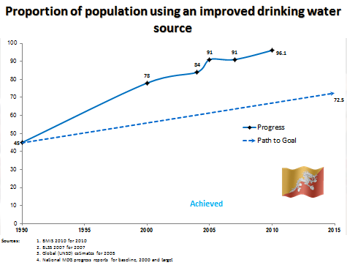

Nevertheless, an estimated four percent of the population still does not have access to improved drinking water sources. These individuals live in rural, remote households and are overwhelmingly from the poorest wealth quintile. These households are often the same that lack improved sanitation facilities and other resources that protect against illness.
In addition, the functionality of the piped water supply schemes requires improvement. Analysis of the RWSS Management Information System (MIS) administrative data from 15 districts in 2006 revealed that while 40 percent of the RWSS schemes were functioning very well, 33 percent were working well with some minor problem, remaining 17 percent were functioning with a need for improvement, and 10 percent were non-functional. The analysis of the inventory revealed that dzongkhags with high functional schemes had high coverage of trained caretakers compared with dzongkhags with least functional schemes. The analysis concluded that functionality of water supply schemes is positively impacted by the presence and maintenance of trained caretakers.

10.2.1 Drinking Water Facilities and Diarrhoea Incidence
Ample evidence shows that quality drinking water reduces the risk of acquiring diarrhoea. UNICEF research indicates that improved water sources reduce diarrhoeal incidence by approximately 25 percent. The Royal Government of Bhutan has defined safe drinking water as a basic necessity and has consequently accorded high priority to provide safe drinking water to all the households in Bhutan. Given the strong relationship between the quality of a household’s water source and diarrhoea, this analysis assessed the percentage of children under the age of 5 who had diarrhoea in the two weeks preceding the survey by whether the household uses an improved drinking water source. Table 65 below shows that 32 percent of children in households without an improved water source had diarrhoea in the two weeks prior to the survey compared with 25 percent of children in households with an improved water source. This difference is statistically and practically significant in that it indicates a 30 percent higher likelihood of having diarrhoea in children living in homes without an improved drinking water source than for those who have an improved source.
Table 65 also examines diarrhoea incidence among children by type of drinking water, controlling for type of sanitation facilities. Controlling for use of improved sanitation in the home, The data show that diarrhoea incidence of children in households with an unimproved drinking water source is statistically higher than in homes without an improved drinking water source (35 percent versus 25 percent, respectively).
Overall, the RGoB has achieved significant progress in realising its goal to provide safe drinking water to the Bhutanese population. BMIS 2010 reveals that 96 percent of all households have an improved drinking water source. However, those without improved drinking water source are disproportionately those from the two poorest wealth quintiles, rural areas, and those without improved sanitation facilities. Children in these homes face multiple vulnerabilities and deprivations that compound their risk of illness. These data indicate that achieving 100 percent coverage of improved drinking water sources to all households is one mechanism by which to mitigate diarrhoea incidence among children and as such, remains a worthy policy objective.

Table 65: Percentage of children who had diarrhoea in the two weeks preceding the survey, according to availability of improved drinking water in the household, Bhutan, 2010
 |  | Household has unimproved drinking water sources |  | Household has improved drinking water sources |  | Total number of children under 5
 |  | Had diarrhoea in last two weeks  (percentage) | Number of children under 5 | Had diarrhoea in last two weeks  (percentage) | Number of children under 5 | Total number of children under 5
Area | Urban | * | 8 | 25.4 | 1,833 | 1,841
Area | Rural | 33.2 | 236 | 24.6 | 4,220 | 4,456
Wealth index quintiles | Poorest | 33.1 | 110 | 25.7 | 1,184 | 1,294
Wealth index quintiles | Second | 22.8 | 69 | 25.2 | 1,090 | 1,159
Wealth index quintiles | Middle | [39.0] | 39 | 27.7 | 1,158 | 1,197
Wealth index quintiles | Fourth | * | 22 | 26.7 | 1,416 | 1,438
Wealth index quintiles | Richest | * | 3 | 18.8 | 1,205 | 1,208
Mother's education | None | 30.7 | 218 | 26.3 | 3,989 | 4,207
Mother's education | Primary | * | 20 | 26.1 | 762 | 781
Mother's education | Secondary | * | 6 | 19.7 | 1,303 | 1,309
Sanitation facilities | Use of Unimproved Sanitation Facilities | 30.8 | 155 | 24.5 | 1,949 | 2,104
Sanitation facilities | Use of Improved Sanitation Facilities | 35 | 89 | 25 | 4,104 | 4,193
Total |  | 32.3 | 244 | 24.8 | 6,053 | 6,297

The most significant public health concern for the drinking water supply in Bhutan is microbiological contamination. Water-related diseases caused by ingestion broadly falls in the water borne and water washed categories. Water borne diseases are caused by the ingestion of water contaminated by human or animal faeces or urine that contains pathogens. Water washed diseases are caused by inadequate use of water for domestic and personal hygiene. Diarrhoea falls in both of these categories.
This analysis tested diarrhoea incidence in households that use unimproved drinking water sources, by the type of treatment used to improve water quality. BMIS data show that boiling and filtering are the most common treatments used at the household level to improve water quality. Diarrhoea incidence was tested by whether a household boils its water, uses a filter, or uses another inappropriate treatment option. As shown in Table 66 below, diarrhoea incidence stands at 34 percent for households using inappropriate treatment method, which is 10 percentage points higher compared to households that uses boiling and 14 percentage points higher for households that use a filter. While there is no statistically significant difference between filtering and boiling, it is evident that the use of an appropriate water treatment option reduces the prevalence of diarrhoeal diseases among children.

Table 66: Percentage of children under 5 who had diarrhoea in the two weeks preceding the survey type of treatment used for drinking water in households without improved drinking water sources, Bhutan, 2010
 |  | Boil |  | Use water filter |  | Household does not use appropriate water treatment method |  | Number of children under 5
 |  | Had diarrhoea in last two weeks  (percentage) | Number of children under 5 | Had diarrhoea in last two weeks  (percentage) | Number of children under 5 | Had diarrhoea in last two weeks  (percentage) | Number of children under 5 | Number of children under 5
Area | Urban | 25.3 | 1,705 | 18.6 | 957 | * | 1 | 1,841
Area | Rural | 23.7 | 3,127 | 23.7 | 541 | 34.4 | 116 | 4,456
Wealth index quintiles | Poorest | 25.1 | 778 | * | 8 | 33.7 | 49 | 1,294
Wealth index quintiles | Second | 24.2 | 740 | [23.5] | 30 | [31.2] | 35 | 1,159
Wealth index quintiles | Middle | 27.2 | 908 | 29.2 | 118 | [33.0] | 26 | 1,197
Wealth index quintiles | Fourth | 26.9 | 1,295 | 25.4 | 442 | * | 7 | 1,438
Wealth index quintiles | Richest | 18.4 | 1,110 | 16.7 | 900 | * | 0 | 1,208
Education of household head | None | 26.2 | 2,666 | 23.8 | 394 | 34.8 | 105 | 3,847
Education of household head | Primary | 26.3 | 845 | 29.7 | 240 | * | 12 | 1,024
Education of household head | Secondary + | 19.0 | 1,319 | 16.4 | 864 | * | 1 | 1,423
Total |  | 24.3 | 4,832 | 20.4 | 1,498 | 34.1 | 117 | 6,297
Households may use more than one water treatment method; Data for two cases in which the education of the household head is not known are not shown.

10.2.2 Time to Collect Water and Diarrhoea Incidence
One of the key factors that compromises water quality is the unsafe transport and storage of water. The more time that is required to transport water to the household, the greater the likelihood of contamination of the water. A household with water on premises is one that has water piped directly into the dwelling, compound, or to a neighbour or uses a public tap or standpipe. A household that obtains its water off premises is the one in which the water source is located outside its dwelling or compound. Households that collect and transport water from an off-premises site risk more exposure to fecal contamination at the water source than those with an on-premises water source. For this reason, this analysis tests whether the incidence of diarrhoea among children under the age of five differs by whether the household has water on or off premises.
Table 67 below shows that 25 percent of children in households with water on premises experienced diarrhoea in the two weeks preceding the survey compared with 31 percent of children in households with water off premises. This difference is statistically significant and indicates that children in households with water off premises are 25 percent more likely to experience diarrhoea in than children in household with water on premises.
Even when controlling for the household having access to improved sanitation facilities, the difference in the incidence of diarrhoea by whether the household has an on- or off-premises water source holds. The diarrhoea incidence rate of children in households with an improved sanitation facility and an on-premises water source is estimated at 25 percent compared with 30 percent for children in households with improved sanitation but with the water source located off-premises. Continued efforts to provide a piped water supply to households will contribute to a reduction in the incidence of diarrhoeal and other water-related illnesses. However, the finding above which estimates the diarrhoea incidence rate of children in households with an improved sanitation facilities and improved water source to be 25 percent indicates that factors other than water and sanitation contribute to the significant prevalence of diarrhoea among young children.

Table 67: Percentage of children under 5 who had diarrhoea in the two weeks preceding the survey by whether household has water on the premises, Bhutan, 2010
 |  | Water on premises |  | Water off premises |  | Number of children under 5
 |  | Had diarrhoea in last two weeks  (percentage) | Number of children under 5 | Had diarrhoea in last two weeks  (percentage) | Number of children under 5 | Number of children under 5
Area | Urban | 25.2 | 1,791 | 29.5 | 49 | 1,841
Area | Rural | 24.4 | 4,036 | 30.9 | 418 | 4,456
Drinking water | Not using improved sources | 32.5 | 56 | 31.8 | 187 | 244
Drinking water | Using improved sources | 24.6 | 5,772 | 30.0 | 280 | 6,053
Sanitation facilities | Not using improved facilities | 24.0 | 1,850 | 31.5 | 254 | 2,104
Sanitation facilities | Using improved facilities | 24.9 | 3,978 | 29.9 | 214 | 4,193
Education of household head | None | 26.0 | 3,503 | 34.7 | 343 | 3,847
Education of household head | Primary | 27.5 | 933 | 20.9 | 91 | 1,024
Education of household head | Secondary + | 19.3 | 1,389 | [17.3] | 33 | 1,423
Wealth index quintiles | Poorest | 25.4 | 1,147 | 32.5 | 146 | 1,294
Wealth index quintiles | Second | 23.6 | 1,016 | 35.2 | 143 | 1,159
Wealth index quintiles | Middle | 28.4 | 1,095 | 24.6 | 103 | 1,197
Wealth index quintiles | Fourth | 27.0 | 1,368 | 27.1 | 70 | 1,438
Wealth index quintiles | Richest | 18.7 | 1,201 | * | 6 | 1,208
Total |  | 24.7 | 5,827 | 30.8 | 467 | 6,297
Data for two cases in which the education of the household head is not known are not shown.

For households that obtain water off-premises, it is customary to categorise the time required to collect and transport water as being between 0-30 minutes or 30 minutes or more, round-trip. Table 68 below shows that for households which require less than 30 minutes to collect water, the diarrhoea incidence of children under the age of five is 33 percent compared with 26 percent for children in households that require 30 minutes or more for water collection. One may expect that water contamination would increase in line with the time required to collect water, thus raising the incidence of diarrhoeal diseases. However, the findings indicate that the diarrhoeal incidence of children in households that require more time to collect water is lower than for children in households in which the water collection time is under 30 minutes. One possible explanation for this may be that households that require less time to collect water may use a source that is in closer proximity to human settlements, which increases the likelihood of contamination. Households that require more time to collect water may use more remote sources that have a lower likelihood of contamination.

Table 68: Percentage of children under 5 who had diarrhoea in the two weeks precediing the survey, by the time needed to collect water, Bhutan, 2010
 |  | Time to source of drinking water |  |  |  | Total number of children under 5
 |  | Less than 30 minutes |  | 30 minutes or more |  | Total number of children under 5
 |  | Had diarrhoea in last two weeks  (percentage) | Number of children under 5 | Had diarrhoea in last two weeks  (percentage) | Number of children under 5 | Total number of children under 5
Area | Urban | [35.1] | 40 | * | 9 | 49
Area | Rural | 32.2 | 304 | 27.5 | 115 | 418
Education of household head | None | 35.7 | 251 | 32 | 92 | 343
Education of household head | Primary | 25.7 | 67 | * | 25 | 91
Education of household head | Secondary + | [19.7] | 26 | * | 7 | 33
Wealth index quintiles | Poorest | 33.3 | 103 | [30.7] | 43 | 146
Wealth index quintiles | Second | 37.7 | 103 | [28.6] | 40 | 143
Wealth index quintiles | Middle | 26.2 | 80 | * | 23 | 103
Wealth index quintiles | Fourth | 28.6 | 55 | * | 15 | 70
Wealth index quintiles | Richest | * | 2 | * | 4 | 6
Drinking water | Not using improved sources | 38 | 110 | 23.1 | 77 | 187
Drinking water | Using improved sources | 30 | 234 | 30.3 | 46 | 280
Sanitation facilities | Not using improved facilities | 30.5 | 193 | 34.4 | 61 | 254
Sanitation facilities | Using improved facilities | 35.1 | 151 | 17.6 | 63 | 214
Total |  | 32.5 | 344 | 25.8 | 124 | 467
Data for 2 cases in which the education of the household head is missing are not shown

Table 69 looks a little more closely at the types of water sources used for households that take less than 30 minutes to collect water. 56 percent of these households use the public tap stand, making it their most common source of water. Another 20 percent use surface water, making this the only other significant source for these households.

Table 69: Distribution of type of drinking water facilities for households that do not have water on the premises and for which the time to collect water is less than 30 minutes, Bhutan, 2010
 |  | Time to collect water: less than 30 minutes
 |  | Main source of drinking water
 |  | Public outdoor tap  (percentage) | Protect-ed well  (percentage) | Unprotect-ed well  (percentage) | Spring  (percentage) | Unprotect-ed spring  (percentage) | Cart with small tank/drum  (percentage) | Surface water  (percentage) | Other  (percentage) | Total | Number of children under 5
Area | Urban | 92.9 | 0.0 | 0.0 | 1.6 | 0.0 | 0.0 | 5.5 | 0.0 | 100 | 65
Area | Rural | 52.5 | 3.5 | 1.8 | 10.1 | 9.7 | 0.5 | 21.3 | 0.7 | 100 | 653
Education of household head | None | 54.6 | 3.9 | 2.0 | 9.0 | 8.6 | 0.5 | 21.0 | 0.4 | 100 | 564
Education of household head | Primary | 57.4 | 0.0 | 0.3 | 9.2 | 12.2 | 0.8 | 20.2 | 0.0 | 100 | 104
Education of household head | Secondary | 71.2 | 0.8 | 0.0 | 13.5 | 4.4 | 0.0 | 5.6 | 4.5 | 100 | 50
Wealth index quintiles | Poorest | 45.9 | 2.7 | 2.0 | 12.3 | 12.5 | 0.2 | 23.7 | 0.7 | 100 | 221
Wealth index quintiles | Second | 53.7 | 5.3 | 0.9 | 5.9 | 11.8 | 0.6 | 21.7 | 0.1 | 100 | 194
Wealth index quintiles | Middle | 61.7 | 2.5 | 2.9 | 11.3 | 4.3 | 0.0 | 16.7 | 0.7 | 100 | 199
Wealth index quintiles | Fourth | 73.0 | 0.0 | 0.0 | 5.5 | 4.6 | 1.7 | 14.0 | 1.2 | 100 | 97
Wealth index quintiles | Richest | * | * | * | * | * | * | * | * | * | 7
Total |  | 56.1 | 3.2 | 1.6 | 9.3 | 8.8 | 0.5 | 19.8 | 0.6 | 100 | 718

Figure 42 below illustrates the distribution of type of water source for households that require less than 30 minutes to collect water. It shows that the clear majority obtain water from a public tap stand, indicating the likelihood these households live in close proximity to human settlements.

Figure 42: Distribution of type of drinking water facilities for those households that do not have water on the premises and the time to collect water is less than 30 minutes, Bhutan, 2010
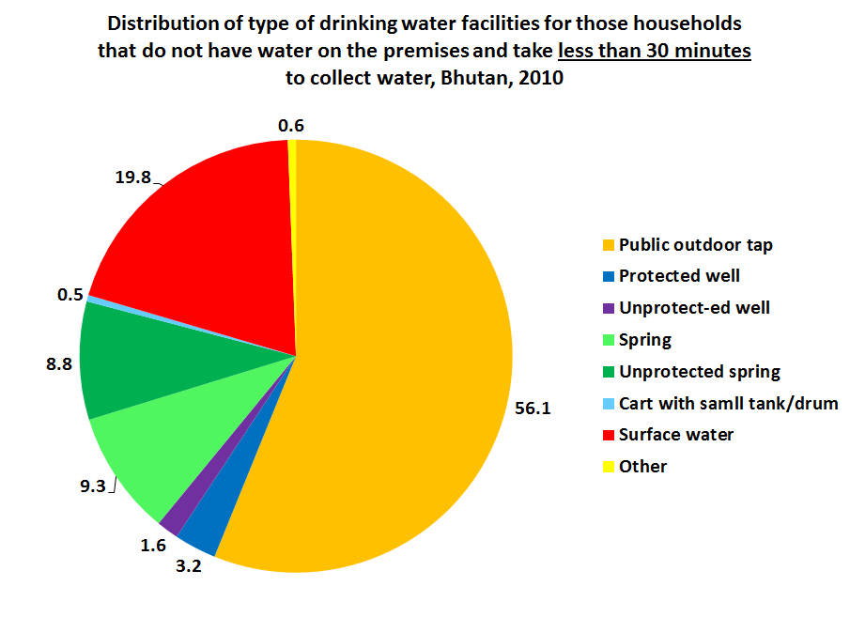

Table 70 below shows the distribution of the types of water sources of households whose members have to travel 30 minutes or more to collect water. These households are more likely to represent the poorest wealth quintile than those that take less time to collect water. It shows that these households obtain water in a very different manner than households that require less time to collect water. The majority of households use surface water at their main source (31 percent). This is followed by the use of unprotected springs (23 percent) and public outdoor taps (17 percent).

Table 70: Distribution of type of drinking water facilities for those households that do not have water on the premises and the time to collect water is 30 minutes or more, Bhutan, 2010
 |  | Time to collect water: 30 minutes or more
 |  | Main source of drinking water
 |  | Public outdoor tap  (percentage) | Protected well  (percentage) | Unprotect-ed well  (percentage) | Spring  (percentage) | Unprotected spring  (percentage) | Tanker-truck  (percentage) | Cart with small tank/drum  (percentage) | Surface water  (percentage) | Other  (percentage) | Total | Number of children under 5
Area | Urban | * | * | * | * | * | * | * | * | * | * | 16
Area | Rural | 16.9 | 4.3 | 5.9 | 15.9 | 23.7 | 0.4 | 0.0 | 30.6 | 2.5 | 100 | 240
Education of household head | None | 20.4 | 4.9 | 6.8 | 17.3 | 18.8 | 0.0 | 0.0 | 29.0 | 3.0 | 100 | 201
Education of household head | Primary | [2.2] | [1.3] | [1.2] | [8.2] | [44.6] | [2.2] | [0.0] | [40.4] | [0.0] | 100 | 42
Education of household head | Secondary + | * | * | * | * | * | * | * | * | * | * | 13
Wealth index quintiles | Poorest | 15.9 | 2.2 | 9.8 | 12.1 | 23.8 | 0.0 | 0.0 | 31.8 | 4.6 | 100 | 101
Wealth index quintiles | Second | 24.1 | 3.6 | 4.2 | 19.8 | 27.1 | 0.0 | 0.0 | 20.3 | 0.9 | 100 | 77
Wealth index quintiles | Middle | [10.4] | [5.4] | [2.1] | [17.0] | [18.9] | [0.0] | [0.0] | [44.8] | [1.4] | 100 | 46
Wealth index quintiles | Fourth | [9.3] | [7.8] | [0.0] | [25.3] | [18.4] | [0.0] | [5.5] | [33.5] | [0.0] | 100 | 23
Wealth index quintiles | Richest | * | * | * | * | * | * | * | * | * | * | 9
Total |  | 16.5 | 4.0 | 5.5 | 16.9 | 22.6 | 0.4 | 0.5 | 31.3 | 2.3 | 100 | 256
Data for 2 cases in which the education of the household head is missing are not shown
Of the households in this sample, none source drinking water from piped facilities or from rainwater collection, tanker trucks, or bottled water (except for 0.4 percent of households who take 30 minutes or more to collect water who obtain water from tanker trucks.

Figure 43 illustrates the distribution of the types of water sources of households whose members travel 30 minutes or more to collect water. The majority of households obtain water from surface water and unprotected springs, which is a very different pattern than Figure 42 above. These data alongside the higher likelihood that these households are very poor, suggest that they may be from more remote communities in the country.

Figure 43: Distribution of type of drinking water facilities for those households that do not have water on the premises and for which the time to collect water is 30 minutes or more, Bhutan, 2010
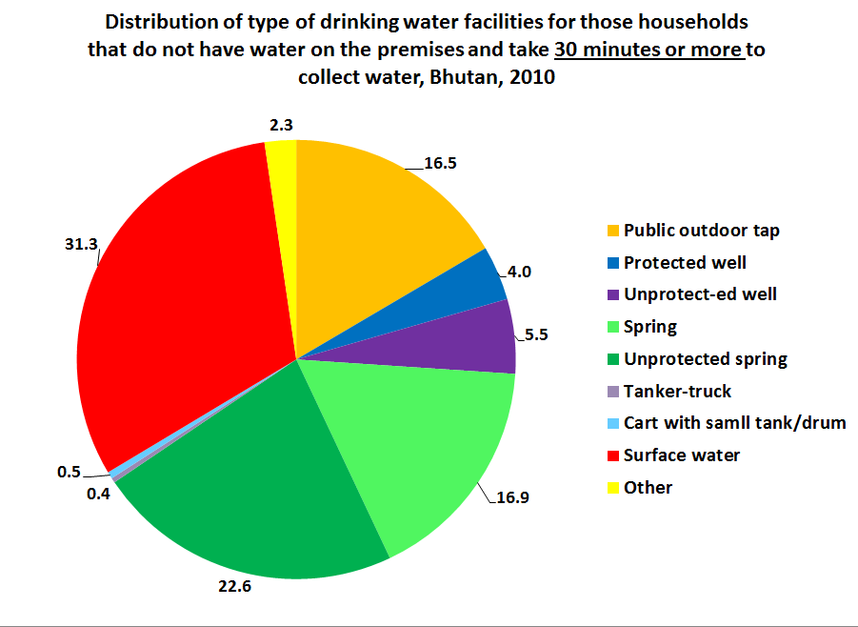

10.3 Sanitation and hygiene
Inadequate disposal of human excreta and personal hygiene is associated with a range of diseases, including diarrhoeal diseases. An improved sanitation facility is defined as one that hygienically separates human excreta from human contact and is not shared by more than one household. Improved sanitation can reduce diarrhoeal disease by more than a third and can significantly lessen the adverse health impacts of other disorders responsible for death and disease among millions of children in developing countries. Improved sanitation facilities for excreta disposal include flush or pour flush to a piped sewer system, septic tank, or latrine, ventilated improved pit latrine, pit latrine with a slab, and composting toilet.
Historically, however, the definition of an improved sanitation facility in rural areas of Bhutan has included pit latrines without slabs. Under this definition that includes pit latrines without slabs, the 2011 AHB estimates that 91 percent of the population has access to improved sanitation. The 2005 PHCB, which uses the same definition, estimated improved sanitation coverage at 84 percent in that year.
However, the 2010 Joint Monitoring Programme (JMP) report, which excludes pit latrines without slabs from the definition, estimates that in 2008, 65 percent of the population had access to improved sanitation. Using the same globally recognised definition, the BMIS 2010 estimates that 58 percent of the population has access to improved sanitation. The higher estimates of the AHB and PHCB are due to the exclusion of pit latrines without slabs and shared facilities from the global definition of improved sanitation employed by the JMP and BMIS.
BMIS estimates of access to improved sanitation facilities show a considerable disparity by area of location. 78 percent of the urban population has access to improved sanitation compared with only 51 percent of the rural population. This inequality in access to improved sanitation is even more pronounced by wealth status. The population in the richest households is three times as likely to have access to improved sanitation than those from the poorest wealth quintile (95 percent and 32 percent, respectively).
In summary, the MDG 7 target for sanitation is to reduce by half the proportion of population without access to basic sanitation between 1990 and 2015. Although, JMP does not have baseline data for Bhutan in 1990, Bhutan’s progress on access to improved sanitation is considered insufficient.

10.3.1 Sanitation and diarrhoeal incidence
Another cause of diarrhoea among children is unsafe disposal of their faeces. Safe disposal of child faeces includes the child using a toilet or latrine or putting or flushing the faeces into the toilet or latrine. All other methods are considered unsafe and include putting or flushing the faeces into a drain, throwing it into the garbage, burying the faeces in any way, or leaving it in the open.
Table 71 below shows the difference in diarrhoea incidence among children under the age of three by whether their faeces are disposed of in a safe or unsafe method. The data indicate that 35 percent of children in homes with unsafe disposal of their faeces had diarrhoea as compared with 27 percent among children in households with safe disposal of diarrhoea, a difference that is statistically significant. In other words, unsafe disposal of child faeces is associated with a 30 percent higher risk of children under the age of three having diarrhoea.

Table 71: Percentage of children under 3 who had diarrhoea in the two weeks preceding the survey, by whether their stool was disposed of safely, Bhutan, 2010
 |  | Was stool disposed of safely? |  |  |  | Number of children under 3
 |  | No |  | Yes |  | Number of children under 3
 |  | Had diarrhoea in last two weeks  (percentage) | Number of children under 3 | Had diarrhoea in last two weeks  (percentage) | Number of children under 3 | Number of children under 3
Area | Urban | 38.1 | 256 | 26.5 | 874 | 1,130
Area | Rural | 34 | 1,360 | 26.5 | 1,308 | 2,668
Mother's education | None | 34.5 | 1,176 | 29.1 | 1,299 | 2,474
Mother's education | Primary | 35.2 | 205 | 32.4 | 251 | 457
Mother's education | Secondary | 34.9 | 235 | 18.9 | 633 | 867
Wealth index quintiles | Poorest | 30.2 | 454 | 31.9 | 299 | 753
Wealth index quintiles | Second | 33.7 | 396 | 25.2 | 296 | 692
Wealth index quintiles | Middle | 38 | 419 | 28.6 | 335 | 754
Wealth index quintiles | Fourth | 40.8 | 251 | 28.1 | 610 | 862
Wealth index quintiles | Richest | 28.2 | 96 | 22 | 642 | 738
Total |  | 34.6 | 1,616 | 26.5 | 2,182 | 3,798

Figure 44 illustrates the data presented in Table 71 above, showing the higher rate of diarrhoea among children under the age of three who live in households in which the child’s stool is disposed of in an unsafe manner.

Figure 44: Percentage of children under 3 who had diarrhoea in the last two weeks, by whether their stool was disposed of safely, Bhutan, 2010
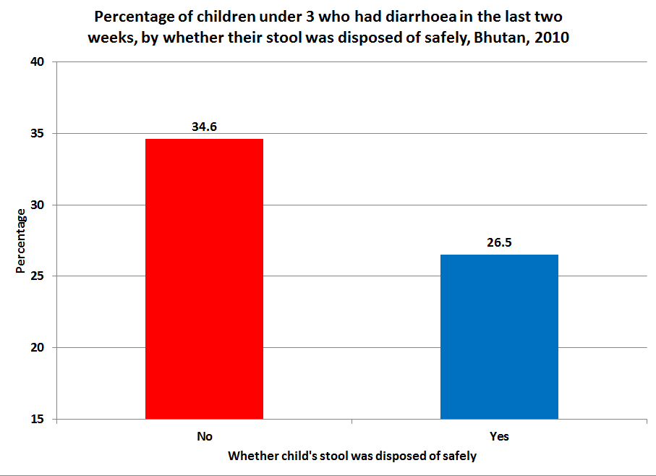

Table 72 below looks more closely at the diarrhoea incidence rate of children under the age of three by the exact method used by the household to dispose of their stools. It shows a near equivalent rate of diarrhoea among children who use a toilet or latrine and those whose stools are disposed of directly into a toilet and latrine (27 percent and 26 percent, respectively). These figures stand in contrast to the statistically higher rates of diarrhoea among children whose stools were disposed of by any of the unsafe methods. Of the methods for which there was a sufficient sample size to generate a robust estimate, throwing faeces into the garbage produced the highest incidence of diarrhoea (38 percent).

Table 72: Percentage of children under 3 who had diarrhoea in the two weeks preceding the survey, by the method by which their stool was disposed, Bhutan, 2010
 | Place of disposal of child's stool
 | Child used toilet / latrine |  | Put / Rinsed into toilet or latrine |  | Put / Rinsed into drain or ditch |  | Thrown into garbage (solid waste) |  | Buried |  | Left in the open
 | Had diarrh-oea  in last two weeks  (percentage) | Number of children under 3 | Had diarrho-ea in last two weeks  (percentage) | No. of children under 3 | Had diarrho-ea in last two weeks  (percentage) | Number of children under 3 | Had diarrhoea in last two weeks  (percentage) | Number of children under 3 | Had diarrhoea in last two weeks  (percentage) | Number of children under 3 | Had diarrhoea in last two weeks  (percentage) | Number of children under 3
Total | 26.7 | 687 | 26.4 | 1,496 | 35.3 | 1,187 | 37.9 | 145 | * | 39 | 32.4 | 194
Only 21 children (unweighted) had stool that was buried. For this reason, it is not possible to provide a robust estimate. However, for those 21 cases, the estimate is 42%

Figure 45 below illustrates the data presented in Table 72 above, clearly showing that children under the age of three whose stools were disposed of safely have a lower rate of diarrhoea incidence than those whose stools were disposed of by any one of the unsafe methods.

Figure 45: Percentage of children under 3 who had diarrhoea in the last two weeks, by whether their stool was disposed of safely, Bhutan, 2010
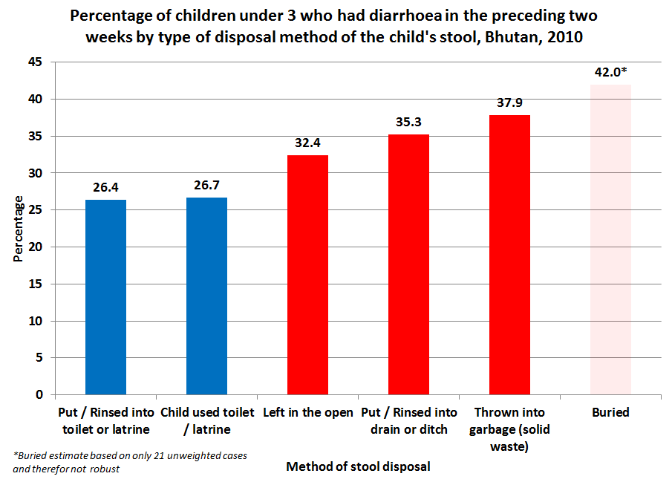

Figure 46 below shows the diarrhoea incidence of children under the age of five by the quality of sanitation facilities and by whether the child practices open defecation. This analysis observed a slightly higher percentage of diarrhoea for children under the age of five in households with improved sanitation facilities than for children in households with unimproved sanitation facilities. While the observed rate of diarrhoea incidence in children who openly defecate is higher, none of the observed differences between these three categories are statistically significant. In addition, BMIS 2010 estimates that 3 percent of the population engages in open defecation in Bhutan, making this practice relatively rare and in decline. The Ministry of Health’s objective is to eradicate the practice entirely and to expand access to improved sanitation facilities for all.
This may indicate that improved sanitation facility alone cannot reduce diarrheal incidence. In addition, the sanitation facilities categorised as an improved facility may not be functionally sanitary and/or of the required standard and quality. In addition to the quality of sanitation facilities, there are many factors that contribute to diarrhoeal diseases such as personal hygiene, safe drinking water, and hand washing practices amongst others. To address this issue, PHED, with technical assistance from SNV, has been implementing the Rural Sanitation and Hygiene Promotion programme to bring about sustainable improvement in rural sanitation and hygiene behaviour.

Figure 46: Percentage of children under 5 who had diarrhoea in the last two weeks, against the type of toilet facility used in the household
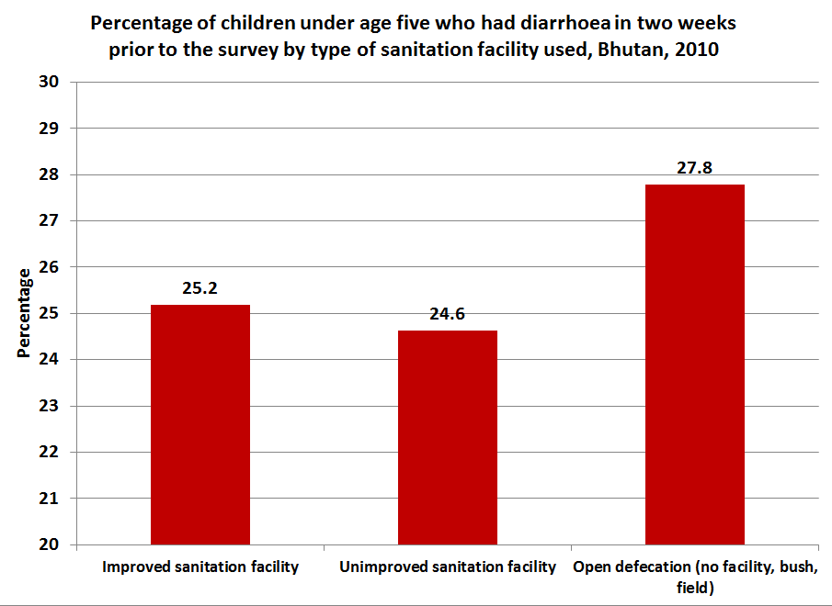

10.3.2 Hand washing facilities and diarrhoeal incidence
It is very difficult to measure whether individuals practice hand washing with soap on a regular basis. For this reason, household surveys routinely use the availability of hand washing facilities with water and soap as a proxy indicator for proper hygienic practices. This analysis considered whether the incidence of diarrhoea among children under the age of five differed by the extent to which hand washing facilities, soap and water were available in the household at the time of the survey. These findings should be treated with caution as presence of a hand washing place does not necessary translate into practice of hand washing with soap.
Table 73 shows no significant difference in the incidence of diarrhoea among children under the age of five between those who live in a household with both water and soap (25 percent), and those in households with water but no soap (23 percent). Children in households with soap but no water had a statistically higher level of diarrhoea than children in the former two groups (29 percent). Although soap was not available at the hand washing place, almost 100 percent of the households in Bhutan had soap available in their dwelling. Therefore, from a programmatic perspective, it is very important to ensure that clean water is available to promote hand washing practices.

Table 73: Percentage of children under 5 who had diarrhoea in the two weeks preceding the survey, by availability of handwashing facilities at household, Bhutan, 2010
 |  | Both water and soap available |  | Water available, but not soap |  | Soap available, but not water |  | Neither water nor soap available |  | Number of children under 5
 |  | Had diarrhoea in last two weeks  (percentage) | Number of children under 5 | Had diarrhoea in last two weeks  (percentage) | Number of children under 5 | Had diarrhoea in last two weeks  (percentage) | Number of children under 5 | Had diarrhoea in last two weeks  (percentage) | Number of children under 5 | Number of children under 5
Area | Urban | 25 | 1,613 | 36.1 | 74 | 19.4 | 116 | [35.6] | 38 | 1,841
Area | Rural | 24.6 | 3,318 | 20.8 | 461 | 32.2 | 409 | 26.4 | 267 | 4,456
Wealth index quintiles | Poorest | 25.4 | 935 | 26.4 | 149 | 32.3 | 129 | 27.8 | 82 | 1,294
Wealth index quintiles | Second | 25.6 | 878 | 16 | 106 | 32.5 | 112 | 18.5 | 63 | 1,159
Wealth index quintiles | Middle | 28.2 | 842 | 23.8 | 158 | 29.7 | 99 | 31.7 | 98 | 1,197
Wealth index quintiles | Fourth | 26.8 | 1,165 | 25.8 | 103 | 28.3 | 119 | 31 | 51 | 1,438
Wealth index quintiles | Richest | 18.8 | 1,111 | * | 19 | 19.7 | 66 | * | 11 | 1,208
Total |  | 24.8 | 4,931 | 23 | 536 | 29.4 | 525 | 27.5 | 305 | 6,297

The analysis also considered the association between access to an improved drinking water source and the availability of a hand washing facility equipped with water and soap. Table 74 below shows that 80 percent of households with an improved drinking water source also have a hand washing facility with soap and water. This compares to only 42 percent of households that do not have an improved source of drinking water. In other words, there is a clearly positive correlation between having an improved source of drinking water and the presence of facilities needed to practice good hygiene.
Table 74 also shows this relationship by whether the household has an improved sanitation facility. As with drinking water, households with an improved sanitation facility are more likely to have hand washing facilities with soap and water than households without improved sanitation (83 versus 70 percent, respectively). Together, these data suggest that the presence of improved water and/or sanitation facilities encourage investment in hand washing facilities with soap and water.

Table 74: Percentage of households with hand-washing facilities by quality of drinking water and sanitation facilities, Bhutan, 2010
 |  | Not using improved sources of drinking water |  | Using improved sources of drinking water |  | Unimproved sanitation facilities |  | Improved sanitation facilities |  | Number of households
 |  | % of households with water & soap | Number of households | % of households with water & soap | Number of households | % of households with water & soap | Number of households | % of households with water & soap | Number of households | Number of households
Area | Urban | * | 15 | 87.8 | 4,305 | 71 | 247 | 88.6 | 4,073 | 4,320
Area | Rural | 42.6 | 502 | 76.6 | 9,854 | 70.4 | 4,508 | 78.5 | 5,849 | 10,356
Education of household head | None | 42.2 | 405 | 76.4 | 8,859 | 69.8 | 4,044 | 78.8 | 5,220 | 9,265
Education of household head | Primary | 40.6 | 94 | 81.7 | 2,040 | 73 | 508 | 82.1 | 1,627 | 2,134
Education of household head | Secondary + | * | 17 | 88.9 | 3,258 | 75.9 | 202 | 89.5 | 3,073 | 3,275
Wealth index quintiles | Poorest | 45.6 | 224 | 72 | 2,538 | 67.1 | 1,867 | 75.6 | 895 | 2,762
Wealth index quintiles | Second | 41.6 | 146 | 75.9 | 2,703 | 70.6 | 1,493 | 78 | 1,355 | 2,849
Wealth index quintiles | Middle | 36.1 | 103 | 76.2 | 2,890 | 73.9 | 1,072 | 75.4 | 1,920 | 2,992
Wealth index quintiles | Fourth | [41.3] | 38 | 83 | 3,049 | 75.9 | 299 | 83.2 | 2,788 | 3,087
Wealth index quintiles | Richest | * | 6 | 91.2 | 2,980 | [88.7] | 23 | 91.1 | 2,963 | 2,986
Sanitation facilities | Unimproved | 43.8 | 308 | 72.2 | 4,447 | 43.8 | 308 | 38.7 | 208 | 4,755
Sanitation facilities | Improved | 38.7 | 208 | 83.6 | 9,713 | 72.2 | 4,447 | 83.6 | 9,713 | 9,921
Total |  | 41.8 | 516 | 80 | 14,160 | 70.4 | 4,755 | 82.6 | 9,921 | 14,676

Figure 47 illustrates the data presented above in Table 74. It shows the strong association between having an improved drinking water source and/or improved sanitation facility, and the presence of hand washing facilities with soap and water.

Figure 47: Percentage of households with hand-washing facilities by quality of drinking water and sanitation facilities, Bhutan, 2010
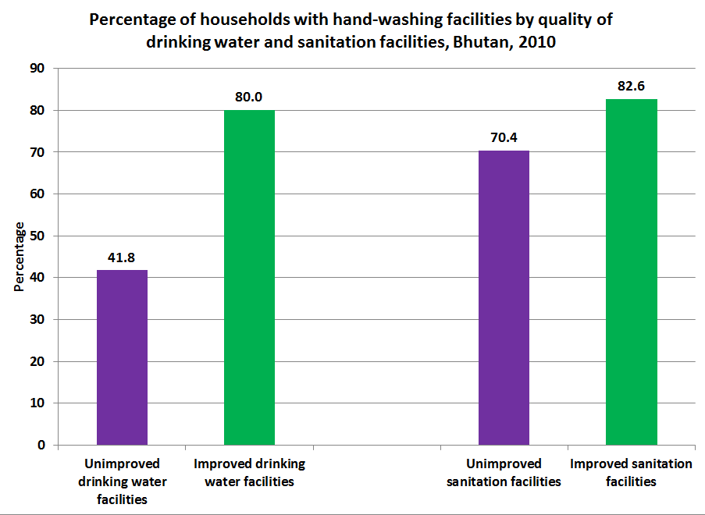

10.4 Section summary
Safe drinking water is a key factor for good health in general, and in particular, for children’s health. The situation of access to safe drinking water in Bhutan has improved considerably since 1990. According to BMIS 2010, the proportion of the population without access to safe drinking water declined from 55 percent in 1990 to only 4 percent in 2010. The findings indicate that children who live in households without an improved water source are at a greater risk of experiencing diarrhoea than children in households with an improved water source.
Although people may have access to an improved drinking water supply, if the source is off-premises, water is often contaminated during transportation and storage. Controlling for the availability of improved sanitation facilities, the diarrhoeal incidence rate of children in households with an on-premises water source is lower than for children in households with an off-premises water source. This indicates that continued efforts to provide a piped water supply to households will contribute to a reduction in the incidence of diarrhoeal and other water-related illnesses. In the absence of a piped water supply, the data suggest that use of an appropriate water treatment reduces the prevalence of diarrhoeal disease among children.
The data also show that diarrhoeal incidence among children in households that require under 30 minutes to collect water is higher than in households in which the water collection time is higher. This suggests that off-premises water sources close to homes are more likely to be contaminated by sources originating from nearby human settlements.
Diarrhoeal incidence among children whose faeces are unsafely disposed of is higher than among children whose faeces are safely disposed of. Unsafe disposal of child faeces increases the risk of diarrhoeal disease for children under three by 30 percent. No difference was observed, however, in diarrhoeal incidence among children under the age of five between improved sanitation facilities, unimproved sanitation facilities, and open defecation, suggesting that access to improved sanitation facilities alone cannot reduce diarrhoeal incidence.
Children in households with soap but no water had a statistically higher incidence of diarrhoea than children in households where water was available but not soap, and households with both soap and water available. This underpins, once more, the importance of making clean water available in the households.
Overall, Bhutan has achieved remarkable progress in delivering safe water supplies to the population. However, Bhutan’s progress on access to improved sanitation facilities is considered insufficient by JMP standards, which exclude pit latrines without slabs and shared toilets. More effort will be required in order to achieve MDG 7 by 2015.

Annex 1: Additional tables
This annex gives additional background information on the profile of children and other background information.

1. Distribution of child population by wealth quintiles, Bhutan, 2010
 |  | Wealth index quintiles |  |  |  |  | Total | Number of individuals
 |  | Poorest | Second | Middle | Fourth | Richest | Total | Number of individuals
Sex | Male | 20.4 | 19.6 | 19.5 | 21.1 | 19.4 | 100 | 12,847
Sex | Female | 20.1 | 18.5 | 19.5 | 21.5 | 20.4 | 100 | 12,923
Dzongkhag | Bumthang | 8.7 | 25.3 | 30.0 | 19.5 | 16.5 | 100 | 619
Dzongkhag | Chukha | 15.0 | 16.4 | 15.1 | 23.9 | 29.6 | 100 | 2,631
Dzongkhag | Dagana | 47.0 | 22.3 | 14.1 | 11.1 | 5.5 | 100 | 993
Dzongkhag | Gasa | 27.5 | 35.8 | 26.3 | 6.3 | 4.0 | 100 | 175
Dzongkhag | Haa | 7.0 | 8.3 | 24.7 | 41.5 | 18.4 | 100 | 500
Dzongkhag | Lhuntse | 34.8 | 27.3 | 24.0 | 9.7 | 4.2 | 100 | 585
Dzongkhag | Mongar | 36.5 | 28.2 | 13.8 | 8.5 | 13.0 | 100 | 1,843
Dzongkhag | Paro | .4 | 7.8 | 28.8 | 36.8 | 26.2 | 100 | 1,397
Dzongkhag | Pemagatshel | 25.4 | 34.2 | 20.7 | 10.5 | 9.2 | 100 | 942
Dzongkhag | Punakha | 3.4 | 15.4 | 31.7 | 32.2 | 17.3 | 100 | 996
Dzongkhag | S/jongkhar | 34.4 | 17.0 | 15.5 | 22.7 | 10.4 | 100 | 1,667
Dzongkhag | Samtse | 27.7 | 17.7 | 16.7 | 23.6 | 14.4 | 100 | 2,878
Dzongkhag | Sarpang | 12.2 | 12.1 | 21.5 | 28.7 | 25.5 | 100 | 1,518
Dzongkhag | Thimphu | .1 | 1.1 | 12.0 | 32.5 | 54.3 | 100 | 3,216
Dzongkhag | Trashigang | 21.3 | 33.0 | 31.9 | 8.7 | 5.2 | 100 | 2,086
Dzongkhag | Trashiyangtse | 15.1 | 38.9 | 23.8 | 10.9 | 11.4 | 100 | 654
Dzongkhag | Trongsa | 25.7 | 28.2 | 20.6 | 16.4 | 9.1 | 100 | 581
Dzongkhag | Tsirang | 47.1 | 27.9 | 8.2 | 8.1 | 8.7 | 100 | 797
Dzongkhag | Wangdi | 12.8 | 22.5 | 28.1 | 24.3 | 12.2 | 100 | 1,030
Dzongkhag | Zhemgang | 46.3 | 22.6 | 12.5 | 10.6 | 8.0 | 100 | 664
Area | Urban | .4 | 1.1 | 10.6 | 36.2 | 51.7 | 100 | 7,410
Area | Rural | 28.3 | 26.2 | 23.1 | 15.3 | 7.0 | 100 | 18,361
Age group | 0-4 years | 20.7 | 18.3 | 19.1 | 22.8 | 19.1 | 100 | 6,514
Age group | 5-9 years | 21.7 | 19.0 | 19.7 | 21.5 | 18.2 | 100 | 7,386
Age group | 10-17 years | 19.1 | 19.5 | 19.6 | 20.4 | 21.3 | 100 | 11,870
Total |  | 20.3 | 19.0 | 19.5 | 21.3 | 19.9 | 100 | 25,770

2: Percentage of households members that use improved quality of drinking water, sanitation facilities, have electricity, faced food insecurity in the past 12 months, and number of persons per sleeping room for households with and without at least one individual under the age of 18, Bhutan, 2010
 |  | Household has at least one individual under the age of 18
 |  | No |  | Yes
 |  | Percentage of households members | Number of households members/households | Percentage of households members | Number of households | Number of households members/ households
Sanitation facilities | Use of improved drinking water facilities | 96.6 | 8,938 | 96.1 | 58,382 | 67,320
Sanitation facilities | Use of improved sanitation facilities | 58.4 | 8,938 | 58.5 | 58,382 | 67,320
Sanitation facilities | Household has electricity | 71.8 | 8,938 | 71.6 | 58,382 | 67,320
Sanitation facilities | Household faced food insecurity | 9.1 | 8,938 | 12.3 | 58,382 | 67,320
Sanitation facilities | Household density | 1.8* | 3,672 | 3.5* | 11,004 | 14,676
* persons per sleeping room

3 Data on Siblings
Indicators on Data Quality, Bhutan 2010
 | Respondents | Siblings
Year of Birth
Before 1950 | 0 | 1.1
1950-54 | 0 | 1.9
1955-59 | 0 | 4.1
1960-64 | 5.9 | 5.9
1965-69 | 10.5 | 8.3
1970-74 | 13.1 | 11.7
1975-79 | 15 | 14.6
1980-84 | 19.2 | 16.3
1985 or later | 36.4 | 36
Total | 100 | 100
Lower year of birth | 1,960 | 1,925
Upper year of birth | 1,995 | 2,010
Median | 1,973 | 1,972
No of Cases | 13,989 | 60,559

4 Data on Sibship size
Respondents year of birth | Evolution
Respondents year of birth | Mean sibship size | Sex ratio at birth
1960-64 | 5.2 | 110.2
1965-69 | 5.3 | 110.8
1970-74 | 5.6 | 103.2
1975-79 | 5.6 | 106.2
1980-84 | 5.6 | 103.5
1985-89 | 5.3 | 109.1
1990-95 | 4.7 | 102.7

Annex 2: Additional notes on mortality estimates

2.1 The different sources for the underlying data in the UN-IGME estimates and their limitations
The underlying data for the UN-IGME trend estimates are derived from the following sources:
- Vital registration systems are the preferred source of data on child mortality because they collect information prospectively and cover the entire population. However, many developing countries lack fully functioning vital registration systems that accurately record all births and deaths. Under-reporting of deaths and births are common in vital registration systems of developing countries.
- Household surveys, such as MICS and DHS, are the primary source of data on child mortality in developing countries; but there are some limits to their quality. Estimates obtained from household surveys have uncertainty ranges that need to be considered when comparing values over time or between countries. These estimates are often affected by sampling and non-sampling errors that may affect levels and trends of child mortality.
- Like census data, survey data on child mortality may omit births and deaths, include stillbirths along with live births, and suffer from survivor selection bias and age truncation, resulting in errors in the mortality figures.
- Direct estimates of child mortality based on survey data may also suffer from mothers misreporting their children’s birth dates, current age or age at death — perhaps more so if the child has died. The heaping of deaths at age 12 months is especially common. Age heaping may result in a transfer of deaths across the one-year boundary and lead to underestimates of infant mortality rates. However, it has little effect on under-five mortality rates; making the under-five mortality rate a more robust estimate than the infant mortality rate if the information is drawn from household surveys.
- Censuses are another source for child mortality data. Information on child mortality is usually collected through questions on household deaths in the last 12 months prior to the census or the number of children ever born and the number of children surviving among women aged 15 to 49. Child mortality estimates obtained from a census usually suffer from underreporting of deaths or violation of the assumptions of the indirect method if questions on the number of children ever born and surviving are used to collect the information.

UN IGME child mortality estimates are important for following reasons:
- Many developing countries lack a single source of high quality data covering the last several decades.
- Available data collected by countries are also often inconsistent from one data source to another. It is important to analyze, reconcile and evaluate all data sources simultaneously for each country. Each new survey or data point must be examined in the context of all other sources, including previous data.
- Data sources suffer from sampling or non-sampling errors (e.g., misreporting of age, survivor selection bias). Under-reporting of child deaths are common.
- Additionally, the latest data sources produced by countries often are not current estimates, but refer to several years in the past. For this reason, UN-IGME also needs to project estimates to a common reference year.
- A consistent and comparable trend line from 1990 is needed for monitoring MDG 4.
- The UN-IGME aims to minimize the errors for each estimate and harmonize trends over time.
- Applying a consistent methodology also allows for comparisons between countries, despite the varied number and types of data sources. The UN-IGME uses original empirical data from the country to derive child mortality estimates.

Population Projections Bhutan 2005-2030, National Statistics Bureau, 2007, p10
Child Epidemiology Reference Group, WHO 2006.
WHO, UNICEF, UNFPA, The World Bank (2010). Trends in Maternal Mortality: 1990 to 2008.
WHO, UNICEF, UNFPA, The World Bank (2010). Trends in Maternal Mortality: 1990 to 2008.
Administrative data, Ministry of Health
Pneumonia: The Forgotten Killer of Children, UNICEF and WHO 2006
Drayang is a legal entertainment establishment or bar where alcohol is sold and where adolescent females are known to dance and sing karaoke. Drayangs have strong association with transactional sex and are therefore identified as risky settings for young people, particularly adolescent females.
Standard background variable categories include: age group, sex, area of residence (urban/rural), dzongkhag, educational attainment, wealth quintile, and marital status.
The number of unweighted cases in the sample is the actual number of observations for which there are data. Estimates presented in this report weight observations in order to adjust for over- or under-representation of any particular group and to produce population-wide representative estimates.
In BMIS, the households were divided into five equal groups, from “poorest” (Quintile 1) to “richest” (Quintile 5) using principal components analysis to calculate “weights”. Each variable among a set of variables that are thought to indicate wealth status are weighted and then compiled into a wealth score, which is assigned to each household. Households are then ranked into five quintiles, from richest to poorest.
Pelletier, DL.Bulletin of the World Health Organization. 1995; 73(4): 443-8.
Please see Table NU.1, BMIS 2010 Final Report.
Health facilities include: public and private hospitals and Basic Health Units (BHUs).
99 percent of all children not born in a health facility were delivered in a private home. The place of delivery for the remaining children has been categorized as “other”.
In the BMIS 2010 survey, mothers of children under the age of two were asked whether their child was weighed at birth. Women may have interpreted the meaning of “at birth” to include a time period beyond the one hour period used in the health facility.
BHU deliveries as a percentage of all institutional deliveries by demographic background: Poorest quintile (33 percent), richest quintile (4 percent), rural (17 percent), urban (5 percent), women with no education (16 percent), women with secondary level education (6 percent).
This difference is only statistically significant at the 90 percent confidence level.
The estimate of stunting prevalence of 34.4 percent for children aged 12-23 differs slightly from the estimate of 35.9 percent in the BMIS 2010 final report because the sample for the former only considers those who were weighed at birth.
The difference in estimates of wasting between low birth weight children and non-low birth weight children during year two is on the cusp of statistical significance at the 90 percent confidence level.
WHO: Complementary feeding: report of the global consultation and summary of guiding principles for complementary feeding of the breastfed child, 2001.
National Nutrition Infant and Young Child Feeding Survey.(2009). Food and Nutrition Programme.Department of Public Health.Ministry of Health, Bhutan. p.30
An improved sanitation facility is defined as one that hygienically separates human excreta from human contact and is not shared by more than one household. Improved sanitation facilities include flush or pour flush to a piped sewer system, septic tank, or latrine, ventilated improved pit latrine, pit latrine with a slab, and composting toilet.
The increased likelihood of being underweight in food insecure homes is even more pronounced for males who are 62 percent more likely to be underweight than their food secure peers.
Revised 1990 baseline comes from the The UN Inter-agency Group for Child Mortality Estimation Levels & Trends in Child Mortality Report 2011
Pneumonia: The Forgotten Killer of Children, UNICEF and WHO 2006
Pneumonia, the Forgotten Killer, UNICEF, 2006
The Forgotten Killer of Children, UNICEF and WHO 2006
WHO, Acute Respiratory Infection update, September 2009.
Ministry of Health Annual Health Bulletin 2011.
World Health Organization and UNICEF, ‘Joint Statement on Management of Pneumonia in the Community’, New York, 2004,
Pneumonia-The Forgotten Killer of Children, UNICEF, 2006
SEDI 2005, page 59.
BMIS 2010, Table No. 16, Percentage of household members living in households using solid fuels for cooking, Bhutan, 2010
ECDI is calculated as the percentage of children who are developmentally on track in at least three of four domains related to child development, namely literacy-numeracy, physical, social-emotional skills, and learning.
WHO, Diarrhoeal disease, Fact Sheet, August 2009
Worms: Identifying Impacts on Education and Health in the Presence of Treatment Externalities. (2003) Econometrica;
Ministry of Health Annual Health Bulletin 2011, (based on cases reported in Table 19 p101)
Diarrhoea incidence rates for children under the age of five: not underweight (24.9 percent), moderately/severely underweight (26.6 percent), not stunted (24.3 percent), moderately/severely stunted (26.9 percent), not wasted (25.1 percent), moderately/severely wasted (28.9 percent).
Oral rehydration therapy refers to providing the child with oral rehydration salts or recommended homemade fluids (rice water/rice porridge, whey or weak tea) or increased fluids and continued feeding, which means the child eats somewhat less, the same amount, or more food.
Underweight prevalence of children who received ORT (13.5 percent) and who did not receive ORT (13.1 percent); Stunting prevalence of children who received ORT (37.2 percent) and who did not receive ORT (30.5 percent); Wasting prevalence of children who received ORT (5.2 percent) and who did not receive ORT (12.8 percent);
Percentage of children who received ORT whose mothers are age 15-19 years (82.5 percent), 20-24 years (81.9 percent), 25-49 years (79.5 percent).
Child Health Epidemiology Review Group (CHERG), World Health Organization, Nov 2006
Pneumonia-The Forgotten Killer of Children, UNICEF, 2006
Revised 1990 baseline and 2015 target as well as estimates for 2010 come from the The UN Inter-agency Group for Child Mortality Estimation Levels & Trends in Child Mortality Report 2011.
BMIS 2010 Final Report, Table CM.1
United Nations Inter-Agency Group for Child Mortality Estimation. 2011. Levels and Trends in Child Mortality,
Child Health Epidemiology Review Group (CHERG), World Health Organization, Nov 2006
Levels and trends in Child Mortality: Report 2011, Estimates Developed by the UN Inter-Agency
SEDI 2005 and BMIS 2010
Estimation Methods Used by the UN Inter-agency Group for Child Mortality Estimation, 2009
Child Health Epidemiology Review Group (CHERG), World Health Organization, Nov 2006
Estimate BMIS, 2010
BMIS, 2010
Spacing refers to the interval of time between pregnancy or childbirths and limiting refers to preventing further pregnancy or childbirth
Revised Midwifery Standard, Ministry of Health, 2009
See Graham,W. 2001. “Monitoring and Evaluating: The Impact of Skilled Attendance.” In J Fullerton (ed). Skilled Attendant at Delivery: A Review of the Evidence. New York, N.Y.: Interagency Group for Safe Motherhood/Family Care International.
In this report, an institution is synonymous with health facility, which includes hospitals, basic health units (BHUs), and satellite clinics.
BMIS 2010 data show that less than 0.1 percent of births occurred in satellite clinics.
See Table HA.7, Bhutan Multiple Indicator Survey (BMIS) 2010 Final Report.
See Table HA.1, Bhutan Multiple Indicator Survey (BMIS) 2010 Final Report.
United Nations Population Fund, State of the World Population 2005: The promise of equality: Gender equity, reproductive health, and the Millennium Development Goals, UNFPA, New York, 2005, pp. 12-13; cited in UNICEF Child Protection Information Sheets, 2006.
Vision 2020, Royal Government of Bhutan Planning Commission 1999, p.26.
Separating women who are pregnant for the first time from those who have given a live birth shows that none of the 42 women who are pregnant attend school although this secondary school net attendance ratio of 0.0 percent is not significantly different than the 1.8 percent school attendance of those women who have already had a live birth.
For most indicators, the analysis considered the current age of the mother but for primary school attendance and breastfeeding the analysis used the age of mother at birth.
The three indicators are: inadequate care, primary level school attendance, and underweight prevalence.
Reproductive Health Programme, Ministry of Health, Bhutan 2011
"Trends in Maternal Mortality Report 1990-2008"
Age heaping occurs because respondents may not know or offer their exact age in a survey. They may round their age up or down to the nearest number that ends in 0 or 5. When the ages are graphed, the distribution isn't smooth; instead, there are heaps over the ages ending in 0 and 5.
Ministry of Health National Health Surveys 1994 and 2000
WHO, UNICEF, UNFPA, The World Bank (2010). Trends in Maternal Mortality: 1990 to 2008.
STI/HIV/AIDS Programme, Ministry Health 2011
Global AIDS Response Progress Report 2012: Bhutan
See Table HA.1 in the BMIS 2010 Final Report.
The Department of Youth and Sports, Ministry of Education formally introduced HIV education into the Teacher’s Manual for School Health Programme in 2009 as an integral component of the secondary level education curriculum (Class VII to Class XII).
Young People and HIV/AIDS, Opportunity in Crisis. (2002). UNICEF, UNAIDS, WHO.
14 percent of femal youth aged 15-24 who do not have knowledge of HIV had sex with a man ten or more years older in the year prior to the survey compared with 11 percent of female youth who have knowledge of HIV. Conversely, among those female youth who had sex with a man ten or more years older, 14 percent have comprehensive knowledge of HIV compared with 17 percent of those who did not have sex with an older man. These differences are not statistically significant and their statistical equivalence may partly be a function of the fact that urban and wealthy women are more likely to have sex with a man ten or more years older than rural and poorer women.
The questions regard a) purchasing fresh vegetables from a shopkeeper known to have HIV, b) whether a female teacher who has HIV should be allowed to teach, c) caring for a family member that has been sickened because of HIV, and d) whether the respondent would keep it a secret if a family member got infected with HIV.
Annual Health Bulletin, 2011- Health Indicator Table, p.1.
Both the Joint Monitoring Project (JMP) and the BMIS employ the terms “use” and “access to” interchangeably. While BMIS 2010 enumerators officially assessed “access”, data in the report refer to “use”. This document maintains this equivalency of terms, using “access” and “use” interchangeably.
If the household’s main source of water supply is one of those on the improved list and its drinking water is “bottled water”, the household is categorised as having an improved drinking water source.
BMIS 2010 for 2010, Global (UNSD) estimates for 2000, 2005 and 2008 & National MDG progress reports for baseline and target.
Cited in UNICEFs WASH Position Paper 2011, “Lorna Fewtrell, Rachel B Kaufmann, David Kay, Wayne Enanoria, Laurence Haller and Jr, John M Colford, 2005.Water, sanitation, and hygiene interventions to reduce diarrhoea in less developed countries: a systematic review and meta-analysis. The Lancet Infectious Diseases, Volume 5, Issue 1, January 2005, pp. 42-52.
10th FiveYear Plan, Royal Government of Bhutan, 2008-2013 Volume 2, Programme Profile, p. 312
Inappropriate treatment methods include: no treatment, straining through cloth, letting it stand and settle, and any other treatment besides boiling, adding bleach or chlorine, using a water filter, or solar disinfection.
Fewtrell et al. (2005), cited in Global Handwashing Day Planner’s guide,2nd edition, p. 14. .
Using the definition of improved sanitation facility historically employed by the RGoB, BMIS would provide an estimate of 95 percent access to improved sanitation (inclusive of pit latrines without slabs and not controlling for whether the facility is shared).
The Joint Monitoring Programme (WHO and UNICEF) 2010 estimated open defecation in Bhutan to be 9 percent in the year 2008.
See Table WS 10, Bhutan Multiple Indicator Survey (BMIS, 2010)

